EURAMET Key Comparison for 100 MPa Range of Hydraulic Gauge Pressure EURAMET.M.P-K?? (EURAMET project 1801)

Technical Protocol

Pilot laboratory: Physikalisch-Technische Bundesanstalt (PTB), Germany
Co-pilot laboratory: Ulusal Metroloji Enstitüsü (UME), Turkiye

1. Introduction
At the EURAMET SC Pressure meeting held in Delft on October 15th, 2025, the plan for a new EURAMET key comparison of hydraulic gauge pressure was presented. This comparison is aimed at renewing the equivalence statements derived from the last comparison conducted in this technically important pressure range, in the range 10 MPa to 100 MPa. It was agreed that PTB will pilot this key comparison, and UME will be the co-pilot and provide a transfer standard. This will be a DH pressure balance with a 1 MPa/kg piston-cylinder assembly and a set of weights.
This key comparison will be linked to the respective CCM key comparison for hydraulic gauge pressure. The last CCM key comparison, CCM.P-K7, was finished in 2005, and a new one is in preparation and will start soon.

This Technical Protocol specifies the procedures to be followed in the comparison and has been prepared in accordance with the Guidelines for Measurement comparisons in the CIPM MRA, CIPM MRA-G-11 document of 5 November 2025, and the EURAMET Guide on Comparisons, EURAMET Guide No. 4, Version 2.0 (04/2021).
2. Participants
The list of the participating laboratories with their addresses being the delivery addresses for the transfer standard (TS) and the names of the contact persons in the participating laboratories with their phone numbers, as well as their e-mail addresses, is given in Annex 1.
3. Timetable
The measurements with the TS will be performed in accordance with the schedule given below
1st loop
Month.Year | Institute
till 31st May 2026 | UME (Turkiye), initial investigation of TS, TS export
June-July 2026 | PTB (Germany), TS import, initial investigation
August 2026 | GUM (Poland)
September 2026 | HMI/FSB-LPM (Croatia)
October 2026 | CMI (Czechia)
November 2026 | IMT (Slovenia)
December 2026 | SMU (Slovakia)
January 2027 | BFKH (Hungary)
February 2027 | BIM (Bulgaria)
March 2027 | LEI (Lithuania)
April 2027 | PTB, intermediate investigation, reexport
May 2027 | UME, reimport

2nd loop
Month.Year | Institute
June 2027 | UME, TS export
July 2027 | PTB, TS import
August 2027 | VTT-MIKES (Finland)
September 2027 | RISE (Sweden)
October 2027 | VSL (Netherlands)
November 2027 | NSAI (Ireland)
December 2027 | CEM (Spain)
January 2028 | LNE (France)
February 2028 | IPQ (Portugal)
March 2028 | INRiM (Italy)
April 2028 | PTB, intermediate investigation, reexport
May 2028 | UME, reimport

3rd loop
Month.Year | Institute
June 2028 | UME, TS export
July 2028 | INM-MD (Moldova)
August 2028 | DMDM (Serbia)
September 2028 | IMBIH (Bosnia and Herzegovina)
October 2028 | BMM (Montenegro)
November 2028 | NPL (UK)
December 2028 | SASO-NMCC (Saudi-Arabia)
January 2029 | EMI (Emirates)
February 2029 | UzNIM (Uzbekistan)
March 2029 | UME, reimport, final investigation

Each time slot in the table includes the time of measurement and the time of transport to the next NMI. This means that the TS should arrive at each NMI before the start of each next time slot. Each participant is requested to adhere strictly to this schedule and to send the TS to the next laboratory as soon as the measurements have been finished and no later than 2 weeks before the start of the next laboratory's time slot.

When sending the TS, the laboratory must inform the pilot laboratory and the addressee about the TS departure.

Receipt should be confirmed to the pilot laboratory and to the sender.

In the event of any delay or circumstances that will lead to a delay, the participant shall inform the pilot laboratory and the next laboratory of the problem.
4. Transportation
Each participant is responsible for the transportation of the TS to the next participant according to the circulation scheme. Each participant bears the costs for its own measurements, any customs charges, transport costs to the next participant and the costs occurring from a loss or damage to the TS within its country.
The transport method should be chosen by the participant to deliver the TS to the next participant safely and in time. All TS parts should be carefully packed using original packing materials and containers. The completeness of all components is to be checked before departure and after the arrival of the TS.
Sending the TS from UME to PTB in the 1st and 2nd loops will be realised via the temporary export/import method without using an ATA carnet. For sending the TS outside the European Union in the 3rd loop, an ATA Carnet will be prepared by UME.
The timetable of each loop should be strictly complied with to ensure that the TS returns to UME before the documents for temporary export/import or the ATA Carnet expire. In the case of any delay exceeding the period of the temporary export/import or ATA Carnet, the loop will be terminated, and the TS will be sent to UME to be there in time. The timetable will be rearranged to catch up on the skipped measurements. When travelling with the ATA Carnet, care should be taken that it always accompanies the TS.
The indication that the instrument can be unpacked and handled only by qualified personnel should be clearly seen on the package. After arrival, the TS shall be first visually inspected, and any deviation shall be recorded and reported to the pilot and co-pilot laboratories.
5. Costs
Each participant bears the costs for its own measurements, any customs charges, transport costs to the next participant and the costs occurring from a loss or damage of the TS within its country.
6. Transfer standard
The TS is a pressure balance equipped with a piston-cylinder assembly (PCA) of 0.1 cm² nominal effective area with serial number 5877 and a set of masses, all parts manufactured by DH-Budenberg, France.
The PCA was manufactured in France before 1993 and is therefore considered to be old enough to have a stable value for its effective area over the period of the comparison. The stability properties that have been observed so far are provided in Annex 2. Nevertheless, TS stability will be checked by comparing the results obtained at the start of the comparison, at the intermediate measurements and at the final test.

Details of the initial evaluation of the TS by the co-pilot laboratory and all relevant technical data of the TS are given in Annex 2.

The list of the TS components for BOX-1 is shown below:
- Piston-cylinder assembly serial no. 5877 in a carrying case with a special mounting key and torque wrench special apparatus
- Carrying bell, serial no. 3387
- Pressure balance model 5304 serial no. 9162
- 4 footrests for the pressure balance
- 3 piston travel limit pins inserted on the mounting post of the base
- Cylinder retaining nut
- Quick-connector knurled nut
- Plug for quick-connector knurled nut
- Sebacate oil in a plastic bottle
- Oil run-off cup (cylindrical cup available at the bottom, behind the base)
- Temperature probe with terminal 5000 display with serial no. 2651 (probe is built in pressure balance base)
- Temperature probe output cable
- Power supply SCL25-7612, AC input (100-240) V, (50-60) Hz for base power up
- Power supply cord for the terminal 5000 display
- User’s Manual Reference Pressure Balance, 5300 Series, Model 5304
- Plug for mounting post
- Torque wrench for tightening the cylinder retaining nut

The list of the TS components for BOX-2 is shown below:
- Set of 26 masses with serial no. 3387

The TS is sent in two (2) boxes (BOX-1 and BOX-2).
The size of BOX-1 is (69×82×62) cm is made of a wooden case. The weight (with contents) is about 69 kg. The picture of box-1 is given below.

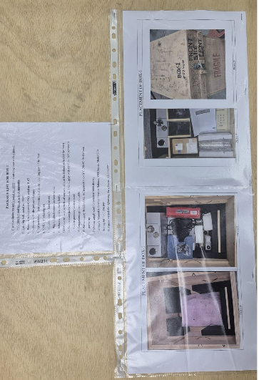
The Box-1 Containing TS (base, PCA, Temperature probe etc)

The size of BOX-2 is (58×76×101) cm is made of a wooden case. The weight (with contents) is about 174 kg. The picture of box-2 is given below

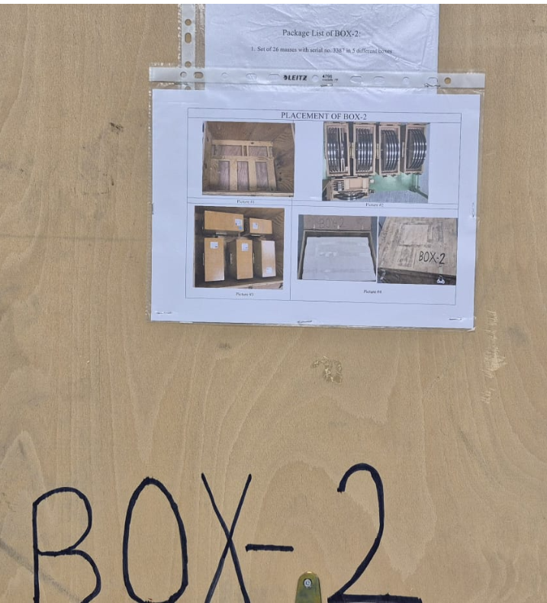
The Box-2 Containing Mass Set

The TS and all accompanying parts are the property of UME. The total cost of the TS, including the pressure balance, the piston-cylinder assembly and the mass set is 16 000 €.

The participants shall provide a quick connector for connecting the TS to their standard.

7. Arrival and departure checks
When the TS arrives at a participating laboratory, it should be checked by the laboratory personnel on the subject of damage and completeness of its components. The arrival check report presented in Annex 3 should be filled in and sent to the pilot, co-pilot laboratory and to the TS sender by e-mail.

When sending the TS to the next participant, it should be checked again, and the departure check report given in Annex 4 should be filled in and sent to the pilot, co-pilot laboratory and destination laboratory by e-mail.

Completely screw in the four adjustable feet of the pressure balance before putting it into the wooden box.

Follow the instructions in the User’s Manual when preparing the pressure balance for work or shipping.
8. Measurement procedures
The TS should be handled, and the PCA mounted in accordance with the instructions given in the User’s Manual Reference Pressure Balance, 5300 Series, Model 5304.

The results of a metrological characterisation of the TS by the co-pilot laboratory are presented in Annex 2. They should be used to check that the TS is operating normally. In case of any anomaly or deviation from the results of the co-pilot laboratory, the latter should be contacted.

Gloves should be worn when handling the piston, the carrying bell and the masses of the TS.

At the beginning, the magnetisation of the piston and cylinder should be checked. The magnetic flow density at their surfaces should not exceed 2⋅10⁻⁴ Tesla. If it is higher, the parts should be demagnetised, and the magnetisation should be controlled again.

Before mounting the PCA, the piston and cylinder should be cleaned according to the usual practice in the laboratory.

The verticality of the PCA should be controlled using the instructions in Annex 2. Do not use the built-in cross spirit level on the base.

To check the tightness of the TS, the piston fall rate shall be measured at 50 MPa and 100 MPa. The target fall rates are given in Annex 2.

The temperature of the TS PCA will be measured with a PT100 platinum resistance thermometer, which is already available on the base and delivered with its terminal 5000 display. That was calibrated by the co-pilot laboratory (see Annex 2). Each laboratory shall use this PT100 probe to measure the TS PCA temperature during the measurements.

The reference temperature for the comparison is 20 °C. If measurements are performed at a temperature other than 20 °C, the effective area of TS should be related to 20 °C using the PCA thermal expansion coefficient given in Annex 2.

The TS is recommended to be placed close to the laboratory reference standard to keep the pressure line between the two instruments as short as possible.
It is also recommended to adjust the height position of the TS to minimise the height difference between the reference level of the TS defined in Annex 2 and the reference level of the laboratory standard.

A piston displacement indicator can be used to control the piston position. However, before starting the measurement, it is recommended to check that the zero position of the indicator corresponds to the piston working position. A procedure to calibrate the built-in piston position sensors can be found in Annex 7.

At equilibrium, the piston of the TS should not deviate from its working position by more than 0.5 mm.

The pressure balance model 5304 has no electronics to be warmed up.
The direction and speed of piston rotation are predefined by the motor of the pressure balance model 5304. Before starting the measurements, the rear cover of the base unit must be removed. In this way, the temperature effect caused by the motor will be reduced. Measurements should be performed with the rear cover of the base unit removed. As the motor is the main source of heat (s. Annex 2), the piston rotation should be switched on at least 30 minutes before the start of the measurement to get a quasi-stationary distribution of temperatures in the pressure balance. It is recommended to leave the engine running between measurements. Only if the time until the next measurement exceeds approximately 2 hours can the motor be switched off. However, in this case, it should be switched on at least 30 minutes before the next measurement.

The time between a change in pressure level and the acquisition of the data corresponding to the equilibrium of the laboratory standard and TS should not be less than 5 minutes.

The measurements shall include five cycles each with nominal pressures generated in the following order (10, 20, 30, 40, 50, 60, 70, 80, 90, 100, 100, 90, 80, 70, 60, 50, 40, 30, 20, 10) MPa. A total of 100 measurements should therefore be made. It should be waited for at least 15 minutes between two measurements at 100 MPa.

The mass pieces to be placed on the TS carrying bell to generate the nominal pressures are given in the table below.

Nominal pressure in MPa | Mass pieces
10  20  30  40  50  60  70  80  90  100 | 4 kg + 1  4 kg + 1 to 3  4 kg + 1 to 5  4 kg + 1 to 7  4 kg + 1 to 9  4 kg + 1 to 11  4 kg + 1 to 13  4 kg + 1 to 15  4 kg + 1 to 17  4 kg + 1 to 18 + 2 kg(1) + 2 kg (2) + 1 kg

The conventional mass of the mass pieces is given in Annex 2.
To achieve equilibrium between the TS and the laboratory standard, the mass of the latter should be adjusted. No additional mass should be added to the piston of the TS.
9. Report of results
Each laboratory should provide the pilot laboratory with the data of its own pressure standard, using the form in Annex 5, as well as with additional information as appropriate.

To prepare the results of the measurements in a form convenient for further processing, participants should use the tables presented in Annex 6.

The effective area of TS is determined from a particular measurement ($A_{p}$) referred to 20 °C should be calculated using the equation

$$A_{p}=\frac{\sum_{i}{m_{i}g\left(1-\frac{{}_{0a}}{{}_{0}}+\frac{{}_{0a}-{}_{a}}{{}_{i}}\right)+2\sqrt{A_{0, nom}}}}{p\left[1+\left({}_{p}+{}_{c}\right)\left(t-t_{0}\right)\right]} ,$$
where

$m_{i}$ are the conventional masses of the piston, the weight carrier and the mass pieces placed on the weight carrier of the TS;
${}_{i}$ Are the densities of the parts with masses $m_{i}$;
${}_{a}$ is the air density;
${}_{0a}$ is the conventional value of the air density, ${}_{0a}=$ 1.2 kg/m³;
${}_{0}$ is the conventional value of the mass density, ${}_{0}=$ 8000 kg/m³;
$g$ is the local gravity acceleration;
is the surface tension of the TS oil;
$A_{0, nom}$ is the nominal effective area of the TS;
$p$ is the pressure generated by the laboratory standard at the TS reference level;
${}_{p}$ and ${}_{c}$ are the thermal expansion coefficients of the piston and cylinder materials, respectively;
$t$ is the temperature of the TS;
$t_{0}$ is the reference temperature, $t_{0}=$ 20 °C.

The values of $p$ and ${}_{a}$ are calculated and $t$ is measured by the participating laboratory. All other parameters can be found in Annex 2.

Additionally, the zero-pressure effective area of the TS ($A_{0}$) and its pressure distortion coefficient which satisfies the equation

$$A_{p}=A_{0}\left(1+p\right)$$

and are based on the results of all 100 measurements, the combined standard uncertainties of $A_{0}$ and as well as a description of how they were calculated should be included.

Any additional information, which, in the opinion of the participating laboratory, is important for the interpretation of the comparison results, is welcome.

Reports containing the results of the measurements are expected to be prepared as a WORD file, with the tables from Annex 6 additionally provided as an EXCEL file. The reports should be sent to the pilot laboratory by email to the following address.

jens.koenemann@ptb.de

within two months after finishing the measurements.

Annex 1. List of Participants
NMI, contact person(s), e-mail(s), phone(s) | Delivery address
PTB  Jens Könemann  jens.koenemann@ptb.de  +49-531-592-3331  Wladimir Sabuga  wladimir.sabuga@ptb.de  +49 531-592-3230 | PTB  Working Group "Pressure" 3.33  Bundesallee 100  38116 Braunschweig  GERMANY
UME  Yasin Durgut  Yasin.durgut@tubitak.gov.tr  +90 262 679 5000  Abdullah Hamarat  abdullah.hamarat@tubitak.gov.tr  +90 262 679 5000 | UME  TUBITAK Gebze Yerleskesi  Bariş Mah. Dr. Zeki Acar Cad. No:1  41470 Gebze/Kocaeli  TURKIYE
LNE  Djilali Bentouati  Djilali.bentouati@lne.fr  +33 1 40 43 37 36 | LNE  23 Avenue Albert Bartholomé  75015 Paris  FRANCE
CEM  Carmen Garcia Izquierdo  mcgarciaiz@cem.es  +34 918074789 | CEM  Alfar, 2  28760 Tres Cantos (Madrid)  SPAIN
CMI  Dominik Pražák  dominik.prazak@cmi.gov.cz  +420 734 681 579 | CMI  Okružní 31  63800 Brno  CZECHIA
LEI  Andrius Tonkonogovas  Andrius.Tonkonogovas@lei.lt  +370 67113961 | LEI  Breslaujos 3  44403 Kaunas  LITHUANIA
NPL  Claudiu Giusca  Claudiu.Giusca@npl.co.uk  +44 20 8943 6224 | NPL  Hampton Road  TW11 0LW Teddington  UNITED KINGDOM
DMDM  Boris Laštro  borislastro@dmdm.rs  +38 1668604002 | DMDM  Mike Alasa 14  11158 Belgrade  SERBIA
VSL  J.L.W.A. van Geel  Jvangeel@vsl.nl  +31 631 119 899 | VSL  Thijsseweg 11  2628 JA Delft  THE NETHERLANDS
INM-MD  Tatiana Apostol  tatiana.apostol@inm.gov.md  +373 69 716 753 | INM-MD  28 E. Coca Street  MD-2064 Chisinau  REPUBLIC OF MOLDOVA
RISE  David Szabo  david.szabo@ri.se  +46 703625586 | RISE  Brinellgatan 4  50462 Borås  SWEDEN
SMU  Filip Kysel  kysel@smu.gov.sk  +421 910 767 988 | SMU  Karloveská 63  841 04 Bratislava  Slovak Republic
BFKH  Edina Rita Tóth-Sáfrány  safrany.edina@bfkh.gov.hu  +36 1 45 85 947 | BFKH  Németvölgyi út 37-39.  1124 Budapest  HUNGARY
IMT  Janez Setina  janez.setina@imt.si  +386-41-765-821  Franci Vode  franci.vode@imt.si  +386-1-4701-998 | IMT  Lepi pot 11  1000 Ljubljana  SLOVENIA
FSB-LPM  Lovorka Grgec Bermanec  lovorka.grgec@fsb.hr  +385 91 2505444 | FSB-LPM  Faculty of Mechanical Engineering and Naval Architecture - Laboratory for Process Measurements  Ivana Lucica 5  10000 Zagreb  CROATIA
BIM  Aleksandar Ivanov  a.ivanov@bim.government.bg  +359 2 9702 716  Vladimir Dikov  v.dikov@bim.government.bg  +359 2 9702 749 | BIM  52-B, Dr G. M. Dimitrov Blvd.  1797 Sofia  BULGARIA
GUM  Adam Brzozowski  adam.brzozowski@gum.gov.pl  +48 22 581 90 85  Seweryn Maciejewski  seweryn.maciejewski@gum.gov.pl  +48 22 581 91 85 | GUM  ul. Elektoralna 2,  00-139 Warszawa  POLAND
VTT-MIKES  Antti Lakka  antti.lakka@vtt.fi  +358505952231 | VTT-MIKES  Tekniikantie 1  Espoo 02150  Finland
NSAI  Sam Boles  Sam.Boles@NSAI.ie  +353 87 000 4199 | NSAI National Metrology Laboratory  Griffith Avenue Extension  Glasnevin  Dublin 11  D11 E527  Ireland
IPQ  Isabel Spohr  ispohr@ipq.pt  (+ 351) 21 294 81 00 | IPQ  Rua António Gião, 2  2829-513 Caparica,  PORTUGAL
INRiM  Domenico Mari  d.mari@inrim.it  +39 0113919914 | INRiM- Istituto Nazionale di Ricerca Metrologica  Strada delle Cacce, 91  10135 Torino, ITALY
IMBIH  Alen Bošnjaković  alen.bosnjakovic@met.gov.ba  +387 33 568 954 | IMBIH  Dolina 6  71000 Sarajevo  BOSNIA AND HERZEGOVINA
BMM  Goran Vukoslavović  goran.vukoslavovic@metrologija.gov.me  +382 67 596 125  Mirjana Radević  mirjana.radevic@metrologija.gov.me  +382 67 085 174 | BMM  Zavod za metrologiju/Bureau of Metrology  Arsenija Boljevića bb  81000 Podgorica  MONTENEGRO
SASO–NMCC  Homood Alotaibi  h.otaibi@saso.gov.sa  +966 590348846  Faisal Alotaibi  Fm.otaibi@saso.gov.sa | SASO–NMCC  Riyadh - Al Muhammadiyah –  PO. B 3437  Riyadh 11471  Kingdom of Saudi Arabia
EMI  Brian Justice  brian.justice@qcc.gov.ae  +9712406540  Abdulrahman Mohamed Mubarak  abdulrahman.mubarak@qcc.gov.ae  +9712406657 | EMI  Emirates Metrology Institute  (Abu Dhabi Quality and Conformity Council)  Masdar City, Abu Dhabi  United Arab Emirates
UzNIM  Marat Yunusov  marat@nim.uz  marat.yunusov@icloud.com  +998 71 2020011 (1214) | UzNIM  Uzbek National Institute of Metrology  333 B, Farobiy street, Almazar district,  100174, Tashkent, Uzbekistan

Annex 2. Technical data of the transfer standard
Unless indicated otherwise, all uncertainties in this Annex are standard ones (k = 1)

Piston-cylinder assembly

The serial number, 5877, is engraved on the upper cylinder face and the upper piston cap face. The nominal effective area of the assembly is $A_{0,nom}$= 9.81 mm².

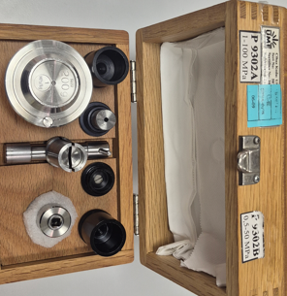
Piston-cylinder assembly serial no. 5877 in a carrying case with a special mounting key and torque wrench special apparatus

After the installation of the cylinder, it is suggested that the cylinder be tightened up to 5.5 Nm using the torque wrench key and the provided special apparatus in the PCA box. Torque wrench and tightening operation is given in the figure below:

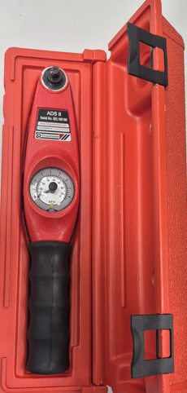 | 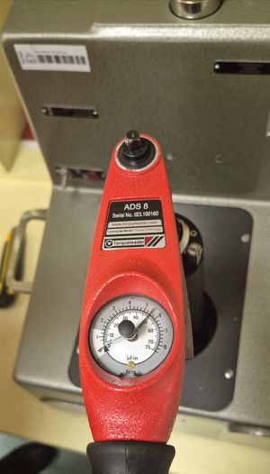
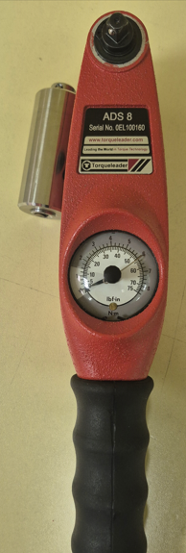
Torque Wrench and special apparatus | Tightening the Cylinder with Torque Wrench

Alignment of the base

To achieve PCA verticality, the base should be aligned. During the initial study of the TS, it was found that when the built-in cross spirit level of the base was aligned horizontally, the PCA deviated from verticality (see the figure below).

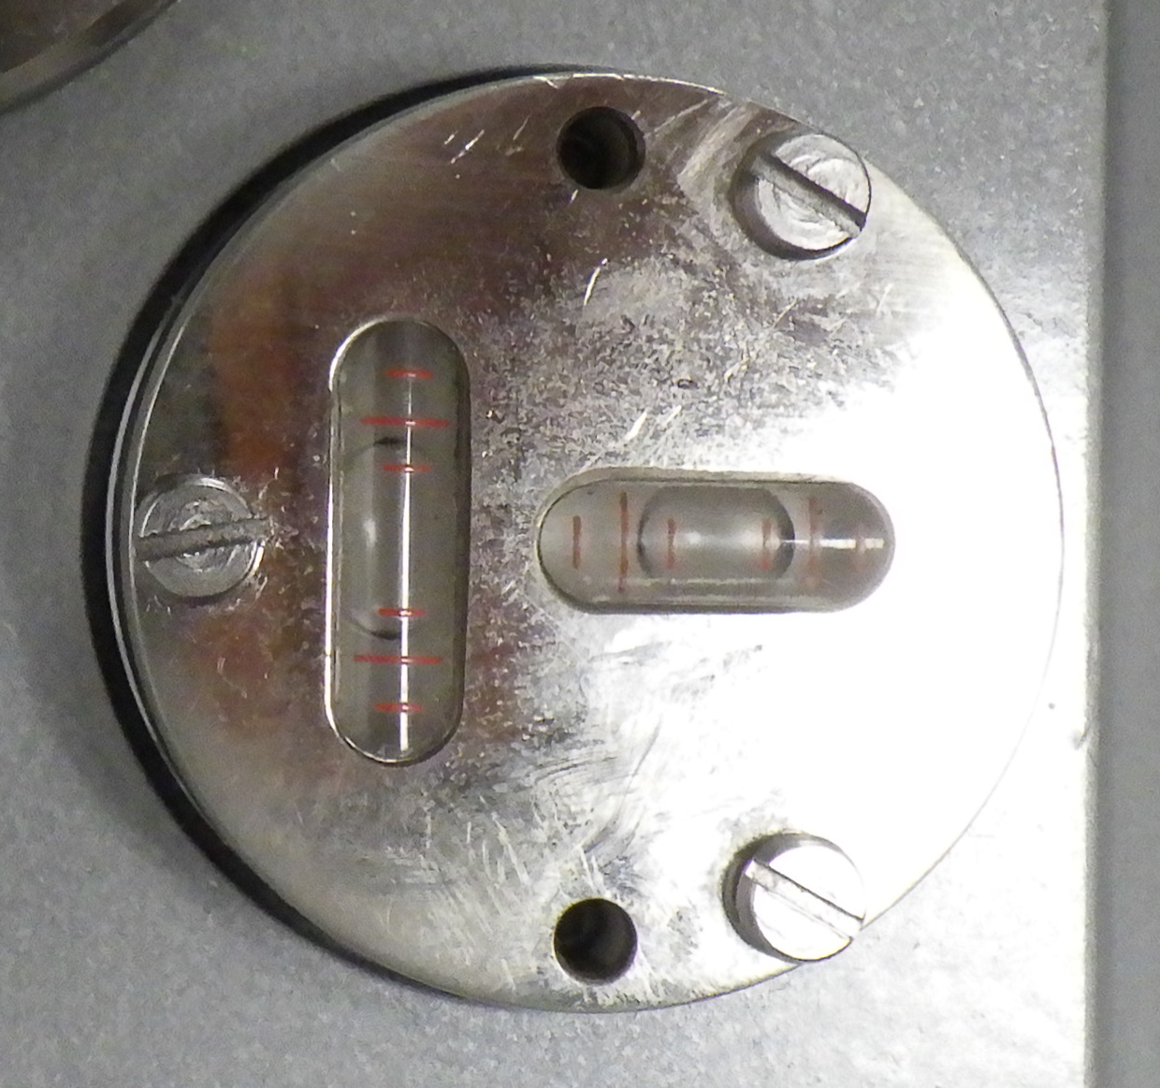 | 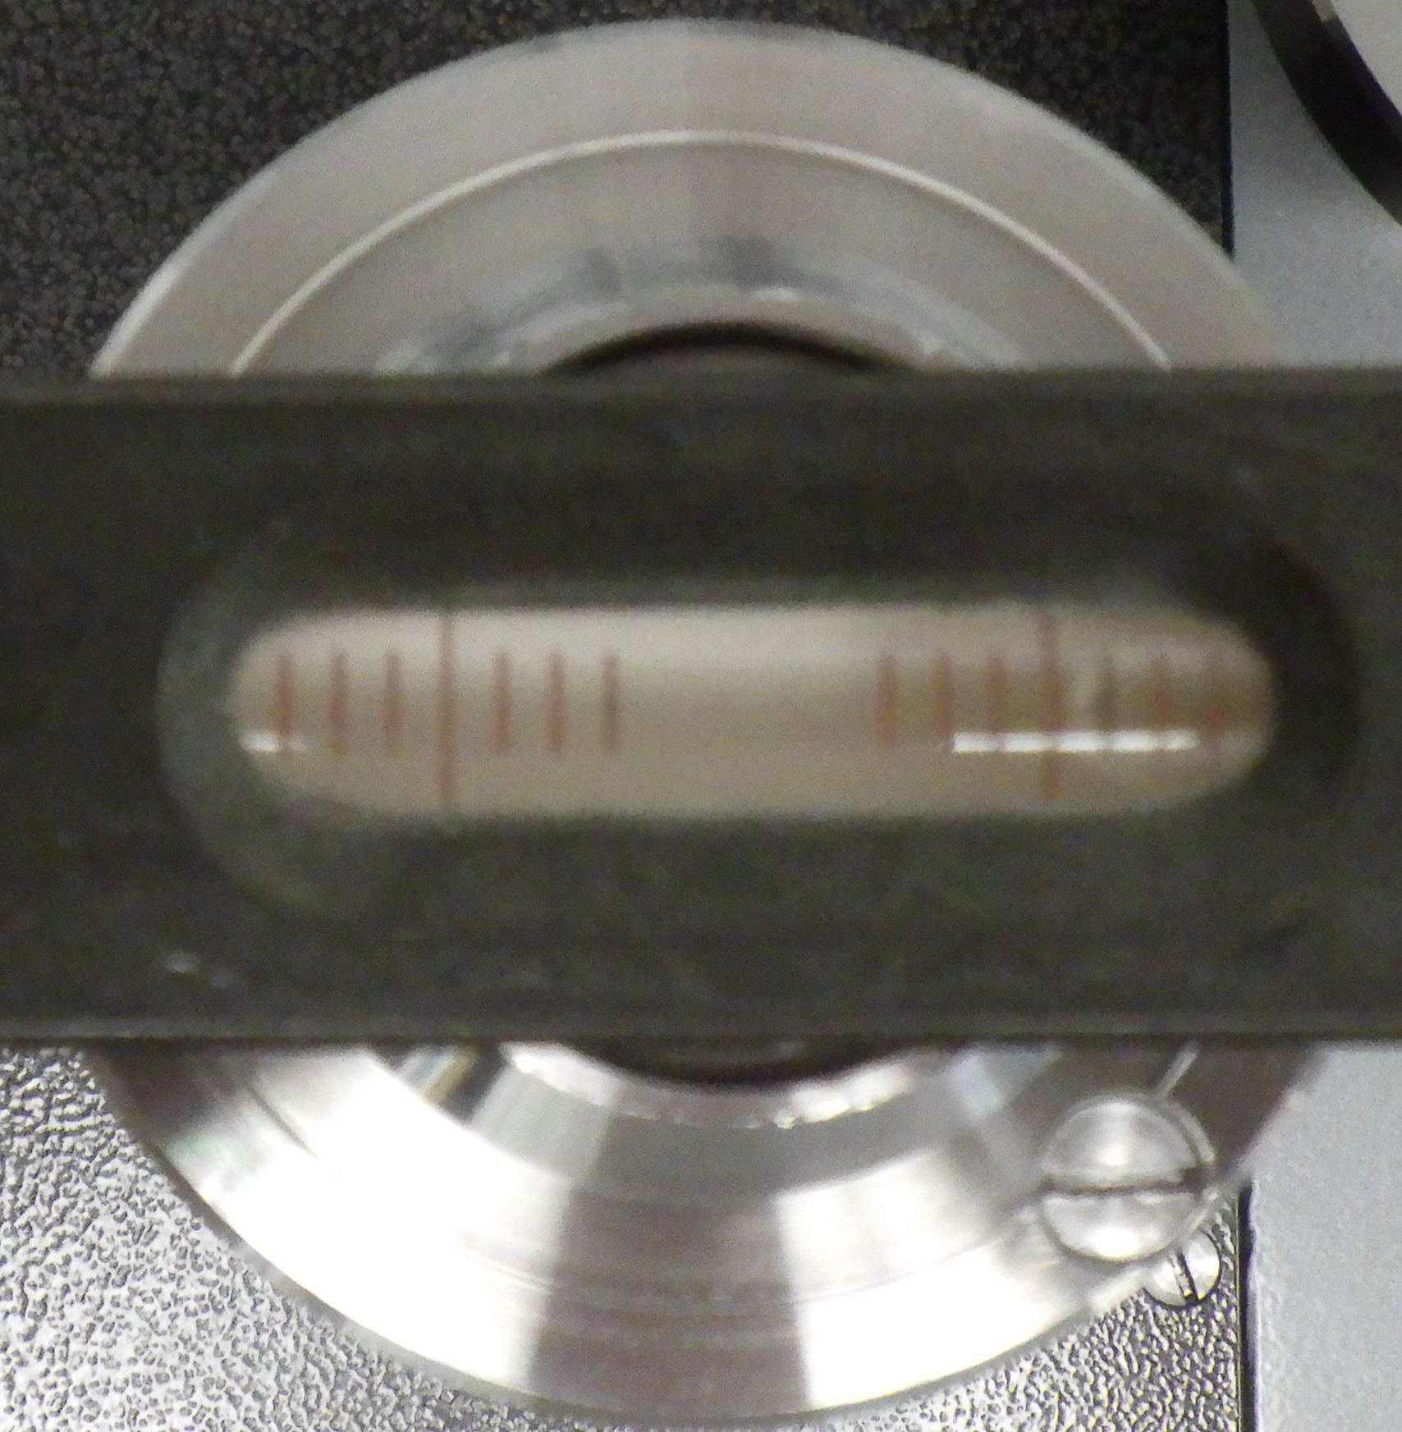 | 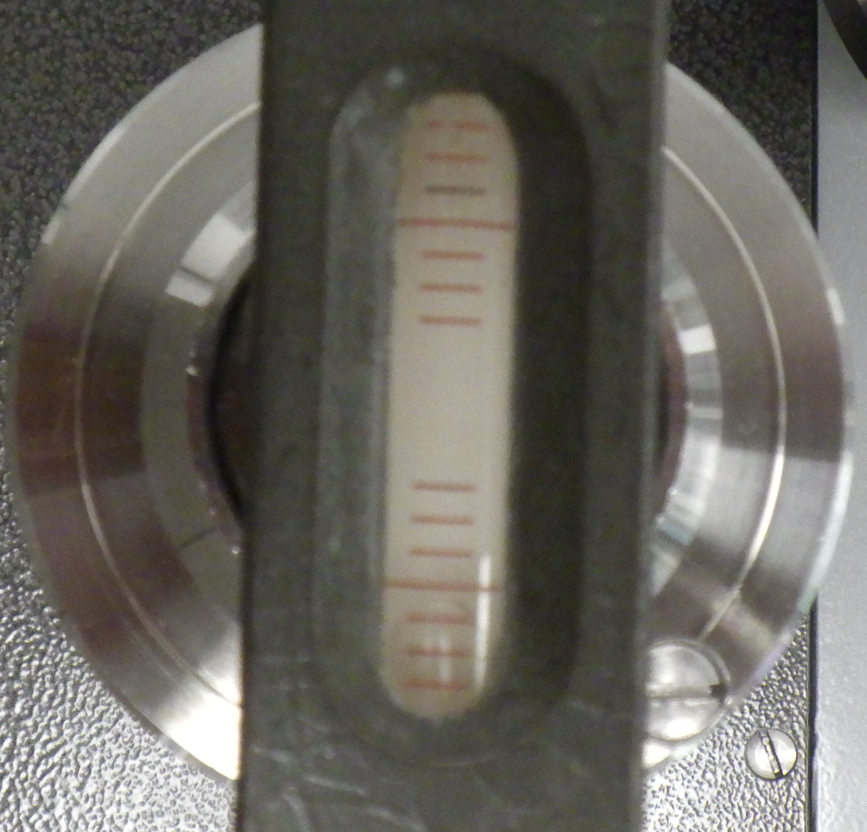
Indication of the built-in cross spirit level | Indication of a spirit level placed on piston head

Therefore, each laboratory is recommended to control the horizontal position of the piston head using its own spirit level, which should be placed on the piston head.

Piston-cylinder material properties

The PCA is made of tungsten carbide. The piston cap is of stainless steel. According to the manufacturer's information, the tungsten carbide of the assembly has the following properties:
Young’s modulus $E=$ 560 GPa (Piston)
Young’s modulus $E=$ 620 GPa (Cylinder)
Poisson’s coefficient $=$ 0.218
Linear thermal expansion coefficient $=$ 4.5⋅10⁻⁶ 1/°C
The thermal expansion coefficient of the piston-cylinder assembly is herewith
${}_{p}+{}_{c}=$ (9.0 ± 1.0)⋅10⁻⁶ 1/°C.
Its standard uncertainty is based on the manufacturer's information and the experience of the pilot laboratory.

Piston mass and density

The conventional mass of the piston is $m_{p}=$ (199.99473 ± 0.00003) g.
The uncertainty given correspond to the expanded uncertainty at k=2.
Its mean density is ${}_{p}=$ (8100 ± 100) kg/m³.
$m_{p}$ was measured and ${}_{p}$ estimated by the co-pilot laboratory.

Reference level and piston working position

The piston working position is 5.5 mm above its rest position.
The reference level of the TS coincides with the piston lower face; the total piston length (distance from the piston lower face to the upper piston cup edge) is 84.07 mm.
Herewith, the reference level lies 0.07 mm below the middle of the reference level line shown on the housing of the pressure balance.
The co-pilot laboratory measurements, where the piston was moved by ±1 mm around its normal working position, showed no systematic change in the effective area.

Typical cross-float sensitivity and reproducibility

The change in mass of 20 mg and 100 mg at 10 MPa and 100 MPa, respectively, could be seen in the behaviour of TS when compared with the UME reference standard. This corresponds to the relative pressure sensitivity of 2.0⋅10⁻⁶ and 1.0⋅10⁻⁶, respectively.
The relative standard deviations of the effective areas measured at the pressures specified for the comparison were between 1.0 and 3.0 ⋅10⁻⁶.

Piston-cylinder temperature drift

When the driving motor continuously works, the temperature of the PCA increases with a typical rate between (1 and 4.0) mK/min.

Piston fall rates

Piston fall rates ($v_{f}$) measured by the co-pilot laboratory after 15 minutes waiting under different thermal conditions at temperatures around 21 °C are:
$p$ / MPa $v_{f}$ / (mm/min)
20 -0.05
20 -0.04
50 -0.16
50 -0.13
100 -0.45
100 -0.37

The experimental fall rates are obviously affected by the temperature rise.

Basic suitability of the TS with respect to stability

Based on the results of previous calibrations of this PCA, which were performed at UME in 2006 and 2009 and at PTB in 2011, 2018, and 2024, the stability of the zero-pressure effective area of the TS was estimated to be approximately 4 ppm for the UME measurements and around 6 ppm for the PTB measurements.

Magnetisation of the piston and cylinder

During the preliminary investigation of the TS by the pilot laboratory, the magnetic flow density at the midpoint of the piston and cylinder length was measured. The maximum values were 8⋅10⁻⁵ Tesla for the cylinder and 1.4⋅10⁻⁴ Tesla for the piston. Demagnetisation should be performed if the magnetic flow density is greater than 2⋅10⁻⁴ Tesla.

Carrying bell

The carrying bell is made of stainless steel.
Its conventional mass is $m_{b}=$ (799.961 ± 0.002) g.
The uncertainty given correspond to the expanded uncertainty at k=2.
Its density is ${}_{b}=$ (7920 ± 160) kg/m³.

Mass set

The mass set consists of 18 mass pieces of 5 kg nominal mass, marked by numbers from 1 to 18 and one mass piece of 4 kg nominal mass, 2 mass pieces of 2 kg nominal mass, 1 mass pieces of 1 kg nominal mass, 1 mass pieces of 500 g nominal mass, 2 mass pieces of 200 g nominal mass, 1 mass pieces of 100 g nominal mass. All pieces are identified by serial number 3387.
The material density of the mass pieces is ${}_{m}=$ (7920 ± 160) kg/m³.
The conventional mass of the mass pieces is given in the table below.

Nominal value | Marking | Conventional mass in kg | Uncertainty (k = 2) in mg
5 kg | 1 | 4.999998 | 9
5 kg | 2 | 4.999979 | 9
5 kg | 3 | 4.999970 | 9
5 kg | 4 | 4.999965 | 9
5 kg | 5 | 4.999980 | 9
5 kg | 6 | 4.999963 | 9
5 kg | 7 | 4.999971 | 9
5 kg | 8 | 4.999965 | 9
5 kg | 9 | 4.999955 | 9
5 kg | 10 | 4.999964 | 9
5 kg | 11 | 4.999957 | 9
5 kg | 12 | 4.999958 | 9
5 kg | 13 | 4.999965 | 9
5 kg | 14 | 4.999968 | 9
5 kg | 15 | 4.999976 | 9
5 kg | 16 | 4.999988 | 9
5 kg | 17 | 4.999965 | 9
5 kg | 18 | 4.999979 | 9
4 kg | - | 4.000005 | 7
2 kg | 1 | 1.999988 | 4
2 kg | 2 | 1.999981 | 4
1 kg | - | 0.999999 | 2
0.8 kg | - (mass carrier) | 0.799961 | 2
0.5 kg | - | 0.499998 | 1
0.2 kg | 1 | 0.199999 | 1
0.2 kg | 2 | 0.199999 | 1
0.1 kg | - | 0.100000 | 1

Temperature probe

The temperature of the TS PCA will be measured with a Pt100 platinum resistance thermometer, which is already inserted into the base and supplied with a terminal 5000 display. That was calibrated by the co-pilot laboratory. The calibration results of the Pt100 probe are given below:

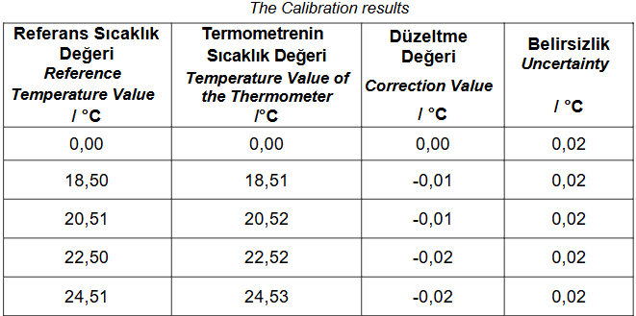

Pressure-transmitting medium

The working liquid is Di(2-ethylhexyl) sebacate (DEHS). According to the literature data, its density (${}_{l}$) in dependence on pressure ($p$) and temperature ($t$) is
${}_{l}=$ [912.7 + 0.752($p$/MPa) - 1.65⋅10⁻³($p$/MPa)² + 1.5⋅10⁻⁶ ($p$/MPa)³] ×
× [1 - 7.8⋅10⁻⁴ ($t$/°C - 20)] × (1 ± 0.01) kg/m³.
The surface tension σ of DEHS, as determined by the pilot laboratory is
$=$ 31.2 × (1 ± 0.05) mN/m.

Annex 3. Arrival check protocol
Laboratory name:

Arrival of TS
Date:
From:

TS is free of damage (yes/no):
If not, describe the damage

TS set is complete (yes/no):
If not, indicate the missing part from the list below:

The list of Transfer Standard (TS) components for BOX-1 is shown below:
- Piston-cylinder assembly serial no. 5877 in a carrying case with a special mounting key and torque wrench apparatus
- Carrying bell, serial no. 3387
- Pressure balance model 5304 serial no. 9162
- 4 footrests for the pressure balance
- 3 piston travel limit pins inserted on the mounting post of the base
- Cylinder retaining nut
- Quick-connector knurled nut
- Plug for quick-connector knurled nut
- Sebacate oil in a plastic bottle
- Oil run-off cup (cylindrical cup available at the bottom, behind the base)
- Temperature probe with terminal 5000 display with serial no. 2651 (probe is built in pressure balance base)
- Temperature probe output cable
- Power supply SCL25-7612, AC input (100-240) V, (50-60) Hz for base power up
- Power supply cord for the terminal 5000 display
- User’s Manual Reference Pressure Balance, 5300 Series, Model 5304
- Plug for mounting post
- Torque wrench for tightening the cylinder retaining nut

The list of Transfer Standard (TS) components for BOX-2 is shown below:
- Set of 26 masses with serial no. 3387

Report date:
Name of inspecting person:
Address, phone, e-mail, if deviating from those given in section 2 “Participants”

Annex 4. Departure check protocol
Laboratory name:

Departure of TS
Date:
To:

TS is free of damage (yes/no):
If not, describe the damage

TS set is complete (yes/no):
If not, indicate the missing part from the list below
The list of Transfer Standard (TS) components for BOX-1 is shown below:
- Piston-cylinder assembly serial no. 5877 in a carrying case with a special mounting key and torque wrench apparatus
- Carrying bell, serial no. 3387
- Pressure balance model 5304 serial no. 9162
- 4 footrests for the pressure balance
- 3 piston travel limit pins inserted on the mounting post of the base
- Cylinder retaining nut
- Quick-connector knurled nut
- Plug for quick-connector knurled nut
- Sebacate oil in a plastic bottle
- Oil run-off cup (cylindrical cup available at the bottom, behind the base)
- Temperature probe with terminal 5000 display with serial no. 2651 (probe is built in pressure balance base)
- Temperature probe output cable
- Power supply SCL25-7612, AC input (100-240) V, (50-60) Hz for base power up
- Power supply cord for the terminal 5000 display
- User’s Manual Reference Pressure Balance, 5300 Series, Model 5304
- Plug for mounting post
- Torque wrench for tightening the cylinder retaining nut

The list of Transfer Standard (TS) components for BOX-2 is shown below:
- Set of 26 masses with serial no. 3387

Report date:
Name of inspecting person:
Address, phone, e-mail, if deviating from those given in section 2 “Participants”

Annex 5. Laboratory standard and measurement conditions
Table 5.1. Laboratory standard – pressure balance, uncertainties are standard ones (k = 1).

Manufacturer
Measurement range in MPa
Material of the piston
Material of the cylinder
Operation mode, free-deformation or controlled-clearance
Zero-pressure effective area ($A_{0, LS}$) at reference temperature in cm²
Relative uncertainty of $A_{0, LS}$ in 10⁻⁶
Pressure distortion coefficient (${}_{LS}$) in MPa⁻¹
Uncertainty of ${}_{LS}$ in MPa⁻¹
Relative uncertainty of mass pieces in 10⁻⁶
Linear thermal expansion coefficient of the piston ($α_{p, LS}$) in °C⁻¹
Linear thermal expansion coefficient of cylinder ($α_{c, LS}$) in °C⁻¹
Reference temperature ($t_{0, LS}$) in °C
Local gravity acceleration ($g$) in m/s²
Relative uncertainty of $g$ in 10⁻⁶
Height difference between laboratory standard (LS) and TS ($h$), positive if LS is higher than TS, in mm
Uncertainty of $h$ in mm

In addition, the traceability of the LS to SI units should be explained. Details of how $A_{0, LS}$ and ${}_{LS}$ and their uncertainties should be reported.

Annex 6. Measurement results
Table 6.1. Results in individual cycles

Laboratory name :

Date (period) :

Cycle number: … of 5

Average relative air humidity and its uncertainty :

Meas.  no. | $$p_{nom}$$  / MPa | $$t_{LS}$$  / °C | $$t_{amb}$$  / °C | p_{amb}  / kPa | $$p$$  / MPa | $$t$$  / °C | $$A_{p}$$  / mm²
1 | 10
2 | 20
3 | 30
4 | 40
5 | 50
6 | 60
7 | 70
8 | 80
9 | 90
10 | 100
11 | 100
12 | 90
13 | 80
14 | 70
15 | 60
16 | 50
17 | 40
18 | 30
19 | 20
20 | 10

$p_{nom}$ is the nominal pressure.
$t_{LS}$ is the temperature of the LS.
$t_{amb}$ is the ambient air temperature.
p_{amb} is the ambient air pressure.
$p$ is the pressure generated by the LS at the TS reference level.
$t$ is the temperature of the TS.
$A_{p}$ is the effective area of the TS at the reference temperature of 20 °C.

The formula to calculate $p$ must be reported.

Table 6.2. Summary of all cycles

Laboratory name :

Date (period) :

$$p_{nom}$$  / MPa) | m_{min,adjust}  / mg | $$〈A_{p}〉$$  / mm² | $${\left(A_{p}\right)}/{〈A_{p}〉}$$  / 10⁻⁶ | $${u\left(p\right)}/p$$  / 10⁻⁶ | $$u\left(t\right)$$  / °C | $${u\left(A_{p}\right)}/{〈A_{p}〉}$$  / 10⁻⁶
10
20
30
40
50
60
70
80
90
100

m_{min, adjust} is the minimum mass adjusted on the piston of the laboratory standard to achieve equilibrium between it and the TS, if the classical fall rate method is used to check equilibrium. If another method is used, the typical uncertainty of the pressure difference between the reference standard and the TS (in MPa) due to this method should be given. In this case, the column heading should be changed accordingly.
$〈A_{p}〉$ is the average of the $A_{p}$ values measured at the same nominal pressure.
${\left(A_{p}\right)}/{〈A_{p}〉}$ is the standard deviation of the $A_{p}$ mean value.
${u\left(p\right)}/p$ is the type B uncertainty of the pressure at the reference level of the TS.
$u\left(t\right)$ is the uncertainty of the TS temperature.
${u\left(A_{p}\right)}/{〈A_{p}〉}$ is the combined uncertainty of the $A_{p}$ mean value.

In addition, a list of main uncertainty sources and their contributions to $u\left(A_{p}\right)$ The pressures of 10 MPa and 100 MPa must be presented.

All uncertainties should be expressed as standard ones.

Annex 7. Adjusting the piston position sensors

Start screen
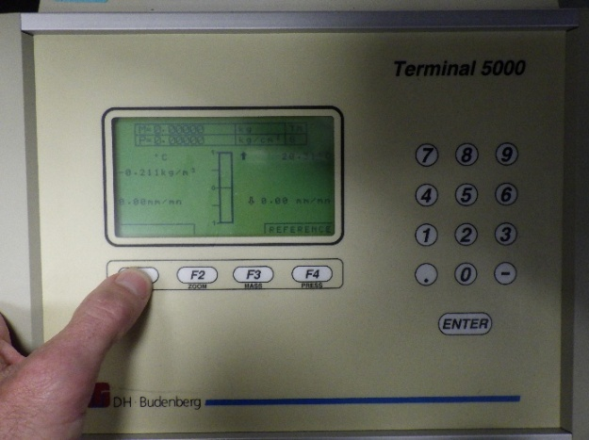

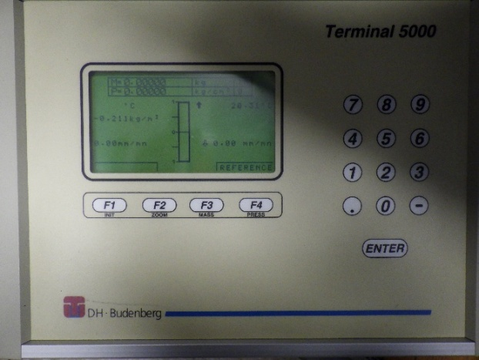

F1 for sub menu

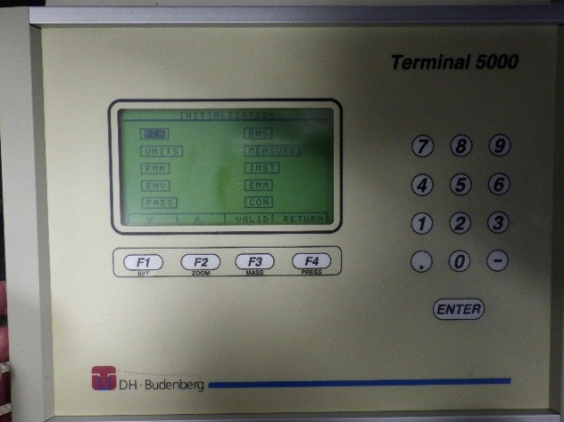

Sub menu

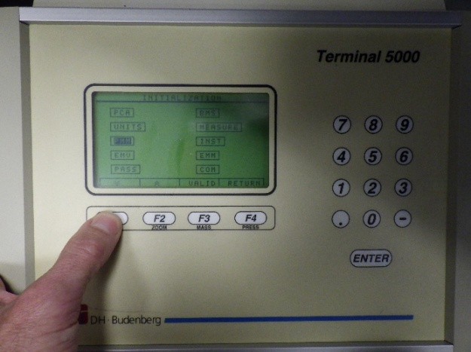

with cursor F1 or F2
for selection - PMM -
confirm with F3-VALID

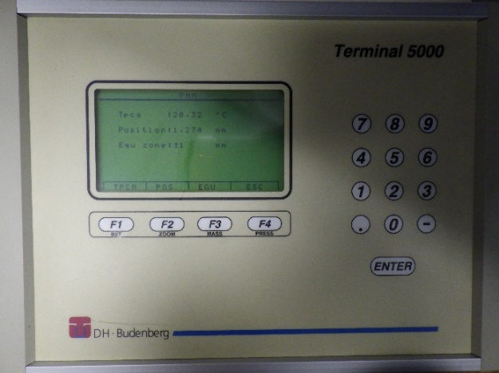

F2-POS selection
of settings for
height adjustment

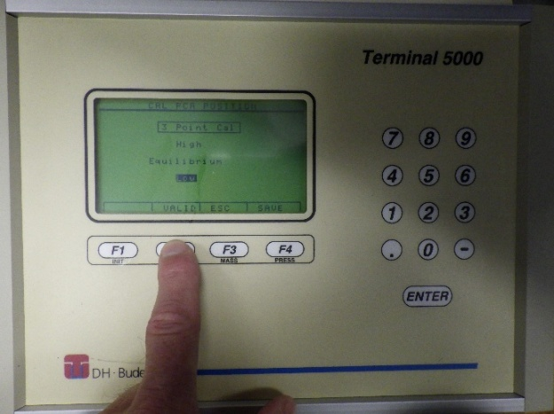

Set the working
position at 10 MPa
LOW – mass carrier down,
then F2-VALID

i
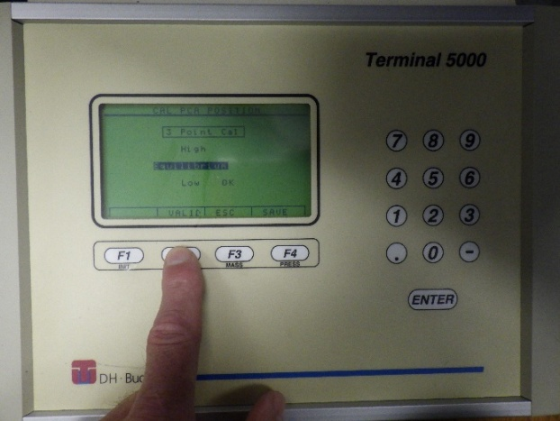

Equilibrum – mass carrier in
working position: 5,5 mm
away from bottom position
then F2

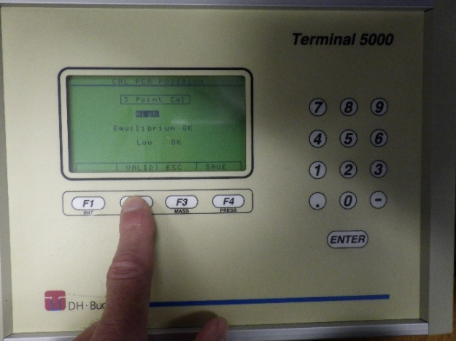

HIGH – mass carrier at top
then F2-VALID

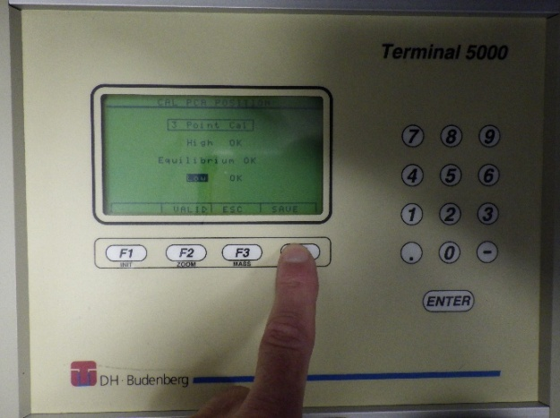

F4-SAFE
Adjustment completed.

Start screen via
F4-ESC und
F4-RETURN

