EURAMET Comparison of Stainless Steel Multiples and Sub-Multiples of the Kilogram

200 mg, 1 g, 50 g, 200 g and 10 kg

Comparison: EURAMET.M.M-SX
Technical protocol

Contents

1. Aim 2
2. Participants 2
3. Travelling standards 2
4. Time schedule 3
5. Transportation 3
6. Unpacking, handling and care of the standards 3
7. Measurements 3
8. Reporting 4
9. Financial aspects and insurance 4
Annex I. Visual inspection, record of the surfaces of the transfer standards 5

Aim
The objectives of this supplementary comparison are to facilitate the demonstration of metrological equivalence between the two participating national laboratories, and to enable Bureau Luxembourgeois de métrologie (ILNAS) to publish Calibration and Measurement Capabilities (CMCs) in the BIPM Key Comparison Database (KCDB).

Participants
Participant 1 (Pilot laboratory)
Laboratoire National de métrologie et d’Essais (LNE)
1 rue Gaston-Boissier
F-75015 Paris
France
Phone: +33 1 40 43 37 98
Fax: +33 1 40 43 37 37
Contact Person: Bartholomé Blanc (bartholome.blanc@lne.fr)

Participant 2
Bureau Luxembourgeois de Métrologie (ILNAS)
11A, rue de la Gare
L-8325 Capellen
Luxembourg
Phone: +352 247 743 78
Fax: +352 247 943 90
Contact Person: Quentin Sanchez (quentin.sanchez@ilnas.etat.lu)

Collector of results
Research Institutes of Sweden (RISE)
Brinellgatan 4
SE-504 62 Borås
Sweden
Phone: +46 10 516 62 07
Mobile: +46 76 846 62 07
Contact Person: Mikolaj Wozniak (mikolaj.wozniak@ri.se)

Travelling standards
One set of travelling standards provided by LNE will be used in the comparison:
- Five weights of nominal value 200 mg, 1 g, 50 g, 200 g and 10 kg.
The weights are identified in Table 1.
The densities of the weights have been measured by LNE prior to the comparison.

Nominal value | Weight ID | Density at 20 °C | Standard uncertainty
200 mg | E | 7960 kg/m³ | 10 kg/m³
1 g | E | 8027 kg/m³ | 16 kg/m³
50 g | E | 7974,3 kg/m³ | 1,7 kg/m³
200 g | E | 7958,50 kg/m³ | 0,20 kg/m³
10 kg | MET 10 kg 8 | 7962,70 kg/m³ | 0,9 kg/m³

Table 1. Identification of the weights used as transfer standards in the comparison.
No cleaning of the travelling standards should be carried out.

Measurement schedule
Preliminary time schedule:
- Measurements at LNE, Paris: April 2026
- Measurements at ILNAS, Capellen: April 2026 – May 2026
- Measurements at LNE, Paris: May 2026
- Draft report expected: June 2026

Transportation
The travelling standards are transported by the company Arthur Welter. The standards are shipped in wooden boxes. It is the responsibility of ILNAS to organize the transport between France and Luxembourg.

Unpacking, handling and care of the standards
When the standards arrive at the participating laboratory, the transportation case and its contents should be checked for damage and missing items. A visual inspection of the surfaces of the standards should be made and the results noted on the measurement report. The pilot laboratory should be informed about the arrival and departure time and about the result of the visual inspection as soon as possible by email.

Every incident during handling of the transfer standards, where the standards may have been polluted or damaged, should be documented and communicated to the pilot laboratory as soon as possible. Also, the pilot laboratory should be informed about any delay or required change of the time schedule.

The standards should be stored at a place where they are protected from dust, aerosols and vapours all the time they are not in the balance, for example in their travelling containers or in a suitable clean environment protected from dust, drafts and vapour. If the weight is placed on a table, the table surface should be clean and covered by acid free tissue paper.

The transfer standards should be handled carefully and only ever with the appropriate tools. When being manipulated the weights should be handled with tongs or tweezers. The standards should never be touched with bare hands.

Measurements
The participating laboratories shall determine the conventional mass of the mass standards according to their normal calibration procedure. An appropriate time should be allowed for the stabilisation of the weights following transportation (as specified in OIML R111 for class E1). Before the mass determination, dust particles should be removed from the surface of the standard by a clean, soft brush. No further washing should be performed. After visual inspection for dust particles on the surface, the weights should be placed in the weighing chamber of the comparator. All weighings should be performed in air. For the buoyancy correction, the air density should be determined using the laboratory’s standard procedure, specified in the measurement report.

Reporting
A completed measurement report (see Comparison results.xlsx) for the measurement results, data of the ambient conditions, instruments used, and traceability of the participant’s reference standard must be submitted to the collector of results within two weeks after the completion of the measurements. When all measurement reports have been collected, they will be sent to LNE which, will carry out the data analysis.

Financial aspects and insurance
Each participating laboratories is responsible for its own costs for the measurements as well as any damage that may occur within its country. ILNAS will cover the cost of transportation and travel insurance.

Visual inspection, record of the surfaces of the transfer standards

A visual inspection of the surfaces shall be made, and the results shall be reported immediately after receiving and before sending the standards using this protocol by sending it to the Pilot Laboratory by email (scanned in PDF format).

Procedure:
- Put the standards on clean lens cleaning paper as described.
- Always use gloves or forceps.
- In case of dust on the surface, use only brush to remove the visible particles.
DO NOT CLEAN THE TRANSFER STANDARDS.
- Record on the diagrams any mark(s) seen on the travelling standard (scratches, contamination, etc.)
- Scan the page and send it to the Pilot Laboratory before starting any measurements.
Sample inspection sheet.
Identification of the standard
Carried out by
Date
Notes:

10000 / 200 / 50 / 1 gram

Top surface

Base surface

Sample inspection sheet.
Identification of the standard
Carried out by
Date
Notes:

200 mg
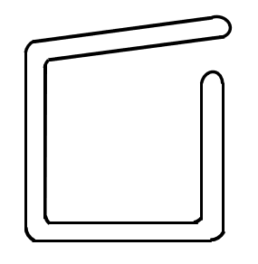
Front Surface
Reverse Surface

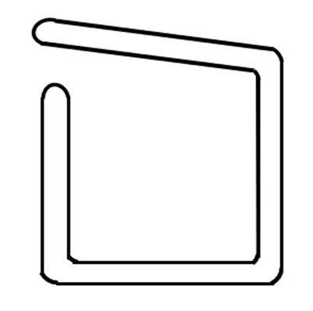
Other Comments:

