912/RU/24

Key comparison
In the Field of Force Measurements in force values:
50; 100; 500; 1000 kN
COOMET.M.F.-ХХ

Technical protocol

Pilot:
D. I. Mendeleyev Institute for Metrology VNIIM

Contact person:
Ilya Shmigelskiy
Head of Mass and Force Laboratory

Address: 190005, Russia, St. Petersburg, Moskovsky pr., 19

Phone: + 7 812 315-15-14
E-mail: i.y.shmigelskiy@vniim.ru

1 Introduction
The COOMET.M.F-XX (912/RU/24) comparison for force values ​​of 50, 100, 500, and 1000 kN is conducted based on the decision of the 27th meeting of COOMET TC 1.6 "Mass and Related Quantities."
D. I. Mendeleyev Institute for Metrology VNIIM is the pilot laboratory and provides the transportable transfer standard.
The comparison results in the determination of the actual values ​​of the force reproduced by the force-reproducing machines of the participating laboratories and an assessment of the expanded relative uncertainty in the force reproduction.

2 Purpose of this Document
The purpose of this document is:
- To organize comparison;
- To instruct the comparison participants in transporting the transfer standard and processing the measurement results;
- Denote the way in which the measurement results are presented.

3 Participants of the comparisons
Six national metrological institutes will participate in the key comparison, five of which are members of COOMET and one, which is GULFMET. The participating laboratories are listed in Table 1.

Table 1. NMI - participants in the comparisons.
NMI | Abbreviation | Contact person
D.I. Mendeleyev Institute for Metrology  190005, Russia, St. Petersburg, Moskovsky pr., 19  Tel.: +7 812 251 76 01  Website: www.vniim.ru  E-mail: info@vniim.ru | VNIIM | Ilya Shmigelskiy  Email: i.y.shmigelskiy@vniim.ru  Address: 190005, Russia, St. Petersburg, Moskovsky pr., 19  Tel.: +7 812 315 15 14  Sergey Semenov  Email: s.a.semenov@vniim.ru  Address: 190005, Russia,  St. Petersburg, Moskovsky pr., 19  Tel.: +7 812 315 15 14
Belarusian State Institute for Metrology  220053, Republic of Belarus, Minsk, Starovilensky tract, 93  Tel.: +375 17 374 55 01  Website: https://belgim.by/  E-mail: info@belgim.by | BelGIM | Natalia Kamkova  Email: Kamkova@belgim.by  Address: 220053, Republic of Belarus, Minsk, Starovilensky tract, 93  Tel.: +375 17 357 48 77
Center for Standardization and Metrology  720040, Kyrgyz Republic, Bishkek, Panfilova strееt, 197  Tel.: +996 312 62 37 90  Website: www.nism.gov.kg  E-mail: nism@nism.gov.kg | Kyrgyzstandart | Adilet Marselyev  Email: adil.marselev@gmail.com  Address: 720040, Kyrgyz Republic, Bishkek, Panfilova street., 197  Tel.: +996 312 66 26 20
Agency for Standardization, Metrology, Certification and Trade Inspection under the Government of the Republic of Tajikistan  734018, Republic of Tajikistan, Dushanbe, N. Karabaev street, 42/2  Tel.: +992 37 233 68 69  Website: www.standard.tj  E-mail: info@standard.tj | Tajikstandard | Musalama Khudoyeva  Email: mkhudoieva@inbox.ru  Address: 734018, Republic of Tajikistan, Dushanbe, N. Karabaev street, 42/2  Tel.: +992 77 700 74 75
Uzbek National Institute for Metrology  100174, Republic of Uzbekistan, Tashkent, Farobiy street, 333A  Tel.: +998 712 02 00 11(1200)  Сайт: http://nim.uz/ru/  E-mail: info@nim.uz | UzNIM | Zidullakhuzha Mukhtorov  Email: muxtorov@nim.uz  Address: 100174, Republic of Uzbekistan, Tashkent, Farobiy street, 333B  Tel.: +998 90 960 99 96
The Saudi Standards, Metrology and Quality Organization  11471, Saudi Arabia, Riyadh, Imam Saud bin Abdulaziz bin Mohammed Road, the intersection of Prince Turki bin Abdulaziz I Road  Тел.: +966 92 000 90 85  Сайт: www.saso.gov.sa  E-mail: info@saso.gov.sa | SASO | Abdulelah Bin Awn  Email: a.binown@saso.gov.sa  Address: 11471, Saudi Arabia, Riyadh, Imam Saud bin Abdulaziz bin Mohammed Road, the intersection of Prince Turki bin Abdulaziz I Road  Телефон: +966 1 252 97 34

4 Organization of comparison
Each Participant is responsible for transporting the transfer standard to the next Participant of the Pilot Laboratory in accordance with the Comparison Schedule (Table 2), as well as for the proper customs paperwork. The transfer standard must be handed over by a courier company or an NMI employee.
Each Participant bears its own costs for shipping the standard to the next Participant and any customs costs in its own country.
Each Participant must have insurance covering any damage or loss in its country or while shipping the transfer standard to the next Participant.
Before shipping, each Participant must inform the Pilot Laboratory and provide transporting information. Each Participant must be informed on the arrival of the transfer standard at least a week in advance.
Any circumstances to which the transfer standard is exposed during transportation that may affect the comparison results must be reported to the Pilot Laboratory at the first opportunity.
Upon reception, the transfer standard must be inspected. Photographs of the transported reference standard should be e-mailed to i.y.shmigelskiy@vniim.ru or s.a.semenov@vniim.ru to the pilot laboratory within 24 hours of the inspection.

4.1 Scheme for conducting comparisons and comparison schedule
The scheme of conducting the comparison is mixed. Shipping of the transfer standard should follow the schedule presented in Table 2.
Table 2. Comparison schedule.
NMI | Force values, kN |  |  |  | Period of measurements
NMI | 50 | 100 | 500 | 1000 | Period of measurements
VNIIM | + | + | + | + | 10/2025
BelGIM | + | + | + | + | 11/2025
Kyrgyzstandart | + | + | + | + | 12/2025
VNIIM (stability control) | + | + | + | + | 01/2026
Tajikstandard | + |  |  |  | 02/2026
UzNIM | + | + | + | + | 03/2026
SASO | + | + | + | + | 04/2026
VNIIM (stability control) | + | + | + | + | 05/2026
Note: The dates are approximate. If necessary, the schedule can be adjusted.

4.2 Транспортируемые эталоны сравнения
The force transducer ODS-10 (S/N: 332112) with the measuring range up to 100 kN (Fig. 1) and force transducer ODS-100 (S/N: 341672) with the measuring range up to 1 000 kN (Fig. 2), manufactured by Weight-Measuring Company «Tenso-M», Russia, are used as a transfer standard.
Together with the ODS-10 force transducer (S/N: 332112), the TС 225.2 measuring amplifier (S/N: 1952), manufactured by TestSystems, Russia, is used. Together with the
ODS-100 force transducer (S/N: 341672), the TC 225.2 measuring amplifier (S/N: 1953), manufactured by Testsystems, Russia, is used.
The transfer standard also includes the Interface CX-0404 calibrator (S/N: 1967).
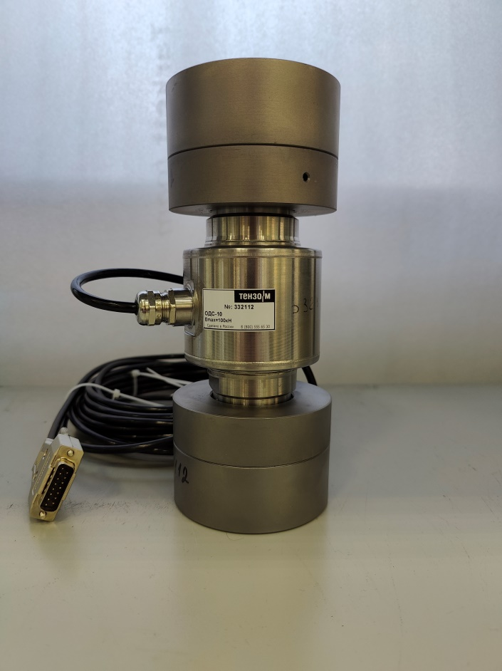 | 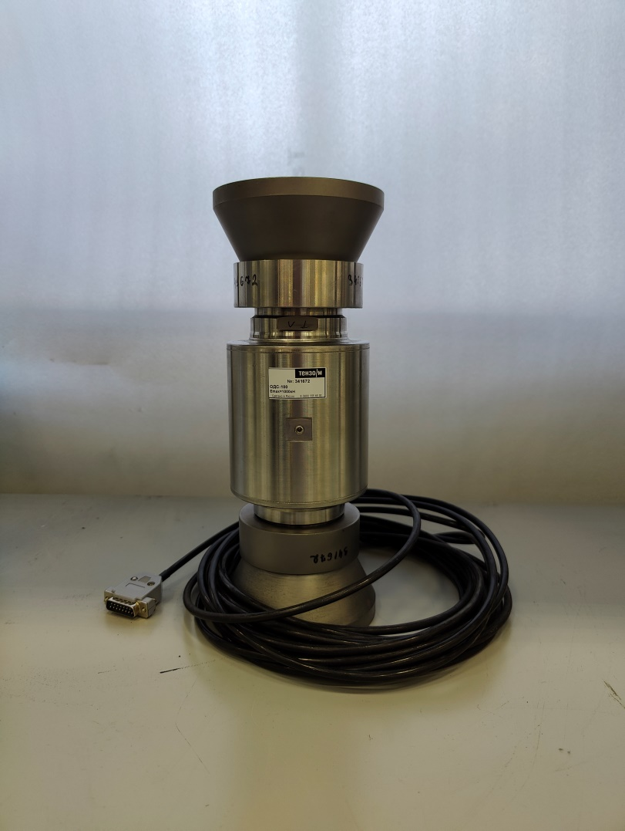
Fig. 1. Force Transducer ODS-10 (S/N: 332112). | Fig. 2. Force Transducer ODS-100 (S/N: 341672)
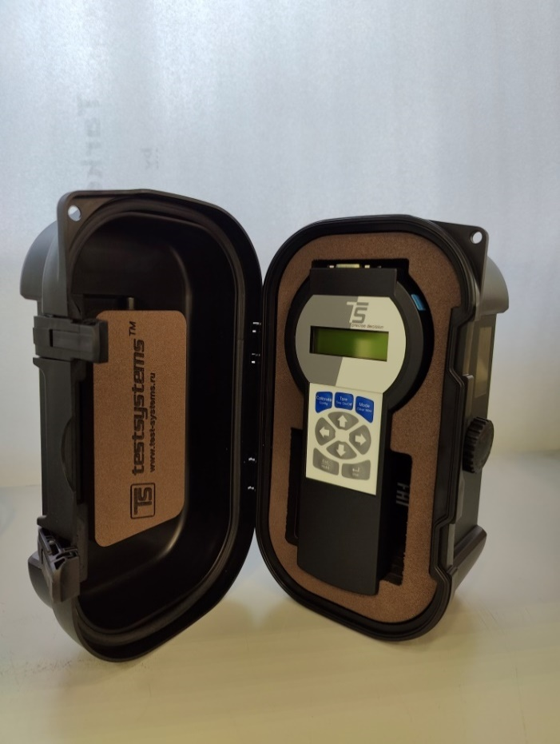
Fig. 3. Measuring Amplifier ТС 225.2.

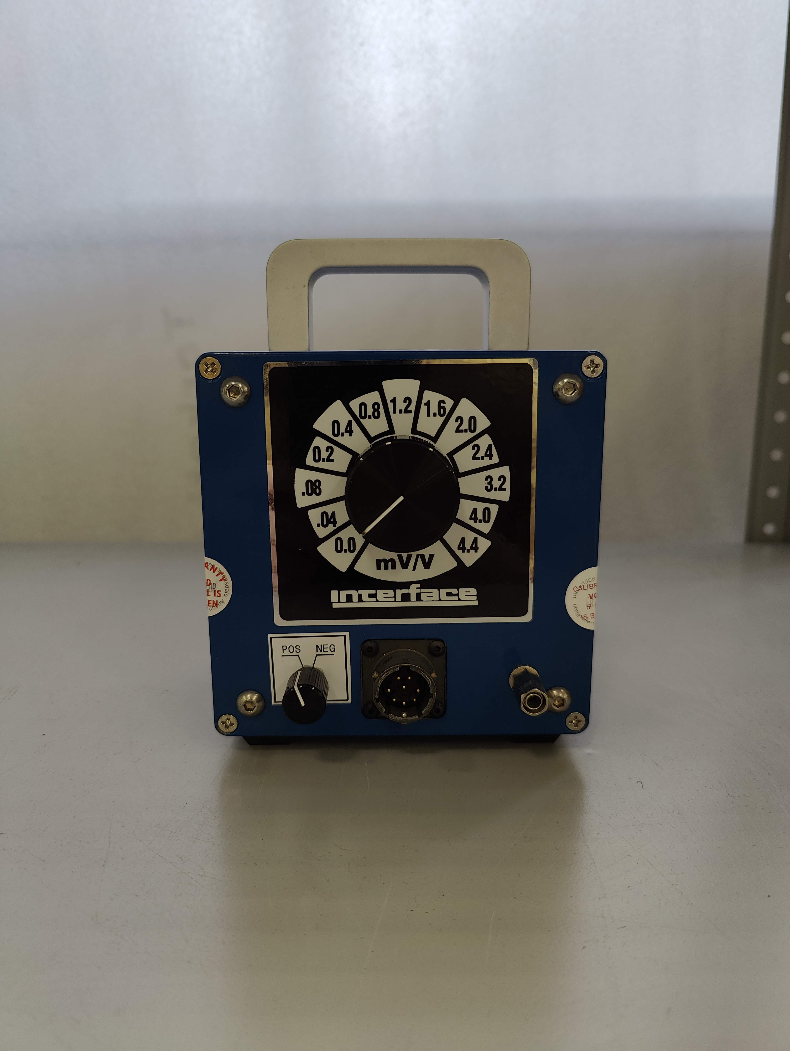
Fig. 4. Calibrator Interface CX-0404 (S/N: 1967).

Table 3. Completeness of the transfer standard.
Name | Amount
ODS-10 (S/N: 332112) | 1 pc.
ODS-100 (S/N: 341672) | 1 pc.
ТС 225.2 (S/N: 1952) | 1 pc.
ТС 225.2 (S/N: 1953) | 1 pc.
Calibrator Interface CX-0404 (S/N: 1967) | 1 pc.
Сables | 4 pc/

Weight and size of the packing space:
- overall dimensions 70 х 50 х 38 centimeter;
- weight 40 kilogram;

5 Methodology for performing measurements

5.1 Preparing for work
After transportation and removal from the transport container, the transported reference standard shall undergo an external inspection. During the external inspection, the amplifiers, sensors, and calibrator shall be checked:
- Compliance of completeness with the list specified in the technical protocol (Table 3);
- Connectors are clean and in good working order;
- Labeling with modification and serial number;
- Absence of mechanical damage and looseness of fastening of construction elements (damage of the case, connectors).
The result of the external inspection is considered positive if all the specified requirements are met.
The transported reference standard shall reach a temperature of 25.0 ±1.0˚C before measurements are made.
To establish temperature equilibrium, the force transducers ODS-10 (S/N: 332112) and ODS-100 (S/N: 341672) are connected to the measuring amplifiers TC 225.2 (S/N: 1952) and TC 225.2 (S/N: 1953), respectively, the day before the measurements. The whole system should be switched on overnight.
Before and after measurements, each measuring amplifier involved in the comparison must be calibrated using the Interface CX-0404 calibrator. If there is a deviation, it can be reduced by performing an internal automatic calibration of TC 225.2 several times. The calibration procedure is performed by pressing the "Calibrate" key and takes about 5 seconds. The calibration results of TC 225.2 are recorded in Annex A and Annex B.
The measurement protocol specifies the settings of TC 225.2:
- Measuring range of ±3 mV/V;
- Resolution 0,00001 mV/V.
The temperature should not change by more than ±0,2 °C during an hour during measurements. Environmental conditions: temperature in °C, relative humidity in %, atmospheric pressure in hPa are recorded in the measurement protocol.

5.2 Procedure for carrying out measurements
Loading times on force-reproducing machines can vary significantly between laboratories. Therefore, to minimize creep effects on the load cells included in the comparison standards, an interval of 6 minutes from the moment the load is applied or removed was chosen.
The loading procedure for a force value of 50 kN for laboratories with a force-reproducing machine up to 50 kN is shown in Fig. 5
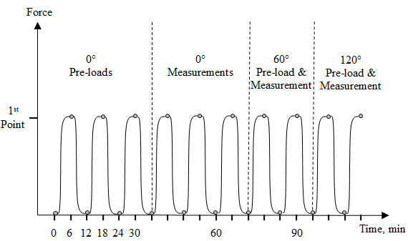
Fig. 5. Loading procedure up to 50 kN.

The loading procedure for force values ​​of 50, 100 kN and 500, 1000 kN is shown in Fig. 6.
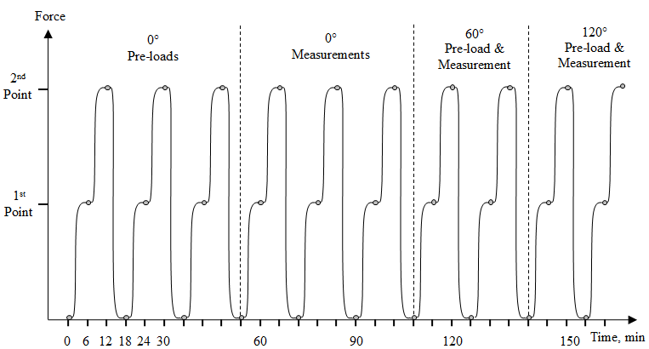
Fig. 6. Loading procedure for force values ​​of 50, 100 kN and 500, 1000 kN.

5.2.1 Measurements at a force value of 50 kN
Measurements at a force value of 50 kN are carried out using the ODS-10 force transducer (S/N: 332112) and the TС 225.2 measuring amplifier (S/N: 1952). The use of a TC 225.2 measuring amplifier (S/N: 1953) with the ODS-10 force transducer is not allowed.

Table 4. Sequence of measurements.
Position of the force transducer relative to the axis of force application | Sequence of measurements
0˚ | 3 pre-loads: 0 kN, 50 kN
0˚ | 3 measurements: 0 kN, 50 kN
60˚ | Pre-load: 0 kN, 50 kN  Measurement: 0 kN, 50 kN
120˚ | Pre-load: 0 kN, 50 kN  Measurement: 0 kN, 50 kN
180˚ | Pre-load: 0 kN, 50 kN  Measurement: 0 kN, 50 kN
240˚ | Pre-load: 0 kN, 50 kN  Measurement: 0 kN, 50 kN
300˚ | Pre-load: 0 kN, 50 kN  Measurement: 0 kN, 50 kN
0˚ | Pre-load: 0 kN, 50 kN  Measurement: 0 kN, 50 kN
60˚ | Pre-load: 0 kN, 50 kN  Measurement: 0 kN, 50 kN
120˚ | Pre-load: 0 kN, 50 kN  Measurement: 0 kN, 50 kN
180˚ | Pre-load: 0 kN, 50 kN  Measurement: 0 kN, 50 kN
240˚ | Pre-load: 0 kN, 50 kN  Measurement: 0 kN, 50 kN
300˚ | Pre-load: 0 kN, 50 kN  Measurement: 0 kN, 50 kN
0˚ | Pre-load: 0 kN, 50 kN  Measurement: 0 kN, 50 kN

    - Measurements at force values ​​of 50 kN and 100 kN
Measurements at force values ​​of 50 kN and 100 kN are carried out using the ODS-10 force transducer (S/N: 332112) and the TС 225.2 measuring amplifier (S/N: 1952). The use of the TС 225.2 measuring amplifier (S/N: 1953) with the ODS-10 force transducer is not allowed.
Table 5. Sequence of measurements.
Position of the force transducer relative to the axis of force application | Sequence of measurements
0˚ | 3 pre-loads: 0 kN, 50 kN
0˚ | 3 measurements: 0 kN, 50 kN, 100 kN
60˚ | Pre-load: 0 kN, 50 kN, 100 kN  Measurement: 0 kN, 50 kN, 100 kN
120˚ | Pre-load: 0 kN, 50 kN, 100 kN  Measurement: 0 kN, 50 kN, 100 kN
180˚ | Pre-load: 0 kN, 50 kN, 100 kN  Measurement: 0 kN, 50 kN, 100 kN
240˚ | Pre-load: 0 kN, 50 kN, 100 kN  Measurement: 0 kN, 50 kN, 100 kN
300˚ | Pre-load: 0 kN, 50 kN, 100 kN  Measurement: 0 kN, 50 kN, 100 kN
0˚ | Pre-load: 0 kN, 50 kN, 100 kN  Measurement: 0 kN, 50 kN, 100 kN
60˚ | Pre-load: 0 kN, 50 kN, 100 kN  Measurement: 0 kN, 50 kN, 100 kN
120˚ | Pre-load: 0 kN, 50 kN, 100 kN  Measurement: 0 kN, 50 kN, 100 kN
180˚ | Pre-load: 0 kN, 50 kN, 100 kN  Measurement: 0 kN, 50 kN, 100 kN
240˚ | Pre-load: 0 kN, 50 kN, 100 kN  Measurement: 0 kN, 50 kN, 100 kN
300˚ | Pre-load: 0 kN, 50 kN, 100 kN  Measurement: 0 kN, 50 kN, 100 kN
0˚ | Pre-load: 0 kN, 50 kN, 100 kN  Measurement: 0 kN, 50 kN, 100 kN

5.2.3 Measurements at force values ​​of 500 kN and 1000 kN

Measurements at force values ​​of 500 kN and 1000 kN are carried out using the ODS-100 force transducer (S/N: 341672) and the TС 225.2 measuring amplifier (S/N: 1953). The use of the TС 225.2 measuring amplifier (S/N: 1952) with the ODS-100 force transducer is not allowed.

Table 6. Sequence of measurements
Position of the force transducer relative to the axis of force application | Sequence of measurements
0˚ | 3 pre-loads: 0 kN, 500 kN, 1000 kN
0˚ | 3 measurements: 0 kN, 500 kN, 1000 kN
60˚ | Pre-load: 0 kN, 500 kN, 1000 kN  Measurement: 0 kN, 500 kN, 1000 kN
120˚ | Pre-load: 0 kN, 500 kN, 1000 kN  Measurement: 0 kN, 500 kN, 1000 kN
180˚ | Pre-load: 0 kN, 500 kN, 1000 kN  Measurement: 0 kN, 500 kN, 1000 kN
240˚ | Pre-load: 0 kN, 500 kN, 1000 kN  Measurement: 0 kN, 500 kN, 1000 kN
300˚ | Pre-load: 0 kN, 500 kN, 1000 kN  Measurement: 0 kN, 500 kN, 1000 kN
0˚ | Pre-load: 0 kN, 500 kN, 1000 kN  Measurement: 0 kN, 500 kN, 1000 kN
60˚ | Pre-load: 0 kN, 500 kN, 1000 kN  Measurement: 0 kN, 500 kN, 1000 kN
120˚ | Pre-load: 0 kN, 500 kN, 1000 kN  Measurement: 0 kN, 500 kN, 1000 kN
180˚ | Pre-load: 0 kN, 500 kN, 1000 kN  Measurement: 0 kN, 500 kN, 1000 kN
240˚ | Pre-load: 0 kN, 500 kN, 1000 kN  Measurement: 0 kN, 500 kN, 1000 kN
300˚ | Pre-load: 0 kN, 500 kN, 1000 kN  Measurement: 0 kN, 500 kN, 1000 kN
0˚ | Pre-load: 0 kN, 500 kN, 1000 kN  Measurement: 0 kN, 500 kN, 1000 kN

6 Report form
Annex A and Annex B They must be completed and sent to the following e-mail address: i.y.shmigelskiy@vniim.ru or s.a.semenov@vniim.ru within two weeks after taking the measurements. If necessary, the participating laboratory can provide additional information that is not available in the proposed report form.

7 Evaluating the results of comparisons
The uncertainty of the measurement results of the participants in the key comparison will be assessed according to Annex C.
The pilot laboratory draws up a draft report on comparisons (DRAFT A) and coordinates it with the participant. After that, the final draft of the comparison report (DRAFT B) is drawn up, which will be presented at the next meeting of TC 1.6 COOMET "Mass and related quantities". After the approval of the project in COOMET TC 1.6, the results and the report will be sent to the COOMET Secretariat, as well as to the Consultative Committee for Mass and Related Quantities (CCM-WGFT).

