EURAMET Comparison of Stainless Steel Multiples and Sub-Multiples of the Kilogram
2 kg, 1 kg, 100 g, 100 mg

Comparison: EURAMET.M.M-
Technical protocol

Contents

1 Introduction 2
1.1 Aim 2
1.2 Organisation 2
2 Contacts 3
2.1 Pilot, Steering Committee and Linking Laboratories 3
2.2 Participants 3
3. Timetable 4
3.1 Measurement Schedule 4
3.2 Plan of circulation 4
4 Travelling standards 4
5 Evaluation 5
6 General Information and procedure 5
6.1 Transport of the transfer standards 5
2.2 Measurements to be performed 6
2.3 Reporting, Paperwork 7
3. Annexes 8

1 Introduction

1.1 Aim
The scope of this supplementary comparison is the calibration of stainless steel mass standards of multiples and sub-multiples of the kilogram by the participating institutes. The objectives of the comparison are to validate the calibration measurement capabilities (CMCs) of the participants and to provide a basis for the submission and review of updated or new CMCs.

The comparison will be undertaken within the EURAMET RMO.

Purpose of this document is:
- to define the organization of the comparison
- to provide instructions to the participants on the transport and handling of the transfer standards
- to explain the method for the reporting of results.

The purpose of a supplementary comparison is to compare the calibration results of the participating institutes. It is not required that each participant adopts precisely the same measurement conditions or procedures. Therefore, this protocol specifies the procedures necessary for the comparison, but not for the measurements.

1.2 Organisation
Pilot Laboratory and contact:
Jaroslav Zuda
Czech Metrology Institute
Okruzni 31
63800 Brno, Czechia
e-mail: jaroslav.zuda@cmi.gov.cz
Tel: +420 602 551 921

2 Contacts

2.1 Pilot, Steering Committee and Linking Laboratories

Institute (Acronym) | Czech Metrology Institute (CMI) (Pilot)
Contact person in TC  (Name and email) | Jaroslav Zuda  Jaroslav.zuda@cmi.gov.cz
Technical contact person for comparison  (Name and email) | Jaroslav Zuda  Jaroslav.zuda@cmi.gov.cz
Address | Okruzni 31  63800 Brno, Czechia
Phone | +420 602 551 921

2.2 Participants
Institute (Acronym) | INM-Moldova
Contact person in TC  (Name and email) | Corina Tonu, corina.tonu@inm.gov.md
Technical contact person for comparison  (Name and email) | Ana Rusu, ana.rusu@inm.gov.md
Address | Eugen Coca street 28  2064 Chisinau
Phone | +373 78 932 404

3. Timetable

3.1 Measurement Schedule

Table 1. Measurement schedule for the comparison

Activity | Deadline *
Protocol agreed among participants | Jul 2025
CCM approval of the protocol | Jul 2025
Finalisation of the participants, timetable.  Complete measurements of the Pilot Laboratory | Jul 2025
Circulation and measurements by participants (Leg 1) | Jul – Sep 2025
Final measurements by Pilot Laboratory | Sep 2025
Preparation of Draft A | 2 weeks after completion of measurements
Circulation of Draft A for comments/corrections | 4 weeks for comments
Production of Draft B | 4 weeks after the last comments
Circulation of Draft B for comments/corrections | 4 weeks after the last comments
Final report | 2 weeks after Draft B approval  (aim Oct 2025)
*The deadline corresponds to the end of the month shown in table 1.

3.2 Plan of circulation

The travelling standards will be sent to each participating institute. The comparison will be organized in single petal. Pilot Laboratory will undertake stability measurement of the travelling standards at the beginning and end of the comparison.

Each laboratory has three weeks for the measurements and one week for the transport to the next laboratory. The circulation schedule has been arranged so that the transportation distance between any two successive laboratories is minimized.

In the case of unexpected delays, the institute involved must give details to the Pilot Laboratory as soon as possible giving details of the cause and expected duration of the delay. If the delay is considered too long, the Pilot Laboratory will attempt to accommodate the delay by rescheduling the participation of the institute in question. Each participant is expected to report its results to the Pilot Laboratory within 4 weeks after completing the measurements.

4 Travelling standards

The travelling standards comprise a set of stainless steel mass standards of nominal values 2 kg, 1 kg, 100 g and 100 mg. Each participating NMI is asked to determine the mass of the travelling standards against their own stainless steel standards.

The properties of the standards have been determined by CMI and are listed in the Appendix of this protocol.

The mass stability of the standards will be regularly monitored by CMI prior to the start of the comparison. No cleaning of the travelling standards should be carried out. If any participant believe that the weights have been contaminated either in transit or while at an NMI they should contact the Pilot laboratory immediately.

5 Evaluation

All the result will be corrected to consider any drift of the travelling standards as determined by the pilot laboratory. The consensus value of 2025 is considered for this comparison.

6 General Information and procedure

6.1 Transport of the transfer standards

Each laboratory is responsible for the organisation of the transport of the weights to the next participant. Each participating institute shall cover the costs of the measurements, transport and any customs charges as well as any damage that may occur within its country. The overall costs of organizing the comparison, including the supply of the transfer devices, is borne by the Pilot institute in collaboration with the support committee.

Insurance of transfer of the standard is a decision of the participants, taking into account the risk for any damage that might occur within its country. In case of any transportation problems of a travelling standard, the institute sending the standard must report to the Pilot Laboratory as soon as possible with the necessary data: e.g. the cause of the problem, the expected delay or the eventual damage to the standard. The institute sending the standard and the institute receiving the standard must strive to resolve it in order to minimize its impact. In case of any damage to the standard, the institute sending it must return the standard to the Pilot Laboratory for expert advice.

As a general rule, the travelling standards are to be carried by hand between institutes. If the cost of transfer by hand is not acceptable to the sending institute the option of shipping the travelling standards by using a safe Carrier Company, which can deal with customs formalities, can be used in exceptional circumstances.

Essential customs formalities will be handled through a temporary importation form.
Detailed arrangements for each time the standards are transported will be made between the sending institute, the receiving institute and the Pilot Laboratory. Email information should contain: the method of transportation of the weights (carried by hand or by a carrier company), date the standards left the country and the expected date of entry into the country of the next participant.

The Pilot Laboratory will provide photographs of the open boxes so that customs and airport security will be able to visualize the contents. In addition, the institute sending the standards, the receiving institute and the Pilot Laboratory will collaborate to supply a short letter describing the standards and their metrological importance. The letter should be written in English and in the language of the customs and security officers and should be typed on official institute stationery (see example in ANNEX VI).

In the event that the containers must be opened for inspection: Place the box on a table or counter. Open the top of the box. Close it as soon as possible. They shall be manipulated only with special tools, special gloves. They should never be touched with bare hands. A brief message should be sent to the Pilot Laboratory and the receiving institute if any problems occur during transport (customs, airport security or other).

When the standards arrive at the participating laboratory the suitcase and its contents should be checked for damage and missing items.

The standards should only be manipulated with special tools or special gloves.
They should never be touched with bare hands or placed on a contaminated surface.
A visual inspection of the surfaces should be made, and the results noted on the corresponding page. The Pilot Laboratory should be informed about the arrival and departure time and about the result of the visual inspection as soon as possible by email.
The standards should be stored protected from dust, aerosols and vapours at all times.
NEVER CLEAN THE TRANSFER STANDARDS.

The procedure of receiving and unpacking the standards are in annex II.
The procedure of packing the standards is in annex III.
The visual inspection procedure of the standards is in annex IV.

2.2 Measurements to be performed
Each participating institute is asked to determine the mass in air of travelling standards.

Any dust should be removed by using a clean brush provided by the Pilot Laboratory. The mass must not include any visible surface contamination. Visible surface contamination must be reported immediately to the Pilot Laboratory.
Determine the mass of the travelling standards to the best of your ability. There are few requirements that must be followed, although sufficient data must be taken to complete the reports. (annex VII).

The participants must follow these guidelines:
- Comparisons should be made between the travelling standards and your stainless steel reference standards (a sub-division weighing process may be used).
- Always use the gloves provide by the Pilot Laboratory or your own gloves and forceps
- The (true) mass of the travelling standards should be determined by weighing in air against the participants (stainless steel) reference standards.
- In order to achieve a good mass stability, it is recommended that the travelling standards are placed in the balance and allowed to stabilise. (Minimum of one full day recommended before carrying out the first measurement).
- There is no need to check the magnetic properties of the travelling standards.
- Use the brush provided to remove any visible dust from the surface of the standard.

2.3 Reporting, Paperwork
The forms (provided in the form of an excel file) of the measurement results, data of the ambient conditions, instruments used, and traceability of the participant's reference standards should be filled out and sent to the Pilot Laboratory within one month after the measurements are completed.
- Each participant shall determine the mass of the travelling standards with respect to its own reference standards in stainless steel.
- Each participant will supply the Pilot Laboratory with the general information requested. Please use the Excel table provided.
- Institutes should report their results in air, traceable to the International Prototype of the Kilogram, calculate their uncertainties in a coherent way. Please use the Excel table provided.
- A complete table of uncertainties (including estimated degrees of freedom) is requested. Please use the Excel table provided.
- The uncertainty must include details of traceability to the International Prototype of the Kilogram. All uncertainties should be reported in accordance with the ‘Guide to the expression of Uncertainty in Measurement’ (GUM) using a coverage factor of unity (k = 1).
- The results should be sent to the Pilot Laboratory.

Every incident, where the transfer standards may have been damaged, should be documented and communicated to the Pilot Laboratory immediately. The Pilot Laboratory should also be informed about any delay in the comparison schedule.

3. Annexes
- Time schedule,
- Transportation protocol (arrival)
- Transportation protocol (departure)
- Visual inspection, record of the surfaces of the transfer standards
- Data determined by the Pilot Laboratory
- Example form for security control
- Forms for general data, traceability, calibration results, and environmental data during calibration, the recommended form for reporting the uncertainty budget and the details of the used instruments and description of the measuring room.

Annex I. Time schedule

-
Table 2. Timetable for the comparison

Leg | NMI | Date of arrival | Date of departure | Deadline for sending the results
1 | CMI |  | 01/08/2025 | 01/09/2025
1 | INM | 04/08/2025 | 01/09/2025 | 22/09/2025
1 | CMI | 08/09/2025 |  | 01/10/2025

Notes on the schedule:
- The schedule has been compiled taking into account the availability of the participants, geographic proximity and custom formalities.

Annex II. Transportation protocol (arrival)

List of the content of the transport container:
- Four transfer standards of nominal values 2 kg, 1 kg, 100 g and 100 mg
- Glove supplied by the pilot laboratory.
- Lens cleaning tissues surrounding the transfer standards.
- Lens cleaning tissue sheet to place under/above the standards.
- Lens cleaning tissues as reserve.
- (Inspection forms, report forms, technical protocol will be sent electronically).

The standards should only be manipulated with special tools or special gloves.
They should never be touched with bare hands or placed on a contaminated surface.

Procedure of unpacking (arrival)
- Visual inspection of the case (damaged, clean). If not clean please carefully clean it.
- Take the suitcase into the mass laboratory.
- Prepare a clean surface.
- Open the case and check for damage and missing items.
- Check the content (list below).
- Open the envelope (for your laboratory) with the gloves and lens papers (assigned to you).
- Remove the box from the suitcase and the protecting bag and place it on a clean surface.
- Open the box (with clean hands or normal gloves)
- Put on the gloves supplied by the Pilot Laboratory
- Put a lens cleaning tissue on the surface.
- Remove the lens paper and using the gloves or the forceps provided place the standard on the lens cleaning tissue and covered with a bell jar (or with a clean lens cleaning tissue).
- Perform steps 7-12 for the next standard.
- Perform the visual inspection of the surfaces of the standards using a record sheet (Annex IV).
- (Never clean the standards).
- If the standard is not placed into the balance after inspection, it should be placed on the lens cleaning tissues and covered by a bell jar.

Illustrations:
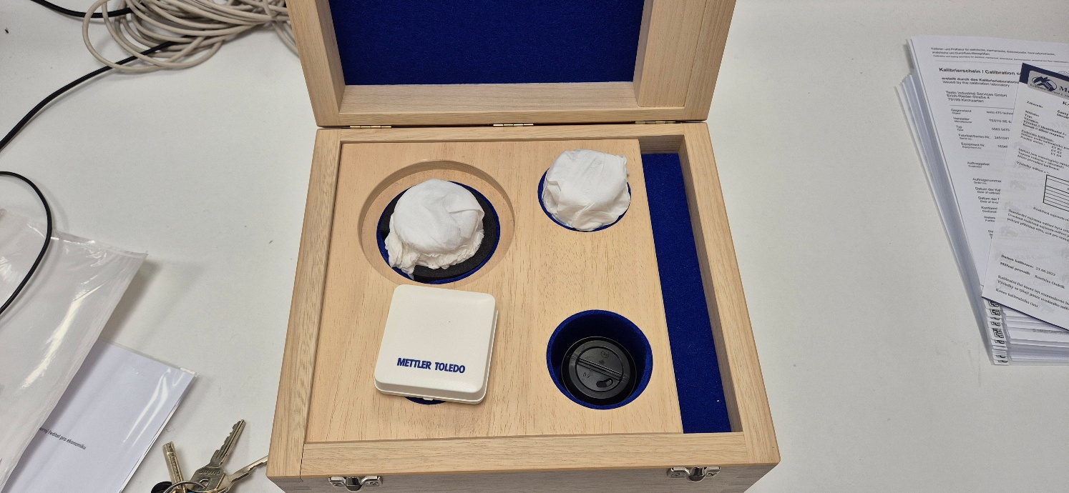
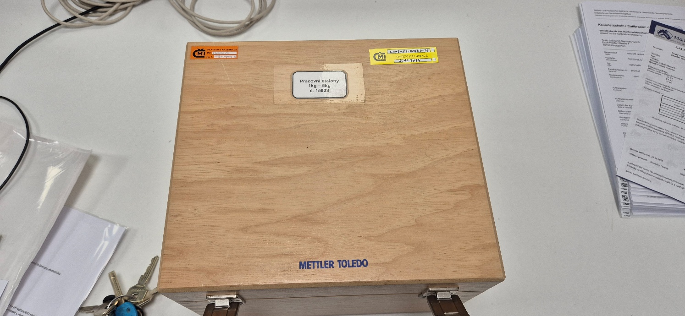

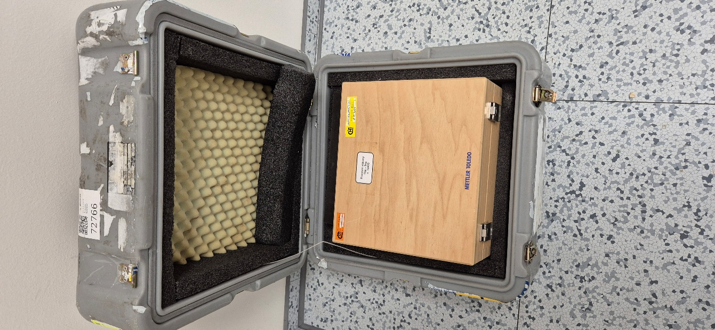
Form to be fill out on arrival of the standards

Name of NMI:
Name of Contact Person:
Full mailing address:
Telephone:
e-mail:
Current date:

Date of arrival: |  | From NMI:
Transportation box: (e.g. damaged, missing items)
Package of the weights was according to the requirements?
Surface conditions:
(use record sheets)
Other remarks:

Annex III. Transportation protocol (departure)

The standards should only be manipulated with special tools or special gloves.
They should never be touched with bare hands or placed on a contaminated surface.
- Carry out a visual inspection of the surfaces using a record sheet (Annex IV).
- Place a lens cleaning tissue (supplied by the Pilot Laboratory) on a clean surface. Please use new tissue.
- Using gloves (supplied by the Pilot Laboratory) or forceps , place the standards on top of the tissue
- Wrap the standard into the lens paper.
- Put the standard into the box and gently close the lid.
- Put the box into the protecting bag and into the suitcase.
- Repeat steps 1-6 for the other standards.
- Place the gloves and envelopes for other participants inside the suitcase.
- Close the suitcase and secure it with the cable ties.

Illustrations:

Form to be filled out on departure of the standards

Name of NMI:
Name of Contact Person:
Full mailing address:
Telephone:
e-mail:
Current date:

Date of sending: |  | To NMI:
The brush, the forceps and envelopes of other NMI are packed
Package of the weights was according to the requirements?
Surface conditions:
(use record sheets if there any changes)
Other remarks:

Annex IV. Visual inspection, record of the surfaces of the transfer standards

A visual inspection of the surfaces shall be made, and the results shall be reported immediately after receiving and before sending the standards using this protocol by sending it to the Pilot Laboratory by email (scanned in PDF format).

Procedure:
- Put the standards on clean lens cleaning paper as described.
- Always use gloves or forceps provided by the Pilot Laboratory.
- In case of dust on the surface, use only the brush provided by the Pilot Laboratory to remove the visible particles. DO NOT CLEAN THE TRANSFER STANDARDS.
- Record on the diagrams any mark(s) seen on the travelling standard (scratches, contamination, etc.)
- Scan the page and send it to the Pilot Laboratory before starting any measurements.
Sample inspection sheet.
Identification of the standard
Institute
Carried out by
Date
Notes:

2000 / 1000 / 100 gram

Top surface

Base surface

Sample inspection sheet.
Identification of the standard
Institute
Carried out by
Date
Notes:
100 mg

Front Surface


Annex V. Data determined by the Pilot Laboratory.
Other Comments:

The transfer standard set consists of weights of nominal values 2 kilograms, 1 kilogram, 100 grams, and 100 milligrams. Details of each mass standard are given in table 2.

The participants will be supplied with the following data:
- Volume of each mass standard at 20 °C
- Coefficient of cubical expansion
- The gravity height of each mass standards
- The magnetic properties of all travelling standards as the volume magnetic susceptibility and the magnetic polarization.

All data have been determined by CMI.

Table 2. Information on the five travelling standards.
Nominal Value  g | Identi-fication | Volume  at 20 °C  cm³ | Uncertainty  (k=2)  cm³ | Coefficient of cubic expansion  10⁻⁶ °C⁻¹ | CofG height  mm | Volume magnetic susceptibility | Magnetic polarization less than  µT
2 000 | * | 251,119 | 0,010 | 48 | 45,8 | 0,003 | 0,22
1 000 | * | 125,428 | 0,004 | 48 | 36,5 | 0,003 | 0,30
100 | * | 12,5634 | 0,0010 | 48 | 17,1 | 0,003 | 0,31
0,1 | Lifted end | 0,01257 | 0,00003 | 48 | 1 | - | -

Uncertainty (k=2) of the gravity height is less than 2 mm.
Annex VI Example form for security control

This is an example document for security purposes when the transfer standards are carried by hand (for air travel).

Additional forms can be provided (in the language of the sender/recipient country) to the person who will have to assure the mass transfer. This model should be adapted in accordance with the experts and NMIs involved in the transfer.

To whom it may concern 1. 8. 2025, Brno, Czechia

I the undersigned, Jaroslav Zuda of the Mass Department of the Czech Metrology Institute, certify that DHL Service is carrying a set of stainless steel mass standards of values 2 kg, 1 kg, 100 g and 100 mg from Czech Metrology Institute (Czechia) to the Institut National de Metrology (Republic of Moldova) country:

Name of the Institute: Institut National de metrology
Address: Eugen Coca Street 28, 2064 Chisinau
Tel: +37378932404
e-mail: ana.rusu@inm.gov.md

These mass standards are made of stainless steel and have nominal material value but an enormous scientific value. They are very delicate (fragile) and may not be manipulated by unauthorized persons. Improper handling during transportation would render them useless. The container has been designed to protect the masses during their transport so that they remain clean.

Pilot Laboratory and contact:
Jaroslav Zuda
Czech Metrology Institute
Okruzni 31
63800 Brno, Czechia
e-mail: jaroslav.zuda@cmi.gov.cz
Tel: +420 602 551 921

Annex VII

All reporting forms are provided only electronically in excel format.

Forms are for general data, traceability, calibration results, and environmental data during calibration, the recommended form for reporting the uncertainty budget and the details of the used instruments and description of the measuring room.

All the reporting shall be preferably done by using the provided excel file.

http://www.bipm.org/utils/common/CIPM_MRA/CIPM_MRA-D-05.pdf
Note that at the time of the comparison traceability for new (BIPM) calibrations will be to the kilogram “consensus value”. The calculation of the consensus value has been selected by the CCM Task Group to ensure continuity of the global mass scale and so the change in traceability will have no impact on the equivalence of results in this comparison. The increase in uncertainty when transferring from IPK traceability to the consensus value (and the potential increase in NMIs CMCs) will be dealt with as a separate exercise.
JCGM 100:2008, Evaluation of measurement data - Guide to the expression of uncertainty in measurement, 2008. http://www.bipm.org/en/publications/guides/gum.html

