

Technical Protocol

Comparisons of standards for liquid milli-micro flow rates

EURAMET identifier: xxxx
EURAMET Supplementary comparison
BIPM KCDB identifier: EURAMET.M.FF-Sxx

Co-ordinator / pilot
CMI/Czech Republic
CETIAT/France

February, 2025
Contents
1 Introduction 3
2 Participants and planning 3
3 Transfer standards 4
3.1 Specifications of TS1: Coriolis flow meter mini CORI-FLOW ML120, 1 to 200 g/h 4
3.2 Specifications of TS2: Coriolis flow meter mini CORI-FLOWTM M14, 0.2 to 30 kg/h 5
3.3 Pictures of the transfer standards and flight case 5
3.4 Plugging and connections 6
4 Measurement procedure and calibration protocol 7
4.1 Measured quantity 7
4.2 Facilities 7
4.3 Calibration protocol and measurement conditions 8
4.4 Zeroing procedure for TS1 and TS2 8
4.5 Transfer standard 1: ML120 8
4.6 Transfer standard 2: M14 9
4.7 Reporting the results 10
5 Measurement results 11
6 Evaluation 11
6.1 Uncertainty u(ε_{lab, i}) of laboratory reported value ε_{lab, i} 11
6.2 Determination of Comparison Reference Value (CRV) and its uncertainty 12
6.3 Determination of normalized degree of equivalence E_{N, i} - Evaluation criterion A 13
6.4 Determination of calibration conclusiveness - Evaluation criteria B and D 14
6.5 Final evaluation procedure of comparison data for decision table 14
7 References 15

Introduction
The CIPM Mutual Recognition Arrangement (CIPM MRA) is the framework through which National Metrology Institutes demonstrate the international equivalence of measurement standards. In this context, BIPM publishes on its homepage a list of Calibration and Measurement Capabilities (CMC-lists) of the institutes which have signed the MRA. Calibration services can, however, only be included if a quality management system according to ISO standard 17025 is established. However, quality assurance and confidence in the capabilities of other laboratories can be ensured by the successful participation in a comparison in which the degree of equivalence with other national metrology institutes or calibration laboratories is determined.
A comparison is organized in order to determine the degree of equivalence of standards for micro liquid flow rates under static load changes in the range of 1 g/h to 30 000 g/h at ambient pressure and temperature. Two Coriolis Mass Flow Meters will be used as Transfer Standards (TS):
- TS1: a Bronkhorst Low Flow Coriolis Mass Flow Meter, mini CORI-FLOW ML120, for mass flow rates in range from 1 to 200 g/h
- TS2: a Bronkhorst Low Flow Coriolis Mass Flow Meter, mini CORI-FLOW M14 for mass flow rates in range from 500 to 30 000 g/h.

Participants and planning
The participants and planning are shown in Table 1 based on availability of the transfer standards. Each laboratory is requested to arrange the transport to the next Institute thus pays for the cost of shipment of the package to the next laboratory. The package has to be sent by road by a logistics company (e.g. DHL), not by air. It is advised to include in each shipment order an insurance covering the hardware cost of 15 000 € for the package including Mini CORI-FLOW ML120 or M14.
After arrival of the transfer standards, the participating institute shall inform the pilot institutes by e-mail (mbenkova@cmi.gov.cz, kevin.romieu@cetiat.fr ). Immediately after receipt a visual inspection should be made. The participating institute shall check the instruments for any damage. The pilots for should be informed about the arrival and departure dates and about the results of the visual inspection as soon as possible, by e-mail. In addition a digital photo will be taken.
Table 1: Participants and time schedule for partners
Institute | Country | Shipping address | Contact/mail/phone | Remarks | Date
CETIAT | France | CETIAT  Laboratoire Micro-Débitmètrie Liquide  Domaine Scientifique de la Doua 54, boulevard Niels Bohr  FR - 69100 Villeurbanne  FRANCE | Kevin Romieu  kevin.romieu@cetiat.fr |  | February/March 2025
CMI | Czech Republic | Czech Metrology Institute  Okruzni 31, 63800 Brno | Miroslava Benkova  mbenkova@cmi.gov.cz |  | April 2025
METAS | Switzerland | Federal Institute of Metrology  Hugo Bissig  Lindenweg 50  CH-3003 Bern-Wabern | Hugo Bissig  Hugo.Bissig@metas.ch |  | May 2025
CMI | Czech Republic | Czech Metrology Institute  Okruzni 31, 63800 Brno | Miroslava Benkova  mbenkova@cmi.gov.cz | Re-send after measurement in Switzerland
RISE | Sweden | RISE Research Institutes of Sweden AB, Brinellgatan 4, 504 62, Borås, Sweden | Oliver Büker  oliver.buker@ri.se |  | June 2025
DTI | Denmark | Danish Technological Institute  Kongsvang Allé 29, DK-8000 Aarhus C | Thomas Schrøder Daugbjerg  tsda@teknologisk.dk |  | July 2025
PTB | Germany | Physikalisch-Technische Bundesanstalt (PTB)  Fachbereich 1.5 Flüssigkeiten  Bundesallee 100, 38116 Braunschweig | Corina Kroner  corinna.kroner@ptb.de |  | August 2025
- | - | - | - | - | -
IPQ | Portugal | Instituto Português da Qualidade (IPQ). Rua António Gião 2 2829-513 Caparica | Elsa Batista  ebatista@ipq.pt |  | October 2025
CETIAT | France | CETIAT  Laboratoire Micro-Débitmétrie Liquide  Domaine Scientifique de la Doua 54, boulevard Niels Bohr  FR - 69100 Villeurbanne  FRANCE | Kevin Romieu  kevin.romieu@cetiat.fr |  | November 2025

Transfer standards

Specifications of TS1: Coriolis flow meter mini CORI-FLOW ML120, 1 to 200 g/h
- Type: ML120V21-BGD-CC-0-S
- Manufacturer: Bronkhorst High-Tech
- Zero stability: < ± 10 mg/h
- Qmax: 200 g/h
- Serial number: M20215065A
- Connection type: ¼” OD Swagelok compression type
- Communication: RS232
- Electrical connection 9-pin D-connector (male), (power connection included)

Specifications of TS2: Coriolis flow meter mini CORI-FLOWTM M14, 0.2 to 30 kg/h
- Type: M14-AGD-33-0-S
- Manufacturer: Bronkhorst High-Tech
- Zero stability: 6 g/h
- Qmax: 30 kg/h
- Serial number: M20207047A
- Connection type: ¼” OD Swagelok compression type
- Communication: RS232
- Electrical connection 9 pins sub-D (power connection included)

Pictures of the transfer standards and flight case
The two transfer standards (Figure 1) are transported in a common flight case.
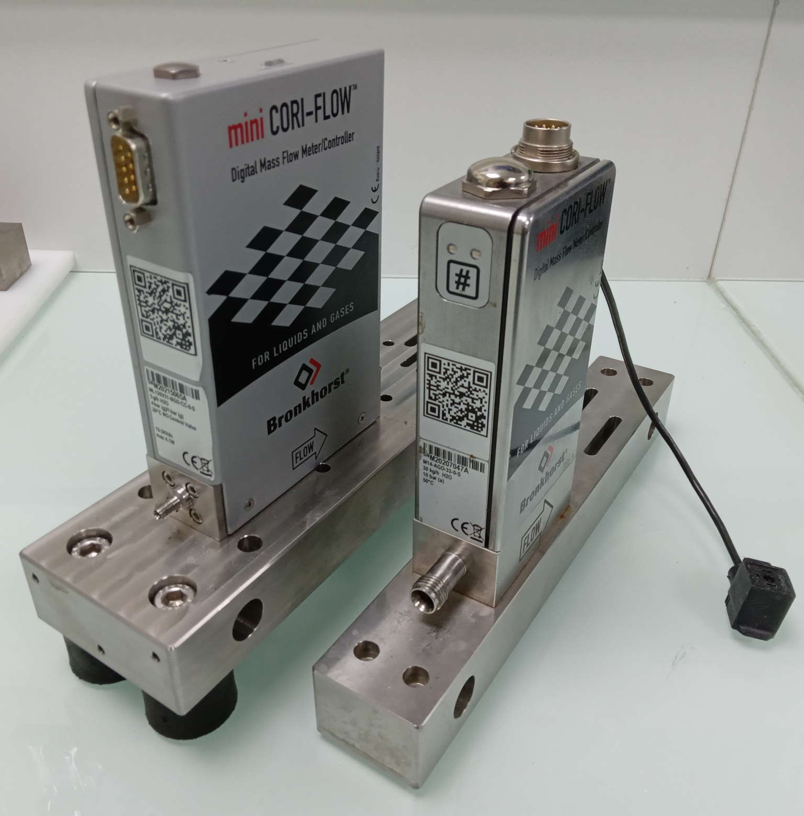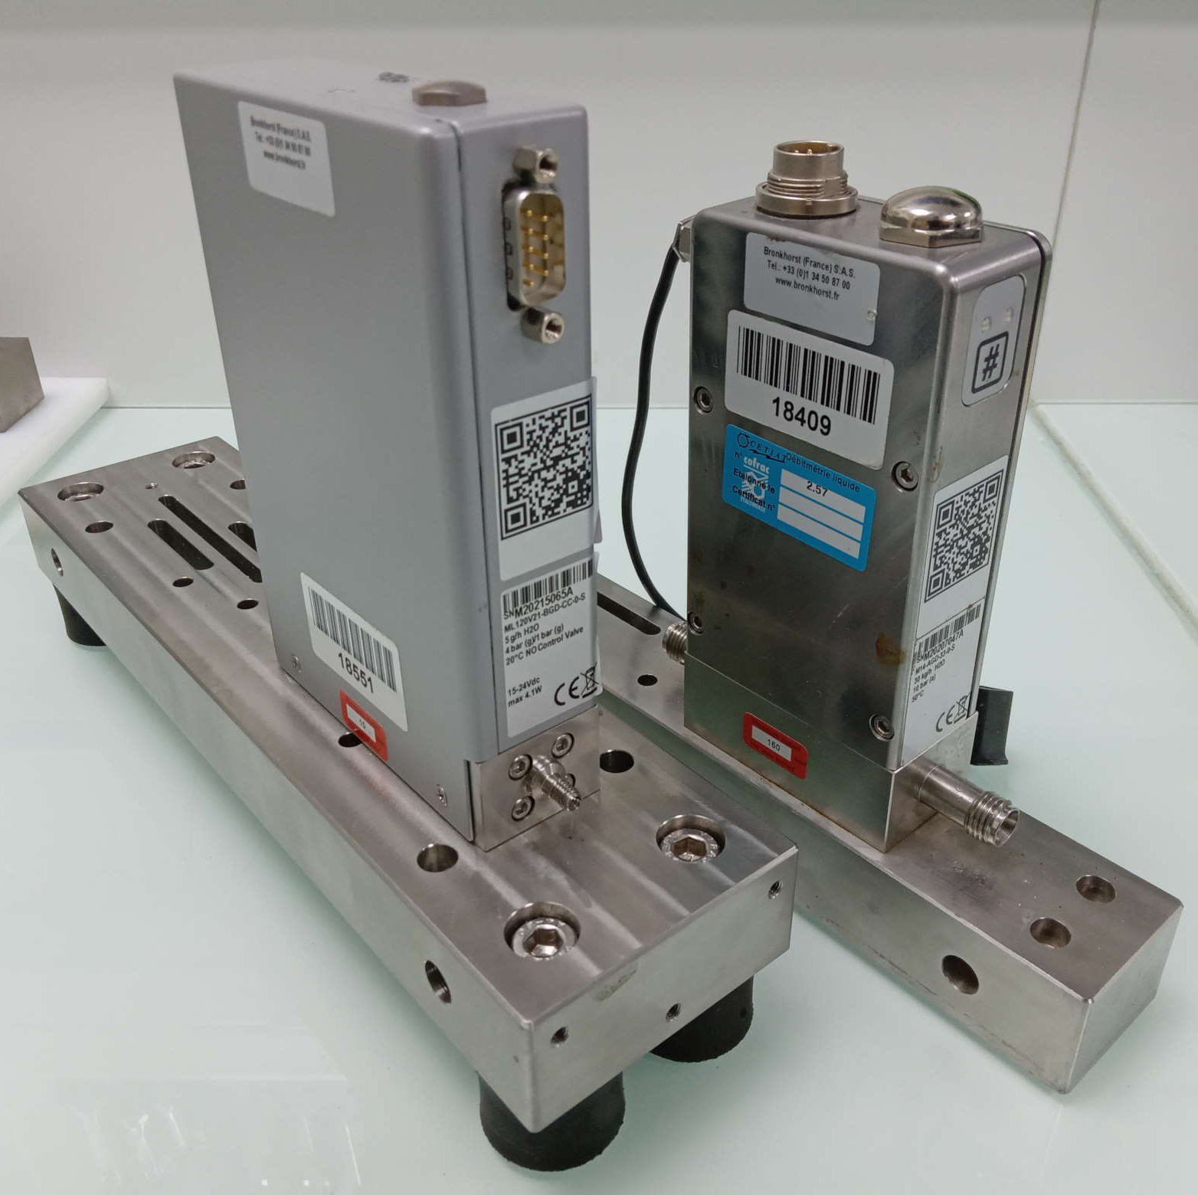
Figure 1: pictures of TS1 (left) and TS2 (right).
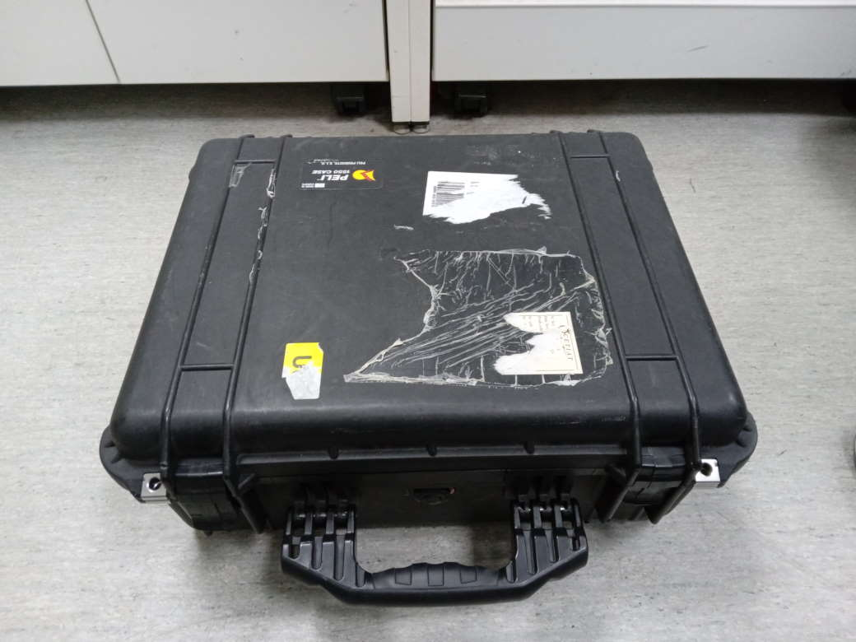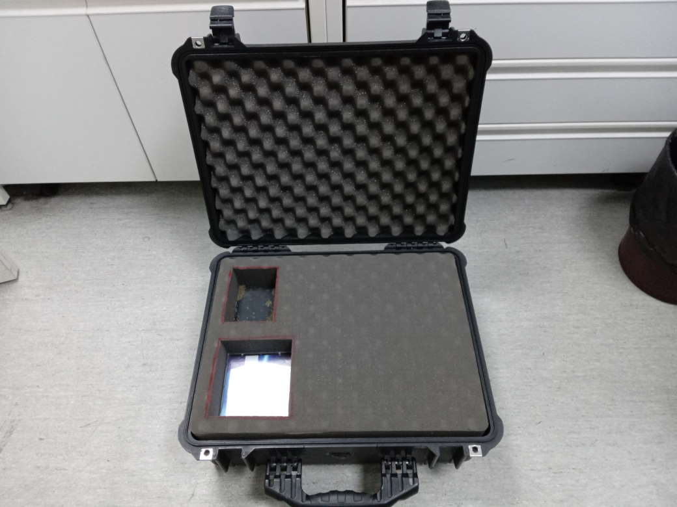
Figure 2: upper part of the flight case
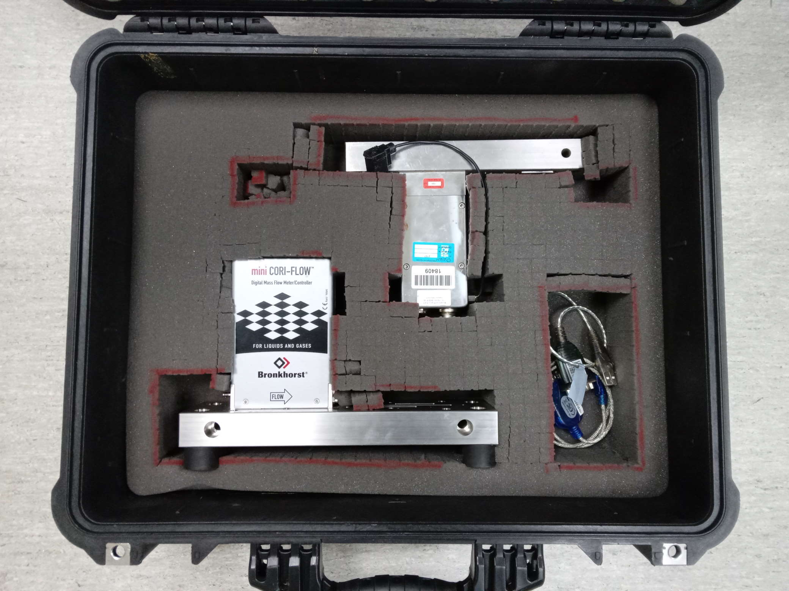
Figure 3: lower part of the flight case, with the two transfer standards and two USB-RS232 cables if needed.

Plugging and connections
The Bronkhorst CORI-FLOW flow sensor comes with 1/16" connectors from Swagelok for tubing with outer diameter of 1/16". Connection of the transfer standard to the calibration bench will be realized using the fast connectors as shown below:
Install the connectors (Nut + Ferrule) on the tubes (metal or preferred peek to connect to the 1/16”OD of the L01). The tubes are the one from each partners laboratory.
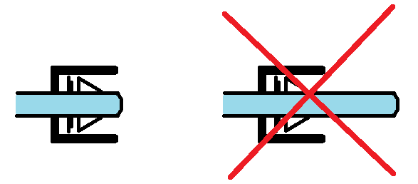
Figure 5: Connection Swagelok 1/16"

Measurement procedure and calibration protocol

Measured quantity
The intercomparison is based on comparing the relative error of the transfer standard and determined by the participating labs. The relative error ε (%) is defined as:
$$ε=100\frac{q_{indicated }- q_{ref}}{q_{ref}}$$
where $q_{indicated }$ is the indicated flow rate and $q_{ref}$ is the reference flow rate.

Facilities
The participating National Metrology Institutes (NMI) used their own calibration procedures to calibrate the flow meter. In Table an overview is given of the participating laboratories, the type of facility, calibration procedure and references for further reading if existing. All laboratories are independent; however Bronkhorst High-Tech does not contribute to the reference value (RV) because it is not an NMI or DI.
Table 2: Overview participating laboratories, type of facility, calibration procedure and references for further reading if existing.
Laboratory | Country | Test rig / method of measurement | Measured flow range in g/h | References
CETIAT | France | Gravimetric | 1 to 100 000
CMI | Czech Republic | Volumetric with piston prover and gravimetric with weighing system | 1 to 6 000
METAS | Switzerland | Piston Prover and gravimetric | 0.0012 – 23'000 | https://doi.org/10.1016/j.flowmeasinst.2014.11.008.  https://doi.org/10.1515/bmt-2022-0049
RISE | Sweden | Gravimetric | 1 to 200  200 to 30 000
DTI | Denmark
PTB | Germany | Gravimetric | 1000 to 30 000
VSL | Netherlands
IPQ | Portugal | Gravimetric method | 1 to 2 000

Calibration protocol and measurement conditions
In this section the calibration protocol is described and the range of measurement conditions are given.
Participating laboratory ensures the following conditions during the measurements:
- working fluid temperature: 20 °C ± 5 °C
- ambient temperature: 20 °C ± 5 °C
- ambient humidity: from 30 % to 80 %
- atmosphere pressure: from 86 kPa to 106 kPa
- absence of free air in the measuring line of the standard.
Before starting work, it is necessary to withstand at least 8 hours in the laboratory room.

Zeroing procedure for TS1 and TS2
Will be added a screenshots of the software FlowPlot here

Transfer standard 1: ML120
Perform a static calibration in accordance with your internal calibration procedure (mass and time are not prescribed), and respect the following requirements:
- Install, purge and warm-up the transfer standard using your internal procedures.
- Close the valves upstream and downstream of the transfer standard and record the indication of the flow meter during a period long enough to check its stability. This value will be used to correct the measurements.
- If needed, perform the zeroing procedure for TS1 according to section 4.4, then record the new value with no flow.
- Perform a static calibration (constant and regulated flow rate) with water at room temperature (20 ± 5) °C by recording the indication of TS1 at the following flows. Each point must be measured 5 times. Maximum upstream pressure: 8 bar.
  - 1 g/h
  - 5 g/h
  - 10 g/h
  - 50 g/h
  - 100 g/h
  - 150 g/h
  - 200 g/h
- After the last measurement, close the valves upstream and downstream of the transfer standard and record the indication of the flow meter with no flow to check for deviation.
  - It is advised to record a zero after each point to check for deviation before changing for the next flow rate.
  - If the calibration cannot be performed continuously (e.g. spread over two days), it is advised to record a zero after the last point before the break, and after the break before resuming calibration.

Transfer standard 2: M14
Perform a static calibration in accordance with your internal calibration procedure (mass and time are not prescribed), and respect the following requirements:
- Install, purge and warm-up the transfer standard using your internal procedures.
- Install, purge and warm-up the transfer standard using your internal procedures.
- Close the valves upstream and downstream of the transfer standard and record the indication of the flow meter with no flow during a period long enough to check its stability. This value will be used to correct the measurements.
- If needed, perform the zeroing procedure for TS1 according to section 4.4, then record the new value with no flow.
- Perform a static calibration (constant and regulated flow rate) with water at room temperature (20 ± 5) °C by recording the indication of TS1 at the following flows. Each point must be measured 5 times. Maximum upstream pressure: 8 bar.
  - 200 g/h
  - 500 g/h
  - 1 000 g/h
  - 3 000 g/h
  - 6 000 g/h
  - 10 000 g/h
  - 15 000 g/h
  - 20 000 g/h
  - 30 000 g/h
- After the last measurement, close the valves upstream and downstream of the transfer standard and record the indication of the flow meter with no flow to check for deviation.
  - It is advised to record a zero after each point to check for deviation before changing for the next flow rate.
  - If the calibration cannot be performed continuously (e.g. spread over two days), it is advised to record a zero after the last point before the break, and after the break before resuming calibration.

Reporting the results
The following measured parameters should be reported: Indicated mass flow rate by the meter, Average Upstream Pressure and temperature at the meter location, relative error of the meter and reported relative expanded uncertainty and expanded laboratory uncertainty in the reference flow (k=2). For the uncertainty of the reference flow the CMC of the facility should be used. Following the WG-FF guidelines [1] , the CMC is determined as:
$$U_{CMC}=2\sqrt{u_{base}^{2}+{\left(\frac{t_{95}}{2} \frac{s_{repeat,BED}}{\sqrt{n}}\right)}^{2}}$$
where $s$ is the sample standard deviation of $n$ repeatability measurements and $t_{95}$ is 95% confidence level t-value for $n$-1 degrees of freedom.
The clear indication of the determination of the uncertainty of the reference flow is a prerequisite. Furthermore, it is requested to send the results to pilots within 1 month after the tests have been performed. Further, the participants are requested to use the table in the Excel sheet to report on the individual measurement results. This table has the following layout:
Table 3: Measurements results – for each TS
Reference flow | Mean upstream pressure | Mean water temperature | TS mean flow | TS zero-flow correction | TS mean flow including zero-flow correction | Mean relative error | Reported relative expanded uncertainty  (k = 2) | Expanded  lab uncertainty (k = 2)
(g/h) | (bar) | (°C) | (g/h) | (g/h) | (g/h) | (%) | (%) | (%)

The relative error of the transfer standard $ε$ in % is the quantity that will be used to compare the results. It is defined as the difference between the mass flow rate indicated by the transfer standard and the mass flow rate according to the reference:
$ε=\frac{Q_{TS corrected}-Q_{ref}}{Q_{ref}}·100\%$ (1)
where:
$ε$ is the relative error of the transfer standard in %,
$Q_{TS corrected}$ is the mass rate indicated by the transfer standard including the correction for zero-flow in g/h,
$Q_{ref}$ is the mass rate measured by the reference in g/h.
Based on the reported results the following values are computed: the average reference flow rate in g/h, the average indicated flow rate including the correction for zero-flow in g/h, the relative error in % and the uncertainty of the calibration (k=2) (%).

Measurement results
The reference value will be determined for all individual flow points and will be determined on the weighted average from all individual labs. All results will be compared against this reference value. The chi-squared test will be used to identify outliers. The procedure according to [1] will be used.
Summarized uncertainty $u_{TS}$ of transfer standards including long-term stability of the transfer standards - meter drift, pressure sensitivity, temperature sensitivity will be provided by pilots/copilots.

Evaluation

Uncertainty u(ε_{lab, i}) of laboratory reported value ε_{lab, i}
As described in [1], [2] and [3], the uncertainty of the reported value $ε_{lab, i}$ includes uncertainties introduced by the participant’s flow reference $u_{lab, i}$ by the transfer meter $u_{TS}$ and by the repeatability of the reported value (Equation (8)). The used input parameters of $u_{lab, i}$ do represent the claimed uncertainty values of the laboratories, which were under evaluation during this comparison. As values for $u_{lab, i}$ the expanded laboratory uncertainty of Table 12 to Table 24, marked with a), were are used. Uncertainty calculations of $u_{TS}$ are based on the discussions in Chapter 5.1, final values of $u_{TS}$ are summarized in Table 11. The term s/$\sqrt{n}$ represents the repeatability of measurements in the participants laboratory and are based on reported calibration results.
$$u\left(ε_{lab,i}\right)=\sqrt{{ u}_{lab,i}^{2}+u_{comp}^{2}}=\sqrt{u_{lab,i}^{2}+u_{TS}^{2}+{\left(\frac{s}{\sqrt{n}}\right)}^{2}}$$ | (8)

where:
$u\left(ε_{lab,i}\right)$ Uncertainty of reported meter error of laboratory i (%)
$u_{lab, i}$ Uncertainty of laboratory reference (%)
$u_{comp}$ Uncertainty of transfer meter measurements (%)
$s$ Standard deviation of the mean of measurements at one flowrate point (%)
$n$ Number of calibrations at one flowrate point (-)
All values of $u$ are valid for k = 1.

Determination of Comparison Reference Value (CRV) and its uncertainty
The Key Comparison reference value is calculated separately for each flowrate, following the procedure A of [4]. The determination of CRV includes a consistency check according to [5]. The reference value y is calculated as weighted mean error of the participating laboratories, including standard uncertainties u(ε _{lab,i}) of the measurements as the weights:
$$y=\frac{\left(\frac{ε_{lab1}}{u_{ε,lab 1}^{2}}+\frac{ε_{lab2}}{u_{ε,lab 2}^{2}} + … \frac{ε_{lab i}}{u_{ε,lab i}^{2}} \right)}{\left(\frac{1}{u_{ε,lab 1}^{2}}+\frac{1}{u_{ε,lab 2}^{2}} + … \frac{1}{u_{ε,lab i}^{2}}\right)}$$ | (9)

where $y$ is the reference value of the comparison (%).
The standard uncertainty $u_{y}$ is given with:
$$\frac{1}{u_{y}^{2}}=\frac{1}{u_{ε,lab 1}^{2}}+\frac{1}{u_{ε,lab 2}^{2}}+ … + \frac{1}{u_{ε,lab i}^{2}}$$ | (10)

where $u_{y}$ is the standard uncertainty of y with k=1 (%).
The expanded uncertainty of $y$ for $k=2$ is calculated with
$$U\left(y\right)=2∙u_{y}$$ | (11)

Finally, the chi-squared test is applied to check whether the determined errors and accompanying uncertainties can be expected based on a Gaussian distribution. If so, the y is accepted. The chi-squared test is defined as follows:
$$χ_{obs}^{2}=\sum_{i=1}^{n}{{\left(\frac{ε_{lab i}-ε_{RV}}{u\left(ε_{lab i}\right)}\right)}^{2}}$$ | (12)

where $χ_{obs}^{2}$ is the observed chi-squared value.
The degrees of freedom $υ$ are estimated with:
$$υ=n_{i}-1$$ | (13)

where $n_{i}$is the number of evaluated laboratories.
For data evaluation the CHIINV(0.05;v) function of MS Excel is used. The consistency check fails if CHIINV(0.05;v) gives values < than $Χ_{obs}^{2}$. Note, here $u\left(ε_{lab i}\right)$ is the standard uncertainty (k = 1). The set of measurement results for a certain flow point is only accepted when:
$$Pr\left\{Χ_{v}^{2}>Χ_{obs}^{2}\right\}<0.05$$ | (14)

where $Χ_{v}^{2}$ is the chi-squared test value.
If consistency check of Equation (14) passes, $y$ is accepted as the Comparison Reference Value $ε_{CRV}$ and $U(y)$ is accepted as the expanded uncertainty $U\left(ε_{CRV}\right)$. If the test of Equation (14) fails, the laboratory with the highest value of ${\left(ε_{i}-y\right)}^{2} / u_{ε,i}^{2}$is excluded for the next evaluation round. New values of $y$, $U(y)$ and $χ_{obs}^{2}$ are calculated and the consistency check of Equation (14) is repeated.

Determination of normalized degree of equivalence E_{N, i} - Evaluation criterion A
Differences between laboratory results ($ε_{lab, i}$) and CRV ($ε_{CRV}$) are calculated in accordance with equation (15) separately for each flow meter and flow rate. The results give the degree of equivalence (DoE) of each laboratory.
$$d_{i}=ε_{lab, i}-ε_{CRV}$$ | (15)

where:
$d_{i}$ Degree of equivalence (DoE) for each laboratory i in %
$ε_{lab, i}$ Reported meter error of laboratory i in %
$ε_{CRV}$ Comparison Reference value in %
Based on the differences d_{i}, the normalized Degree of Equivalence E_{N,i} is calculated for each laboratory and flowrate with:
$$E_{N,i}=\left|\frac{d_{i}}{U\left(d_{i}\right)}\right|$$ | (16)

where $E_{N,i}$ is the normalized Degree of Equivalence.

The expanded uncertainty of $d_{i}$ is calculated with equation (17) for laboratories with contribution to the CRV. Participating laboratories, which are excluded from the CRV determination, do not have any interference. In that case the value of U(d_{i}) is calculated according to equation (18).
$$U\left(d_{i}\right)=2∙\sqrt{u_{ε, lab i}^{2}+u_{CRV}^{2}-2∙u_{CRV}^{2}}=2∙\sqrt{u_{ε, lab i}^{2}-u_{CRV}^{2}}$$ | (17)

$$U\left(d_{i}\right)=2∙\sqrt{u_{ε, lab i}^{2}+u_{CRV}^{2}}$$ | (18)

Determination of calibration conclusiveness - Evaluation criteria B and D
To follow the latest developments in the field of comparison evaluation, an improved method of evaluation comparison results is further used. This method was discussed for a long time within the CCM Working Group for Fluid Flow (WGFF) and results were presented at Flomeko 2022 [6]. Criteria B and D, both apply a quality check of the comparison uncertainty to see if a result is conclusive before applying the |$E_{n}$| ≤ 1.00, respectively, |$E_{n}$| ≤ 1.20 criterion.
In detail, the conclusiveness of the calibration results is verified by the following two criteria, whereas Criterion B is more a recommendation and Criterion D is final decision value [3]:
- Ratio of u_{comp}/u_{lab i}, also called evaluation criterion B, underlines a suitability of the transfer standard as well as a sufficient high quality of the calibrations, expressed as the repeatability. The WGFF proposed that u_{comp}/u_{lab i} ≤ 2 for conclusive comparison results and to avoid a participant passing solely because the transfer standard uncertainty and repeatability are large [2, 3, 6,]. Following Equation (8), u_{comp} was calculated by using:
$$u_{comp}=\sqrt{u_{TS}^{2}+{\left(\frac{s}{\sqrt{n}}\right)}^{2}}$$ | (19)

- The second additional evaluation criterion D was introduced by [2] as a probability-based measure for evaluating whether a comparison result is conclusive or not. Here, laboratory results are evaluated by the degree to which two Gaussian probability density functions (PDFs) overlap, one representing the comparison reference value N(ε_{CRV}, u_{ε CRV}) and the other representing the participant’s reported value for the measurand N(ε _{I} , u_{lab i}). The degree of overlap between both PDFs is assessed by a probability content P_{i} of the CRV PDF bound by the participant’s 2.5th and 97.5th percentile confidence limits for the uncertainty of the participant’s flow reference. The calculation of the probability P_{i} is given in [2] along with a “threshold” value of P_{th} = 0.35. The value of P_{th} determines the minimum required overlapping area between the PDFs of ε_{CRV} and ε _{i} for conclusive calibration results.

Final evaluation procedure of comparison data for decision table
For final data evaluation and decision table the following criteria were used - based on [2], [3], [4] and [5], [7]:
- Chi-squared test - Data evaluation and consistency check, based on Equation (12) to Equation (14)
- The participant passes the comparison if E_{N,i} $≤$ 1.0 and P_{th} ≥ 0.35
The results of participating laboratory i agrees within 95 % confidence level uncertainty expectations with the CRV (k = 2). The calibrations are conclusive.
- The participant passes the comparison at “warning level” if 1.0 < E_{N,i} $≤$ 1.2 and P_{th} ≥ 0.35
- The participant fails the comparison if E_{N,i} $>$ 1.2. The claimed laboratory results cannot be accepted.
- Inconclusive results if E_{N,i} $≤$ 1.2 is combined with P_{th} < 0.35
The results are inconclusive, due to the low overlapping between density functions. This decision involves an evaluation of the transfer meter, which did not show sufficient low uncertainties to discern lab to CRV below certain level. In this case, the transfer standard was not suitable for a confirmation of the declared laboratory uncertainties.

References
[1] WGFF (2013): WGFF Guidelines for CMC Uncertainty and Calibration Report Uncertainty. 21.10.2013, http://www.bipm.org/utils/en/pdf/ccm‐wgff‐guidelines.pdf.
[2] Wright, J., Toman, B., Mickan, B., Wübbeler, G., Bodnar, O., Mickan, B., and Elster, C. (2016): Transfer standard uncertainty can cause inconclusive inter-laboratory comparisons, Metrologia 53, 1243 – 1258. DOI 10.1088/0026-1394/53/6/1243
[3] Frahm, E. and Wright, J. D. (2023): Evaluation of Inter-Laboratory Comparison Results: Representative Examples, Measurement, Volume 223, 2023, 113723, ISSN 0263-2241, https://doi.org/10.1016/j.measurement.2023.113723.
[4] Cox M. G. (2002): Evaluation of key comparison data, Metrologia 39 589 – 595.
[5] Cox M. G. (2007): the evaluation of key comparison data: determining the largest consistent subset, Metrologia, 44, 187 – 200
[6] Frahm, E. and Wright, J. D., Evaluating Inter-laboratory Comparison Data, FLOMEKO, Chongqing, China, November 1 to 4, 2022.
[7] Wright, J., Mickan, B., Benkova, M., Chun-Lin Ch. (2022): Laboratory Comparison Calculations Spreadsheet Template Following Cox 2002 Method, BIPM WGFF, unpublished working paper.

