EURAMET Key Comparison
EURAMET.L-K4.n02

Calibration of Roundness standards

Technical protocol

Contents
1. Document control 3
2. Introduction 3
3. Organization 3
3.1. Participants 3
3.2. Schedule 4
3.3. Reception, transportation, insurance, costs 4
4. Artefacts 5
4.1. Description of artefact 5
5. Measuring instructions 7
5.1. Handling the artefact 7
5.2. Traceability 7
5.3. Measurands 7
5.4. Measurement uncertainty 7
5.5. Reference conditions 8
6. Reporting of results 8
6.1. Results and uncertainties 8
7. Analysis of results 9
7.1. Calculation of the reference value 9
7.2. Artefact instability 9
7.3. Correlation between laboratories 9
7.4. Linking to other comparisons 9
8. References 10
Appendix A – Reception of Standards 10
Appendix B – Results Report Form 11
Appendix C –– Description of the measurement instrument 16

Document control
Version rev0 Issued on September 2024

Introduction
The metrological equivalence of national measurement standards and of calibration certificates issued by national metrology institutes is established by a set of key and supplementary comparisons chosen and organized by the Consultative Committees of the CIPM or by the regional metrology organizations in collaboration with the Consultative Committees.
At its meeting in October 2023, the EURAMET Technical Committee for Length, decided upon a key comparison on roundness standards, named EURAMET.L-K4.n02, with GUM as the pilot laboratory.
The EURAMET comparison will be registered by November 2024, artefact circulation shall start in February 2025 and will be completed in September 2025.
The results of this international comparison will support the Calibration and Measurement Capabilities (CMCs) declared by the NMIs in the CIPM Mutual Recognition Arrangement (MRA).

Organization
The participating laboratories are NMIs fulfilling the following conditions:
- signatory (or applicant) of the CIPM MRA;
- having submitted CMCs for roundness calibration (or intending to do so soon);
- calibrating roundness standards for their customers as a regular service;
- being well trained in handling roundness standards without the risk to damage them;

Participants
Table 1. List of participant laboratories and their contacts.
NMI code | Contact person, Laboratory | Contact
GUM | Czułek Dariusz, Kamil Kubiak  Główny Urząd Miar  Elektoralna 2  00-139 Warsaw  Poland | Tel.: +48 22 581 95 43  Fax: +48 22 581 93 92  Email: dariusz.czulek@gum.gov.pl
FSB | Marko Katić  Faculty of Mechanical Engineering and Naval Architecture. Laboratory for Precise Measurement of Length  Ivana Lucica 5  1000 Zagreb  Croatia | Tel.: +385 161 68 327  Fax: +385 1 6168 599  Email: marko.katic@fsb.unizg.hr
INM | Lásló-Iozsef-Dragos Teodorescu  National Institute of Metrology  Sos. Vitan-Bârzesti 11  042122 Bucuresti  Romania | Tel.: +40 21 334 5060  Email: dragost@inm.ro
LNE | José Salgado  Laboratoire national de métrologie et d'essais  1, rue Gaston Boissier  75724 Paris cedex 15  France | Tel.: +33 1 40 43 37 00  Fax: +33 1 40 43 37 37  Email: jose.salgado@lne.fr

PTB | Michael Neugebauer, Harald Bosse  Physikalisch-Technische Bundesanstalt  Bundesallee 100  38116 Braunschweig,  Germany | Tel.: +49 531 592 5212  Fax: +49 531 592 69 5212  Email: michael.neugebauer@ptb.de
VSL | Richard Koops  VSL National Metrology Institute  Thijsseweg 11  2629 JA Delft  Netherlands | Tel.: +31 15 269 1642  Fax: +31 15 2612 971  Email: rkoops@vsl.nl
VTT-MIKES | Antti Lassila, Bjorn Hemming  VTT Technical Research Centre of Finland Ltd, Centre for Metrology MIKES  Tekniikantie 1  02150 Espoo  Finland | Tel.: +358 40 7678584  Fax: +358 20 722 7001  Email: bjorn.hemming@vtt.fi

Schedule
Each laboratory has one month for calibration, including transportation. With its confirmation to participate, each laboratory has confirmed that it is capable of performing the measurements in the limited allocated time. It guarantees, that the standards arrive in the country of the next participant at the beginning of the next month. If for some reasons, the measurement facility is not ready or customs clearance takes too much time in a country, the laboratory has to contact the pilot laboratory immediately.
Table 2. Schedule of the comparison.
Laboratory | Country | RMO | Starting date of measurement
GUM (Pilot) | Poland | EURAMET | February 2025
VSL | Netherlands | EURAMET | March 2025
MIKES | Finland | EURAMET | April 2025
PTB | Germany | EURAMET | May 2025
FSB | Croatia | EURAMET | June 2025
INM | Romania | EURAMET | July 2025
LNE | France | EURAMET | August 2025
GUM (Pilot) | Poland | EURAMET | September 2025

Reception, transportation, insurance, costs
Roundness standards will circulate within a box together with a copy of this protocol.
Upon reception of the package, each laboratory has to check that the content is complete and that there is no apparent damage on the box or on the standards. The reception has to be confirmed immediately to the pilot with a copy to the former participant (sender), preferably using the form of Appendix A.
It is of utmost importance that the artefacts be transported in a manner in which they will not be lost, damaged or handled by un-authorised persons. Packaging for the artefact has been made to be suitably robust to protect the artefacts from being deformed or damaged during transit. The packaging should be marked as ‘Fragile’.
Once the measurements have been completed, the package shall be sent to the following participant.
Each participating laboratory shall cover the costs of shipping and transport insurance against loss or damage. The package should be shipped with a reliable parcel service of its choice. Once the measurements have been completed, please inform the pilot laboratory and the following participant when the package leaves your installations indicating all pertinent information. If, at any point during circulation, the package is damaged, it shall be repaired by the laboratory before shipping it again. Always use the original packaging provided with the standard.

Artefacts

Description of artefact
The measurement artefacts are:
- A ceramic sphere:
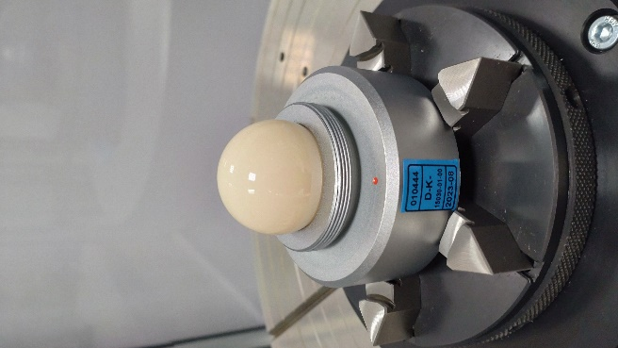
Fig. 2: Ceramic sphere.
The sphere is made out of ceramic, it has a diameter of 30 mm and is set on an aluminium base.

Roundness measurements needs to be performed up to 1 mm off of a maximum circumference level.
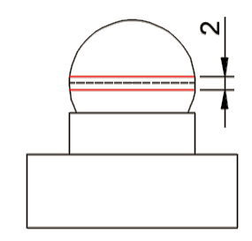
Fig. 3. Measurement range.
The standard shall be clamped by each laboratory’s own usual methods which have to be described shortly on the report form. Do not try to remove the sphere from the base. The sphere shall be measured by clamping its base support.
- A steel ring:
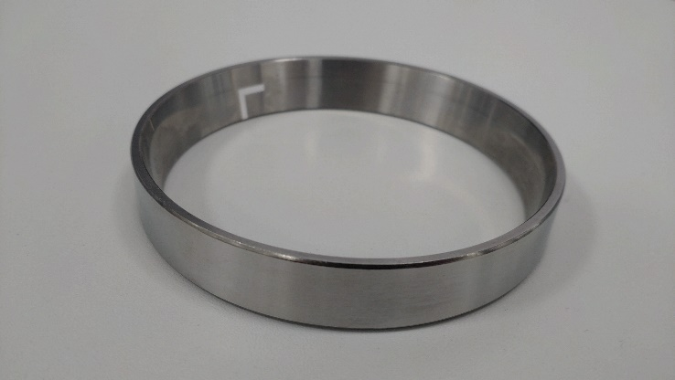
Fig. 4. Steel ring.
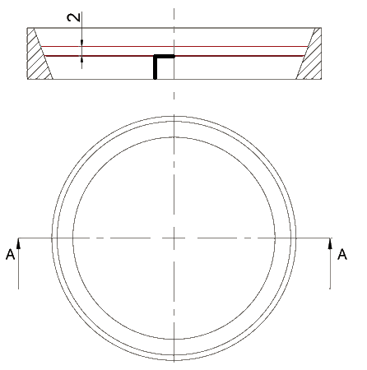
Fig. 4. Measurement range.
The standard is a steel ring with 90 mm outer diameter and with changing inner diameter. The inner surface of the ring has a marker placed on it, which indicates the placement of the measurement. Inner roundness measurement must be carried out no more than 2 mm above the marker.

Measuring instructions

Handling the artefact
The roundness standards should be stored in such a way as to prevent damage. They shall only be handled by authorized persons. No other measurements are to be attempted by the participants and the roundness standard should not be used for any purpose other than described in this document. The artefacts may not be given to any party other than the participants in the comparison.
Before making the measurements, the roundness standards need to be checked to verify that the measuring surface is not damaged (never touch the measuring surface with bare fingers).
The artefact should be examined before despatch and any change in condition during the measurement at each laboratory should be communicated to the pilot laboratory. Ensure that the content of the package is complete before shipment. Always use the original packaging.

Traceability
Length measurements should be traceable to the latest realisation of the metre as set out in the current “Mise en Pratique”. Temperature measurements should be made using the International Temperature Scale of 1990 (ITS-90).

Measurands
The measurands of the artefact are peak-to-valley roundness deviations with 1-15, 1-50, 1-150 and 1-500 Gaussian filtering method and LSCi reference circle, and, if possible, to the minimum zone reference circles (MZCi) in accordance with the ISO/TS 12181-1:2011. The measurements should be carried out using the measurement lines laid out in section 4.1. All measurements must be performed at the speed of traverse not more than 10 revolutions per minute. Probing force must be specified and should not exceed 0.25 N. Stylus tip radius must be specified. Probing direction for measurement should be perpendicular to the axis of rotation. In case a different orientation is used, this should be clearly reported.
Laboratories should report the temperatures at which the roundness measurements were made. Laboratories should only measure the artefact at a temperature close to 20 °C.
Only one result for a measurand shall be given irrespective of the number roundness measurements performed. For each method applied, a complete description of the method has to be given. The measurements have to be reported for measuring conditions, given in 5.7.
Before calibration, the artefact must be inspected for damage. Any scratches, dirty spots or other damages have to be documented.
The measurement results (appropriately corrected to the reference conditions) have to be reported using the table in Appendix B.1.

Measurement uncertainty
The uncertainty of measurement shall be estimated according to the ISO Guide to the Expression of Uncertainty in Measurement. The participating laboratories are encouraged to use their usual model for the uncertainty calculation.
The participants are asked to report the standard uncertainty. Moreover, the expanded measurement uncertainty U has to be expressed in the usual length-dependent form:
$$U=Q[A,B∙L]$$
where A is the fixed part and B the proportional part
using a coverage factor of k = 2.
Table 4: Example of measurement uncertainty budget
Description | Quantity | Standard uncertainty | Sensitivity coefficient | Standard uncertainty | Standard uncertainty
 | x_{i} | u(x_{i}) | c_{i} = ∂l/∂x_{i} | (Fixed component µm) | (proportional component µm L in m)
Electric and mechanical noise of measurement instrument
Error of clousure
Measurement repeatability
Spindle run-out
Selected instrument resolution
Inductive gauge amplification
Surface roughness of measured standard
Not precisely centered setting of measured stanrad and the displacement of measuring stylus tip
Tilt of axis of calibrated standard

Reference conditions
Measurement results should be reported for the reference temperature of 20 °C. For the spherical standard, the linear thermal expansion coefficient (4.6 ± 0.5) × 10⁻⁶ K⁻¹ should be used. For ring standard, the linear thermal expansion coefficient (10,1 ± 0.5) × 10⁻⁶ K⁻¹ should be used.

Reporting of results

Results and uncertainties
As soon as possible after measurements have been completed, the results should be communicated to the pilot laboratory, within six weeks at the latest.
The measurement report forms in appendices B & C of this document will be sent by e-mail (Word/Excel document) to all participating laboratories. It would be appreciated if the report forms (in particular the results sheet) could be completed by computer and sent back electronically to the pilot. Appendix B with measurement results should be submitted in an Excel spreadsheet. The signed report must also be sent in paper form by mail or electronically as a scanned pdf document. In case of any differences, the signed forms are considered to be the definitive version. Please observe the correct units to be used when reporting results.
Following receipt of all measurement reports from the participating laboratories, the pilot laboratory will analyse the results and prepare a draft A0 check. This will be sent to each participant to check their own results entered to analysis sheet. Within 3 months a first draft A.1 report on the comparison should be done. This will be circulated to the participants for comments, additions and corrections.

Analysis of results

Calculation of the reference value
The key comparison reference value (KCRV) is calculated as the weighted mean of the participant results. The check for consistency of the comparison results with their associated uncertainties will be made based on Birge ratio, the degrees of equivalence for each laboratory and each interval with respect to the KCRV will be evaluated using E_{n} values, along the lines of the WG-MRA-KC-report-template. If necessary, artefact instability, correlations between institutes and the necessity for linking to another comparison will be taken into account.

Artefact instability
The instability of the standards must be determined in course of the comparison. Because during the transportation and measurement the artefact may be deformed due to temperature change or shock, the instability of the artefact must be determined in course of the comparison. For this check the measurements of the pilot laboratory are used exclusively, not that of the other participants.
Using these data a linear regression line is fitted and the slope together with its uncertainty is determined.
Three cases can be foreseen:
- The linear regression line is an acceptable drift model and the absolute drift is smaller than its uncertainty. The artefact is considered stable and no modification to the standard evaluation procedure will be applied. In fact the results of the pilot’s stability measurements will not influence the numerical results in any way.
- The linear regression line is an acceptable drift model and the absolute drift is larger than its uncertainty, i.e. there is a significant drift for roundness standard. In this case an analysis similar to [Nien F Z et al. 2004, Statistical analysis of key comparisons with linear trends, Metrologia 41, 231] will be followed. The pilot influences the KCRV by the slope of the drift only, not by the measured absolute lengths.
- The data are not compatible at all with a linear drift, regarding the uncertainties of the pilot’s measurements. In this case the artefact is unpredictably unstable or the pilot has problems with its measurements. All participants have to agree on a suitable approach

Correlation between laboratories
Since the topic of this project is the comparisons of primary measurements, correlations between the results of different NMIs are unlikely. A possible exception is the common use of the recommended thermal expansion coefficients (from table 3). A correlation will become relevant only when an artefact is calibrated far away from 20 °C which should not be the case. Thus correlations are normally not considered in the analysis of this comparison. However if a significant drift exist, correlations between institutes are introduced by the analysis proposed in section 7.2.

Linking to other comparisons
The CCL task group on linking CCL TG-L will set guidelines for linking this comparison to any other key comparison within CCL for the same measurement quantity.

References
[1] EURAMET Guide on Comparisons – EURAMET Guide No. 4, Version 2.0 (04/2021)
[2] CIPM MRA-D-05: Measurement comparisons in the CIPM MRA
[3] JCGM 100 :2008 (GUM with minor corrections) ”Evaluation of measurement data – Guide to the expression of uncertainty in measurement”, Sept. 2008
[4] EA-4/02 M:2021 ”Expression of the uncertainty of measurement in calibration”, Nov. 2021
[5] Cox M G 2002 The evaluation of key comparison data, Metrologia 39 589–95

Appendix A – Reception of Standards
To: | Dariusz Czułek  Central Office of Measures, Elektoralna 2, Warsaw, 00-139, Poland  Fax: +48 22 581 95 43 e-mail: length@gum.gov.pl
From: | NMI: ……………………………… Name: ………………………………  Signature: ……………………………… Date: ………………………………

We confirm having the roundness standard for the EURAMET comparison on the date given above.
After a visual inspection:
There is no apparent damage.
There are scratches on the sphere surface. Please indicate the location and, if possible, include photos.
There is severe damage of the sphere. Please indicate it and, if possible, include photos.
We confirm having received ATA carnet (only to labs outside EU)
Yes
No

Appendix B – Results Report Form – fill Excel file XXX_EURAMET.L-K5.n01 Results Report Form
To: | Dariusz Czułek  Central Office of Measures, Elektoralna 2, Warsaw, 00-139, Poland  Fax: +48 22 581 95 43 e-mail: length@gum.gov.pl
From: | NMI: ……………………………… Name: ………………………………  Signature: ……………………………… Date: ………………………………
      - Measurement results
Sphere – outer diameter
Filter | Roundness deviation (LSCi) [µm] | Standard uncertainty [µm] | Roundness deviation (MZCi)  [µm] | Standard uncertainty [µm]
1-15 Gaussian
1-50 Gaussian
1-150 Gaussian
1-500 Gaussian

Ring – inner diameter
Filter | Roundness deviation (LSCi) [µm] | Standard uncertainty [µm] | Roundness deviation (MZCi)  [µm] | Standard uncertainty [µm]
1-15 Gaussian
1-50 Gaussian
1-150 Gaussian
1-500 Gaussian

      - Measurement conditions
Sphere – outer diameter
Set-up | Detail
Rotating workpiece or probe (CW or CCW)
Rotation speed (rev/min)
Number of measured values per revolution
Stylus static force (mN)
Ball tip diameter (mm)

Ring – inner diameter
Set-up | Detail
Rotating workpiece or probe (CW or CCW)
Rotation speed (rev/min)
Number of measured values per revolution
Stylus static force (mN)
Ball tip diameter (mm)

      - Uncertainty of measurement
Sphere – outer diameter
Name and symbol x_{i} | distrib. | u(x_{i}) unit | ν_{i} | c_{i} = ∂dl/∂x_{i} | u_{i}(dl) /µm

Combined standard uncertainty: u_{c}(L)=
Expanded uncertainty: U(L) (k = ) =
$U\left(L\right)=Q\left[A,BL\right]=\sqrt{a^{2}+{(BL)}^{2}}=$

Ring – inner diameter
Name and symbol x_{i} | distrib. | u(x_{i}) unit | ν_{i} | c_{i} = ∂dl/∂x_{i} | u_{i}(dl) /µm

Combined standard uncertainty: u_{c}(L)=
Expanded uncertainty: U(L) (k = ) =
$U\left(L\right)=Q\left[A,BL\right]=\sqrt{a^{2}+{(BL)}^{2}}=$

Please state your CMC uncertainty for your corresponding measurement service(s) (if you have such a CMC) and the identifier of the service (in MRA Appendix C).

If the uncertainty of the CMC is significantly different than that of the related CMC, please explain why this is the case.

Appendix C –– Description of the measurement instrument
To: | Dariusz Czułek  Central Office of Measures, Elektoralna 2, Warsaw, 00-139, Poland  Fax: +48 22 581 95 43 e-mail: length@gum.gov.pl
From: | NMI: ……………………………… Name: ………………………………  Signature: ……………………………… Date: ………………………………

Description of measuring technique (enclose photo(s) and/or sketch(es) of the instrument)
....................................................................................................................................................
....................................................................................................................................................
....................................................................................................................................................
....................................................................................................................................................
....................................................................................................................................................
....................................................................................................................................................
....................................................................................................................................................
....................................................................................................................................................
....................................................................................................................................................
....................................................................................................................................................
....................................................................................................................................................
....................................................................................................................................................

