TECHNICAL PROTOCOL
GULFMET No--
Supplementary Comparison of Relative Humidity

Table of Contents
1. Introduction 4
2. Travelling Standard artifact 4
2.1. Artifact 4
2.1. Measurement Process 5
2.2. Operation of the travelling standard 5
2.3. Data Collection 6
2.4. Precautions and additional information 6
3. Participating Laboratories 6
3.1. Pilot Laboratory 6
3.2. Participants 7
3.3. Artifact Circulation 7
4. Time Schedule 8
5. Transport Case 8
6. Transportation of Travelling Standard 8
6.1. Failure of Travelling Standard 8
6.2. Financial aspects 8
7. Measurement Points and Quantities 9
8. Calculation of the Comparison Reference Value 9
9. Measurement Instructions 10
9.1. Precautions and Initial Actions Prior to Comparison measurements 10
9.2. Before the Measurements 11
9.3. Powering of the standard during the measurements 12
9.4. Environmental Conditions 12
9.5. Method of measurement 12
10. Measurement Uncertainty 12
11. Reporting of Results 13
12. Final Report of the Comparison 14
13. References 14
Annex (1): Receiving Artifact 15
Annex (2): TEMPLATE for SUBMISSION of RESULTS 16
Annex (3): CIRCULATION TIME SCHEDULE 17

Introduction

It is planned to organize a comparison on relative humidity realization in the Gulf Association for Metrology (GULFMET). The protocol is agreed by all participants. The comparison will be performed by measuring a thermo-hygrometer - transfer standard instrument within the range from 10 %rh to 90 %rh relative humidity values at 23 °C, 50 °C, 10 °C and 23 °C air temperature values. The measurand for the comparison is relative humidity (RH). SASO-NMCC will be the pilot institute of this comparison. The travelling standard will be provided by pilot laboratory. SASO-NMCC will be responsible for monitoring the performance of the standard during the circulation, the evaluation and reporting of the comparison results. The purpose of comparison is to demonstrate degree of equivalence and to support CMCs. The comparison will be carried out in accordance with the “Measurement Comparisons in the CIPM MRA” and “EURAMET Guide on Comparisons”. [1, 2, 3]

Travelling Standard artifact

Artifact

Thermo-hygrometer Vaisala HMT 337 is the transfer standard instrument, has relative humidity range from 0 %rh to 100 %rh, and temperature range from 0 °C to 100 °C, see Table 1. Within the comparison, only the relative humidity values within the range from 11%rh to 90 %rh at 23°C, at 50 °C, 10 °C, and 23 °C temperature values will be measured.

Table 1. Artifact Specifications
Artifact | Thermo-hygrometer | 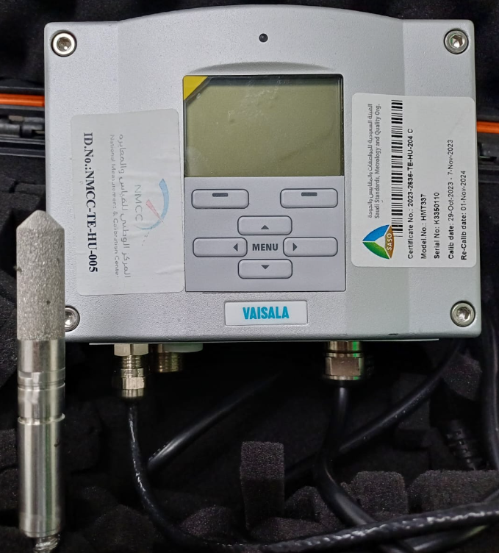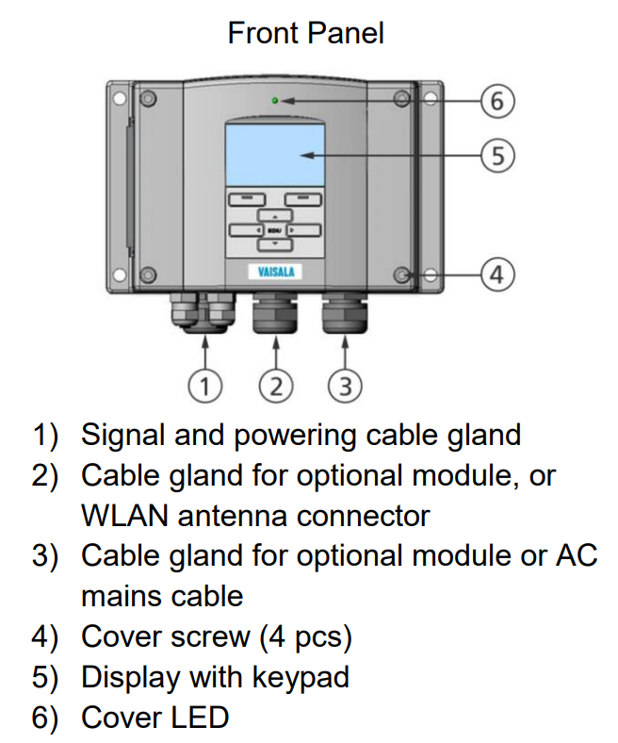
Manufacturer | Vaisala
Model | HMT 337
Owner | SASO-NMCC
Probe cable length | 5 m
Probe dimensions | Φ12 mm x 99.5 mm
RH range | 0 %rh to 100 %rh
Temperature range | -40 °C to 180 °C
Display operating temperature | 0 °C to 60 °C
Electrical supply | 100 V to 240 V AC, 50/60 Hz
Accessories | RS232 cable
Interface | Display, RS232
Serial no | K3350110
Weight of the display together with sensor | 4 Kg

Measurement Process

Participants should refer to the operating manuals for instructions and precautions for using the travelling standard [3]. Participants may perform any initial checks of the operation of the thermo-hygrometer that would be performed for a normal calibration. In the case of an unexpected instrument failure at a participant institute, the pilot shall be informed as early as possible. Sensor head of the standard shall be exposed to an air stream of known temperature and relative humidity. Display unit of the sensor shall be kept outside at room conditions. Room conditions should be recorded during the measurements. At least one meter (1 m) of a cable from the sensor’s head should be thermalized at the same temperature (as the sensor’s head).

Operation of the travelling standard

Before any humidity measurements, follow the special instructions for using the Vaisala HMT337:
1) Read the operating instructions delivered by the manufacturer (a copy of the instructions is in the transport case or can be downloaded from the web page). [3]
2) Important: The transfer standard use pilot’s default settings, which MUST NOT be modified or adjusted other than described in this document.
3) Remove the protection cap from the sensor before taking the measurements. Do not touch the sensor’s head/filter with your fingers or any other object at any time. After you finish with the measurements, wait until sensor’s head is cooled down and dried out to ambient conditions (approx. 23 °C, 50 %rh) before putting the protection cap back on.
4) Pressure compensation value should be left at default pressure value of 1013.25 hPa. If the pressure setting differs, it should be changed to this default value (1013.25 hPa) using the Display/Keypad as explained in the page 104 of the User’s Guide.
5) Chemical purging shall be turned off (default pilot settings). Participant should check this setting and remove the potential check mark in front of “Purge on power up” and “Automatic purge”. See page 135 of the User’s Guide for checking/turning off the chemical purge.
6) Measurements of RH, temperature and calculated dew-point can be read from the display with resolution of 0.01 %rh and 0.01 °C, respectively.
7) IMPORTANT NOTE: The Vaisala sensor has factory implemented data-logging, which unfortunately cannot be turned-off. This is essentially against the very purpose of the inter-laboratory comparison. Therefore, AFTER you finish ALL the measurements, DO NOT FORGET to permanently delete all the recorded values from the sensor’s memory. The provided software deletes all internal memory, after you hit STOP button.

Data Collection

- RH readings used primarily in this comparison shall be obtained from the display and/or through the serial port.
- Each measured value (incl. its experimental standard uncertainty) is obtained calculating the mean and standard deviation of at least 10 readings of the RH recorded during 10 to 20 minutes.
- The mean and standard deviation of a set of at least 10 readings, taken over the same period as the RH measurements should be reported.
- Values reported for RH produced or measured by a participant's standard should be the value applied to the instruments, after any allowances for pressure and temperature differences between the point of realization (laboratory standard generator or reference hygrometer) and the point of use (travelling standard).

Precautions and additional information

- Participants should avoid lengthy additional measurements, except those necessary to give confidence in the results of this comparison.
- The travelling standard used in this comparison must not be modified, adjusted or used for any purpose other than described in this document, nor given to any party.
- The pilot will make an assessment of any drift in the travelling standard during the comparison, based on measurements at the pilot laboratory at the beginning and end of the comparison period.
- If drift is found, this will be considered in the final analysis of the comparison results.

Participating Laboratories

Pilot Laboratory

The pilot institute for this comparison is SASO-NMCC Saudi Arabia. The contact details of the coordinator are given below:
Table 2. Pilot Institute information
Pilot institute | SASO-NMCC KSA
Coordinator | IBRAHIM SAAD ALSBAIE
Tel | 00966555110690
E-mail | e.sbaiy@saso.gov.sa
Address | Saudi Standards, Metrology and Quality Organization of The Kingdom of Saudi Arabia (SASO)  Riyadh 11471  P.O. Box 3437, KINGDOM of SAUDI ARABIA

Participants

The participating institutes and contact persons with their addresses are given below:
Table 3. Participant Institutes information
Country | Institute | Acronym | Shipping Address | Contact Person
Saudi Arabia | SASO The National Measurement and Calibration Center | SASO NMCC | Saudi Standards, Metrology and Quality Organization of The Kingdom of Saudi Arabia (SASO) Riyadh 11471, P.O. Box 3437 KINGDOM of SAUDI | IBRAHIM SAAD ALSBAIE
United Arab Emirates | Emirates Metrology Institute | EMI | Emirates Metrology Institute  Masdar City,  KryptoLabs Building,  Abu Dhabi, UAE | Dr. Miltiadis Anagnostou
--------------- | ------------------ | ------------------ | ------------------ | ------------------
--------------- | ------------------ | ------------------ | ------------------ | ------------------
--------------- | ------------------ | ------------------ | ------------------ | ------------------
--------------- | ------------------ | ------------------ | ------------------ | ------------------
--------------- | ------------------ | ------------------ | ------------------ | ------------------

- By their declared intention to participate in this supplementary comparison, the laboratories accept the general instructions and the technical protocol written down in this document and commit themselves to follow strictly the procedures of this protocol as well as the version of the "Measurement Comparisons in the CIPM MRA”, and “EURAMET Guide on Comparisons" in effect at the time of the initiation of the Supplementary Comparison [1, 2, 4].
- Once the protocol and list of participants have been approved, no change to the protocol or list of participants may be made without prior agreement of all participants.
- If for some reason, the measurement facility is not ready or customs clearance takes too much time in a country, the participating laboratory must contact the Pilot laboratory immediately.
- Exclusion of a participant's results from the report may occur if the results are not available in time to prepare the draft report.

Artifact Circulation

SASO-NMCC
UME
EMI
----
----
----

Time Schedule
The time schedule for the comparison is given in the Appendix 3. The performance of the travelling standard will be monitored and analyzed at SASO-NMCC from the measurements made at the beginning and end of the circulation scheme as given in Annex 3. Any deviation in the agreed plan should be approved by the pilot institute.

Transport Case
The travelling standard is packed in a transport case of size 30 x 23 x 14 cm and a total weight of 4.00 kg. The transport case can easily be opened for customs inspection. The content of the transport case is given below:
1. Vaisala HMT 337 Transfer Standard Thermo-Hygrometer Display (Serial No: K3350110).
2. Vaisala HMT 337 Transfer Standard Thermo-hygrometer Sensor
3. Five-meter sensor cable
4. PC connection cable with USB end
5. Power cord
6. Software
7. User’s Guide

Transportation of Travelling Standard
- Each participant is responsible for the transportation of the travelling standard to the next participant.
- After arrival in the participant’s laboratory, the standard should be allowed to stabilize in a temperature and humidity-controlled environment for at least one day before use.
- Each institute will have 60 days available. This includes the measurements and the transportation of the standard to the next participant.

Failure of Travelling Standard
- In case of any damage or malfunction of the travelling standard, the Pilot institute (SASO-NMCC) should be informed as soon as possible.
- The comparison will be carried out after the travelling standard is repaired, and additional check measurements carried out by the Pilot institute.

Financial aspects
- Each participant institute is responsible to cover the cost of shipping to the next participant including any customs charges.
- Each participant institute is also responsible for its own costs for the measurements as well as any damage that may occur within its country.
- Transportation and insurance are each laboratory’s responsibility and cost.
- Each laboratory is responsible for any damage of the artifact from the point of receipt at their site until the artifact is signed for on receipt at the next laboratory.
- The insurance value of the artifact is 15000 SR
- The overall costs for the organization, initial and interim measurements and the processing of results are covered by the pilot laboratory however any damage to or loss must be paid by the responsible participant.
- By their confirmation of participation, each laboratory agrees to be bound by these requirements.

Measurement Points and Quantities
- Main quantity which must be measured is the relative humidity
- The temperature values are conditions of the comparison, not “measured values” of the comparison.
The quantities to be measured and the measurement points are given in the table below:

Table 4. Measurement points of the comparison
Quantity | Temperature Values ºC | Measurement Points
Relative humidity | 23 ºC | 11 %rh → 30 %rh → 50 %rh → 70 %rh → 90 %rh
Relative humidity | 50 ºC | 11 %rh → 30 %rh → 50 %rh → 70 %rh → 90 %rh
Relative humidity | 10 ºC | 11 %rh → 30 %rh → 50 %rh → 70 %rh → 90 %rh
Relative humidity | 23 ºC | 11 %rh → 30 %rh → 50 %rh → 70 %rh → 90 %rh

- Each participant should use their own stabilization times that they would normally use.
- For the measurements carried out using travelling standard, The first RH set point for each temperature sequence (underlined by double line) shall be maintained at least 1 hour and no longer than 5 hours before taking the measurements, must be applied.
- If the prescribed sequence of set points would inevitably need to be stopped for more than 4 hours (overnight,), it is suggested to first end a RH sequence at current temperature level and then leave the sensor at ambient conditions (23 °C ± 3 °C and 50 %rh ± 20 %rh) in order to avoid a potential drift due to dwell at extreme conditions.
- If even the RH sequence cannot be properly finished, then you should maintain the sensor at approximately 50 %rh at current temperature.
- If the scope/capability of a laboratory does not cover the whole range of this comparison, the laboratory is allowed to limit measurement values according to their capability. In this case, the Pilot institute (SASO-NMCC) should be informed by the participant laboratory.
- Laboratory have to record the following
- Ambient Pressure
- Ambient temperature
- Ambient humidity

Calculation of the Comparison Reference Value
- The Comparison Reference Value (CRV) for each measurement point $x_{CRV}$ will be calculated using the weighted mean from the participating labs [3, 4, 5], equation 1.
$$x_{CRV}=\frac{\sum_{i=1}^{p}{\frac{x_{i}}{u_{i}^{2}}}}{\sum_{i=1}^{p}{\frac{1}{u_{i}^{2}}}}$$ | 1

Where $x_{i}$ and $u_{i}$ are the result and standard uncertainty reported by the participant $i$, and $p$ is the number of participants.
- The standard uncertainty associated with the weighted mean is calculated as:
$$u\left(x_{CRV}\right)=\sqrt{\frac{1}{\sum_{i=1}^{p}{\frac{1}{u_{i}^{2}}}}}$$ | 2

where $u_{i}$ are the result and standard uncertainty reported by the participant $i$, and $p$ is the number of participants.

- To reduce the effect of outlier value on the calculated comparison reference value $x_{CRV}$ , consistency of the results using a chi-square test was applied as.
$$χ_{obs}^{2}=\sum_{i=1}^{p}{\frac{{\left(x_{i}-x_{CRV}\right)}^{2}}{u^{2}\left(x_{i}\right)}}$$ | 3
where the degrees of freedom are: $v$ = p -1.
- The consistency check is regarded as failed if:
$$\operatorname{Pr}\left\{χ^{2}\left(v\right)>χ_{obs}^{2}\right\}<0.05$$ | 4
where $Pr$ denotes “probability of” and $χ^{2}\left(v\right)$ is the inverse of the chi-square cumulative distribution function with degree of freedom specified by $v$ for the probability of 0.05 (corresponding to the 95% level of confidence).
- In this case, the institute with the highest value of $χ_{obs}^{2}$ is excluded from the evaluation and a new reference value, reference standard uncertainty, and chi-squared values are calculated again without the excluded laboratory.
- If the consistency check did not fail, then $x_{CRV}$ was accepted comparison reference value and U(x_{ref}) was accepted as the expanded uncertainty.
- The pilot will make an assessment of any drift in the travelling standards during the comparison.
- The assessment will be based on initial and final measurements done by the pilot.
- If drift is found, this will be taken into account in the final analysis of the comparison results as an additional term u_{drift} in the uncertainty budget.

Measurement Instructions

Precautions and Initial Actions Prior to Comparison measurements
The values of RH and temperature applied to the travelling standards should be within ± 2 %rh and ± 2 °C, respectively, of the agreed nominal values for the comparison, and ideally closer than this. Deviations greater than this may increase the uncertainty in the comparison, for a particular result.
  - At least 1 meter of a cable from the sensor’s head should be thermalized at the same temperature (as the sensor’s head).
  - Read the operating instructions delivered by the manufacturer (a copy of the instructions is in the transport case or can be downloaded from their respective web pages).
  - Important: The transfer standard use pilot’s default settings, which MUST NOT be modified or adjusted other than described in this document.
  - Instructions for using the Vaisala HMT337:
- Remove the protection cap from the sensor before taking the measurements.
- Do not touch the sensor’s head/filter with your fingers or any other object at any time.
- After you finish with the measurements, wait until sensor’s head is cooled down and dried out to ambient conditions (approx. 23 °C, 50 %rh) before putting the protection cap back on.
- Pressure compensation value should be left at default pressure value of 1013.25 hPa.
- If the pressure setting differs, it should be changed to this default value (1013.25 hPa) using the Display/Keypad as explained in the page 104 of the User’s Guide.
- Chemical purging shall be turned off (default pilot settings).
- Participants should check this setting and remove the potential check mark in front of “Purge on power up” and “Automatic purge”. See page 135 of the User’s Guide for checking/turning off the chemical purge.
- Measurements of RH, temperature and calculated dew-point can be read from the display with resolution of 0.01 %rh and 0.01 °C, respectively.
- The sensor has been preconfigured by pilot (do not change this configuration!) for RS232 communication with the setting 9600,8,N,1.
- This way all three measured quantities can be obtained by issuing a SEND command, preceded by a carriage return.
- It is advised to use logging software that is provided with the instrument.
- Values, obtained through serial communication, have additional digit (resolution 0.001 %rh).
- IMPORTANT NOTE: The Vaisala sensor has factory implemented data-logging, which unfortunately cannot be turned-off. This is essentially against the very purpose of the inter-laboratory comparison. Therefore, AFTER you finish ALL the measurements, DO NOT FORGET to permanently delete all the recorded values from the sensor’s memory.
- The provided software deletes all internal memory, after you hit STOP button.
- Alternatively, this is done through the serial port with the following sequence of special commands, which are not included in the User’s guide (use carriage return after each command): PROTECT OFF DELETE+ (wait several seconds for response) PROTECT ON

Before the Measurements
- Ensure that the mains voltage setting is applicable to the local supply (220 V, 50 Hz).
- No initial tests are required.
- Check that the standard is functioning correctly that RH and temperature values appear in the display.
- It should be allowed to stabilize in a temperature and humidity-controlled environment for at least 1 day before commencing measurements

Powering of the standard during the measurements
- Measurements will be made with the standard connected to the AC line power.

Environmental Conditions
- The ambient temperature and humidity must be measured.
- No corrections will be performed for temperature and humidity effects.
- Preferably, the measurements should be carried out at the ambient conditions given below;
- Temperature: (21 ± 3) °C
- Relative humidity: (45 ± 15) %rh

Method of measurement
- participant institutes should use their own measurement methods for their laboratory standards.

Measurement Uncertainty

The uncertainty of measurement must be calculated according to the JCGM 100 “Guide to the Expression of Uncertainty in Measurement” [5] for the coverage probability of approximately 95%. All contributions to the measurement uncertainty should be listed in the report submitted by each participant. Even though the contributions to the uncertainty are specific to the measurement method used, it may be useful to consider the list of uncertainty sources given below.
- The Type A standard uncertainty
- The quoted uncertainty of the RH realization (applied RH)
- The estimated uncertainty relating to the short-term stability of the travelling standard at the time of measurement
- The estimated uncertainty relating to the hysteresis of the travelling standard at the time of measurement. (Difference between two consecutive measurements of mid-point, i.e. 50 %rh)
- The estimated uncertainty in mean values due to dispersion of repeated results (reflecting the combined reproducibility of laboratory standard and travelling standards)
- The estimated uncertainty due to non-linearity of the travelling standards in any case where measurements are significantly away from the agreed nominal value
- The estimated covariance between applied (laboratory standard) and measured (travelling standard) values of RH (if found significant)
- Any other components of uncertainty that are thought to be significant. This is not a complete list and should be extended with uncertainty contributions that are specific for the participant’s measurement system.
Each participant is required to submit detailed analyses of uncertainty for their RH standards. A list of the all-significant components of the uncertainty budget should be evaluated, and should support the quoted uncertainties. Type B estimates of uncertainty may be regarded as having infinite degrees of freedom, or an alternative estimate of the number of degrees of freedom may be made following the methods in the ISO Guide. A template for reporting uncertainty of measurement will be in electronic form. Participants may add to the template any additional uncertainties they consider relevant. The uncertainty budget stated by the participating laboratory should be referenced to an internal report (e.g. calibration instruction including uncertainty evaluation) and/or a published article.

Reporting of Results
The results should be sent to the pilot institute at the latest six (6) weeks after completing the measurements. A template for reporting results will be provided in electronic form. Use of this format, including calculations of means and differences, allows participants to see clearly the values and uncertainties of the parameters they are submitting for comparison. Participants should report results to the pilot in terms of relative humidity (RH) at nominal temperature values stated in Table 4. The main measurement results comprise:
- Values of RH applied to the travelling standard at nominal temperature, and associated standard uncertainty.
- Values of nominal temperatures.
- Values measured using travelling standard (and their associated uncertainties derived from standard deviation of the set of readings).
- Values of difference between applied RH point and measured RH point.

From the data measured by the participants, results will be analyzed in terms of differences between applied and measured RH at nominal temperatures.
The participants should report the conditions of realization and measurement, as background information to support the main results. These conditions should include room conditions, placement of the temperature probe(s); set-up for simultaneous installation of the travelling standards; sealing of the travelling standards; actual length of the cable that is thermalized at approximately same temperature as the sensor’s head; pressure difference between saturator or reference hygrometer and travelling standards; photo of the enclosure that affects the local flow rate around the sensor’s probe; measurement traceability, and other items. A template for reporting conditions of measurement will be provided in electronic form. Participants should provide a description of the operation of their facilities used in the comparison. Participants should also provide an example plot of equilibrium condition at a nominal RH/t setpoints 95 %rh / 10°C and 50 %rh / 23 °C, respectively, over at least one hour for the travelling standard. However, results shall also be reported to the pilot institute.
The report must contain at least:
- Details of participating institute.
- The date and time of the measurements.
- A detailed description of the method used.
- The measurement standards used in the comparison measurements.
- Software used in the comparison measurements
- The environmental conditions during the measurements;
  - ambient temperature
  - relative humidity
  - ambient pressure (if applicable)
- Results of measurement
- A statement of traceability
- The Type A standard uncertainty;
- Detailed uncertainty budget with the different sources of uncertainty and their values, as;
  - The quoted uncertainty of the RH realization (applied RH)
  - The estimated uncertainty relating to the short-term stability of the travelling standard at the time of measurement
  - The estimated uncertainty due to any drift of the travelling standard over the period of the comparison (estimated by the pilot)
  - The estimated uncertainty in mean values due to dispersion of repeated results (reflecting the combined reproducibility of laboratory standard and travelling standard)
  - The estimated uncertainty due to non-linearity of the travelling standard in any case where measurements are significantly away from the agreed nominal value
  - The estimated covariance between applied (laboratory standard) and measured (travelling standard) values of RH (if found significant)
  - Any other components of uncertainty that are thought to be significant
  - Expanded uncertainty, estimated for the coverage probability of approximately 95 %.
  - Participants should avoid sharing any data until the Draft report is completed by the pilot.

Final Report of the Comparison
The pilot institute is responsible for the preparation of a comparison report. The draft version of the comparison report will be issued within 12 weeks after receiving the last participant report by the pilot institute. Draft report will be sent to each participant for discussion and approval. This draft will be confidential to the participants. The participants will have four weeks to send their comments on Draft Report. After four-week, Draft Report will become the Final Report. The Final Report will form the basis for the publication of results. The supplementary Comparison Reference Value (CRV) will be calculated using the weighted mean from the participating labs. The Final Report will provide the degrees of equivalence of the laboratories and their associated uncertainties.

References
[1]. Measurement Comparisons in the CIPM MRA, MRA-D-05, V1.6.
[2]. EURAMET Guide on Comparisons, EURAMET Guide No. 4, V1.0 (05/2016)
[3].Humidity and Temperature Transmitter series HMT330 Manual.
[4]. COX, The evaluation of key comparison data, 2002 Metrologia 39 589, DOI 10.1088/0026-1394/39/6/10
[5]. JCGM-100. (2008). Evaluation of measurement data - Guide to the expression of uncertainty in measurement. JCGM.

Annex 1

Receiving Artifact
1
This is to clarify that …………………………(NMI Name)…………………………. have receive a case by Courier company to perform measurements according to the comparison of relative humidity realization that contains (Vaisala hygrometer HMT337) “” SN (K3350110)
Date Of Receipt: …………………………(DD/MM/YYYY)………………………….
Item |  | Availability |  | Visible check |  |  | Comments
 |  | Available | Not Available | good | Bad
Vaisala hygrometer HMT335, s/n: K3350110 |  | □ | □ | □ | □
sensor’s probe with 5 m cable (attached to HMT335) |  | □ | □ | □ | □
power cord with standard CEE7/7 plug (attached to HMT335) |  | □ | □ | □ | □
Cable with USB end for connection to a PC (attached to HMT335) |  | □ | □ | □ | □
User’s guide (Vaisala HTM330) |  | □ | □ | □ | □
Logging software (CD) |  | □ | □ | □ | □
Transport case |  | □ | □ | □ | □
In case of items unavailability or in bad conditions, please send a photo to SASO-NMCC immediately.
We are responsible for this test items with conditions previously stated from now up to the date we give it back to next NMI according to the time frame of the current protocol. in case of any damage or deterioration (cause by us) we will pay all the fees required as a result of this damage.
Received by |  |  |  |  |  | Job Title
E-mail |  |  |  |  |  | Mobile
Sign. |  |  |  |  |  | Date

Annex 2

TEMPLATE for SUBMISSION of RESULTS

The template for submission of results is available in electronic form only (Excel workbook). It will be sent to each participant during the comparison

Annex 3

CIRCULATION TIME SCHEDULE

Institute | Country | Starting Date | Measurement and transportation time
SASO-NMCC | Saudi Arabia | ---------------------- | 60 Days
UME | Turkey | ---------------------- | 60 Days
EMI | United Arab Emirates | ---------------------- | 60 Days
---------------------- | ---------------------- | ---------------------- | 60 Days
---------------------- | ---------------------- | ---------------------- | 60 Days
---------------------- | ---------------------- | ---------------------- | 60 Days
---------------------- | ---------------------- | ---------------------- | 60 Days
SASO-NMCC | Saudi Arabia | ---------------------- | 60 Days

