2024-07-08

EURAMET Project 1669

Supplementary comparisons of air kerma standards in ²⁴¹Am and ⁶⁰Co radiation beams for radiation protection

Proposed identifier in Appendix B of the BIPM key comparison database (BIPM KCDB):
EURAMET.RI(I)-SXX

Technical Protocol
(accepted by EURAMET TC-IR)

Pilot laboratory: SSM (reporting) and STUK (measurements)

Contact persons:

Linda Persson
Swedish Radiation Safety Authority (SSM)
Riksmätplatsen
Solna Strandväg 122
17154 SOLNA, Sweden
Tel: +46 70 917 66 71
e-mail: linda.persson@ssm.se

Jussi Huikari
STUK – Radiation and Nuclear Safety Authority
Jokiniemenkuja 101370 Vantaa, Finland
Tel. +358 40 822 5559
e-mail: Jussi.Huikari@stuk.fi

Contents
1 Object and participants 2
1.1 Objective of the comparison 2
1.2 Participants 2
2 Transfer instruments 3
3 Measurement Procedure 4
3.1 Radiation qualities and quantities 4
3.2 Reference conditions 4
3.3 Reference value 5
3.4 Determination of the calibration coefficient 5
3.5 Uncertainty budgets 6
3.6 Reporting the results 6
3.7 Evaluation the results 6
4 Course of comparison 7
4.1 Transport and time schedule 7
5 References 9
Appendix I: Complete addresses of the participants (used for shipment) 11
Appendix II. Pictures of transfer chambers. 13

Objective and participants
The national metrology laboratories for dosimetry quantities of Spain (CIEMAT, the Spanish National Metrology Institute for Ionising Radiation), United Kingdom (NPL, The National Physical Laboratory UK ), Sweden (SSM, Swedish Radiation Safety Authority), Norway (DSA, Norwegian Radiation and Nuclear Safety Authority), and Finland (STUK, Radiation and Nuclear Safety Authority) have agreed to perform a comparison in terms of air kerma in ²⁴¹Am and ⁶⁰Co radiation protection beams. NPL acts as a Primary Standards Dosimetry Laboratory (PSDL). For ⁶⁰Co in protection levels CIEMAT has recently implemented its own traceability based on the primary standard for ¹³⁷Cs (Cornejo, 2022 and Kessler C. et al., 2024) and the use of a beam quality correction factor (k_{Co,Cs}) for a well-characterized secondary standard ionization chamber (Cornejo Díaz et al. 2024).
In the project three transfer chambers will be circulated among participants and each laboratory will report calibration coefficients and their expanded uncertainties for those chambers in terms of air kerma. NPL as a primary dosimetry laboratory will provide the reference value.
This technical protocol prepared by the laboratories specifies the procedure to be followed in this particular dosimetry comparison. The technical protocol is prepared according to the BIPM technical protocols for the BIPM ongoing key comparisons. The purpose of a comparison is to compare the calibration results of the participating laboratories, without requiring each participant to adopt precisely the same conditions of measurement. The protocol, therefore, specifies the procedures necessary for the comparison, e.g. reference conditions, but not the procedures used in the calibration of the laboratories being compared.
The comparison is performed simultaneously with key comparison of air kerma standards for ¹³⁷Cs beam quality.

Objective of the comparison
The objective of the comparison is to support the ionising radiation CMCs of CIEMAT, SSM, DSA, and STUK in the dosimetry branch for the quantity air kerma/rate in ⁶⁰Co beams, at radiation protection levels. And to support submission of CMCs for ²⁴¹Am for Nordic laboratories.

Participants
Table 1 lists the participants. In Appendix I, the complete contact details for the participants are presented. Table 2 presents the traceability of participating laboratories in terms of K_{air} in ²⁴¹Am and ⁶⁰Co radiation protection beams.

Table 1. Participants of the project.
Institute | Country | Contact person | e-mail
CIEMAT | Spain | Néstor Armando Cornejo Díaz | nestorarmando.cornejo@ciemat.es
NPL | United Kingdom | Martin Kelly | martin.kelly@npl.co.uk
SSM (pilot, reporting) | Sweden | Linda Persson | linda.persson@ssm.se
DSA | Norway | Per Otto Hetland | per.otto.hetland@dsa.no
STUK (pilot, measuring) | Finland | Jussi Huikari | jussi.huikari@stuk.fi

Table 2. Traceability of calibrations at the participating laboratories in terms of K_{air} in ²⁴¹Am and ⁶⁰Co radiation protection beams.
Traceability
Institute | ²⁴¹Am | ⁶⁰Co | Type of standard
CIEMAT | - | CIEMAT | Secondary⁽¹⁾
NPL | NPL | NPL | Primary
SSM | NPL | PTB | Secondary
DSA | VSL | IAEA | Secondary
STUK | NPL | PTB | Secondary
- Calibrated against the primary standard for ¹³⁷Cs and applying a beam quality correction factor for ⁶⁰Co.

Transfer instruments
Three reference ionisation chambers will be used as transfer instruments for this comparison. Three chambers will be used to minimize the risk of potential transfer instrument breakage during the comparison. Due to low air kerma rates one chamber is a 10 liter chamber. If a chamber suffers a failure during the comparison, the comparison will be continued with the other chambers, which are listed in this protocol. If there are results from a half of the participating laboratories (before chamber failure), results will be reported in the final publication. The chambers are the property of STUK and SSM. The chamber stability will be evaluated over the period of the comparison from the measurements carried out by STUK in the framework of the comparison. These chambers have not been calibrated outside the laboratory before this comparison. No electrometer is circulated, and laboratories shall use their own electrometers and cables for performing the measurements during the comparison and ensure traceability for their ionisation current measurements and high-voltage setting applied to the ion chamber. The details of the electrical measurement equipment (e.g. measurement mode) shall be specified when reporting results.
The technical details of the chambers are listed in table 3.

Table 3. Technical data of the transfer chambers
Chamber type | EXRADIN A6 | EXRADIN A6 | PTW TN32003
Serial number | XQ200282 | XQ152602 | 000296
Geometry | spherical | spherical | Spherical
Wall material | C552 | C552 | POM (polyoxymethylene)
Wall thickness  [mm] | 3,0 | 3,0 | 3,0
External diameter / mm | 120 | 120 | 276
Nominal volume / cm³ | 800 | 800 | 10000
Reference point for the air kerma measurements | Geometric center of the chamber | Geometric center of the chamber | Geometric center of the chamber
Polarising voltage of a chamber | +400 V on collector (central) electrode, 0 V on chamber wall (collecting negative charge)  (if +400 V on collector is not available: -400 V on chamber wall, 0 V on collector electrode) | +400 V on collector (central) electrode, 0 V on chamber wall (collecting negative charge)  (if +400 V on collector is not available: -400 V on chamber wall, 0 V on collector electrode) | +400 V on collector (central) electrode, 0 V on chamber wall (collecting negative charge)  (if +400 V on collector is not available: -400 V on chamber wall, 0 V on collector electrode)
Connector type | Triax BNC (male) (2 lug) | Triax BNC (male) (2 lug) | Triax BNC (male) (2 lug)

Measurement Procedure
The dosimetry laboratories are expected to ensure that their reference standard is in perfect working order prior to the comparison. When the participant receives the transfer chambers, they shall perform a visual check for any damage and verify correct functioning prior to any additional measurements. If it seems that the chambers are broken, the participant should contact the piloting laboratories SSM and STUK to discuss further actions.
Each participant will proceed following their own calibration procedure(s) according to their quality management system to determine the calibration coefficients of the transfer chambers in terms of air kerma. Furthermore, each laboratory may add needed correction factors for calibrations and these correction factors shall be reported when reporting results.

Radiation qualities and quantities
The radiation qualities used in the comparison are ²⁴¹Am and ⁶⁰Co. The quantity used for the comparison is the air kerma, defined according to ICRU85a The relevant data from ICRU90 should be used for the primary standards from participants in the comparison and for primary standards against which the secondary standards have been calibrated.

Reference conditions
Radiation fields for ²⁴¹Am and ⁶⁰Co in radiation protection levels should fulfil the requirements of ISO 4037-1:2019 and the ISO4037-2:2019. The reference points for chambers are described in table 3. For the chamber setup, the marking on the stem shall be oriented facing the radiation source and placed free in air. In order to reduce the uncertainty due to the beam radial non-homogeneity, the diameter of the useful beam cross-section should be at least twice the chamber diameter. To minimize the contribution of scattered radiation, the presence of scattering objects in the useful beam (except required holders of light materials and small sections, the chamber stem and the temperature probe) should be reduced as far as possible.
The calibration coefficients for the transfer chambers should be given in terms of air kerma per charge in units of Gy/C and corrected to standard conditions of air temperature and pressure; T = 293.15 K and p = 101.325 kPa. The reference conditions for relative humidity (RH = 50%) will not be corrected for the measurements performed between 20 and 80% RH. Each laboratory will use their own equipment to measure environmental conditions and ensure traceability for those measurements.

Reference value
NPL, as primary laboratory, will provide the reference values for this comparison. All other results will be compared to these values. The reference values will be determined separately for each chamber and radiation quality and the values reported by other laboratories will be compared to the reference value by calculating a ratio between calibration coefficients, e.g. N_{K,LabX}/N_{K,NPL}

Determination of the calibration coefficient
Each laboratory details their own procedure or refers to international practices/ guidance followed when performing the calibration.
Typically for air kerma free in air, Secondary Standards Dosimetry Laboratories (SSDLs) establish the reference air kerma rate $\dot{K}$ at their facilities in accordance with their own procedure following an equation such as:
$\dot{K}=N_{\text{K}\text{,PSDL}}I_{\text{SSDL}}$ (1)
where N_{K,PSDL} is the calibration coefficient used by the given SSDL in order to reach traceability to a primary standards laboratory for air kerma in ⁶⁰Co or ²⁴¹Am beams, and where I_{SSDL} is the ionisation current measured by the SSDL with an electrometer system with traceability to electrical standards. In accordance with ISO 4037-2:2019, I_{SSDL} is corrected to standard conditions of air temperature and pressure (T=20 °C and p=101.325 kPa), and if needed for relative humidity, chosen for the comparison. For the other corrections to I_{SSDL} a laboratory shall proceed according to their own procedure and may include e.g. the electrometer correction factor, correction for leakage, correction for distance, correction for lack of saturation, correction for ion recombination etc. All corrections used shall be reported in addition to the final results.
NPL will determine calibration coefficients in the same way as the SSDLs, except that realization of the quantity is performed at NPL using their air kerma standards, based on graphite-walled cavity ionisation chambers as described in the respective comparison reports (Bass GA. et.al. 2019a and Bass GA. et.al. 2019b).

Each laboratory positions a transfer chamber at the reference set-up such that the calibration coefficient for the transfer chamber N_{K,lab} is computed as:
$N_{K,lab}=\frac{\dot{K_{lab}}}{I_{M,lab}}$ (2)
where $\dot{K_{lab }}$is the air kerma rate under reference condition from equation (1), and where I_{M} is the signal from the transfer chamber measured by the SSDL at the specific reference polarity stated in table 3 using their own electrometer systems with traceability to electrical standards. Like I_{SSDL}, I_{M} is corrected to standard conditions of air temperature and pressure, and if needed for relative humidity, chosen for the comparison. Similar corrections as for I_{SSDL} may be applied to I_{M}.

Uncertainty budgets
In addition to calibration coefficients each participant shall provide a detailed measurement uncertainty budget for each radiation quality. Each participant shall describe the main components of the uncertainty in the budget at the level of one standard uncertainty and provide the final expanded combined uncertainty, k=2. The detailed uncertainty budget shall be provided in accordance with the Guide to the Expression of Uncertainties in measurements (JCGM, 2008) with corresponding level of confidence. Components of the uncertainty budget shall be provided as relative values [%]. It is expected that in these measurements, participants achieve the best uncertainty that is regularly available. The report Excel sheet includes an example form for the uncertainty budget, into which each laboratory is recommended to add components according to their procedures.

Reporting the results
The measuring pilot laboratory (STUK) will send their results to the CCRI Executive Secretary Vincent Gressier (vincent.gressier@bipm.org) within 6 weeks of completing their measurements. Other participants will send their results (calibration coefficients and uncertainty budgets) to STUK (jussi.huikari@stuk.fi) within 6 weeks of completing their measurements. The last measurement set by STUK is used only to check stability of the transfer chambers and it will not be published as a separate result. STUK will deliver data for chamber stability within 2 weeks of completing their last measurement set, after which SSM will begin data analysis. All results shall be received by SSM by the beginning of February 2025. If a participant has not sent their results (calibration coefficients and uncertainty budgets) by the due date, the laboratory will be excluded from the comparison.
A common Excel template for reporting the results will be provided to each participant in addition to the technical protocol.
Before the draft A is delivered to participants, the pilot laboratory (SSM) will confirm with all participants that they will participate using the given results. If there is not enough information available, e.g., uncertainty budgets don’t include all needed components, the pilot laboratory (SSM) reserves the right to contact the participant to obtain the particular details. In this case a participant is expected to answer quickly (i.e. within two weeks) to the pilot laboratory in order to keep the comparison on track.

Evaluation of the results
After the reporting pilot laboratory (SSM) has received all results, i.e., at beginning of February 2025, the results of the participating laboratories will be evaluated in comparison to NPL’s results.
NPL provides a reference value for each chamber and radiation quality. The results will be analysed for single chambers.
The ratios of the calibration coefficients, are evaluated as follows, separately for each transfer chamber and beam quality:
$R_{lab}=\frac{N_{K,lab}}{N_{K,NPL}}$ (3)
A variance of R_{SSDL} is:
$u_{R,lab}^{2}=(u_{lab}^{2}+u_{NPL}^{2}-\sum_{j}{f_{j}^{2}(u_{lab, j}^{2}}))+u_{tr}^{2}$ (4)
In which f_{j} are weighting factors related to correlating components, which will be evaluated during the analysis. Correlating components will be subtracted if the participating laboratory is traceable to NPL (²⁴¹Am).
In equation (4) u_{tr} combines the stability of the transfer chambers over the period of the comparison and the variation in the ratios for a specific chamber. u_{tr} will be calculated based on standard uncertainties of R_{lab} for each laboratory according to CCRI(I)/17-09. Additionally, the pilot laboratory (STUK) will perform several measurements for each transfer chamber and u_{tr} may also be calculated and adjusted based on these (e.g. if STUK repeatability data is significantly higher than u_{tr}, more than two standard deviations). If u_{tr} is significantly higher (more than two standard deviations of repeatability data) for a specific chamber, that chamber will be excluded from the comparison.

For the case of the 3 transfer chambers which will be circulated in this comparison, equation (3) for the quantity air kerma and for each of the two radiation qualities becomes:
$R_{lab}= \frac{1}{3}\sum_{j=1}^{3}{\frac{N_{K,lab,j}}{N_{K,NPL,j}}}$ (5)
and its expanded relative uncertainty is U_{SSlab} = 2 u_{Rlab}
Further details for data analysis may be discussed among the participants on the basis of the Draft A report.
In the reporting of the results, document “CIPM MRA-G-11: Measurement comparisons in the CIPM MRA, Guidelines for organizing, participating and reporting” will be applied.

Course of comparison

Transport and time schedule
The laboratory should make all the arrangements for safe transport of the transfer standards once measurements have been completed. Each participating institute is responsible for its own costs regarding the measurements. The standards won’t be insured by the pilot, and each participant is responsible for the good care of the chambers in their facilities and good packing of the chambers for the subsequent shipment. Each participant is responsible for the chambers within their country and onward shipment until the receiving laboratory has received the equipment. Shipping outside/back to EU, i.e., to Norway and NPL is done by STUK and DSA and they will agree on the cost allocation. SSM will cover the shipping and cost to/back to CIEMAT. Shipment shall be made using a courier. It is recommended to take photographs of the chambers before the shipment.
The transfer standards are packed in a Pelican protection box together with a complete information of the devices (i.e. technical protocol) including information about the manufacturer, type, serial number, size, weight and technical data needed for their operation. The information also includes weight and size of the whole package as well as value of the equipment for customs purposes.
The measurements will start in summer 2024 at STUK and the last measurements are scheduled to be performed in December 2024 at CIEMAT. Table 4 summarises the proposed schedule of the comparison measurements and table 5 summarises the course of the comparison events. Due to two participants outside EU/EEC the course will have two loops. STUK will perform a stability check of the chamber after the first and second loop i.e STUK will perform three sets of measurements (in the beginning, in the middle between loops and in the end of the comparison).

Table 4. Proposed schedule for the comparison measurements.
Institute | Measuring period | Date of chamber leaving to next participant
STUK | June-August 2024 | August 16th, 2024
DSA | August-September 2024 | Sept 13th, 2024
NPL | October 2024 | October 11th, 2024
STUK, stability check | October2024 | October 25th, 2024
SSM | October 2024 | November 22th, 2024
CIEMAT | December2024 | December 20th, 2024
STUK, stability check | 13-17 January 2025

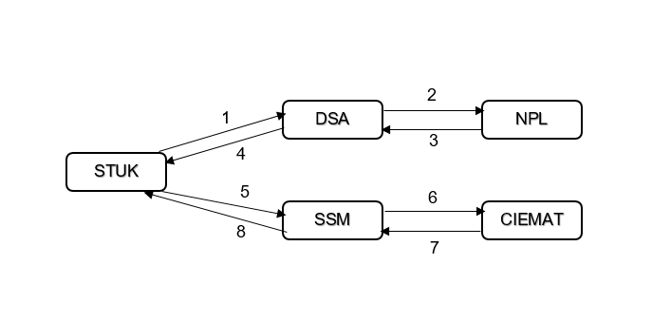
Figure 1. Schematic illustration of the comparison course.

Table 5. Proposed comparison events.
Event | Due date
Comparison measurements (see table 4) | June 2024 – January 2025
Final due date for STUK results to BIPM | October 1st, 2024
Earliest results to be submitted to STUK | October 3st, 2024
Chamber stability measurement reported (from STUK to SSM) | February 1th, 2025
Draft A delivered to participants | March 31st, 2025
Comments by the participants to draft A | April 31st, 2025
Draft B available | June 30th, 2025
Final report available | Depending upon comments by evaluators

References
Bass, G A; Duane, S; Homer, M J; Kelly, M; Manning, J W; Maughan, D J; Nutbrown, R F; Sander, T; Shipley, D R; Snaith, J A D (2019) The NPL Air Kerma Primary Standard PS5-1/PS5-2 for 137CS and 60CO: Summary Of Factors Including ICRU 90 Recommendations. NPL Report. IR 53
Bass, G A; Duane, S; Kelly, M; Manning, J W; Maughan, D J; Nutbrown, R F; Sander, T; Shipley, D R The NPL Air Kerma Primary Standard Free-Air Chamber for Medium Energy X-rays: Summary of Factors Incorporating ICRU Report 90 Recommendations. NPL Report. IR 54, 2019b
BIPM, rapport BIPM-2018/06, Kessler C and Burns DT, measuring conditions and uncertainties for the comparison and calibration of national dosimetric standards at the BIPM
BIPM, Technical Protocol for ongoing BIPM Dosimetry comparisons, date of issue: 20130129, https://www.bipm.org/kcdb/comparison/doc/download/62/bipm-dosimetry_technical_protocol.pdf

CCRI(I)/17-09, Burns DT, Butler D, Updated report on the evaluation of degrees of equivalence in regional dosimetry comparisons, May 2017

CIPM MRA-G-11, Measurement comparisons in the CIPM MRA
Guidelines for organizing, participating and reporting, version 1.1, 18/01/2021 https://www.bipm.org/documents/20126/43742162/CIPM-MRA-G-11.pdf/9fe6fb9a-500c-9995-2911-342f8126226c

Cornejo Díaz N. A., New LMRI-CIEMAT primary standard for ¹³⁷Cs air-kerma. Measurement 188 (110374) 2022.

Cornejo Díaz N, García Mulas C, Avilés Lucas P, Embid Segura M, Respuesta relativa de la cámara de ionización PTW 32002 (00345) a la calidad del ⁶⁰Co respecto a la calidad del ¹³⁷Cs para la magnitud kerma en aire. DT-LMRI-2402. CIEMAT, 2024.

ICRU Report 85a, Fundamental Quantities and Units for Ionizing Radiation (revised). Journal of the ICRU Vol 11 No 1 (2011) Report 85.
https://www.icru.org/report/fundamental-quantities-and-units-for-ionizing-radiation-icru-report-85a-revised/

ICRU, ICRU Report 90, Key Data For Ionizing-Radiation Dosimetry: Measurement Standards And Applications, https://www.icru.org/report/icru-report-90-key-data-for-ionizing-radiation-dosimetry-measurement-standards-and-applications/

ISO 4037-1:2019 Radiological protection X and gamma reference radiation for calibrating dosemeters and doserate meters and for determining their response as a function of photon energy. Part 1: Radiation characteristics and production methods

ISO 4037-2:2019 X and gamma reference radiation for calibrating dosemeters and doserate meters and for determining their response as a function of photon energy
Part 2: Dosimetry for radiation protection over the energy ranges from 8 keV to 1,3 MeV and 4 MeV to 9 MeV

JCGM (Joint Committee for Guides in Metrology). Evaluation of measurement data – Guide to the expression of uncertainty in measurement. JCGM 100:2008, GUM 1995 with minor corrections. First edition, September 2008.

Appendix I: Complete addresses of the participants (used for shipment)

CIEMAT/Spain
Postal address:
Laboratorio de Metrología de Radiaciones Ionizantes (LMRI)
Centro de Investigaciones Energéticas, Medioambientales y Tecnológicas (CIEMAT)
Avenida Complutense 40
28040, Madrid
Spain

Contact person: Néstor Armando Cornejo Díaz
Tel: +34 91 3466288
e-mail: nestorarmando.cornejo@ciemat.es

NPL/United Kingdom
Postal address:
National Physical Laboratory
Hampton Road
Teddington
Middlesex
TW11 0LW
UK

Contact person: Martin Kelly
Tel: +44 20 8943 8502
e-mail: martin.kelly@npl.co.uk

DSA / Norway
Postal address:
Norwegian Radiation Protection Authority (DSA)
Department of Emergency Preparedness and Response
Grini Næringspark 13
NO-1361 Østerås
Norway

Contact person: Per Otto Hetland
Tel: +47 45 44 56 97
e-mail: per.otto.hetland@dsa.no

SSM / Sweden
Postal address:
Swedish Radiation Safety Authority (SSM)
Riksmätplatsen
Solna Strandväg 122
171 54 SOLNA
Sweden

Contact person: Linda Persson
Tel: +46 70 917 66 71
e-mail: Linda.Persson@ssm.se

STUK / Finland
Radiation and Nuclear Safety Authority (STUK)
Radiation Metrology Laboratory
Jokiniemenkuja 1
01370 Vantaa
Finland

Contact person: Jussi Huikari
Tel: +358 40822 5559
e-mail: jussi.huikari@stuk.fi

Appendix II. Pictures of transfer chambers.
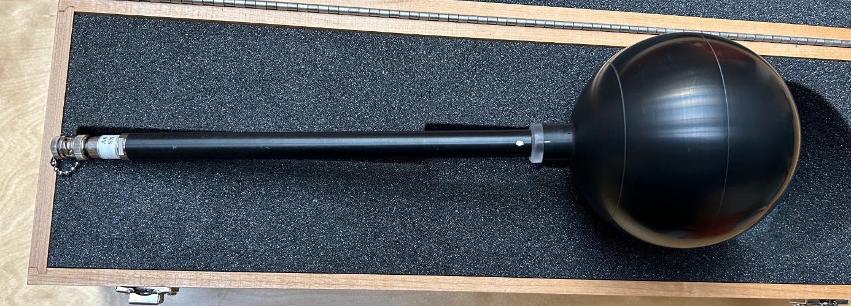
Figure of Exradin A6 XQ152602. The white dot is showing the reference direction of the chamber.
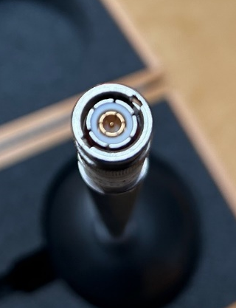
Figure of connector on Exradin A6 XQ152602

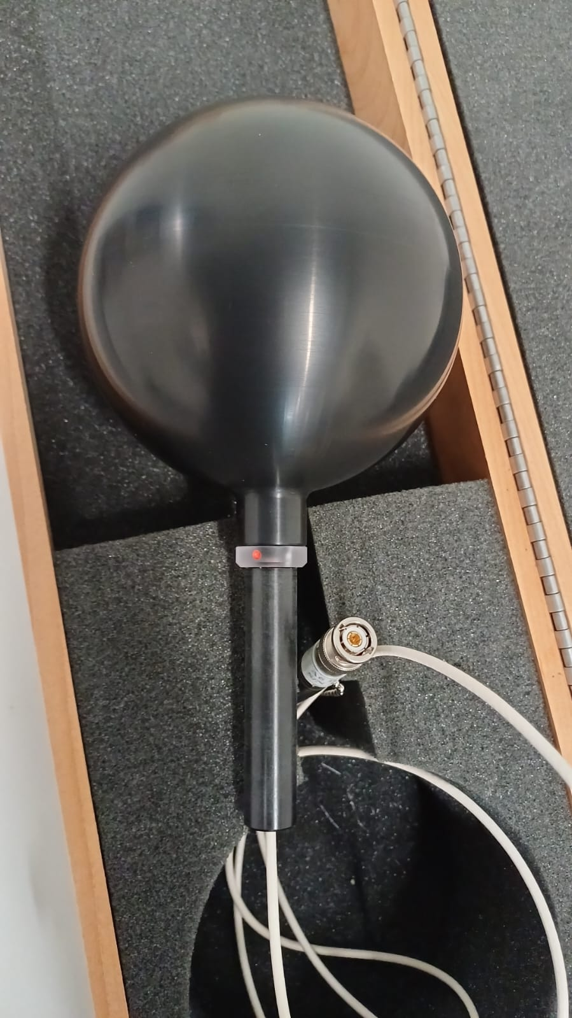
Figure of Exradin A6, sno XQ200282. The red dot is showing the reference direction of the chamber.

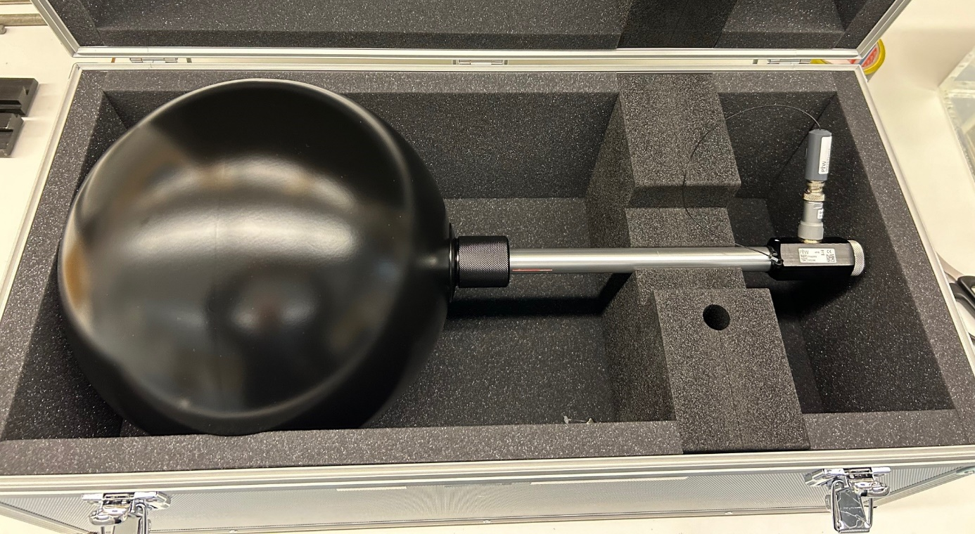
Figure of PTW 32003 s/n00296 The red mark on the stem is showing the reference direction of the chamber.

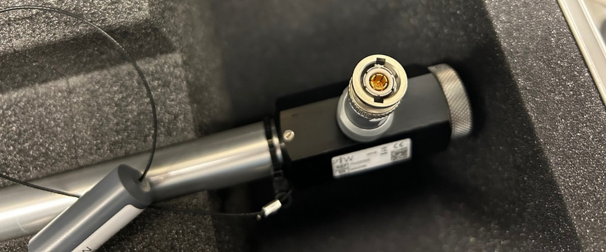
Figure of PTW 32003 s/n00296 connector

