DRAFT

**No. 892/RU-a/23**

**Supplementary comparison in the field of mass measurements in the range from 1 mg to 5 kg**

**COOMET.M.M-XX**

**Technical Protocol**

**Pilot Laboratory:**

D.I. Mendeleyev Institute for Metrology (VNIIM)

**Contact person:**

Viktoria I. Bogdanova

Deputy Head

Laboratory of Mass and Force

19, Moskovsky Ave.

190005 St. Petersburg

Russia

Tel.: +7 (812) 323-9685

E-mail: [v.i.bogdanova@vniim.ru](mailto:v.i.bogdanova@vniim.ru)

**1 INTRODUCTION**

COOMET.M.M-XX (892/RU-a/23) comparison is carried out by the decision of the 27th meeting of the COOMET TC 1.6.

Weights with nominal masses of 1 mg, 10 mg, 100 mg, 1 g, 10 g, 100 g, 1 kg, and 5 kg, made of stainless weak-magnetic steel are used as the transfer standard.

During the comparison, the participants are to determine the actual mass of the weight and its expanded uncertainty. D.I. Mendeleyev Institute for Metrology (hereinafter – VNIIM) is the Pilot Laboratory. Weights with nominal masses of 1 mg, 10 mg, 100 mg, 1 g, 10 g, 100 g, 1 kg, and 5 kg were provided by VNIIM as the transfer standard.

**2 PURPOSE OF PROTOCOL**

Purpose of this document is the following:

* to organize the comparison,
* to instruct the participants on transporting the transfer standard and processing measurement results,
* to specify the way of expression the measurement results.

**3 PARTICIPANTS**

Seven National metrology Institutes (NMIs) – members of the COOMET take part in the supplementary comparison. The participants are listed in Table 1.

Table 1. Participating NMIs.

| **NMI** | **Abbreviation** | **Contact person** |
| --- | --- | --- |
| **D.I. Mendeleyev Institute for Metrology**  19, Moskovsky Ave.  190005 St. Petersburg,  Russia | VNIIM | Viktoria Bogdanova  **E-mail:** [v.i.bogdanova@vniim.ru](mailto:v.i.bogdanova@vniim.ru)  Yuri Kamenskikh  **Email:** [v.i.bogdanova@vniim.ru](mailto:v.i.bogdanova@vniim.ru)  **Address:** 19, Moskovsky Ave.  St. Petersburg 190005, Russia  **Tel.:** +7 812 3239685 |
| **Belarusian State Institute for Metrology**  93, Starovilensky tract  220053 Minsk,  Belarus  Tel.: +375 17 3745501  Fax: +375 17 2449938 | BelGIM | Natalia Kamkova  **E-mail:** [kamkova@belgim.by](mailto:kamkova@belgim.by)  **Address:** 93, Starovilensky tract  220053 Minsk, Belarus  **Tel.:** +375 17 3574877 |
| **Center for Standardization and Metrology**  197, Panfilova Str.  720040 Bishkek,  Kyrgyzstan  Tel.: +996 312 62 37 90  Fax: +996 312 66 13 67  E-mail: [nism@nism.gov.kg](mailto:nism@nism.gov.kg)  Website: www.nism.gov.kg | Kyrgyzstandart | Ekaterina Kotova  **E-mail:** [kakotova@inbox.ru](mailto:kakotova@inbox.ru)  [e.kotova@nism.gov.kg](mailto:e.kotova@nism.gov.kg)  **Address:** 197, Panfilova Str.  720040 Bishkek, Kyrgyzstan  **Tel.:** +996 312 66 02 38  +996 555 49 10 97 |
| **Uzbek National Institute for Metrology**  333A, Farobiy Str.  100174 Tashkent, Uzbekistan  Tel.: +998 712020011(1200)  E-mail: [info@nim.uz](mailto:info@nim.uz)  Website: www.nim.uz/ru | UzNIM | Natalia Farkhodova  **E-mail:** [cms@nim.uz](mailto:cms@nim.uz)  [farhodovanatalya@gmail.com](mailto:farhodovanatalya@gmail.com)  **Address:** 333A, Farobiy Str.  100174 Tashkent, Uzbekistan  **Tel.:** +998 78 1502614 |
| **Agency for Standardization, Metrology, Certification and Trade Inspection under the Government of the Republic of Tajikistan**  42/2, N. Karabaeva Str.  734018 Dushanbe,  Tajikistan | Tajikstandart | Musalama Khudoieva  **E-mail:** [mkhudoieva@inbox.ru](mailto:mkhudoieva@inbox.ru)  **Address:** 42/2, N. Karabaeva Str.  734018 Dushanbe, Tajikistan |

**4 ORGANIZATION OF COMPARISON**

Each Participant is responsible for transporting the transfer standard to the next Participant of the Pilot Laboratory in accordance with the Comparison Schedule (Table 2), as well as for the proper customs paperwork. The transfer standard must be handed over by a courier company or an NMI employee.

Each Participant bears its own costs for shipping the standard to the next Participant and any customs costs in its own country.

Each Participant must have insurance covering any damage or loss in its country or while shipping the transfer standard to the next Participant.

Before shipping, each Participant must inform the Pilot Laboratory and provide transporting information. Each Participant must be informed on the arrival of the transfer standard at least a week in advance.

Any circumstances to which the transfer standard is exposed during transportation that may affect the comparison results must be reported to the Pilot Laboratory at the first opportunity.

Upon reception, the transfer standard must be inspected, and any scratches or other damages to the surface must be recorded in the Transport Standard Visual Inspection Form provided in Appendix A. The Form then must be sent to the Pilot Laboratory within 24 hours of inspection.

**4.1 Comparison scheme and schedule**

The scheme of conducting the comparison is mixed. Shipping of the transfer standard should follow the schedule presented in Table 2.

Table 2. Comparison schedule.

|  |  |  |  |
| --- | --- | --- | --- |
| **NMI** | **Arrival** | **Departure** | **Year** |
| VNIIM | — | May | 2024 |
| BelGIM | June | July/August | 2024 |
| VNIIM (stability control) | July/August | August/September | 2024 |
| Kyrgyzstandart | August/September | September/October | 2024 |
| VNIIM (stability control) | October/November | October/November | 2024 |
| UzNIM | October/November | November/December | 2024 |
| Tajikstandart | December/January | December/January | 2024 |
| VNIIM (stability control) | January | — | 2025 |

Note: The dates are approximate. If necessary, the schedule can be adjusted.

**4.2 Transfer standard**

**4.2.1 Description of transfer standard**

For the comparison, weights with nominal masses of 1 mg, 10 mg, 100 mg, 1 g, 10 g, 100 g, 1 kg, and 5 kg, are used as transfer standards. Gram and kilogram weights are made from a single piece of stainless steel and are cylindrical in shape (OIML shape) with a head marked DIM at the top (Figure 1). Milligram weights have a triangle wire shape (OIML shape) (Figure 2). Transfer standards are stored in a wooden case (Figure 3). The case is placed in a shock-resistant transport case (Figure 4) with overall dimensions 577×456×289 cm. Gross weight – 19 kg.

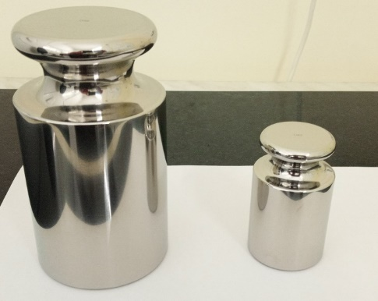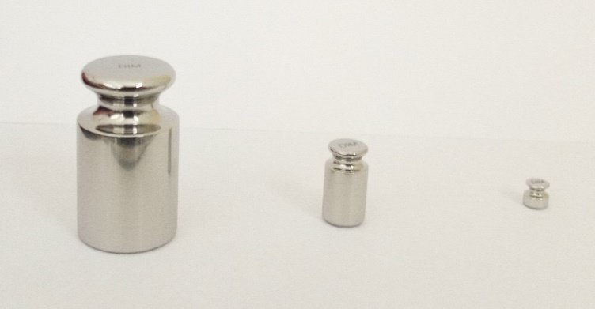

Figure 1. Overall view of kilogram and gram weights.

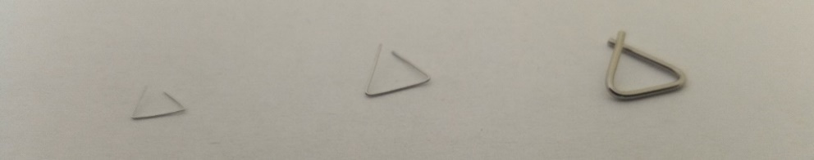

Figure 2. Overall view of milligram weights.

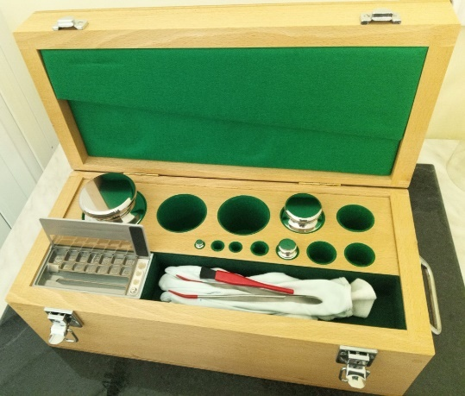

Figure 3. Overall view of the transfer standard in the wooden case.

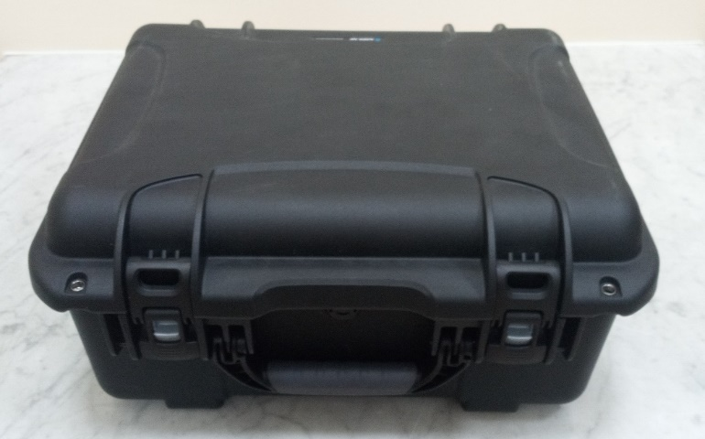

Figure 4. Overall view of the transport case.

**4.2.1 Technical characteristics of transfer standard**

Before the comparison begins, measurements of volume, density, and magnetic properties of weights were carried out in VNIIM. This data is given in Table 3.

Table 3. Technical characteristics of the transfer standard.

|  |  |  |  |  |  |
| --- | --- | --- | --- | --- | --- |
| Nominal | Volume1) *V*, cm3, at  *t* = 20 °C | Expanded uncertainty of volume measurements, UV,  (*k* = 2), cm³ Uv (k=2), см³ | Density 1) at *t* =20 °С and expanded uncertainty of density value  (*k* = 2), kg/m3 | | Magnetic  susceptibility2) |
| 1 mg | — | — | 2700 | 130 | — |
| 10 mg | — | — | 7950 | 140 | — |
| 100 mg | — | — | 7950 | 140 | — |
| 1 g | 0,128 | 0,002 | 7841,82 | 126,66 | 0,0034 |
| 10 g | 1,258 | 0,002 | 7947,85 | 13,01 | 0,0032 |
| 100 g | 12,507 | 0,002 | 7995,37 | 1,33 | 0,0033 |
| 1 kg | 125,385 | 0,005 | 7975,468 | 0,305 | 0,0034 |
| 5 kg | 627,094 | 0,014 | 7973,286 | 0,173 | 0,0036 |
| 1)Values for weights of 1g – 5 kg are provided by the Pilot laboratory (VNIIM); values for weights of  1 mg-100 mg are given according to the manufacturer.  2) The value was measured using a magnetic susceptibility meter (Sartorius, Model: YSZ02C, Germany). | | | | | |

To determine the stability of the transfer standard, mass of the weights will be measured in the Pilot Laboratory at least three times: at the beginning, in the middle, and at the end of the comparison.

**4.3 Comparison scheme and schedule**

**4.3.1 Unpacking procedure**

Temperature stabilization in the transport case for 1 day is required; then the weights are unpacked, inspected, and placed under a glass cover or inside a comparator for further temperature stabilization. If the transport case or weights are damaged or there are signs of external tampering (weights are damaged and/or there are fingerprints or any other traces of contamination on the surface), the Participant must notify the Pilot Laboratory within 24 hours of detecting signs of damage. After receiving notification from the Participant, the Pilot Laboratory informs the Participant about further actions.

Upon receiving the transfer standard, the Participant fulfils the Transport Standard Visual Inspection Form provided in Appendix A of this technical Protocol and sends the Form to the Pilot Laboratory within 24 hours of receiving the transfer standard.

**4.3.2 Packing procedure**

The weights must be placed back in the wooden case that then is placed into the transport case. The weights must be securely fixed in their seats so they will not move during transportation. If necessary, tight fit can be achieved using tissue paper. The transport case is supplemented with an official letter from the NMI stating that the transport case can be opened by the customs service only in the presence of a Participant laboratory’s employee.

Upon the measurements completion, the Participant must package the transfer standard and ship it to the next Participant in accordance with the schedule given in Table 2.

The Participant must inform the Pilot Laboratory by email about the shipping within 24 hours of sending.

**5 MEASUREMENT PROCEDURE**

**5.1 Handling of transfer standard**

5.1.1 All manipulations with the weights are carried out using tweezers or other suitable equipment or while wearing gloves. Avoid touching the surface of the weights with bare hands.

5.1.2 When no measurements are performed, the weights must be stored in a place protected from dust, moisture and condensation, aerosols, and vapors, for example, under a glass cover.

**5.2 Preparing for measurements**

5.2.1 Before taking measurements, the weights can be cleaned of dust with a soft brush or lint-free cloth. DO NOT USE alcohol, water, or any other solvents.

5.2.2 Measurements are performed after temperature stabilization of the weights. Before taking measurements, the weights must be kept in normal conditions, sufficient for their temperature stabilization (for at least 5 days after arrival).

**5.3 Conditions for measurements**

Condition for conducting measurements are as follows:

* ambient temperature: from 18 to 25 °C,
* relative humidity: from 40 to 60 %,
* temperature and relative humidity fluctuations should not exceed values specified in Table C.1 of Appendix C of the GOST OIML R 111-1–2009 for weights of class E1.

**5.4 Conducting measurements**

Measurements should be taken after an appropriate acclimatization time, and in accordance with one's own weighing procedure. The results must be recorded in the forms attached (Appendix B).

Participants must determine the mass of the transfer standard. Correction for buoyancy is mandatory.

To correct for buoyancy, air density should be determined using the CIPM 2007 formula or an approximation formula. The Participant must indicate the formula used in their report.

**5.5 Measurement equations**

To estimate the mass of the test weight (transfer standard), it must be compared with the reference standard weight or a sum of standard weights using a comparator. The direct comparison method or the subdivision method can be used. It is recommended to use subdivision, for which the measured weights are introduced into the Participant’s set. Estimation of the actual mass is carried out in accordance with the procedure given in [1, 2].

The mass value *m*t of the test weight is determined taking into account the correction for air buoyancy in accordance with the following formula:

$m_{t}=m_{r}+\overline{Δm}$ (1)

where $\overline{Δm}=\frac{1}{n}\sum_{i=1}^{n}{Δm_{i}}$, (2)

$Δm_{i}=ΔI_{i}+m_{r}C_{i}=ΔI_{i}+m_{r}ρ_{ai}\left(\frac{1}{ρ_{t}}-\frac{1}{ρ_{r}}\right)$, (3)

$C_{i}=\left(ρ_{ai}-ρ_{0}\right)\left(\frac{1}{ρ_{t}}-\frac{1}{ρ_{r}}\right)$, (4)

or $Δm_{i}=ΔI_{i}+ρ_{ai}\left(V_{t}-V_{r}\right)$ (5)

Thus, the mass value *m*t of the test weight, taking into account the correction for air buoyancy, can be determined (through *ρ*t and *ρ*r) using the following formula:

$m_{t}=m_{r}+\frac{1}{n}\left[\sum_{i=1}^{n}{ΔI_{i}+\left\{m_{r}ρ_{ai}\left(\frac{1}{ρ_{t}}-\frac{1}{ρ_{r}}\right)\right\}}\right]$, (6)

or (through *V*t and *V*r) using the following formula:

$m_{t}=m_{r}+\frac{1}{n}\left[\sum_{i=1}^{n}{ΔI_{i}+ρ_{ai}\left(V_{t}-V_{r}\right)}\right]$. (7)

**5.6 Uncertainty budget for weight’s mass value**

Estimation of the uncertainty of mass measurements can be carried out in accordance with Appendix C of the GOST OIML R 111-1–2009.

The expanded uncertainty *U*(m) of determining the mass of weights at the confidence level 0.95 is calculated by the following formula:

$U=k∙u_{C}$ (8)

To check the validity of the coverage factor choice, the effective degree of freedom *v*eff is calculated:

$ν_{eff}=(n-1)\frac{u_{c}^{4}(m_{t})}{u_{A}^{4}}$ (9)

If the effective degree of freedom is less than 50, then the coverage factor can be selected from the Table C.4 of the GOST OIML R 111-1–2009.

**5.7 Symbols**

|  |  |
| --- | --- |
| t | subscript for test weight |
| r | subscript for reference weight of the Participant |
| Δ*I* | indication difference of the balance, where Δ*I* = *I*t – *I*r |
| *m*t | mass of the test weight |
| *m*r | mass of the reference weight |
| $$\overline{∆m}$$ | average value of measurement results of mass difference of compared weights |
| Δ*m* | result of comparison of the test weight and reference weight in air |
| $$ΔI$$ | indication difference of the balance when comparing weigths |
| *ρ*a | air density |
| *ρ*t | density of the test weight |
| *ρ*r | density of the reference weight |
| *V*r | volume of the reference weight |
| *V*t | volume of the test weight |
| *u*c | standard uncertainty (1σ), “c” indicates the combined uncertainty |
| *U* | expanded uncertainty of the reference weight |

**6 REPORT FORM**

Forms from Appendix B (measurement results, environmental data during measurements, characteristics of the equipment used, information on traceability to the national measurement standard, and uncertainty budget) must be completed and sent to the Pilot Laboratory within 2 weeks of after completion of measurements. If necessary, the Participant can submit additional information that is not included in the Report Form.

**7 METHOD FOR ACCESSING MEASUREMENT RESULTS**

The Pilot Laboratory complies a report based on the measurement results submitted by the Participants. The results are processed in accordance with the COOMET Recommendation R/GM/11:2021 [3]. Further information on processing the measurement results will be given in the first draft of the report on the results of comparisons.

The Pilot Laboratory complies Draft A of the comparison report and sends it to the Participant for approval. Then the final draft of the report is compiled (Draft B), which will be submitted at the next meeting of the COOMET TC 1.6 “Mass and related quantities”. After COOMET TC 1.6 approves the report, it is sent to the COOMET Secretariat, as well as to the Working Group on Mass of the BIPM Consultative Committee.

**8 REFERENCES**

[1] M. Kochsiek, M. Glaser, “Comprehensive mass metrology”.

[2] OIML R 111–1:2004 Weights of classes E1, E2, F1, F2, M1, M1–2, M2, M2–3 and M3. Part 1: Metrological and technical requirements.

[3] COOMET R/GM/11:2021Regulations on Comparisons of. Measurement Standards of COOMET.

**9 LIST OF APPENDICES**

Appendix A. Transport Standard Visual Inspection Form

Appendix B. Measurement results, environmental data during measurements, characteristics of the equipment used, information on traceability to the national measurement standard, and uncertainty budget

The following documents were used in drawing up the Protocol:

COOMET R/GM/11:2021Regulations on Comparisons of. Measurement Standards of COOMET.

**APPENDIX A.** TRANSPORT STANDARD VISUAL INSPECTION FORM

|  |  |
| --- | --- |
| Laboratory: |  |
| Contact person: |  |
| Full postal address: |  |
| Phone: |  |
| Fax: |  |
| E-mail: |  |

|  |  |  |  |
| --- | --- | --- | --- |
| **Visual Inspection Form** | | | |
| Laboratory: |  | Date: |  |
| Date of arrival: |  | Where from: |  |
| State of the transfer standard | | | |
| State of the case: | | State of the transport case: | |
| State of the milligram weights:  1 mg : [*add description*]  10 mg : [*add description*]  100 mg : [*add description*] | | | |
| Additional notes: | | | |

Mark any damage to the surface of the weights (scratches, dirt, etc.) on the sketches, describe the state of transport cases, and send the Form to the Pilot Laboratory.

Please attach a photo of the transfer standard.

State of gram weights:

|  |  |  |
| --- | --- | --- |
| 1 g | 10 g | 100 g |
|  |  |  |

State of kilogram weights:

|  |  |
| --- | --- |
| 1 kg | 5 kg |
|  |  |

**APPENDIX B.** MEASUREMENT RESULTS, ENVIRONMENTAL DATA DURING MEASUREMENTS, CHARACTERISTICS OF THE EQUIPMENT USED, INFORMATION ON TRACEABILITY TO THE NATIONAL MEASUREMENT STANDARD, AND UNCERTAINTY BUDGET

|  |  |
| --- | --- |
| Laboratory: |  |
| Contact person: |  |
| Full postal address: |  |
| Phone: |  |
| Fax: |  |
| E-mail: |  |

|  |  |
| --- | --- |
| Date of arrival of the transfer standard: |  |
| Date of departure of the transfer standard: |  |
|  |  |
| Measurement start date: |  |
| Measurement end date: |  |

**Unusual environmental conditions during shipping or measurements** (if applicable):

**CALIBRATION RESULTS**

Please submit the results as *nominal mass (kg) + correction (mg)*

|  |  |  |  |  |  |  |  |
| --- | --- | --- | --- | --- | --- | --- | --- |
| Nominal mass value | Mass, mg  (*m*0 + Δ*m*) | Standard uncertainty of mass measurements, *u*, mg | Expanded uncertainty of mass measurements, *U*, mg | Coverage factor, *k* | Number of sets of measurements | Number of ABBA cycles | Mean-square deviation, mg (maximum value) |
| 1 mg |  |  |  |  |  |  |  |
| 10 mg |  |  |  |  |  |  |  |
| 100 mg |  |  |  |  |  |  |  |
| 1 g |  |  |  |  |  |  |  |
| 10 g |  |  |  |  |  |  |  |
| 100 g |  |  |  |  |  |  |  |
| 1 kg |  |  |  |  |  |  |  |
| 5 kg |  |  |  |  |  |  |  |

|  |  |  |  |  |  |  |
| --- | --- | --- | --- | --- | --- | --- |
| Name: |  |  | Signature: |  |  | Page __ of __ |

**MEASUREMENT EQUIPMENT**

**Details on the reference weights of the Participants used in the comparison**

|  |  |  |  |  |  |
| --- | --- | --- | --- | --- | --- |
| Symbol of the reference weight(s) | Mass | | Volume / density, cm3 / kg/m3 | | Measurement date  Traceability source |
| Value* | Standard uncertainty | Value | Standard uncertainty |
|  |  |  |  |  |  |
|  |  |  |  |  |  |
|  |  |  |  |  |  |
|  |  |  |  |  |  |
|  |  |  |  |  |  |
|  |  |  |  |  |  |
|  |  |  |  |  |  |
|  |  |  |  |  |  |
|  |  |  |  |  |  |
|  |  |  |  |  |  |

*Please submit the results as *nominal mass (kg) + correction (mg)*

**Mass comparator**

|  |  |  |  |  |
| --- | --- | --- | --- | --- |
| Manufacturer | Type | Discretization | MSD* | Degree of freedom |
|  |  |  |  |  |
|  |  |  |  |  |
|  |  |  |  |  |
|  |  |  |  |  |

* Please indicate the comparison scheme and number of cycles

**Please indicate the weighting method used**

|  |  |  |  |
| --- | --- | --- | --- |
| Direct comparisons |  | Subdivision |  |
|  | |  | |

|  |  |  |  |  |  |  |
| --- | --- | --- | --- | --- | --- | --- |
| Name: |  |  | Signature: |  |  | Page __ of __ |

**Environmental data during measurements[1]**

|  |  |
| --- | --- |
| **Parameter** | **Average value during measurements** |
| Air density (kg/m3) |  |
| Temperature (°C) |  |
| Pressure (kPa) |  |
| Humidity (%) |  |
| CO2 (x10-6) **[2]** |  |

**Characteristics of the equipment used for measuring the environmental conditions**

|  |  |  |  |  |  |  |
| --- | --- | --- | --- | --- | --- | --- |
|  | Unit | Manufacturer | Type | Range | Discretization | Standard uncertainty, *u* |
| Temperature, *t* | °C |  |  |  |  |  |
| Atmospheric pressure, *p* | Pa |  |  |  |  |  |
| Relative humidity, *hr* | % |  |  |  |  |  |
| Molar fraction of CO2  (if necessary) |  |  |  |  |  |  |

|  |  |  |  |  |  |  |
| --- | --- | --- | --- | --- | --- | --- |
| Name: |  |  | Signature: |  |  | Page __ of __ |

**UNCERTAINTY BUDGET**

The uncertainty must be calculated in accordance with GUM

|  |  |  |  |  |
| --- | --- | --- | --- | --- |
| **Uncertainty budget for milligram weights** | | | | |
| **Uncertainty component** | **Standard uncertainty of the component**  ***u*, mg** | | | **Notes** |
| **1 mg** | **10 mg** | **100 mg** |
| From the mass value of the reference standard, *u*(*m*r) |  |  |  |  |
| From the instability of the value of the reference standard, *u*v (*m*r) |  |  |  |  |
| From the weighting process, *u*A |  |  |  |  |
| Uncertainty due to off-center loading, *u*E |  |  |  |  |
| From the comparator display resolution (discretization), *u*d |  |  |  |  |
| Conditional sensitivity of the mass comparator, *u*s |  |  |  |  |
| From the used mass comparator, *u*ba |  |  |  |  |
| From air density fluctuations, *u*ρa |  |  |  |  |
| From the volume/density of weights, *u*Vr |  |  |  |  |
| Uncertainty of air buoyancy correction, *u*b |  |  |  |  |
| Other |  |  |  |  |
| Combined standard uncertainty, *u*c |  |  |  |  |
| Effective degree of freedom, *v*eff |  |  |  |  |
| Expanded uncertainty, *U* (k = ) |  |  |  |  |

Add rows if necessary

|  |  |  |  |  |  |  |
| --- | --- | --- | --- | --- | --- | --- |
| Name: |  |  | Signature: |  |  | Page __ of __ |

|  |  |  |  |  |
| --- | --- | --- | --- | --- |
| **Uncertainty budget for gram weights** | | | | |
| **Uncertainty component** | **Standard uncertainty of the component**  ***u*, mg** | | | **Notes** |
| **1 mg** | **10 mg** | **100 mg** |
| From the mass value of the reference standard, *u*(*m*r) |  |  |  |  |
| From the instability of the value of the reference standard, *u*v (*m*r) |  |  |  |  |
| From the weighting process, *u*A |  |  |  |  |
| Uncertainty due to off-center loading, *u*E |  |  |  |  |
| From the comparator display resolution (discretization), *u*d |  |  |  |  |
| Conditional sensitivity of the mass comparator, *u*s |  |  |  |  |
| From the used mass comparator, *u*ba |  |  |  |  |
| From air density fluctuations, *u*ρa |  |  |  |  |
| From the volume/density of weights, *u*Vr |  |  |  |  |
| Uncertainty of air buoyancy correction, *u*b |  |  |  |  |
| Other |  |  |  |  |
| Combined standard uncertainty, *u*c |  |  |  |  |
| Effective degree of freedom, *v*eff |  |  |  |  |
| Expanded uncertainty, *U* (k = ) |  |  |  |  |

Add rows if necessary

|  |  |  |  |  |  |  |
| --- | --- | --- | --- | --- | --- | --- |
| Name: |  |  | Signature: |  |  | Page __ of __ |

|  |  |  |  |  |
| --- | --- | --- | --- | --- |
| **Uncertainty budget for kilogram weights** | | | | |
| **Uncertainty component** | **Standard uncertainty of the component**  ***u*, mg** | | | **Notes** |
| **1 mg** | **10 mg** | **100 mg** |
| From the mass value of the reference standard, *u*(*m*r) |  |  |  |  |
| From the instability of the value of the reference standard, *u*v (*m*r) |  |  |  |  |
| From the weighting process, *u*A |  |  |  |  |
| Uncertainty due to off-center loading, *u*E |  |  |  |  |
| From the comparator display resolution (discretization), *u*d |  |  |  |  |
| Conditional sensitivity of the mass comparator, *u*s |  |  |  |  |
| From the used mass comparator, *u*ba |  |  |  |  |
| From air density fluctuations, *u*ρa |  |  |  |  |
| From the volume/density of weights, *u*Vr |  |  |  |  |
| Uncertainty of air buoyancy correction, *u*b |  |  |  |  |
| Other |  |  |  |  |
| Combined standard uncertainty, *u*c |  |  |  |  |
| Effective degree of freedom, *v*eff |  |  |  |  |
| Expanded uncertainty, *U* (k = ) |  |  |  |  |

Add rows if necessary

|  |  |  |  |  |  |  |
| --- | --- | --- | --- | --- | --- | --- |
| Name: |  |  | Signature: |  |  | Page __ of __ |

1. Please submit the average value for each parameter measured during the measurement process.
2. Please indicate if applicable.