**«PHOTOMETRY AND RADIOMETRY»**

**COOMET TECHNICAL COMMITTEE 1.7**

**Supplementary comparison**

**Wavelength of SPECTRALLY-SELECTIVE**

**TRANSMITTING MATERIAL**

[**COOMET.PR-S13**](https://kcdb.bipm.org/appendixB/KCDB_ApB_info.asp?cmp_idy=2752&cmp_cod=COOMET%2EPR%2DS11&page=1&search=1&cmp_cod_search=&met_idy=7&bra_idy=51&epo_idy=0&cmt_idy=2&ett_idy_org=3&lab_idy=&cou_cod=UA)

**(COOMET project 878/RU/23)**

**Technical protocol**

**2024**

**Moscow**

Table of Contents

Table of Contents 2

1 Introduction 3

2 Organisation 3

2.1 Participants 3

2.2 Participant Details 3

2.3 Form of Comparison 5

2.4 Timetable 4

2.5 Handling the artefacts 5

2.6 Transportation of artefacts 7

3 Description of the artefacts 6

4 Measurement instructions 6

4.1 Traceability 6

4.2 Measurand 6

4.3 Measurement instructions 8

5 Measurement uncertainty 8

6 Reporting of results 9

6.1 Submitting measurement results 9

6.2 Pre-Draft A process 9

6.3 Preparation, distribution and review of the Draft A 10

6.4 Draft B 10

References 10

Appendix A.1 Description of measurement facility and measurement method 11

Appendix A.2 Measurement results 12

Appendix A.2 - 1 Type B uncertainty budget(a) 13

Appendix B.1 Receipt of artefacts 14

Appendix B.2 Condition of the transfer standards on departure 15

Appendix B. 3 Confirmation of transfer standards receipt 16

1. Introduction
   * 1. The purpose of this comparison is to determine the metrological equivalence of national measurement standards of participants in the field of spectrophotometric wavelength measurements.
     2. The comparison will support the following CMCs from the Classification of Services in Photometry and Radiometry :

4.15.0 Spectrally-selective transmitting material: wavelength / wavenumber range, bandwidth

1. Organisation
   1. Participants
      * 1. VNIIOFI (Russian Federation) was appointed to act as a pilot laboratory in this comparison.
        2. Other participants of the comparison are listed in section 2.2.
        3. Each participant must be able to demonstrate traceability to its own   
           independent realization of the units of wavelength or make clear the route of traceability of its measurements to the quantity via another named laboratory.
        4. All participants shall meet the terms and requirements stipulated in CCPR documents related to key and supplementary comparisons as well as terms and requirements provided in this technical protocol.
        5. This technical protocol has been drawn up by the pilot laboratory, agreed by all the participants, and approved by COOMET TC1.7. The protocol will be sent to CCPR WG-KC for review and comments. The protocol covers the technical procedure to be followed during measurement of transfer standards within this comparison.
        6. Once the technical protocol has been approved, no amendments to the protocol may be made without prior agreement of all participants and the COOMET TC1.7.
   2. Participant Details

|  |  |  |  |
| --- | --- | --- | --- |
| **Laboratory Name** | **Acronym** | **Address /Country** | **Contact person** |
| All-Russian Research Institute for Optical and Physical Measurements | **VNIIOFI (Pilot)** | 46 Ozernaya st., 119361 Moscow,  **Russia** | **Aleksandr Dunaev**  [dunaev@vniiofi.ru](mailto:dunaev@vniiofi.ru)  Phone: +7 495 437-37-00  Fax: +7 495 437-29-92 |
| Belarusian State Institute of Metrology | **BelGIM** | 93 Starovilensky trakt, 220053 Minsk,  **Republic of Belarus** | **Ivan Korseko**  [optic@belgim.by](mailto:optic@belgim.by)  Phone: +375 17 365 50 61  Fax: +375 17 233 57 99 |
| Kazakhstan Institute of Standartization and Metrology | **Kazstandart** | 11, Mangilyk El, Astana, 010000, **Kazakhstan** | **Natalya Vyrodova**  [n.vyrodova@ksm.kz](mailto:n.vyrodova@ksm.kz)  Phone: +7 701 487 50 74  **Valery Belousov**  [v.belousov@ksm.kz](mailto:v.belousov@ksm.kz)  Phone: +7 701 440 56 84 |
| Uzbek National Institute of Metrology | **UzNIM** | 100049 Tashkent Almazor, Farobiy street, 333 A, **Uzbekistan** | **Kamoliddin Najmutdinov**  koma050585@mail.ru  **Jamol Rustamov**  [rustamov@nim.uz](mailto:rustamov@nim.uz)  Phone: +99 878 150 26 03 |

* 1. Form of Comparison
     + 1. The comparison will principally be carried out through calibration of artefact glass filter. Detailed description of the artefact is provided in the section 3 of this Technical Protocol.
       2. Set of two filters will be used in the comparisons. The pilot laboratory will measure both filters two times. Each of the other participants will measure both filter one time. Therefore, the measurements will be performed in one route with the following sequence:

**Filter 1:** **VNIIOFI 🡪 BelGIM 🡪 UzNIM 🡪 KazStandart 🡪 VNIIOFI.**

* + - 1. Filters will initially be calibrated by the Pilot laboratory. Then they will be distributed to participants for calibration. When all participants’ measurements are completed, set will be returned to the Pilot who will carry out a repeat measurement for verification of the artefact stability.
      2. Each participant has 2 months for calibration and transportation of the artefact.
      3. If for some reason, the measurement facility is not ready or customs clearance takes too much time in a country, a participant must contact the Pilot immediately to discuss the further steps and possible correction of the comparison schedule.
  1. Timetable

| **Activity** | **Date** |
| --- | --- |
| Registering comparison at KCDB | March 2024 |
| First measurement by the pilot laboratory | March 2024 |
| Measurements at BelGIM | April 2024 to June 2024 |
| Measurements at UzNIM | July 2024 to September 2024 |
| Measurements at Kazstandart | October 2024 to December 2024 |
| Final measurement by the pilot laboratory | January 2025 |
| Pre-Draft A start | February 2025 |
| Distribution of Draft A | March 2025 |
| Submission of Draft B | April 2025 |

* + - 1. Upon completion of the measurement, each participant must submit a measurement report to the pilot laboratory within 8 weeks.
      2. When all measurements are completed, the participants will be given a deadline date for submitting the results, and if they do not meet the deadline, they might be disqualified.
      3. If, for any reasons, a participant is unable to carry out measurements on time, or customs procedures take too long, the participant should immediately contact the pilot laboratory to discuss next steps and probable changes in the comparison schedule. In case of failure to meet these terms, the participant might be excluded from the comparison. Exclusion may also occur if the results are not submitted within the agreed timeframe without an approved excuse from the pilot laboratory.
  1. Handling the artefacts
     + 1. The artefact should be examined immediately upon receipt at final destination. The condition of the artefacts and associated packaging should be noted. The form in Appendix B.1 should be filled in and sent to the pilot laboratory via email.
       2. The artefact should only be handled by authorized persons wearing lint-free gloves.
       3. The artefact should be stored in such a way as to prevent damage.
       4. Cleaning should not be carried out unless there is clear evidence of filter contamination. Dust could be removed with a stream of dry gas (avoid cans with liquid propellants). Should further cleaning be required, the laboratory should consult with the pilot laboratory.
       5. Cleaning must be indicated in the measurement report and documented using the form in Appendix B.2.
       6. If a filter appears damaged, a replacement may be available from the pilot laboratory.
       7. When the measurements are completed the form in Appendix B.2 must be filled in and forward (via email) to the pilot laboratory and the next participant.
  2. Transportation of artefacts
     + 1. It is of the utmost importance that the artefacts be transported in a manner in which they will not be lost, damaged or handled by unauthorised persons.
       2. The artefact packaging should be marked as “fragile”.
       3. If possible, the artefacts should be transferred as carry-on.
       4. Generally, the cost for transportation will be covers by the participant transporting the artefact to the next participant. For instance, the Pilot will cover the transportation cost to the first participants in each rout. However, if further transportation will be performed via the Pilot, a participant may be requested to cover the costs of both ways transportation: from the Pilot and back to the Pilot (or to the next participant).
       5. Each participating laboratory covers the costs for its own measurements, transportation and any customs charges as well as for any damage that may have occurred within its country.

1. Description of the artefacts
   * 1. The set of artefacts consists of two filters made of PS-7 glass and neodymium gallium crystal (NGG). Size of the filters is 12 mm × 12 mm × 44 mm. Filter of PS-7 glass is marked as “PV C7 №34” on the top of filter. Filter of NGG is marked as “НГГ” on the top of filter The filters are shown on fig.

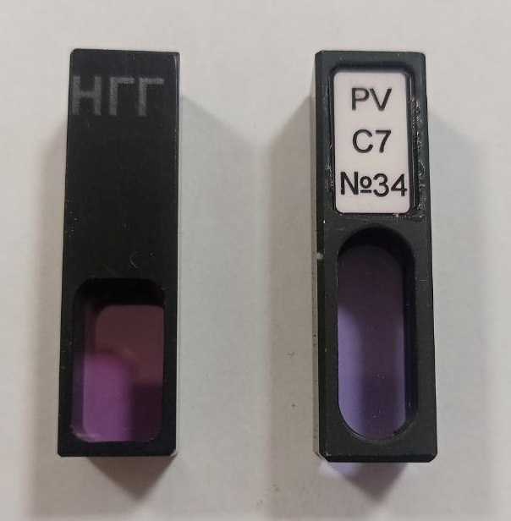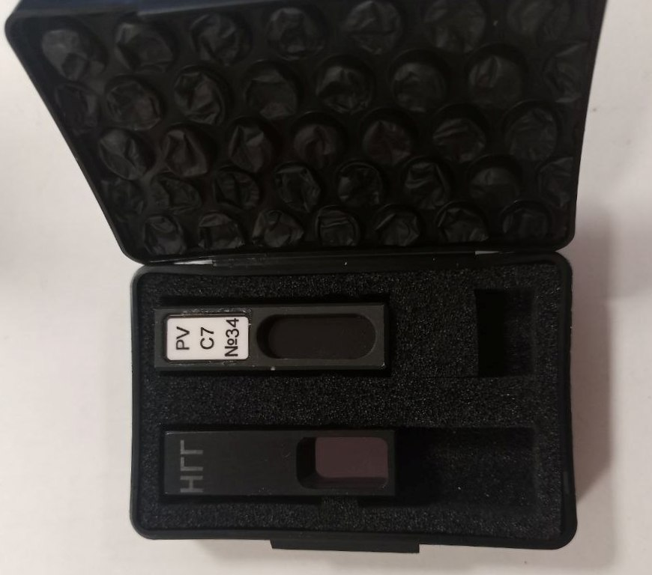

Fig. Filters and its box

1. Measurement instructions
   1. Traceability
      * 1. Wavelength measurements should be traceable to the latest realisation of the metre.
   2. Measurand
      * 1. The measurand is the values of the wavelengths of the minimum transmittances in the regions of next nominal wavelengths:

|  |  |  |  |
| --- | --- | --- | --- |
| PS-7 filter | | NGG filter | |
| Absorption band | Nominal wavelength, nm | Absorption band | Nominal wavelength, nm |
| A1 | 328 | B1 | 262 |
| A2 | 351 | B2 | 264 |
| A3 | 431 | B3 | 292 |
| A4a | 473 | B4 | 365 |
| A5 | 478 | B5 | 431 |
| A6 | 513 | B6 | 434 |
| A7 | 528 | B7 | 548 |
| A8 | 585 | B8 | 682 |
| A9 | 685 | B9 | 826 |
| A10 | 740 | B10 | 890 |
| A11 | 808 | B11 | 930 |
| A12 | 878 | B12 | 936 |
|  |  | B13 | 1572 |
|  |  | B14 | 1732 |
|  |  | B15 | 2297 |
|  |  | B16 | 2484 |

* for the area of the size 5 mm in width x 15 mm in height in the middle of the filter,
* at a temperature from 21 to 25 °C,

* 1. Measurement instructions
     + 1. Before measurement, filters should be inspected for damage or contamination. Any initial or subsequent damage or cleaning should be documented using the appropriate form in Appendix B.1 or B.2.
       2. The measurement should be performed in suitable laboratory accommodation maintained at a temperature as close as possible to 23 оС and at a relative humidity not exceeding 60% RH. The temperature and relative humidity of the laboratory during the time of the measurements should be reported.
       3. Filters have to be measured several times in all spectral ranges. The number of measurements used should be stated in the measurement report but only the mean or final declared value of the filter is required to be included.
       4. The light beam from the instrument lighting source shall fit into a spot of 5 mm × 15 mm locating at the centre of the filter (the filter type identifier must be located on the same face of the filter on which the radiation from the source falls and located in the upper right corner). When failed to do so, the participant shall indicate it in its measurement report. In that case the pilot laboratory may introduce a correction to compensate for the filter inhomogeneity.
       5. To determine the values of the wavelengths of the minimum transmittance of the filter, it is necessary to measure the transmittance of the filter in the spectral ranges specified in paragraph 4.2.1.
       6. The spectral bandwidth (SBW) for PS-7 wavelength measurements should be no more than 0.5 nm;
       7. The spectral bandwidth (SBW) for NGG wavelength measurements should be:
* no more than 0.25 nm for the 250-780 nm spectral range;
* no more than 1.0 nm for the 780-1000 nm spectral range;
* no more than 2.0 nm for the 1000-2500 nm spectral range;
  + - 1. Data interval for PS-7 and NGG wavelength measurements should be not more than 0.1 nm. The spectral range, the data interval and the bandwidth should be stated in the measurement report.
      2. No information relating to the comparison, such as measurement results, obtained by a participant during the course of comparison shall be communicated to any parties other than the pilot laboratory. The pilot laboratory will be responsible for disseminating information to other participant and any other release of information. In the latter case the pilot laboratory will seek permission of all participants before releasing any information.

1. Measurement uncertainty
   * 1. Measurement uncertainty shall be estimated according to the ISO Guide to the Expression of Uncertainty in Measurement (<https://www.bipm.org/utils/common/documents/jcgm/JCGM_100_2008_E.pdf>).
     2. In order to achieve optimum comparability, a list containing the principal influence parameters for calibration of wavelengths is given below. The participating laboratories are encouraged to follow this breakdown as closely as possible, and adapt it to their instruments and procedures if necessary. Other additional parameters that seem appropriate can be added to the list. These include dependence on specific measurement facilities and should be added with an appropriate explanation and/or reference. As well the value associated with the uncertainty, participants should give an indication of the basis for their estimate. All values should be given as absolute uncertainties for a coverage factor of *k* = 1.
     3. The reproducibility of measurements can be determined by calculating the standard deviation of a set of measurements with realignment and repositioning of the filter between each individual measurement. It is this value which has to be taken into account for the uncertainty evaluated according the type A method.
     4. Type B uncertainty components may include the followings:

* Uncertainty of reference wavelength source
* Bandwidth
* Wavelength scale interpolation
* Wavelength scale extrapolation
* Beam size & position
* Absorption Bandshape of filter (identification of minimum transmittance)
* Shape of slit function
* Data spacing interval
* Temperature
* any other uncertainty components specific to the apparatus used for the measurements.

1. Reporting of results
   1. Submitting measurement results
      * 1. The final results should be submitted to the pilot laboratory at the latest within eight weeks from completion of measurements. The tables in appendices A.1 and A.2 should be completed and sent back electronically to the Pilot.

*In any case, the signed report including the results must also be sent in paper form by mail, and in PDF or JPG format of the signed report scanned and sent by e-mail.*

*In case of any discrepancies, the paper versions are considered to be the definitive version.*

* + - 1. In completing the description of the participant’s measurement facility, Appendix A.1, a schematic diagram of the facility should be included.
      2. Following receipt of all measurement reports from the participating laboratories, the pilot laboratory will follow the procedure outlined in the latest versions of the CCPR “Guidelines for RMO PR Supplementary Comparisons” (CCPR-G7) and the “Guidelines for CCPR Key Comparison Report Preparation” (CCPR-G2).
  1. Pre-Draft A process
     + 1. After completion of all measurements, sections 1, 2, 3, and 4 of the Guidelines for CCPR Comparison Report Preparation (CCPR-G2) must be followed by the pilot laboratory before preparing Draft A. The measurement results by participants cannot be revised after the Pre-Draft A process ended.
  2. Preparation, distribution and review of the Draft A
     + 1. After the Pre-Draft A process is completed, the pilot laboratory prepares and distributes Draft A to all the participants, which discloses the absolute results of the comparison with identification of all the participating labs.
       2. The Draft A should be distributed within 6 months after completion of all the measurements of the comparison.
       3. The results will be analysed basically following the *Guidelines for CCPR Comparison Report Preparation (CCPR-G2)*, but the procedures in the final steps for this (supplementary) comparison will be different. Because “KCRV” does not exist for supplementary comparisons, the resulting reference value will be simply called “Reference Value (RV)”. No Degrees of Equivalence will be presented in the report. The RV and the results of each participant with respect to the RV, and their uncertainties, will be presented.
       4. Draft A must be approved by all the participants. If necessary, revised documents (Draft A-1, A-2, …) will be distributed. The version finally approved by all the participants becomes Draft-B
  3. Draft B
     + 1. The Draft-B will be submitted to COOMET TC1.7 for review and approval. Then it is approved by TC, the Draft-B will be submitted to WG-KC Secretary (copy to WG-KC Chair) through the RMO PR TC Chair.

References

1. BIPM IEC ILAC IUPAP and OIML 2008 Guide to the Expression of Uncertainty in Measurement (Geneva: International Organization for Standardization

Appendix A.1 Description of measurement facility and measurement method

|  |  |
| --- | --- |
| Laboratory: |  |

**Table A-1 Details of Measurement Setup**

|  |  |
| --- | --- |
| Type of measurement facility |  |
| Source |  |
| Spectral device |  |
| Detector |  |
| Temperature (a) |  |
| Humidity |  |
| Beam Size |  |
| Measurement sequence(b) |  |

(a) i.e describe method of temperature monitoring of filter and range of temperatures;

(b) i.e describe number of measurements and whether filter orientation with respect to beam changes between measurements

If any damage, contamination or cleaning of filters was carried out, please give details

|  |  |  |  |
| --- | --- | --- | --- |
| Signature: |  | Date (dd/MM/yyyy): |  |

Appendix A.2 Measurement results

|  |  |  |
| --- | --- | --- |
| Laboratory: |  | |
| Address: |  | |
| Date of Measurement: | |  |

1. Measuring conditions:

|  |  |  |
| --- | --- | --- |
| 1.1 | Ambient temperature (oC): |  |
| 1.2 | Atmospheric pressure (kPa) |  |

1. Description and procedure of independent realization of the unit (or traceability of the results to another named NMI)
2. Description and diagram of the standard measuring instrument

Please reproduce the following table for the filters. All uncertainties should be reported as absolute measurement uncertainties

|  |  |  |  |  |  |  |  |
| --- | --- | --- | --- | --- | --- | --- | --- |
| Absorption band | λmeas, nm | N | Data interval, nm | SBW, nm | uA, nm | uB, nm | uc, nm |
| A1 |  |  |  |  |  |  |  |
| ... |  |  |  |  |  |  |  |
| A11 |  |  |  |  |  |  |  |
| B1a |  |  |  |  |  |  |  |
| B1b |  |  |  |  |  |  |  |
| ... |  |  |  |  |  |  |  |
| B14 |  |  |  |  |  |  |  |

Where

λmeas – measured wavelength of minimum transmittance, nm

N – number of measurements

uA – type A uncertainty

uB – type B uncertainty

uc – total uncertainty

(a) The uncertainty associated with the values attributed to reproducibility of the measurement.

(b) The uncertainty associated with the values attributed to all type B sources.

(c) The total of the measurement for a coverage factor of *k* = 1.

|  |  |  |  |
| --- | --- | --- | --- |
| Signature: |  | Date (dd/MM/yyyy): |  |

Appendix A.2 - 1 Type B uncertainty budget(a)

Fill out the table below for the uncertainty contributions in measurement. All uncertainties should be reported as absolute uncertainties.

|  |  |
| --- | --- |
| **Property** |  |
| Uncertainty of reference wavelength source |  |
| Bandwidth |  |
| Wavelength scale interpolation |  |
| Wavelength scale extrapolation |  |
| Beam size & position |  |
| Absorption bandshape |  |
| Shape of slit function |  |
| Data spacing interval |  |
| Temperature |  |
| Other |  |
| Total type B uncertainty (b) |  |

(a) Please record any uncertainties considered negligible as zero (rather than e.g \\ some value).

(b) Add lines to the table as necessary, itemizing other components of uncertainty considered

|  |  |  |  |
| --- | --- | --- | --- |
| Signature: |  | Date (dd/MM/yyyy): |  |

Appendix B.1 Receipt of artefact

|  |  |
| --- | --- |
| To Laboratory: |  |
| From Laboratory: |  |

**After visual inspection**

|  |  |  |  |
| --- | --- | --- | --- |
| Has the aftefact’ transportation package been opened during transit, e.g. by Custom authority?  Yes  No  If yes, please give details: | | | |
|  | | | |
| Is there any damage to the packaging?  Yes  No  If yes, please give details: | | | |
|  | | | |
| Are there any visible signs of damage or contamination on the filter?  Yes  No  If yes, please give details: | | | |
|  | | | |
| Signature: |  | Date (dd/MM/yyyy): |  |

Appendix B.2 Condition of the transfer standards on departure

|  |  |  |  |  |
| --- | --- | --- | --- | --- |
| Laboratory: | |  | | |
| Were the filter contaminated or damaged in any way while at your laboratory?   Yes  No  If yes, please give details: | | | | |
|  | | | | |
| Was any cleaning of filter undertaken while at your laboratory?  Yes  No  If yes, please give details: | | | | |
|  | | | | |
| Signature: |  | | Date (dd/MM/yyyy): |  |

Appendix B. 3 Confirmation of transfer standards receipt

**To:**

|  |  |  |  |  |  |
| --- | --- | --- | --- | --- | --- |
| From: | | | | | |
| *Please provide first and last name, company name and participant address, shipper name and transfer standard details.* | | | | | |
| We confirm, that we received transfer standard | | | | | |
| *Please provide your first and last name, your company name and address.* | | | | | |
| During visual check of transported standard it was revealed that: no damages were found.  Note: If damage persists, please provide details. | | | | | |
|  | | | | | |
| Signature: |  | / |  | Date (dd/MM/yyyy): |  |
|  |  |  | (signature, in letters) |  |  |