**Consultative Committee on Mass and Related Quantities (CCM)**

***Working Group on Gravimetry (WGG)***

**Comparison of Absolute Gravimeters**

**CCM.G-K2.2023 Key Comparison and Pilot Study (Additional Comparison)**

Table Mountain Geophysical Observatory (TMGO)

Boulder, Colorado

Pilot laboratory: NIST-Gaithersburg, MD USA

**Technical Protocol**

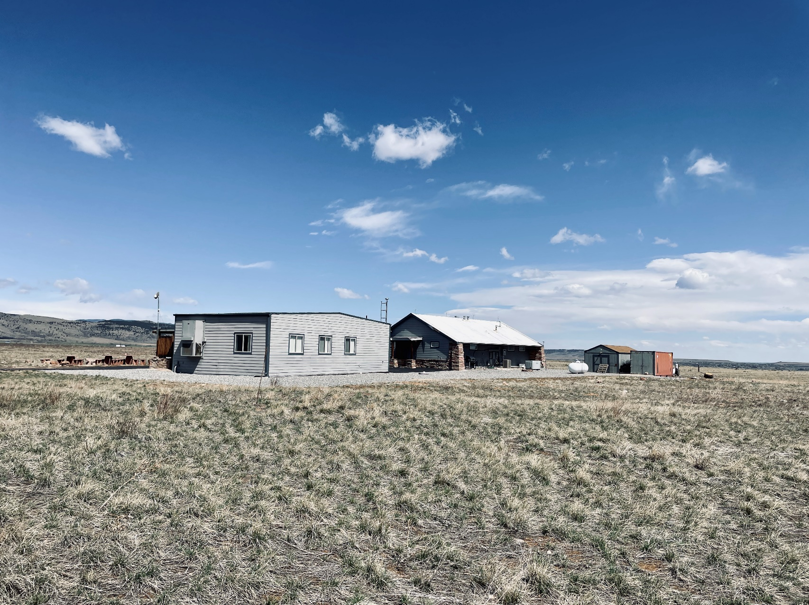

**IMPORTANT DEADLINES**

**We would like to present the results of the comparison as soon as possible. For that, we count on your collaboration to respect the different deadlines.**

**17 May 2023** Approbation of the Technical Report by all the CCM.G-K2.2023 participants.

**1 June 2023** Deadline for sending the completed form of **annex A** to the Local Organisation ([derek.vanwestrum.noaa.gov](mailto:olivier.francis@uni.lu)) and the Pilot Laboratory (david.newell@nist.gov)

**15 June 2023** Vertical gravity gradient measured at TMGO

**21 August – 29 September** Comparison of absolute gravimeters at TMGO

**2023**

**15 November 2023** Presentation of the results by the participants to the Local Organisation ([derek.vanwestrum.noaa.gov](mailto:olivier.francis@uni.lu)) and the Pilot Laboratory (david.newell@nist.gov) (**Annex B**)

**\*\*\*\*\***

**15 January 2024** Draft A (confidential) presented to the participants

**15 April 2024** Deadline for comments on Draft A

**15 May 2024** Draft B (public) and publication in Metrologia “Technical Supplement”

**Content**

1. Introduction 3

2. Participants 3

3. Measurand 6

4. Methods of measurement 6

5. Program of the measurements 7

6. Measurement timetable 8

7. Data report 9

8. Uncertainty evaluation 9

9. Frequency measurements during the comparison 11

10. Results elaboration 12

11. Visitor and Transportation Logistics 12

12. References 13

Annex A - Description of the absolute gravimeter 14

* (≈1.21 m for the FG5 and ≈1.27 m for the FG5-X), distance between benchmark and the effective position of free-fall, where g is invariant on vertical gravity gradient used in the equation of motion 14

Annex B - Report of measurement results 15

* (≈1.21 m for the FG5 and ≈1.27 m for the FG5-X), distance between benchmark and the effective position of free-fall, where g is invariant on vertical gravity gradient used in the equation of motionAnnex C - Example of calculation of uncertainty. 15

Annex D - Parameters of the TMGO site 19

# Introduction

The Key Comparison of Absolute Gravimeters and Pilot Study will be conducted at the Table Mountain Geophysical Observatory (TMGO), near Boulder, Colorado. The comparison is organized in accordance with the International Committee for Weights and Measures (CIPM) document CIPM MRA-G-11 of the Consultative Committee on Mass and Related Quantities (CCM) and is registered with the CIPM as CCM.G-K2.2023. All agencies with absolute gravimetric capabilities are welcome to participate in the comparison. The goals of the comparison are:

* To allow operators of absolute gravimeters to check that their meter operates properly by quantitative measures of the degree of equivalence of participating gravimeters.
* For the validation of the calibration and measurement capability (CMCs) published in the Key Comparison Data Base (KCDB).
* To support Kibble balance (KB) measurements currently being carried out at several metrology institutes in the world with relative uncertainty of less than 1×10-8 as a primary realization of the mass unit (kilogram) in the revised International System of Units (SI).
* To ensure scientific excellence and measurement of the gravity acceleration traceable to the SI at the level of uncertainty of few μGal (1 µGal = 1·10-8 m s-2) or better according to the principles of the CIPM MRA (Mutual Recognition Arrangement of national measurement standards and of calibration and measurement certificates issued by NMIs), for metrology (in particular for the realization of the kilogram) and geosciences (in particular for time variable gravity and gravity networks).

Only National Metrology Institutes (NMIs) that are signatories of the CIPM Mutual Recognition Arrangement (CIPM MRA), and laboratories officially designated by those institutes (DIs), can participate in the Key Comparison aspect of the project. Only their measurements can contribute to the evaluation of the Key Comparison Reference Values (KCRVs), and only their degrees of equivalence can be published in the Key Comparison Data Base (KCDB). However, non-designated institutes are welcome and encouraged to participate in the additional comparison, following the CCM-IAG Strategy [1]. All of the results–including those from non-NMI/DIs–will be the subject of a scientific publication in Metrologia.

The National Institute of Standards and Technology (NIST) has been accepted as the pilot Laboratory. Dr. David Newell will serve as the representative of the pilot laboratory (NIST), and Dr. Derek van Westrum of the National Oceanic and Atmospheric Administration National Geodetic Survey (NOAA-NGS) has agreed to serve as the host of the local organizing committee.

# Participants

The list of the participants who have registered so far is given in Table 1. In total, 34 absolute gravimeters from 28 institutes will take part in the comparisons including 8 different types of instruments.

**Table 1.** List of the 31 participants to CMM.G-K2.2023 and Pilot Study

|  |  |  |  |  |  |  |
| --- | --- | --- | --- | --- | --- | --- |
| **#** | **Country** | **Institution** | **Gravimeter(s)** | **NMI or DI** | **Operator(s)** | **E-mail** |
| 1 | Austria | BEV | FG5-242 | YES | Christian Ullrich  Hubert Butta | [Christian.Ullrich@bev.gv.at](mailto:Christian.Ullrich@bev.gv.at)  [hubert.butta@bev.gv.at](mailto:hubert.butta@bev.gv.at) |
| 2 | Brazil | ON | FG5-223 | YES | Mauro Andrade de Sousa  Rodrigo Melhorato  Daniel Quaresma | [mauro@on.br](mailto:mauro@on.br)  [rodrigomelhorato@hotmail.com](mailto:rodrigomelhorato@hotmail.com)  [dansq@on.br](mailto:dansq@on.br) |
| 3 | Canada | NRC | FG5-105 | YES | Richard Green  Harold Parks | [richard.green@nrc-cnrc.gc.ca](mailto:richard.green@nrc-cnrc.gc.ca)  [Harold.Parks@nrc-cnrc.gc.ca](mailto:Harold.Parks@nrc-cnrc.gc.ca) |
| 4 | China | APM | CAG WAG-H5-2 | NO | Huang Panwei  Haoran Zhu | [huangpanwei@apm.ac.cn](mailto:huangpanwei@apm.ac.cn)  [zhuhr@apm.ac.cn](mailto:zhuhr@apm.ac.cn) |
| 5 | China | NIM China | NIM-3A#001, FG5X-249, NIM-AGRb2 | YES | Ruo Hu  Jinyang Feng  Yang Zhao  Chuan Jing Ruan  Jiamin Yao  Qiyu Wang  Wei Zhuang | [huruo@nim.ac.cn](mailto:huruo@nim.ac.cn)  [fengjy@nim.ac.cn](mailto:fengjy@nim.ac.cn)  [zhaoyang@nim.ac.cn](mailto:zhaoyang@nim.ac.cn)  [ruan_chuanjing@163.com](mailto:ruan_chuanjing@163.com)  [yaojm@nim.ac.cn](mailto:yaojm@nim.ac.cn)  [wangqiyu@nim.ac.cn](mailto:wangqiyu@nim.ac.cn)  [zhuangwei@nim.ac.cn](mailto:zhuangwei@nim.ac.cn) |
| 6 | China | CIMM | 2103 | NO | Yu Wang  Bin Chen  Jinhai Bai  Hongtai Xie  Dong Hu | [wangy158@avic.com](mailto:wangy158@avic.com)  [chenbin9@qq.com](mailto:chenbin9@qq.com)  [baijinhai1@126.com](mailto:baijinhai1@126.com)  [xieht1991@qq.com](mailto:xieht1991@qq.com)  [hudongcimm@163.com](mailto:hudongcimm@163.com) |
| 7 | Czech | VÚGTK/RIGTC | FG5X-251/HS5 | YES | Vojtech Palinkas  Jakub Kostelecky | [vojtech.palinkas@pecny.cz](mailto:vojtech.palinkas@pecny.cz)  [jakub.kostelecky@pecny.cz](mailto:jakub.kostelecky@pecny.cz) |
| 8 | Denmark | DTZ | A10-019 | NO | Nicolaj Hansen  Tim Jensen | [nichsen@space.dtu.dk](mailto:nichsen@space.dtu.dk)  [timj@space.dtu.dk](mailto:timj@space.dtu.dk) |
| 9 | Finland | Finnish Geospatial Research Institute (FGI) | FG5X-221 | YES | Mirjam Bilker-Koivula  Jyri Naranen | [mirjam.bilker-koivula@maanmittauslaitos.fi](mailto:mirjam.bilker-koivula@maanmittauslaitos.fi)  [jyri.naranen@nls.fi](mailto:jyri.naranen@nls.fi) |
| 10 | France | SYRTE | FG5X-228, AQG-B01 | YES | Sebastien Merlet  Nicolas LeMoigne | [sebastien.merlet@obspm.fr](mailto:sebastien.merlet@obspm.fr)  [nicolas.lemoigne@umontpellier.fr](mailto:nicolas.lemoigne@umontpellier.fr) |
| 11 | Germany | BKG | FG5-101, FG5-227 | NO | Erik Brachmann  Alexander Lothhammer  Alfredo Pasquare | [erik.brachmann@bkg.bund.de](mailto:erik.brachmann@bkg.bund.de)  [alexander.lothhammer@bkg.bund.de](mailto:alexander.lothhammer@bkg.bund.de)  [apasquare@aggo-conicet.gob.ar](mailto:apasquare@aggo-conicet.gob.ar) |
| 12 | Germany | PTB | FG5X-263 | YES | Christian Rothleitner  Johannes Konrad | [christian.rothleitner@ptb.de](mailto:christian.rothleitner@ptb.de)  [johannes.konrad@ptb.de](mailto:johannes.konrad@ptb.de) |
| 13 | Italy | INGV | FG5-238, A10-019 | NO | Filippo Greco  Giuseppe Ricciardi  Danilo Contrafatto | [filippo.greco@ct.ingv.it](mailto:filippo.greco@ct.ingv.it)  [Giuseppe.ricciardi@ingv.it](mailto:Giuseppe.ricciardi@ingv.it)  [danilo.contrafatto@ingv.it](mailto:danilo.contrafatto@ingv.it) |

**Table 1.** List of the 31 participants to CMM.G-K2.2023 and Pilot Study (continued)

|  |  |  |  |  |  |  |
| --- | --- | --- | --- | --- | --- | --- |
| **#** | **Country** | **Institution** | **Gravimeter** | **NMI or DI** | **Operator(s)** | **E-mail** |
| 14 | Japan | NMIJ/AIST | FG5-213 | YES | Souichi Telada  Yohei Kayukawa | [souichi.telada@aist.go.jp](mailto:souichi.telada@aist.go.jp)  [kayukawa-y@aist.go.jp](mailto:kayukawa-y@aist.go.jp) |
| 15 | Korea | KRISS | FG5X-104 | YES | In-Mook Choi  Jin Wan Chung | [mookin@kriss.re.kr](mailto:mookin@kriss.re.kr)  [jwchung@kriss.re.kr](mailto:jwchung@kriss.re.kr) |
| 16 | Mexico | CENAM | FG5X-252 | YES | Alfredo Esparza-Ramirez | aesparza@cenam.mx |
| 17 | Saudi Arabia | SASO-NMCC | FG5X-253 | YES | Ahmed Aljuwayr  Homood Alotaibi | [a.juwyr@saso.gov.sa](mailto:a.juwyr@saso.gov.sa)  [H.otaibi@saso.gov.sa](mailto:H.otaibi@saso.gov.sa) |
| 18 | South Africa | NMISA | FG5X-261 | YES | Thapelo Mametja | [tmametja@nmisa.org](mailto:tmametja@nmisa.org) |
| 19 | Spain | Instituto Geografico Nacional | FG5-211 | NO | Arturo Villar Garcia  Felix Manuel Chaves Ruiz | [avillarg@mitma.es](mailto:avillarg@mitma.es)  [fmchaves@mitma.es](mailto:fmchaves@mitma.es) |
| 20 | Sweden | Lantmateriat | FG5-233 | NO | Holger Steffen  Orjan Josefsson  Jan Tobias Nilsson | [Holger.steffen@lm.se](mailto:Holger.steffen@lm.se)  [orjan.josefsson@lm.se](mailto:orjan.josefsson@lm.se)  [jan-tobias.nilsson@lm.se](mailto:jan-tobias.nilsson@lm.se) |
| 21 | Chinese Taipei | ITRI | FG5-231 | YES | Wen-Chi Hsieh | [nickyhsieh@itri.org.tw](mailto:nickyhsieh@itri.org.tw) |
| 22 | Turkey | TUBITAK UME | FG5X-254 | YES | Cafer Kirbas | [cafer.kirbas@tubitak.gov.tr](mailto:cafer.kirbas@tubitak.gov.tr) |
| 23 | UK | British Geological Survey | FG5X-229 | NO | Victoria Smith | vism@nerc.ac.uk |
| 24 | USA | LSU | FG5X-258 | NO | Ben Fernandez  Jon Cilburn | [bferna4@lsu.edu](mailto:bferna4@lsu.edu)  [jclibu1@lsu.edu](mailto:jclibu1@lsu.edu) |
| 25 | USA | MGL | FG5X-302 | NO | Brian Ellis | [brian@microglacoste.com](mailto:brian@microglacoste.com) |
| 26 | USA | NGA | FG5X-105, FG5X-107 | NO | David Wheeler  Daniel Steineman | [robert.d.wheeler@nga.mil](mailto:robert.d.wheeler@nga.mil)  [Daniel.E.Steineman@nga.mil](mailto:Daniel.E.Steineman@nga.mil) |
| 27 | USA | NIST | FG5-204 | YES | David Newell  Frank Seifert | [david.newell@nist.gov](mailto:david.newell@nist.gov)  [frank.seifert@nist.gov](mailto:frank.seifert@nist.gov) |
| 28 | USA | NGS | FG5X-102 | NO | Derek van Westrum  Jeff Kanney | [derek.vanwestrum@noaa.gov](mailto:derek.vanwestrum@noaa.gov)  [jeff.kanney@noaa.gov](mailto:jeff.kanney@noaa.gov) |

# Measurand

The measurand is the mean free-fall acceleration at the reference height corrected for gravimetric Earth tides, atmospheric and polar motion effects on gravity. Corrections are made in compliance with the International Terrestrial Gravity Reference System conventions (ITGRS) [2]. It means applying corrections for

* the gravimetric Earth tides to obtain "zero-tide” values for gravity,
* the polar motion effect, estimated from the coordinates of the Celestial Ephemeris Pole relative to the International Earth Rotation and Reference Systems Service (IERS) Reference Pole,
* the effect of atmospheric mass variations using an admittance factor of -0.3 μGal/hPa on the difference between the normal air pressure [3] and measured air pressure at the station.

The required geographical coordinates and elevation of the measuring sites (stations), as well as the observed tidal parameters are listed in Annex D. The polar motion coordinates are published by the IERS at http://maia.usno.navy.mil.

The reported time of the measurement shall be the average of the times of the observations contributing to the measurement.

Throughout the duration of the comparison, changes in both atmospheric pressure and local gravity will be continuously monitored (using at least two collocated gPhoneX continuous gravity meters). The relevant corrections will be applied to the measurand by the pilot laboratory. All relevant information concerning the measurements and corrections will be made available to the participants after the comparison (draft A).

The vertical change in gravity at each TMGO site is described as a function of the height *z* by a second degree polynomial. Thus, the vertical gravity gradient (VGG) at the specific height is with parameters *a, b* given in Annex D. The participants have to provide the value of VGG in Annex B, which was used within the solution of equation of motion and for transferring *g* to the measurement height. To avoid any possible problems, we recommend reporting *g* in the reference instrumental height (distance between benchmark and the effective position of free-fall, ≈1.21 m for the FG5 and ≈1.27 m for the FG5-X), where *g* is invariant on VGG used in the equation of motion. In a second step provided by the pilot laboratory, the second order vertical gravity change will be used to transfer the *g*-values from the instrumental reference heights to the comparison reference height.

# Methods of measurement

Details concerning the instrumentation and methods of the absolute measurements should be described by each participant (Annex A). This information is mandatory for the KC participants.

# Program of the measurements

A 10-station gravity network is proposed for all the measurements. Figure 1 shows a schematic of TMGO station locations. Each gravimeter should measure at four gravity stations. The comparison will be organized in five sessions each with measurements occurring over four nights. Tentatively the sessions will be composed of seven, nine, eight, eight, and seven instruments. Figure 2 shows the calendar for CCM.G-K2.2023.



**Figure 1.** Schematic of the comparison site at TMGO. Note that station AK is occupied by the gPhoneXs.

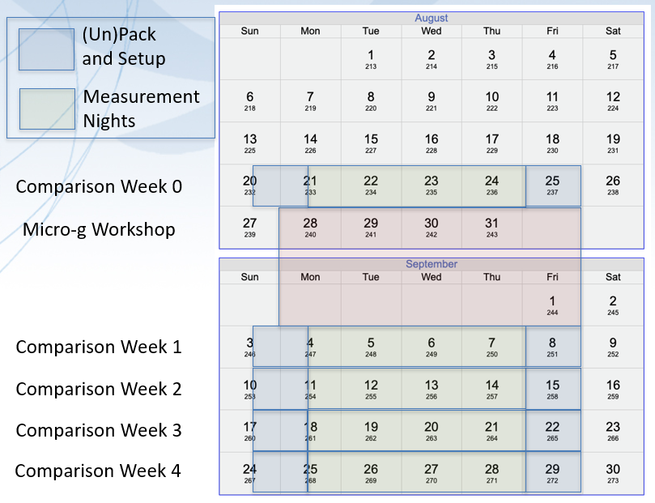

**Figure 2.** Calendar for CCM.G-K2.2023.

# Measurement timetable

An optimal measurement schedule has been prepared by Dr. Derek van Westrum (NOAA-NGS). In designing an optimal schedule, the following conditions have been imposed: 1) an instrument shall not occupy the same pier more than once, 2) the number of missing meter-to-meter comparisons shall be minimized, 3) the number of times any two instruments observe on the same pier more than once shall be evenly distributed among all the instruments (to the extent possible). The measurement timetable is given in Table 2. Assembly of the instruments of a particular gravimeter between stations have to be realized till 11 am.



**Table 2.** Measurement schedule (left) and resulting overlap between instruments. Assignment of piers to instruments TBD. Note that the schedule is necessarily subject to change if an instrument(s) becomes unavailable for some reason.

# Data report

All participants must provide the absolute measurement results for every measured point (pier) in the table format given in Annex B. The operators are responsible for processing their own gravity data, including the application of corrections for all known instrumental effects. They will then submit final *g*-values for all the measured sites at their own preferred height above the benchmark together with the vertical gravity gradient that they employed. Finally, the operators will provide the combined standard uncertainty of final *g*-values. The pilot laboratory will be responsible for reducing the submitted gravity values to a comparison reference height using the measured vertical gravity gradients at each pier.

# Uncertainty evaluation

“*A result from a participant is not considered complete without an associated uncertainty, and is not included in the draft report unless it is accompanied by an uncertainty supported by a complete uncertainty budget*” [4].

Uncertainty of measurements should be estimated **(mandatory for KC participants**) according to the GUM [5]. The calculation can be divided into instrument uncertainty and site uncertainty. Many of the site uncertainty parameters are common to all participating gravimeters and will be included in the relevant corrections applied by the pilot laboratory from the monitored changes in local gravity using relative gravimeters during the Key comparison:

1. uncertainty budget of the instrument that includes, at least, the following influence parameters:

* Laser frequency
* Rb-clock frequency
* Gravity gradient measurement
* Misalignments in the verticality of the laser beam correction
* Imperfect collimation and cosine error effect
* Verticality
* Residual gas pressure
* Diffraction effects
* Glass wedges
* Corner cube rotation
* Air gap modulation
* Inhomogeneous magnetic field
* Apparatus gravity attraction effect
* Electrostatics effect
* Temperature changes
* Beam divergence correction
* Phase shifts in fringe counting and timing electronics
* Choice of the initial and final scaled fringes effect
* Reference height

Other possible effects:

* Laser frequency reproducibility/stability
* Beam shear effect
* Photodetection and fringe counting electronics effect
* Finite speed of light effect
* Optical effects
* Radiation Pressure effect
* Whichever other contribution characterized from the participant laboratory

1. measurement uncertainty in a specific site that includes, at least, the following influence parameters:

* Uncertainty in air pressure correction (admittance factor)
* Air pressure measurement effect
* Earth tide evaluation
* Ocean loading correction evaluation
* Polar motion correction evaluation
* Groundwater effect (estimated by Pilot laboratory)
* Coriolis acceleration effect
* Floor (instrument) recoil effect
* Gravity gradient - transfer to comparison reference height (provided by Pilot laboratory)
* Typical standard deviation of measurements

From the influencing quantities *Xi* , measurement deviations *Δxi* and uncertainties in the form of standard deviation *si* (type A) and *ai* (type B) are considered:

|  |  |  |
| --- | --- | --- |
| * standard uncertainty:   note: *ka* depends on the type of statistical distribution (2 for U distribution, 3 for rectangular , 6 for triangular, etc.) |  | (1) |
| * sensitivity coefficients: |  | (2) |
| * single gravity deviation: |  | (3) |
| * variances: |  | (4) |
| * combined standard uncertainty: |  | (5) |
| * sum of gravity deviations: |  | (6) |
| * effective degrees of freedom, according to the Welch-Satterthwaite formula: |  | (7) |
| * coverage factor (*p=*level of confidence): |  | (8) |
| * expanded standard uncertainty:   note: ⏐*g*⏐ is the calculated error. If it is not corrected, at least it should be included in the estimation of uncertainty. See F.2.4.5 in [2]. |  | (9) |
| * relative expanded standard uncertainty: |  | (10) |

An example of calculation of uncertainty is given in annex C. It contains the unified budget of uncertainty for FG5-type gravimeters, as result of the analysis done in previous comparisons.

**All participants are requested** to estimate (e.g. based on their long-term experience with a gravimeter) the long-term reproducibility of the measurements. It can be understood as a parameter which describes the degree of consistency of an AG after several years. The reproducibility is defined [5] as a closeness of the agreement between the results of measurements of the same measurand carried out under changed conditions of measurement. It includes random errors (e.g. setup error, errors of applied corrections for tides or atmosphere) but also errors which may cause systematic effects over a few months (e.g. in connection with the interferometer alignment, such as collimation or fringe size effect). This information would be helpful for a possibility to separate the systematic and stochastic part of the uncertainty and by such a way to improve the approach of the least-squares adjustment.

# Frequency measurements during the comparison

TMGO (with the kind assistance of nearby Micro-g LaCoste, Inc.) can provide assistance in the determination of

* Frequency calibration (GPS-10 MHz and/or 1PPS)
* Laser wavelength calibration (632nm nominal wavelength)
* Laser beam width determination (diffraction correction)

Depending on the quantity and nature of such assistance requests, arrangements prior to the comparison may be necessary. Participants interested in such assistance are asked to contact Derek van Westrum well in advance of the comparison.

# Results elaboration

The results of the comparison will be the Key Comparison Reference Values with their uncertainties evaluated using all the measurements performed by all the gravimeters participating at the comparison.

The data processing will be based on a weighted least square adjustment including the gravity differences measured by all gravimeters (PS and KC). The observation equation is

*gik = gk + δi + εik*

with the non-weighted condition in the first approach



and with the weighted condition in the second approach



In the first approach, weights *wik* (*wik = uo²/uik2* where *uo* is the unit weight) based on the uncertainty budget of the observations will be applied to the measured values *gik*. In the second approach, weights *wi=* *uo²/ui2* will be also applied on the biases *δi*, where *ui* is computed as root mean square of *uik* for a gravimeter *i*.

The Pilot Laboratory will process the data in the two ways and the results will be presented in the Draft A report. Consequently, the participants will decide which will be the more appropriate method and it will be implemented in the Draft B report.

Since the comparison strive for a blind test type of measurement, **participants cannot communicate their results, neither to other participants nor officially on any other way before the issue of the Draft A.**

Once the draft B of the report on KC is published all the results of the comparison will be made public.

# Visitor and Transportation Logistics

Questions regarding travel to Boulder (letters of invitation, etc.) should be addressed to Derek van Westrum. Foreign nationals will need some extra time for permission to enter the TMGO site. It is requested that these processes be started as quickly as possible (something like at least two months before the comparison).

Questions regarding the logistics of instrumentation transportation (customs formalities, etc) should also contact Derek van Westrum. The name of a local shipping company or consignee who is used to deal with the customs formalities of this kind of equipment will be recommended on request.

# References

1. CCM-IAG Strategy for Metrology in Absolute Gravimetry, 2014. <http://www.bipm.org/wg/CCM/CCM-WGG/Allowed/2015-meet-ing/CCM_IAG_Strategy.pdf>
2. Wziontek, H., Bonvalot, S., Falk, R. et al. Status of the International Gravity Reference System and Frame. J Geod 95, 7 (2021). <https://doi.org/10.1007/s00190-020-01438-9>
3. US Standard Atmosphere, NASA-TM-X-74335, NOAA 77-16482, 1976.
4. T. J. Quinn, Guidelines for CIPM key comparisons carried out by Consultative Committees, BIPM, Paris, 1 March 1999 with modifications by the CIPM in October 2003. <http://www.bipm.org/utils/en/pdf/guidelines.pdf>
5. BIPM, IEC, IFCC, ISO, IUPAC, IUPAP, OIML, Guide to the Expression of Uncertainty in Measurement; Edition 1993, corrected and reprinted 1995, ISO-GUM, International Organization for Standardization, Geneva, Switzerland,ISBN92-67-10188-9. <http://www.bipm.org/en/publications/guides/gum.html>

# Annex A - Description of the absolute gravimeter

|  |  |
| --- | --- |
| **Manufacturer** |  |
| **Model/Type** |  |
| **s/n** |  |
| **Method of the measurement of free-fall acceleration** |  |
| **Approximated reference instrumental height\*** |  |
| **Vibration-isolation device** |  |
| **Interferometer type** |  |
| **Laser type** |  |
| **Throw/drop length used during measurement, number of fringes acquired and fringes used for g-evaluation** |  |
| **Software** |  |
| **Length of the fringe signal cable (e.g. TTL cable)** |  |
| **Add other information** |  |

* (≈1.21 m for the FG5 and ≈1.27 m for the FG5-X), distance between benchmark and the effective position of free-fall, where g is invariant on vertical gravity gradient used in the equation of motion

Annex B - Report of measurement results

**The g-values should be corrected for all known geophysical effects (tides, polar motion, atmospheric pressure, etc.) as well as for all instrumental effects (self-attraction, diffraction effects, etc.).**

**The g-value can be given for any desired height. However, reference instrumental height* is recommend to use.**

|  |  |  |  |  |  |  |  |  |  |  |  |
| --- | --- | --- | --- | --- | --- | --- | --- | --- | --- | --- | --- |
| **Date** | **Time (from÷to)** | **Gravimeter** | Operator/s | **Site** | #sets,  #drops | g@ measure-ment height  /µGal | Measure-ment height / cm | VGG  / µGal m-1 | Long-term reproducibility  /µGal | **Standard uncertainty**  **/µGal** | Degrees of freedom |
|  |  |  |  |  |  |  |  |  |  |  |  |
|  |  |  |  |  |  |  |  |  |  |  |  |
|  |  |  |  |  |  |  |  |  |  |  |  |

**Indicate the value of the applied self-attraction correction and diffraction correction with the associated uncertainty**

|  |  |  |  |  |  |  |  |  |
| --- | --- | --- | --- | --- | --- | --- | --- | --- |
| Date | Time (from÷to) | Gravimeter | Operator/s | Site | Self-attraction /µGal | uSelf-attraction /µGal | Diffraction /µGal | uDiffraction /µGal |
|  |  |  |  |  |  |  |  |  |
|  |  |  |  |  |  |  |  |  |
|  |  |  |  |  |  |  |  |  |

* (≈1.21 m for the FG5 and ≈1.27 m for the FG5-X), distance between benchmark and the effective position of free-fall, where g is invariant on vertical gravity gradient used in the equation of motionAnnex C - Example of calculation of uncertainty.

***Example of instrumental uncertainty (unified for FG5s for CCM.G-K1 2009)***

*****Note: table below is in MS-Excel® format. Double-click to open it. Light blue cells contain formulas that should not be modified***

*Example of site dependent uncertainty (unified)*

***Note: table below is in MS-Excel® format. Double-click to open it. Light blue cells contain formulas that should not be modified***



# Annex D - Parameters of the TMGO site

The same geographical coordinates are used for all the sites:

Name of the station: Table Mountain Geophysical Observatory (TMGO)

Bench mark (pier) designations: AG, AH, AI, AJ, AN, AO, AP, AQ, AS, AT

Latitude: 40.1309 North

Longitude: 105.2327 West

Altitude: 1683 m

The vertical gravity is parameterized as function of the height *z* by a second degree polynomial:

*g(z) = a z2 + b z + c .*

Thus, the vertical gravity gradient at the specific height is

.

A least-squares fit provides with the coefficients *a, b* and *c* as well as a, b and ab (standard deviation and covariance). The results are presented in Table D1, but note that parameters may change slightly if/when the gradients are re-measured before and after the comparison. Not that the coefficient c is omitted as it is of no use.

**Table D1.** Parameters and associated uncertainties of the second degree polynomial for the vertical gravity gradient (in process of being measured and will be provided prior to the start of the Key Comparison).

|  |  |  |  |  |  |
| --- | --- | --- | --- | --- | --- |
| Site | *a*  /μGal m-2 | a  /μGal m-2 | *b*  /μGal m-1 | b  /μGal m-1 | ab  /μGal2 m-3 |
| AG |  |  |  |  |  |
| AH |  |  |  |  |  |
| AI |  |  |  |  |  |
| AJ |  |  |  |  |  |
| AN |  |  |  |  |  |
| AO |  |  |  |  |  |
| AP |  |  |  |  |  |
| AQ |  |  |  |  |  |
| AS |  |  |  |  |  |
| AT |  |  |  |  |  |

The gravity difference between height z1 and z2 is given by:



and the associated uncertainty



These are the two formulas used to transfer the gravity values along the vertical from the reference instrumental height to the reference height of the comparison.

**Table D2.** Observed tidal parameters at TMGO

TIDALPARAM= 0.000000 0.000001 1.00000 0.0000 DC

TIDALPARAM= 0.000002 0.249951 1.16000 0.0000 long

TIDALPARAM= 0.721500 0.906315 1.16052 1.1570 Q1

TIDALPARAM= 0.921941 0.940487 1.16468 1.1775 O1

TIDALPARAM= 0.958085 0.974188 1.15951 1.0326 NO1

TIDALPARAM= 0.989049 0.998028 1.16539 1.1041 P1

TIDALPARAM= 0.999853 1.000147 1.49457 15.9599 S1

TIDALPARAM= 1.001825 1.003651 1.15452 1.1761 K1

TIDALPARAM= 1.005329 1.005623 1.30377 1.3908 PSI1

TIDALPARAM= 1.007595 1.011099 1.20411 0.6319 PHI1

TIDALPARAM= 1.013689 1.044800 1.18028 1.1094 J1

TIDALPARAM= 1.064841 1.216397 1.18279 0.3491 OO1

TIDALPARAM= 1.719381 1.872142 1.16806 -0.4567 2N2

TIDALPARAM= 1.888387 1.906462 1.15681 -0.2398 N2

TIDALPARAM= 1.923766 1.942754 1.15945 0.1973 M2

TIDALPARAM= 1.958233 1.976926 1.16297 0.3812 L2

TIDALPARAM= 1.991787 2.002885 1.17172 -0.5305 S2

TIDALPARAM= 2.003032 2.182843 1.17348 -0.4844 K2

TIDALPARAM= 2.753244 3.081253 1.07285 -0.2409 M3

TIDALPARAM= 3.381379 4.347615 1.03900 0.0000 M4