**APMP Supplementary Comparison**

**APMP.L-S2.3.n01: 1D GRATINGS**

**2022 - 2024**

**Technical Protocol**

Yushu Shi

National Institute of Metrology, China (NIM)

BEIJING, 22-05-10

Contents

1 Introduction 3

2 Organization 3

2.1 Participants 3

2.2 Schedule 4

2.3 Packaging, customs, insurance, costs 5

3 Measuring instruments 5

4 Artefacts and Measurement Instructions 6

4.1 Description of artefacts 6

4.2 Handling the artefact 7

4.3 Measurands 7

5 Reporting of results 9

5.1 Measurement uncertainty 9

5.2 Results and uncertainties as reported by participants 9

6 Analysis of results 9

6.1 Calculation of the KCRV 9

6.2 Draft and final report 10

Appendix A – Customs declaration 11

Appendix B – Reception of Standards 12

Appendix C – Results for Laboratory 13

Appendix D – Uncertainty Analysis 14

# Introduction

The metrological equivalence of national measurement standards is determined by a set of key and supplementary comparisons chosen and organised by the Consultative Committees of the CIPM or by the Regional Metrology Organisations (ROMs) in collaboration with the Consultative Committees.

1D gratings are one of important standard in the field of Nanometrology. But the related intercomparison has been over for a long time, in which the pitch involved were only 300 nm and 700 nm. And NMIs need to verify and improve nanometrology capabilities (KCDB CMC).

At the last APMP TCL meeting in November 2021, NIM (National Institute of Metrology, China) proposed to prepare a supplementary comparison on the calibration of 1D gratings. The APMP-TCL endorsed the proposal and decided to use NIM as the pilot laboratory. The comparison artefact circulation will begin in July 2022.

The procedures outlined in this document cover the technical procedure to be followed during the measurements. A goal of the CCL key comparisons for topics in dimensional metrology is to demonstrate the equivalence of routine calibration services offered by NMIs to clients. On completion of measurements by all participants, the results of the intercomparison will be circulated for comment and a final report presented to the APMP.

# Organization

## Participants

Participants are listed in Table 1.

**Table 1.** List of participant laboratories and their contacts.

|  |  |  |
| --- | --- | --- |
| **Country** | **Laboratory/Address** | **Contact** |
| China  (Pilot)  (APMP) | National Institute of Metrology, China(NIM)  No.18 Bei San Huan Dong Lu, Chaoyang District, Beijing, China, 100029 | Dr. Yushu Shi  Phone: +86 10 64524920  E-Mail: [shiys@nim.ac.cn](mailto:shiys@nim.ac.cn) |
| Japan  (APMP) | National Metrology Institute of Japan(NMIJ)  National Institute of Advanced Industrial Science and Technology(AIST)  Tsukuba Central 5, 1-1-1 Higashi, Tsukuba, Ibaraki 305-8565,Japan | Mr. Ryosuke Kizu  Phone: +81 29 861 2038  E-Mail: r-kizu@aist.go.jp |
| Thailand  (APMP) | National Institute of Metrology Thailand (NIMT)3/4-5 Moo. 3, Klong 5, Klong Luang, Pathumthani  12120 Thailand | Dr. Thammarat Somthong  Phone: +66 25775100 ext.111115, +66 917500027  E-Mail: Thammarat@nimt.or.th |
| Australia  (APMP) | National Measurement Institute Australia (NMIA)  36 Bradfield Road, Lindfield, NSW, 2070, AUSTRALIA | Mr Malcolm Lawn, Dr Bakir Babic  Phone: +61 439 625 496  E-Mail: [bakir.babic@measurement.gov.au](mailto:bakir.babic@measurement.gov.au), malcolm.lawn@measurement.gov.au |
| Chinese Taipei (APMP) | Center for Measurement Standards(CMS)  Industrial Technology Research Institute (ITRI)  Rm 208, Bldg. 2, 321, Sec. 2, Kuang Fu Rd., Hsinchu 30011, Taiwan, R.O.C. | Dr. Ching-Hsuan Chang, Dr. Fang-Hsin Lin  Phone: +886-3-5732746, +886-3-5743744E-mail: [Alice.C.Chang@itri.org.tw](mailto:Alice.C.Chang@itri.org.tw), [itriA40317@itri.org.tw](mailto:itriA40317@itri.org.tw) |
| EURAMET |  | Phone:  E-Mail: |
| COOMET |  | Phone:  E-Mail: |
| SIM |  | Phone:  E-Mail: |
| AFRIMETS |  | Phone:  E-Mail: |

## Schedule

The participating laboratories were asked to specify a preferred timetable slot for their own measurements of the surface measurement standards – the timetable given in Table 2 has been drawn up taking these preferences into account. Each laboratory has four (4) weeks that include customs clearance, calibration and transportation to the following participant. With its confirmation to participate, each laboratory is obliged to perform the measurements in the allocated period and to allow enough time in advance for transportation so that the following participant receives them in time. If a laboratory has technical problems to perform the measurements or customs clearance takes too long, the laboratory has to contact the pilot laboratory as soon as possible and, according to whatever it decides, it might eventually be obliged to send the standards directly to the next participant before completing the measurements or even without doing any measurements.

**Table 2.** Measurement schedule.

|  |  |  |  |  |
| --- | --- | --- | --- | --- |
| **Country** | **Lab** | **Starting date of measurement** | **Cumulative Months** | **Carnet** |
| China  (Pilot) | NIM | 01/2023 | 1 | Yes |
| Australia | NMIA | 05/2023 | 5 |  |
| Thailand | NIMT | 07/2023 | 7 |  |
| Japan | NMIJ | 01/2024 | 13 |  |
| Chinese Taipei | CMS/ITRI | 04/2024 | 16 |  |
| China  (Pilot) | NIM | 07/2024 | 19 |  |
| SIM/EURAMET/AFRIMETS/COOMET |  | 08~10/2024 | 22 |  |
| China  (Pilot) | NIM | 11/2024 | 23 |  |

## Packaging, customs, insurance, costs

The artefacts are transported inside a solid protective case as shown in Figure 1. Each standard is also inside a single box as shown in Figure 2. Upon reception of the package, each laboratory has to check that the content is complete and there is no apparent damage on the box or any of the standards. The reception has to be confirmed immediately to the pilot with a copy to the former participant, preferably using the template in Appendix B.

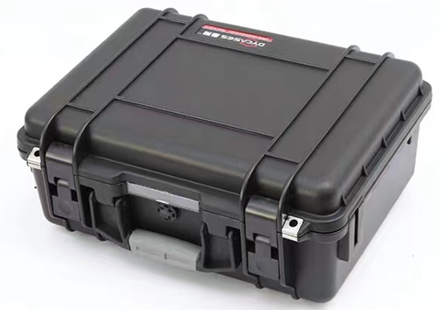

Figure 1. Transporting case(only as example).

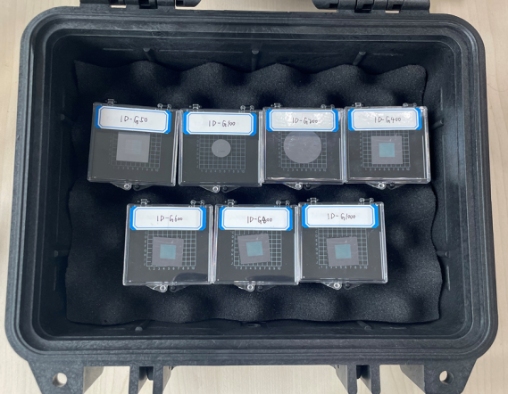

Figure 2. Individual artefact cases(only as example).

Once the measurements have been completed, the package shall be sent to the following participant. A strong envelope is to be attached to the outside of the box (with a second copy inside the box) with the following documents:

* Customs declaration (Appendix A of this document)
* ATA Carnet covering participating countries within the scheduled period
* The protocol

Each participant is responsible for carefully re-packing and shipping the artefacts to the next participant and bearing the costs associated with forwarding the artefacts. The package should be shipped with a reliable parcel service of its choice. Once the measurements have been completed, please inform the pilot laboratory and the following participant when the package leaves your installations indicating all pertinent information. **If, at any point during circulation, the package is damaged, it shall be repaired by the laboratory before shipping it again.**

# Measuring instruments

The measuring instrument is open and the laboratory can choose one or more instruments, such as AFM, SEM, etc. Each laboratory has nominated the equipment listed in Table 3 for measurement of included artefacts.

**Table 3.** Expected measurement instruments.

|  |  |  |  |  |
| --- | --- | --- | --- | --- |
| **Lab** | **Instrument** | **Software** | **Ranges** | **Traceability** |
| NIM | Metrological Atomic Force Microscope | Self | 90 µm×90 µm×10 µm | NIM |
| Metrological Scanning Electron Microscope | Self | 40 µm×40 µm |
| NMIJ | AFM(Meas.Sci.Technol.,162080 (2005)) | Self | 100 µm × 100 µm × 6 µm | NMIJ |
| AFM(Meas.Sci.Technol.,29075005 (2018)) | 12 µm × 12 µm × 8 µm |
| NIMT | Atomic force microscope on Nanomeasuring Machine (NMM) | DME Scan Tool | 25 mm × 25 mm × 5 mm | NIMT |
| NMIA | Asylum Research MFP3D-SA Atomic Force Microscope (AFM) | MountainsSPIPv.9,  Gwyddion, or SPIPv.6.5.8 | 90 µm × 90 µm × 15 µm | X/Y<1µm:PTB,  X/Y>1µm:NIST,  Z-axis:NIST |
| Metrological Scanning Probe Microscope (mSPM) | Gwyddion | 100 μm × 100 μm × 25 μm | NMIA |
| CMS/ITRI | Metrological Atomic Force Microscope | Self | 50 µm × 50 µm × 10 µm | CMS |
| Scanning electron microscope | Self | 15 mm × 15 mm | CMS |
| SIM/EURAMET/AFRIMETS/COOMET |  |  |  |  |

# Artefacts and Measurement Instructions

## Description of artefacts

Some basic information about the artefacts is listed in Table 4.

**Table 4.** List of artefacts.

|  |  |  |  |  |
| --- | --- | --- | --- | --- |
| **Identification** | **Dimensions** | **Nominal pitch** | **Picture** | **Typical AFM image** |
| 1D-G50 | Dia. 18 mm | 50 nm |  |  |
| 1D-G100 | 100 nm |
| 1D-G200 | 200 nm |
| 1D-G400 | 400 nm |
| 1D-G600 | 600 nm |
| 1D-G800 | 800 nm |
| 1D-G1000 | 1000 nm |

## Handling the artefact

The standards should only be handled by authorized persons and stored in such a way as to prevent damage. Before making the measurements, each standard need to be checked and taken photo to verify that its measuring surface is not damaged and do not present severe scratches that may affect the measurement results. And attach the photos to Appendix B.

The artefacts are easily fragile and dirty. Only remove items from their protective cases at the location of measurement. At all times, grab gently only with tweezer, do not touch the surfaces with bare hands especially in the grid area. When the artefacts are tightly attached, a blade can be used to slowly separate it from the base. And any change in condition during the measurement at each laboratory should immediately be communicated to the pilot laboratory.

Ensure that the content of the package is complete before shipment. Always use the original packaging.

**No other measurements are to be attempted by the participants and the standards should not be used for any purpose other than described in this document. The standards may not be given to any party other than the participants in the comparison.**

## Measurands

The measurand to be used in this comparison is the average pitch over the grid area of the standard at (20±2) °C. The direction of the pitch is defined to be orthogonal to the ribs of the grating.

#### Position of the measurement

1. **1D-G50/1D-G100/1D-G400/1D-G600/1D-G800/1D-G1000**

The substrate is 18 mm wafer. The silicon substrate of blazed grating (Nominal piths is 50 nm,100 nm, 400 nm, 600 nm, 800 nm and 1000 nm) is a 10 mm long square with a thickness of about 0.5 mm. As shown in Figure 3, the grid area is a 0.5 mm long square located in the centre of the substrate. The measure area is circled by the red box (a square of 20 µm). The measurement results are the average values of at least three measurement area (more than 10 pitchs) within a square of 20 µm around the centre of the grid area (Marked with red box on the right of Figure 3). And repeat measurements at least 3 times for each measurement area, the result of each measurement is the average of 10 profiles evenly distributed over the whole area of measurement.

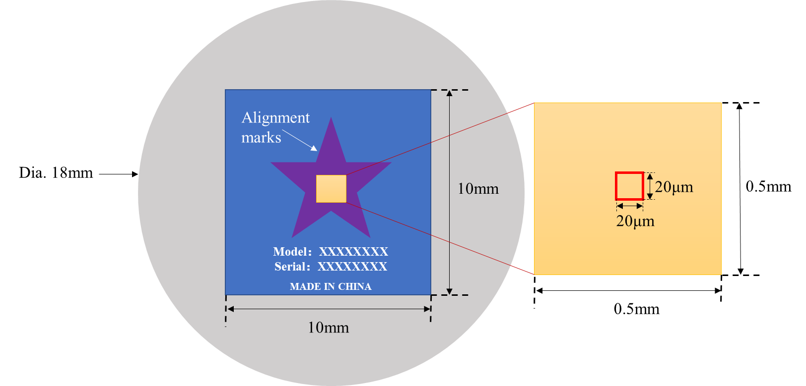

Figure 3. The measurement positions of 1D-G50/1D-G100/1D-G400/1D-G600/1D-G800/1D-G1000

1. **1D-G200**

The substrate is 18 mm wafer. The silicon substrate of blazed grating (Nominal piths is 200 nm) is a 10 mm long square with a thickness of about 0.5 mm. As shown in Figure 4, the grid area is a 0.3mm × 0.6mm rectangular. The positions and times of measurement are similar to 1D-G50/1D-G100/1D-G400/1D-G600/1D-G800/1D-G1000.

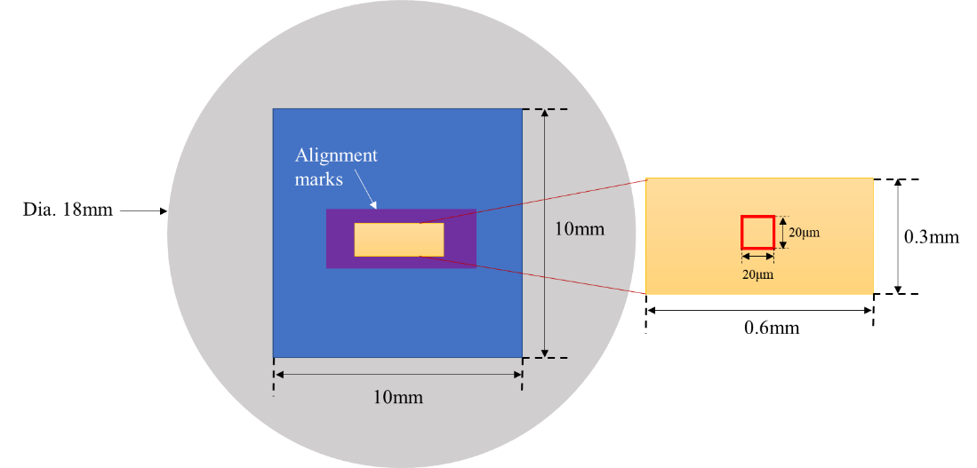

**Figure 4.** The measurement positions of 1D-G200

#### Determination of the pitch values

For non-primary standard (Type-B) SPMs/AFMs, it is necessary to calibrate the instrument with calibration artefacts/transfer standards. And take into account the uncertainty components.

The gravity centre (GC) method (Figure 5) is used to evaluate the mean pitch *P* of the gratings, whose implementation is described in detail in reference1. If other methods are applied, please, indicate it in the report2. And for each method applied a complete description of the method and a detailed estimation of the measurement uncertainty according to the ISO Guide to the Expression of Uncertainty in Measurement (GUM) had to be supplied. **Please use raw data for the evaluation without any form operator.**

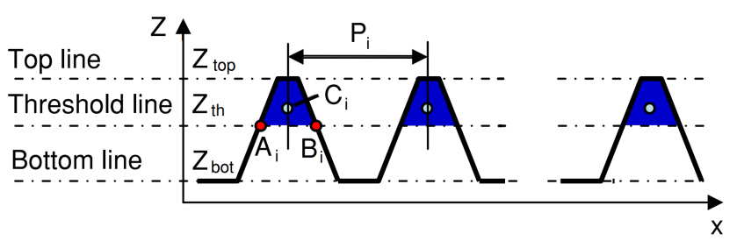

Figure 5. Basic principle of the GC method, where *Z*Th = *Z*Top −(*Z*Top − *Z*Bottom) × *p*% 3.

 (1)

where *P* is the mean pitch, *N* is the number of grating structures, and *Pi* is the distance between the *i*th and (*i* + 1) th structure of the measured grating.

**1** DAI G L, Pohlenz Fank Xu, Min Koenders, et al. Accurate and traceable measurement of nano- and microstructures[J]. Measurement Science & Technology, 2006, 17(3):545-552.

**2** For atomic force microscope, it is best to use the gravity centre method to evaluate the mean pitch. For other measurement methods such as scanning electron microscopy, optical diffractometer, etc., other evaluation methods may be used, but they need to be described in the report.

**3** *p*% denotes the distance between the threshold line and the top line, which may affect the results of measurement, so it is recommended to set it to 50%.

# Reporting of results

## Measurement uncertainty

The measurement uncertainty shall be estimated according to the ISO Guide to the Expression of Uncertainty in Measurement. The participating laboratories are encouraged to use their usual model for the uncertainty calculation.

All measurement uncertainties shall be stated as standard uncertainties and combined standard uncertainty *U*(*k*=2). If appropriate the corresponding effective degree of freedom might be stated by the participants and can be used to calculate the combined uncertainty *U*. If none is given, ∞ is assumed.

## Results and uncertainties as reported by participants

As soon as possible after measurements have been completed, the results of each NMI should be communicated to the pilot laboratory **within four (4) weeks** at the latest.

The report templates in appendix A, B, C and D of this document will be sent from pilot by e-mail (Word documents) to all participating laboratories. In any case, the signed report must also be sent in paper form by mail or electronically as a scanned pdf document. **In case of any differences, the signed forms are considered to be the definitive version.**

Each report will be checked by the pilot for consistency of results. In case of discrepancies the lab will be informed to check measurement results and uncertainty budget, but with no indication of size and direction of discrepancy.

# Analysis of results

## Calculation of the KCRV

When all measurements are completed, the reference value for each measured quantity is to be selected from either the arithmetic value or the weighted mean of the values *xi* from each individual laboratory, as given by:

Arithmetic mean:

 (2)

Weighted mean:

 (3)

Note: The two methods will be calculated for comparison only. The weighted mean will be used for the reference value.

The check for consistency of the comparison results of each laboratory for each measurand with their associated uncertainties will be made based on *E*n criteria using *E*n values, along the lines of the *WG- MRA-KC-report-template*, and on the Birge ratio.

Degree of equivalence ratio:

 (4)

where 𝑢(𝑥𝑖) 𝑖s the standard uncertainty of the individual laboratory and 𝑢(𝑥̅𝑤) is the standard uncertainty of the weighted mean.

Birge ratio:

 (5)

where 𝑢𝐼(𝑥̄𝑤) is propagated (internal) uncertainty and 𝑢𝐸(𝑥̄𝑤) is external uncertainty calculated from the standard deviation of the weighted mean. The 𝑢𝐼(𝑥̄𝑤) and 𝑢𝐸(𝑥̄𝑤) are given by-

 (6)

 (7)

For an infinite population size, the ratio value should be approximately 1. For a limited population size, the Birge criterion is given by-:

 (8)

The consistency condition is satisfied when .

## Draft and final report

Following receipt of all measurement reports from the participating laboratories, the pilot laboratory will analyze the results and prepare within four (4) months a first draft A report on the comparison. This will be circulated to the participants for comments, additions and corrections. After all discussions are complete, the final report will then be submitted to the APMP for publication following recommended international guidelines.

# Appendix A – Customs declaration

**TO WHOM IT MAY CONCERN**

**APMP Regional Comparison**

The Asia Pacific Metrology Program (APMP) is conducting an intercomparison on 1D gratings involving the highest level measurement laboratories in **China, Japan, Thailand, Australia, Chinese Taipei**. This program is coordinated by the National Institute of Metrology, China.

Packing List:

|  |  |  |  |
| --- | --- | --- | --- |
| Item | | Dimensions | Weight |
| transporting case | | 440×320×250 mm | 1.05 kg |
| Individual  artefact  cases | 1D-G50 | Dia. 18 mm | 0.045kg |
| 1D-G100 | Dia. 18 mm | 0.045kg |
| 1D-G200 | Dia. 18 mm | 0.045kg |
| 1D-G400 | Dia. 18 mm | 0.045kg |
| 1D-G600 | Dia. 18 mm | 0.045kg |
| 1D-G800 | Dia. 18 mm | 0.045kg |
| 1D-G1000 | Dia. 18 mm | 0.045kg |

The artefacts have no commercial value (not for sale). They are meant solely for the calibration of national standards and will be exported immediately after the calibration is complete. Refer to the schedule on page 6 of the protocol.

We request that the artefacts are not handled or removed from the container/package. **Please do not touch the artefacts with bare hands as this may contaminate the surfaces.** If a Customs inspection is required then please contact the following contact so that he/she can be present and unpack the items in your presence.

|  |  |
| --- | --- |
| **Contact** | |
| Current Participant | Contact :  E-mail :  Phone number :  Address : |
| Pilot | Contact : Dr. Yushu Shi ( NIM )  E-mail : shiys@nim.ac.cn ( NIM )  Phone number : +86 10 64524920  Address : National Institute of Metrology, China  No.18 Bei San Huan Dong Lu, Chaoyang District, Beijing, China, 100029 |

# Appendix B – Reception of Standards

**Delivery receipt**

|  |  |  |  |  |
| --- | --- | --- | --- | --- |
| Check one by one, if there is no problem, please mark “ √ ” in the corresponding box, otherwise mark “ × ”. | | | | |
| 1. Are the transporting cases in good condition □  2. Are the individual artefact cases in good condition □  3. There are 7 artefacts □  4. Are the artefacts in good condition □  5. Please check each artefact carefully and take photos of it after receiving it. If you have any questions, please contact the pilot laboratory immediately.  If necessary, the detailed description of the receiving state (such as serious scratches, scratches, fractures, etc. ).   |  |  | | --- | --- | | ( Figure ) | ( Figure ) |   6. Handover | | | | |
|  | Lab | Contact person | Date | Note |
| sender |  |  |  |  |
| receiver |  |  |  |  |

**Note** : This form is made in triplicate, with one kept by the receiver and one kept by the sender, and the other copy sent with the box to the next station.

# Appendix C – Results for Laboratory

|  |  |  |  |  |  |  |  |  |  |
| --- | --- | --- | --- | --- | --- | --- | --- | --- | --- |
| **Results and uncertainties as reported by participants** | | | | | | | | | |
| Laboratory | |  | | | | | | | |
| Address | |  | | | | | | | |
| Contact | |  | | | | | | | |
| E-Mail | |  | | Phone | | | |  | |
| Start date. | |  | | End date | | | |  | |
| Instrument 1 | | instrument, range, traceability, etc. | | | | | | | |
| Instrument 2 | | instrument, range, traceability, etc. | | | | | | | |
| Software | |  | | | | | | | |
| Data evaluation methods | |  | | | | | | | |
| Temperature | | ℃ | | Humidity | | | | ％RH | |
| Results | | | | | | | | | |
| Artefact  s/n | *P*  nm | | *u*c  nm | | *U*  nm | *k* | *v*eff | | Note |
| 1D-G50 |  | |  | |  |  |  | |  |
| 1D-G100 |  | |  | |  |  |  | |  |
| 1D-G200 |  | |  | |  |  |  | |  |
| 1D-G400 |  | |  | |  |  |  | |  |
| 1D-G600 |  | |  | |  |  |  | |  |
| 1D-G800 |  | |  | |  |  |  | |  |
| 1D-G1000 |  | |  | |  |  |  | |  |

*P*: Pitch

*uc*: combined standard uncertainty

*U*: expanded uncertainty

*k*: coverage factor

*v*eff: effective degree of freedom

|  |  |  |  |
| --- | --- | --- | --- |
| Signature |  | Date |  |

# Appendix D – Uncertainty Analysis

**Table D1.** 1D grating standard 1D-G50

|  |  |  |  |
| --- | --- | --- | --- |
| The uncertainty components | | Distribution | Value(nm) |
| *u*1 | Repeatability |  |  |
| *u*2 | Uniformity(local pitch variations within the central 100 μm2) |  |  |
| *u*3 | Noise of the instrument |  |  |
| *u*4 | Interferometer alignment |  |  |
| *u*5 | Calibration uncertainty of the instrument |  |  |
| *u*6 | Angle uncertainty (for diffraction methods) |  |  |
| …… | …… |  |  |

**Table D2.** 1D grating standard 1D-G100

|  |  |  |  |
| --- | --- | --- | --- |
| The uncertainty components | | Distribution | Value(nm) |
|  |  |  |  |

**Table D3.** 1D grating standard 1D-G200

|  |  |  |  |
| --- | --- | --- | --- |
| The uncertainty components | | Distribution | Value(nm) |
|  |  |  |  |

**Table D4.** 1D grating standard 1D-G400

|  |  |  |  |
| --- | --- | --- | --- |
| The uncertainty components | | Distribution | Value(nm) |
|  |  |  |  |

**Table D5.** 1D grating standard 1D-G600

|  |  |  |  |
| --- | --- | --- | --- |
| The uncertainty components | | Distribution | Value(nm) |
|  |  |  |  |

**Table D6.** 1D grating standard 1D-G800

|  |  |  |  |
| --- | --- | --- | --- |
| The uncertainty components | | Distribution | Value(nm) |
|  |  |  |  |

**Table D7.** 1D grating standard 1D-G1000

|  |  |  |  |
| --- | --- | --- | --- |
| The uncertainty components | | Distribution | Value(nm) |
|  |  |  |  |

**Note: The above is only example, and additional pages can be attached to add analysis steps.**