Supplementary Comparison EURAMET.EM-S46 and EURAMET.EM-S47
High voltage comparison of DC ratio and high resistance

TECHNICAL PROTOCOL
version 1.0, Oct 07, 2022

A.-P. Elg, J. Hällström, G. Rietveld

Introduction

Metrology area, branch | Electricity and Magnetism, High Voltage and Current
Description | High DC voltage ratio up to 200 kV
Time of measurement | 2022-03-07 – 2022-03-25
Measurand(s) | DC voltage ratio  DC resistance
Parameter(s) | Nominal ratio: 20000  Nominal resistance: 2 GΩ  Voltage: up to 200 kV
Transfer device(s) | Star comparison, all references in one lab at the same time.
Comparison type | Supplementary comparison
Consultative Committee | CCEM (Consultative Committee for Electricity and Magnetism)
Related regional metrology organizations | EURAMET
The 200 kV reference dividers were built in 2014 for RISE, VTT, PTB, VSL and TUBITAK as part of EMRP project HVDC. These dividers will be transported to RISE in February/March 2022 to compare their ratios and high voltage arm resistances.

Standards
The standards to be compared are identical 200 kV divider modules shown in Figure 1.

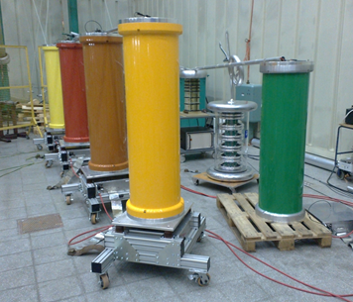
Figure 1 The five high voltage dividers to be compared (coloured).

The outer diameter of a module is 480 mm, it is 1500 mm high, and it weighs about 150 kg. The internal structure of the module is shown in Figure 2. The components are enclosed in an SF6 filled fiberglass tube. The top endplate houses a gas valve, pressure gauge and a feed-through for the reference divider signal. The bottom plate has a mating feed-through, so that the modules can be directly stacked and mounted on top of each other.
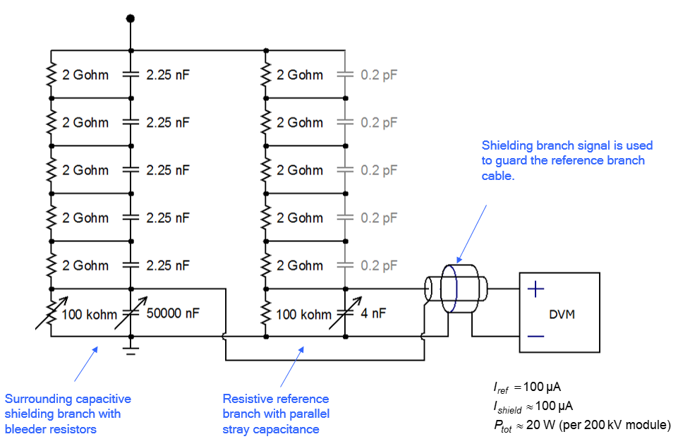
Figure 2 Internal structure of the dividers. The adjustments are
used to optimise the AC behaviour, when needed.

Measurement methods

General
Participants shall define the scale factor (ratio) and the resistance of the reference branch high voltage resistor of their divider using existing home laboratory procedures before sending the divider for comparison measurements at RISE. Each participant shall repeat their home calibration after the divider has returned after comparison.

Quantities to be measured
- The DC ratio of the divider, with nominal value of 20000; and
- The resistance of the high voltage reference branch resistor, with nominal value of 2 GΩ.

Ambient conditions
Ambient conditions shall be reported for each home calibration (before and after measurements at RISE), and for measurements at RISE. Recorded temperature values will be used for correcting the final report results to reflect performance at e.g. 22.0 °C. Humidity does not have to be controlled, but shall be reported.
The dividers must be acclimatized for a suitable duration (not less than 7 days) in the laboratory before the measurements in order to reach stable temperature.

HVDC ratio
The scale factor (ratio) of the dividers will be compared at RISE on the voltage levels shown in Table 1.
Table 1 Voltages for ratio comparison
Nominal voltage [kV]
1
10
100
200
-200

The comparison at RISE will be performed by connecting two or several dividers in parallel to measure the high voltage. The output of each divider will be measured using calibrated 3458A multimeter(s).

High voltage arm resistance
The high voltage arm resistance of each divider will be separately measured at RISE at 1 kV using voltage bridge method.

Measurement reporting

Before RISE comparison measurements
Each participant shall calibrate their divider before the comparison session. The calibration certificate shall be signed before the start of the RISE session and, at minimum, it shall contain the following:
- description of the measuring set-up(s) including the electrical circuit configuration;
- traceability scheme; if the traceability to the SI is provided by another NMI, the name of the NMI has to be stated (needed to identify possible sources of correlation);
- value and uncertainty of the scale factor, and respective voltage level(s);
- value and uncertainty of the reference branch high voltage resistor, and respective voltage level(s);
- description of the measurement procedure(s);
- the ambient conditions of the measurement: the temperature and humidity with limits of variation.

RISE comparison measurements
The pilot (RISE) prepares a report summarising the results of the measurements described in chapters 4.2 and 4.3. RISE will not disclose this report to other participants until all calibration certificates described in clauses 5.1 and 5.3 are submitted.

After RISE comparison measurements
Each participant shall repeat the calibration described in chapter 5.1 within 2 months after return of the divider to their laboratory and send both calibration certificates to the coordinator.

Final report of the comparison
Within 3 months after completion of all measurements, the VTT will prepare the first draft report and send it to the participants for comments.
This final report will summarise the results from the calibration certificates and comparison report described in chapter 5.

Organization

Coordinator
Dr. Alf-Peter Elg
RISE Research Institutes of Sweden
Measurement Science and Technology
Brinellgatan 4, P.O. Box 857
SE-501 15. Boras
SWEDEN
alf.elg@ri.se

Support group
Dr. Jari Hällström  National Metrology Institute VTT MIKES  Tekniikantie 1  FIN 02150 Espoo  FINLAND  jari.hallstrom@mikes.fi | Prof. dr. ir. Gert Rietveld  VSL National Metrology Institute  Thijsseweg 11  Delft 2629JA  The Netherlands  grietveld@vsl.nl

Participants
Acronym | Institute | Country | Status | Contact
RISE | Research Institutes of Sweden AB | Sweden | NMI | Dr. Alf-Peter Elg  alf.elg@ri.se
VTT MIKES | Technical Research Centre of Finland Ltd | Finland | NMI | Dr. Jari Hällström  jari.hallstrom@vtt.fi
PTB | Physikalisch-Technische Bundesanstalt | Germany | NMI | Dr. Johann Meisner  johann.meisner@ptb.de
TUBITAK | TÜBITAK Ulusal Metroloji Enstitüsü | Turkey | NMI | Dr. Ahmet Merev ahmet.merev@tubitak.gov.tr
VSL | VSL National Metrology Institute (VSL) | Netherlands | NMI | Dr. Ernest Houtzager ehoutzager@vsl.nl

Time schedule
Comparison measurement will be performed in February/March 2022 at RISE according to the schedule shown below.

Timetable
Action | Start | Finish
Arrival of dividers to RISE | 20.01.2022 | 22.02.2022
Temperature stabilization (7 days) | 14.01.2022 | 01.03.2022
2 GΩ measurements | 21.01.2022 | 01.03.2022
200 kV scale factor measurements | 7.03.2022 | 11.03.2022
Divider departure from RISE | 21.03.2022 | 06.04.2022

Transportation
Participants will be responsible for arranging transportation for their own divider to and from RISE.

Financial aspects, insurance
Each participating laboratory covers the costs of its own labor and transportation cost, as well as of any possible damage to their own equipment.

RISE Research Institutes of Sweden, Brinellgatan 4, 50115 Borås, Sweden
VTT Technical Research Centre of Finland, National Metrology Institute VTT MIKES, Tekniikantie 1, 02150 Espoo, Finland
VSL National Metrology Institute, Thijsseweg 11, Delft 2629JA, The Netherlands

