EURAMET Key Comparison
EURAMET.L-K5.n01

Calibration of 1-D CMM artefacts: Step Gauges
(EURAMET project 1547)

Technical protocol

Contents
1. Document control 3
2. Introduction 3
3. Organization 3
3.1. Participants 3
3.2. Schedule 4
3.3. Reception, transportation, insurance, costs 5
4. Artefacts 5
4.1. Description of artefact 5
5. Measuring instructions 7
5.1. Handling the artefact 7
5.2. Cleaning 8
5.3. Traceability 8
5.4. Measurands 8
5.6. Measurement uncertainty 9
5.7. Reference conditions 10
6. Reporting of results 10
6.1. Results and uncertainties 10
7. Analysis of results 10
7.1. Calculation of the reference value 10
7.2. Artefact instability 10
7.3. Correlation between laboratories 11
7.4. Linking to other comparisons 11
8. References 11
Appendix A – Reception of Standards 12
Appendix B – Results Report Form 13
Appendix C –– Description of the measurement instrument 17

Document control
Version Draft A Issued on 01 February 2022 – Initial collection of data and outline of comparison
Version 1.1 Issued on 25 April 2022 – Finalised list of participants and schedule

Introduction
The metrological equivalence of national measurement standards and of calibration certificates issued by national metrology institutes is established by a set of key and supplementary comparisons chosen and organized by the Consultative Committees of the CIPM or by the regional metrology organizations in collaboration with the Consultative Committees.
During the meeting of the EURAMET Technical Committee for Length (TC-L) in October 2021 was made a decision to carry out a key comparison subsequent to EURAMET.L-K5.2016 on step gauges. The number of the comparison is EURAMET.L-K5.n01, with GUM (Główny Urząd Miar) as the pilot laboratory. The comparison was registered in February 2022, and artefact circulation is planned to start in September 2022.
The results of this international comparison will support the Calibration and Measurement Capabilities (CMCs) declared by the NMIs in the CIPM Mutual Recognition Arrangement (MRA).

Organization
The participating laboratories are NMIs fulfilling the following conditions
- signatory (or applicant) of the CIPM MRA;
- having submitted CMCs for step gauges calibration (or intending to do so soon);
- calibrating step gauges for their customers as a regular service;
- being well trained in handling step gauges without the risk to damage them;

Participants
Table 1. List of participant laboratories and their contacts.
Laboratory code | RMO | Contact person, Laboratory | Phone  Email
GUM  Pilot | EURAMET | Dariusz Czułek, Piotr Sosinowski  Central Office of Measures (GUM)  Time and Length Department  Elektoralna 2, 00-139 Warsaw  Poland | Tel: +48 22 581 95 43  Fax: +48 22 581 93 92  Email: dariusz.czułek@gum.gov.pl  piotr.sosinowski@gum.gov.pl
BFKH | EURAMET | Gábor Szikszai  Government Office of the Capital City Budapest  37-39 Németvölgyi road,  Budapest 1124  Hungary | Tel. +36 1 458 5854  E-mail: szikszai.gabor@bfkh.gov.hu
CEM | EURAMET | Emilio Prieto, Joaquin Rodriguez Gonzalez,  Centro Español de Metrología  Alfar 2, ES-28760 Tres Cantos (Madrid)  Spain | Tel: +34 91 807 47 16  Email: eprieto@cem.es  jrgonzalez@cem.es
INMETRO | SIM | João A. P. Alves  National Institute of Metrology, Quality and Technology  Mechanical Division - Dimensional Metrology Laboratory  Av. N. Sra. das Graças, 50 - Prédio 3  25250-020 Vila Operária  Xerém - Duque de Caxias  Rio de Janeiro  Brazil | Tel: +55-21-6799107  Fax: +55-21-6799597  Email: jaalves@inmetro.gov.br
LNE | EURAMET | José-Antonio Salgado  Laboratoire national de métrologie et d'essais  1, rue Gaston Boissier  75724 Paris cedex 15  France | Tel: +33 1 40 43 37 00  Fax: +33 1 40 43 37 37  Email: Jose.Salgado@lne.fr
MIRS | EURAMET | Bojan Acko  MIRS/University of Maribor, Faculty for Mechanical Engineering/Laboratory for Production Management  Smetanova ulica 17  2000 Maribor  Slovenia | Tel: +386 2 220 7581  Fax: +386 2 220 7586  Email: bojan.acko@uni-mb.si
NPL | EURAMET | Tim Coveney  National Physical Laboratory  Queens Road, Teddington  Middlesex TW11 0LW  United Kingdom | Tel: +44 20 8943 6297  Email: tim.coveney@npl.co.uk
VSL | EURAMET | Richard Koops  Thijsseweg 11  2629 JA Delft  The Netherlands | Tel: +31 15 269 1642  Fax: +31 15 261 2971  Email: rkoops@vsl.nl

Schedule
The comparison will be carried out in a two loops format. EU laboratory has one month for calibration and 1.5 month for SIM laboratory, including transportation. With its confirmation to participate, each laboratory has confirmed that it is capable of performing the measurements in the limited time allocated to him. It guarantees, that the standards arrive in the country of the next participant at the beginning of the next month. If for some reasons, the measurement facility is not ready or customs clearance takes too much time in a country, the laboratory has to contact the pilot laboratory immediately.
Table 2. Schedule of the comparison.
No. | Laboratory code | RMO | Starting date
 | GUM (official entry) | EURAMET | 1 September 2022
 | MIRS | EURAMET | 1 October 2022
 | VSL | EURAMET | 1 November 2022
 | LNE | EURAMET | 1 December 2022
 | GUM (stability check) | EURAMET | 15 January 2023
ATA carnet | NPL | EURAMET | 1 March 2023
ATA carnet | INMETRO | SIM | 1 April 2023
 | BFKH | EURAMET | 15 May 2023
 | CEM | EURAMET | 15 June 2023
 | GUM (stability check) | EURAMET | 15 July 2023

Reception, transportation, insurance, costs
The step gauge will circulate within a box together with a copy of this protocol and an ATA carnet in case of circulating out of Europe.
Upon reception of the package, each laboratory has to check that the content is complete and that there is no apparent damage on the box or on the standards. The reception has to be confirmed immediately to the pilot with a copy to the former participant (sender), preferably using the form of Appendix A.
It is of almost importance that the artefacts be transported in a manner in which they will not be lost, damaged or handled by un-authorised persons. Packaging for the artefact has been made to be suitably robust to protect the artefact from being deformed or damaged during transit. The packaging should be marked as ‘Fragile’.
Once the measurements have been completed, the package shall be sent to the following participant.
Each participating laboratory shall cover the costs of shipping and transport insurance against loss or damage. The package should be shipped with a reliable parcel service of its choice. Once the measurements have been completed, please inform the pilot laboratory and the following participant when the package leaves your installations indicating all pertinent information. If, at any point during circulation, the package is damaged, it shall be repaired by the laboratory before shipping it again. The step gauge is packed in its original Mitutoyo box and a wooden case. Always use this original packaging.
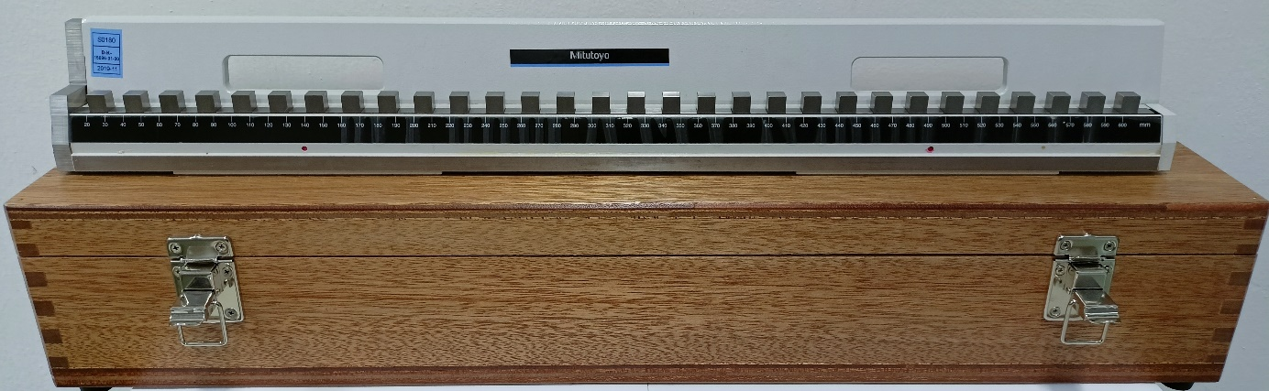 Fig. 1: Step gauge wooden case.

For the outside EU participants the package is accompanied by an ATA carnet, which shall always be shipped with the package, never inside the box, but apart. Please be certain, that when receiving the package, you also receive the carnet! Please inform the pilot that you receipt of both gauge and ATA carnet and confirm that both have been dispatched.

Artefacts

Description of artefact
The measurement artefact is a 610 mm steel step gauge.
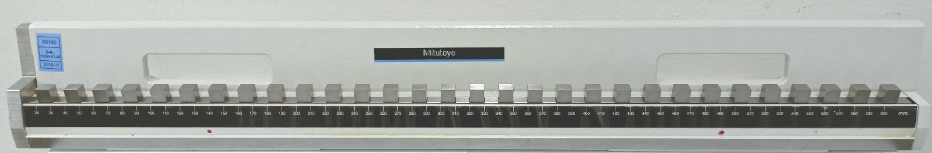Fig. 2: 610 mm step gauge.
The dimension of the step gauge is 630 mm in length (L), 50 mm in width and 80 mm in height.
The main gauge represents a total length of 610 mm with 10 mm steps and consists of 52 measurement faces. The details of the step gauge can be seen in figure 3.
Table 3. Details of the 610 mm artefact.
Manufacturer | Mitutoyo
Model | Precision Check Master, code no 515-742
Serial Number | 1920010
Material | Steel
Weight | 7.2 kg
Thermal expansion coefficient | (10.76 ± 0.50) ´ 10⁻⁶ K⁻¹
The measurement line for this step gauge is the line passing through the midpoint of the third measuring face and the midpoint of the last measuring face. Because the first and second faces of the gauge are of a different design from the others they cannot be used for alignment but should be measured. The datum face of the gauge is as indicated in figure 4.
The faces (with the exception of the first face) are 10 mm², so the midpoint of a face is 5 mm below the top surface and at equal distance from the two sides of the block (note that probing either side is recommended since there may be some variation in exact block width).
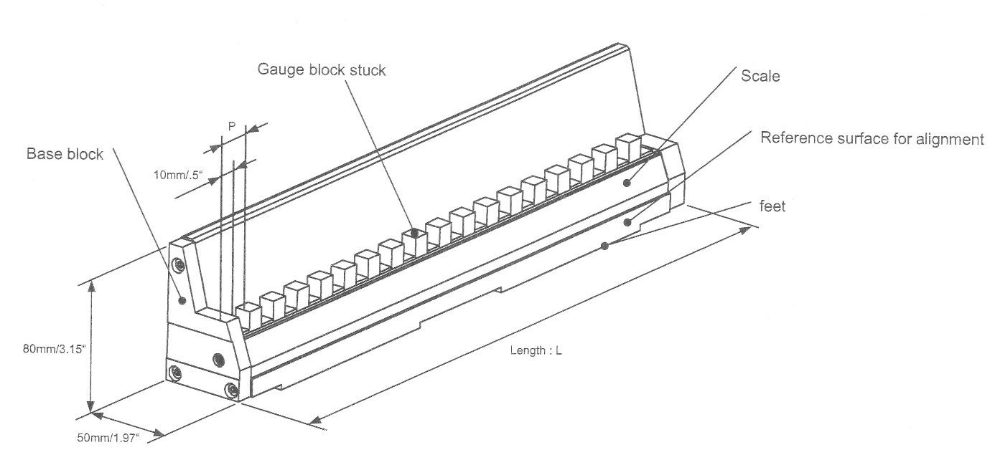 Fig. 3: Details of the step gauge
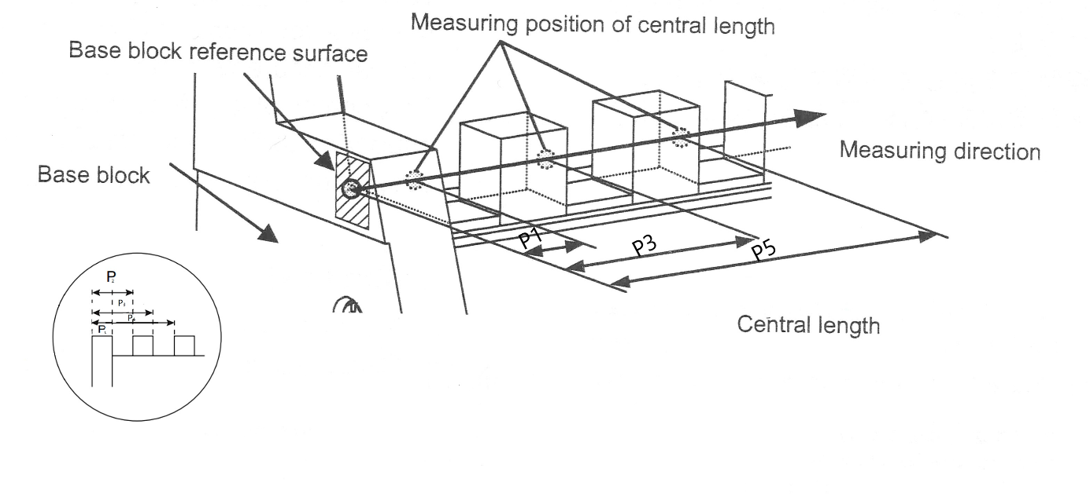 Fig. 4: Measurands

Measuring instructions

Handling the artefact
Step gauge should be stored in such a way as to prevent damage. The step gauge shall only be handled by authorized persons.
Before making the measurements, the step gauge needs to be checked to verify that the measuring surface is not damaged (never touch the measuring faces of step gauge with bare fingers).
Open the wooden case, unscrew the two wing nuts and take out the step gauge as shown in figure 5.
Lay the step gauge gently on a machine table taking care not to give any shock to the instrument.
The step gauge should be examined before despatch and any change in condition during the measurement at each laboratory should be communicated to the pilot laboratory. Ensure that the content of the package is complete before shipment. Always use the original packaging.
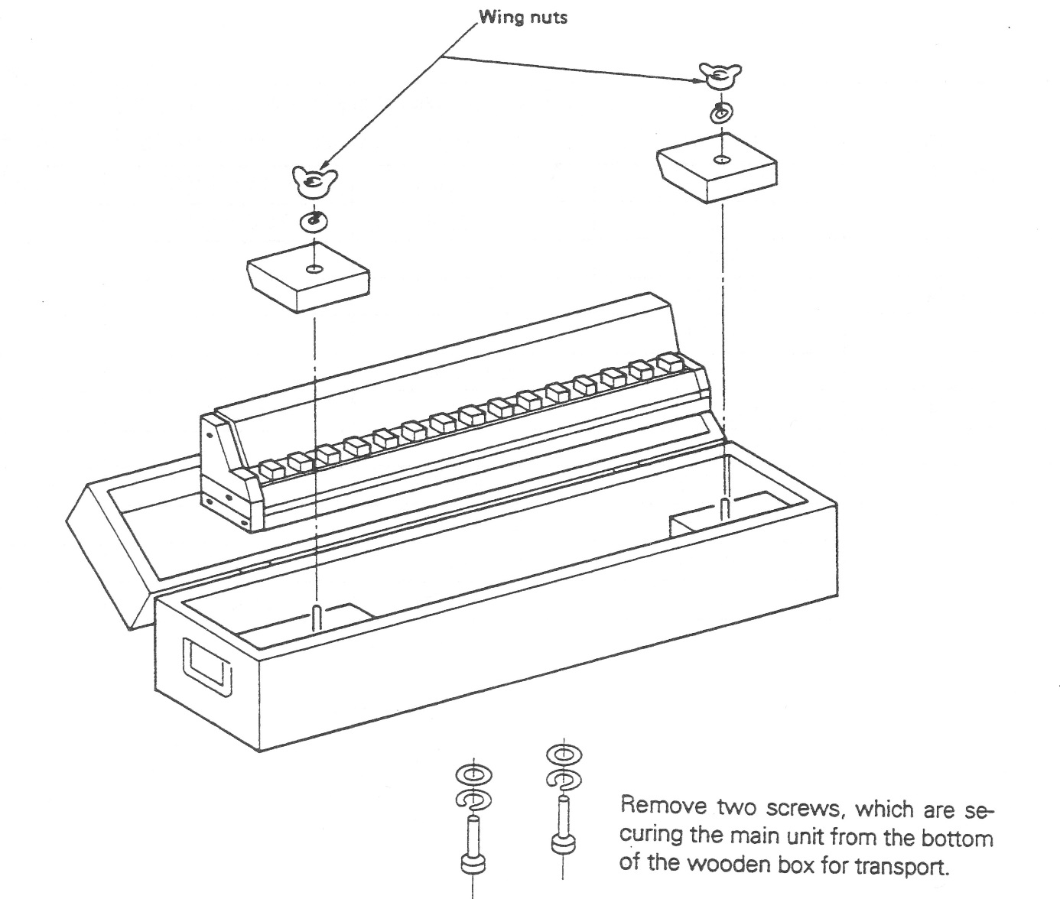Fig. 5: Description of unpacking and packing of the step gauge

Cleaning
The gauge should be cleaned of dust particles using dry, clean air or other clean gases. The measurement surfaces should be cleaned using Ethanol. No other cleaning techniques are permitted.

Traceability
Length measurements should be traceable to the latest realisation of the metre as set out in the current “Mise en Pratique”. Temperature measurements should be made using the International Temperature Scale of 1990 (ITS-90).

Measurands
The measurands of the step gauge are the distances of the centres of the front and back faces of the individual gauges of the step-gauge with respect to the centre of the front face of the first gauge.
The measurements should be carried out using the measurement lines laid out in section 4.1.
The thermal expansion coefficient indicated for the artefact should be used by Laboratories when measuring the artefact. Laboratories should report the temperatures at which the length measurements were made. Laboratories should only measure the artefact at a temperature close to 20 °C.
  - Measurement instructions
The participants are free to choose their own method of measurement. However, under the assumption that the value of the measurand is a true property of the material measure of length, only one result for a measurand shall be given irrespective of the number of different measurement methods used. For each method applied, a complete description of the method has to be given. The measurements have to be reported for measuring conditions, given in 5.7.
Before calibration, the step gauge must be inspected for damage. Any scratches, dirty spots or other damages have to be documented.
The measurement results (appropriately corrected to the reference conditions) have to be reported using the table in Appendix B.1.

Measurement uncertainty
The uncertainty of measurement shall be estimated according to the ISO Guide to the Expression of Uncertainty in Measurement. The participating laboratories are encouraged to use their usual model for the uncertainty calculation.
The participants are asked to report the standard uncertainty. Moreover, the expanded measurement uncertainty U has to be expressed in the usual length-dependent form:
$$U=Q[A,B∙L]$$
where A is the fixed part and B the proportional part
using a coverage factor of k = 2.
Table 4: Example of measurement uncertainty budget
Description | Quantity | Standard uncertainty | Sensitivity coefficient | Standard uncertainty | Standard uncertainty
 | x_{i} | u(x_{i}) | c_{i} = ∂l/∂x_{i} | (Fixed component µm) | (proportional component µm L in m)
Gauge temperature error (measured - actual)
Gauge expansion coefficient
(uncert.* temperature error from 20 °C)
Gauge alignment to measurement axis (includes face)
Gauge alignment errors due to the gauge reference surfaces
Laser interferometer wavelength (traceability)
Optical refractive index (air monitoring)
Optical dead path
Probe(system) repeatability(resolution)
Probe diameter – or bidirectional uncertainty
Abbe error
Others

Reference conditions
Measurement results should be reported for the reference temperature of 20 °C. For corrections, the linear thermal expansion coefficient (10.76 ± 0.50) x 10⁻⁶ K⁻¹ should be used.

Reporting of results

Results and uncertainties
As soon as possible after measurements have been completed, the results should be communicated to the pilot laboratory within six weeks at the latest.
The measurement report forms in appendices B & C of this document will be sent by e-mail (Word/Excel document) to all participating laboratories. It would be appreciated if the report forms (in particular the results sheet) could be completed by computer and sent back electronically to the pilot. Appendix B with measurement results should be submitted in an Excel spreadsheet. The signed report must also be sent in paper form by mail or electronically as a scanned pdf document. In case of any differences, the signed forms are considered to be the definitive version. Please observe the correct units to be used when reporting results.
Following receipt of all measurement reports from the participating laboratories, the pilot laboratory will analyse the results and prepare a draft A0 check. This will be sent to each participant to check their own results entered to analysis sheet. Within 3 months a first draft A.1 report on the comparison should be done. This will be circulated to the participants for comments, additions and corrections.

Analysis of results

Calculation of the reference value
The key comparison reference value (KCRV) is calculated as the weighted mean of the participant results. The check for consistency of the comparison results with their associated uncertainties will be made based on Birge ratio, the degrees of equivalence for each laboratory and each interval with respect to the KCRV will be evaluated using E_{n} values, along the lines of the WG-MRA-KC-report-template. If necessary, artefact instability, correlations between institutes and the necessity for linking to another comparison will be taken into account.

Artefact instability
The instability of the standards must be determined in course of the comparison. Because during the transportation and measurement the artefact may be deformed due to temperature change or shock, the instability of the artefact must be determined in course of the comparison. For this check the measurements of the pilot laboratory are used exclusively, not that of the other participants.
Using these data a linear regression line is fitted and the slope together with its uncertainty is determined.
Three cases can be foreseen:
- The linear regression line is an acceptable drift model and the absolute drift is smaller than its uncertainty. The step gauge is considered stable and no modification to the standard evaluation procedure will be applied. In fact the results of the pilot’s stability measurements will not influence the numerical results in any way.
- The linear regression line is an acceptable drift model and the absolute drift is larger than its uncertainty, i.e. there is a significant drift for the step gauge. In this case an analysis similar to [Nien F Z et al. 2004, Statistical analysis of key comparisons with linear trends, Metrologia 41, 231] will be followed. The pilot influences the KCRV by the slope of the drift only, not by the measured absolute lengths.
- The data are not compatible at all with a linear drift, regarding the uncertainties of the pilot’s measurements. In this case the artefact is unpredictably unstable or the pilot has problems with its measurements. All participants have to agree a suitable approach

Correlation between laboratories
Since the topic of this project is the comparisons of primary measurements, correlations between the results of different NMIs are unlikely. A possible exception is the common use of the recommended thermal expansion coefficients (from table 3). A correlation will become relevant only when the step gauge is calibrated far away from 20 °C which should not be the case. Thus correlations are normally not considered in the analysis of this comparison. However if a significant drift exist, correlations between institutes are introduced by the analysis proposed in section 7.2.

Linking to other comparisons
The CCL task group on linking CCL TG-L will set guidelines for linking this comparison to any other key comparison within CCL for the same measurement quantity. The comparison will be linked to the EURAMET L-K5.2016 through the linking lab NPL.

References
[1] EURAMET Guide on Comparisons – EURAMET Guide No. 4, Version 2.0 (04/2021)
[2] CIPM MRA-D-05: Measurement comparisons in the CIPM MRA
[3] JCGM 100 :2008 (GUM with minor corrections) ”Evaluation of measurement data – Guide to the expression of uncertainty in measurement”, Sept. 2008
[4] EA-4/02 M:2021 ”Expression of the uncertainty of measurement in calibration”, Nov. 2021
[5] Final report of EURAMET key comparison EURAMET.L-K5-2016 ” Calibration of 1-D CMM artefacts: step gauges”, NPL, 2016, EURAMET Project #1365, Metrologia 2020, 57, Tech. Suppl. 04002
[6] Cox M G 2002 The evaluation of key comparison data, Metrologia 39 589–95

Appendix A – Reception of Standards
To: | Dariusz Czułek, Piotr Sosinowski GUM  Central Office of Measures, Elektoralna 2, Warsaw, 00-139, Poland  Fax: +48 22 581 95 43 e-mail: length@gum.gov.pl
From: | NMI: ……………………………… Name: ………………………………  Signature: ……………………………… Date: ………………………………

We confirm having received the 610 mm artefact for the EURAMET.L-K5 comparison on the date given above.
After a visual inspection:
There is no apparent damage.
There are scratches or rust the gauge surface. Please indicate the location and, if possible, include photos.
There is severe damage of the step gauge. Please indicate it and, if possible, include photos.
We confirm having received ATA carnet (only to labs outside EU)
Yes
No

Appendix B – Results Report Form – fill Excel file XXX_EURAMET.L-K5.n01 Results Report Form
To: | Dariusz Czułek, Piotr Sosinowski GUM  Central Office of Measures, Elektoralna 2, Warsaw, 00-139, Poland  Fax: +48 22 581 95 43 e-mail: length@gum.gov.pl
From: | NMI: ……………………………… Name: ………………………………  Signature: ……………………………… Date: ………………………………
      - Measurement results
Face interval | Central length /mm | Standard uncertainty /µm | Effective degrees of freedom
0 – 10
0 – 20
0 – 30
0 – 40
0 – 50
0 – 60
0 – 70
0 – 80
0 – 90
0 – 100
0 – 110
0 – 120
0 – 130
0 – 140
0 – 150
0 – 160
0 – 170
0 – 180
0 – 190
0 – 200
0 – 210
0 – 220
0 – 230
0 – 240
0 – 250
0 – 260
0 – 270
0 – 280
0 – 290
0 – 300
0 – 310
0 – 320
0 – 330
0 – 340
0 – 350
0 – 360
0 – 370
0 – 380
0 – 390
0 – 400
0 – 410
0 – 420
0 – 430
0 – 440
0 – 450
0 – 460
0 – 470
0 – 480
0 – 490
0 – 500
0 – 510
0 – 520
0 – 530
0 – 540
0 – 550
0 – 560
0 – 570
0 – 580
0 – 590
0 – 600
0 – 610

      - Uncertainty of measurement
Name and symbol x_{i} | distrib. | u(x_{i}) unit | ν_{i} | c_{i} = ∂dl/∂x_{i} | u_{i}(dl) /µm

Combined standard uncertainty: u_{c}(L)=
Expanded uncertainty: U(L) (k = ) =
$$U\left(L\right)=Q\left[A,BL\right]$$

Please state your CMC uncertainty for your corresponding measurement service(s) (if you have such a CMC) and the identifier of the service (in MRA Appendix C).

If the uncertainty of the CMC is significantly different than that of the related CMC, please explain why this is the case.

Appendix C –– Description of the measurement instrument
To: | Dariusz Czułek, Piotr Sosinowski GUM  Central Office of Measures, Elektoralna 2, Warsaw, 00-139, Poland  Fax: +48 22 581 95 43 e-mail: length@gum.gov.pl
From: | NMI: ……………………………… Name: ………………………………  Signature: ……………………………… Date: ………………………………

Description of measuring technique (enclose photo(s) and/or sketch(es) of the instrument)
....................................................................................................................................................
....................................................................................................................................................
....................................................................................................................................................
....................................................................................................................................................
....................................................................................................................................................
....................................................................................................................................................
....................................................................................................................................................
....................................................................................................................................................
....................................................................................................................................................
....................................................................................................................................................
....................................................................................................................................................
....................................................................................................................................................

