CCL Key Comparison CCL-K1.n01
Interferometric Measurement of Central Length of Gauge Blocks

Technical protocol

Ian D. Leroux (NRC-CNRC)

Ottawa, October 2022
Contents
1 Document Control 3
2 Introduction 3
2.1 Comparison topic 3
2.2 Support for CMCs/service categories 3
3 Organization 4
3.1 Participants 4
3.2 Schedule 5
3.3 Reception, transportation, insurance, costs 7
4 Artefacts 8
4.1 Description of artefacts 8
5 Measuring instructions 9
5.1 Handling the artefact 9
5.2 Traceability 10
5.3 Measurands 10
5.4 Measurement uncertainty 10
5.5 Optical phase change and roughness correction 11
5.6 Reference condition 11
6 Reporting of results 11
6.1 Results and standard uncertainties as reported by participants 11
7 Analysis of results 12
7.1 Calculation of the KCRV 12
7.2 Artefact instability 12
7.3 Correlation between laboratories 13
7.4 Linking of result to other comparisons 13
Appendix A – Reception of Standards 14
Appendix B – Conditions of Measuring Faces 15
Appendix C – Results Report Form 17
Appendix D – Description of the measurement instrument 18

Document Control
Version Draft A.1 issued on 2022-07-26.
Version Draft A.2 issued on 2022-10-11. Updates to circulation schedule for VTT MIKES, INRIM, and VNIIM. Updates and corrections to contact information for NMC-A*STAR and INMETRO. One gauge’s nominal length changed from 5 mm to 6 mm. Clarify that all circulating standards will be made of steel. Correct error in the full title of the MRA. Omit obsolete reference to the WGDM. Refer to CCL, not TC-L, in case of non-linear drift in gauge length.
Version A.3 issued on 2022-10-21. Added pictures of artifacts and transport case.

Introduction
The metrological equivalence of national measurement standards and of calibration certificates issued by national metrology institutes is established by a set of key and supplementary comparisons chosen and organized by the Consultative Committees of the CIPM or by the regional metrology organizations in collaboration with the Consultative Committees.

Comparison topic
At its meeting in October 2021, the Consultative Committee for Length (CCL) decided upon a key comparison on the measurement of the central length of gauge blocks by interferometry, numbered CCL-K1.n01, with NRC-CNRC as the pilot laboratory. The comparison was registered in January 2022, and artefact circulation is planned to start in October 2022.

General Procedures
The procedures outlined in this document cover the technical procedure to be followed during the measurements. A goal of the key and supplementary comparisons for topics in dimensional metrology is to demonstrate the equivalence of routine calibration services offered by NMIs to clients, as listed in Appendix C of the Mutual Recognition Arrangement (MRA). To this end, participants in this comparison agree to use the same apparatus and methods as routinely applied to client artefacts.
By their declared intention to participate in this key comparison, laboratories accept the general instructions and to strictly follow the technical protocol of this document. Due to the large number of participants, it is very important that participating NMIs perform their measurements during assigned dates. Participants should keep in mind that the allocated time period is not only for measurements, but transportation and customs clearance as well. Once the protocol and list of participants has been agreed, no change to the protocol or list of participants may be made without the agreement of all participants.

Support for CMCs/service categories
This comparison directly tests CMCs linked to the measurand “central length” of service categories 2.2.1 (gauge blocks) and 2.2.2 (long gauge blocks) in the DimVIM. Other service categories and CMCs supported by this comparison can be found by looking up key comparison topic CCL-K1 in the CCL Competence Matrix.

Organization

Participants
Table 1. List of participant laboratories and their contacts.
Lab Code | Institute and address | Contact person, phone, email
NMC-A*STAR | Optical Metrology  National Metrology Centre of the  Agency for Science, Technology and Research  8 CleanTech Loop #01-20  Singapore 673145  Republic of Singapore | Baoxi Xu  +65 67149268  xu_baoxi@nmc.a-star.edu.sg  Shengkai Yu  +65 67149272  yu_shengkai@nmc.a-star.edu.sg
BEV | Bundesamt für Eich- und Vermessungswesen  Arltgasse 35  Wien, A1160  Austria | Michael Matus  +43 1 21110-826540  michael.matus@bev.gv.at  Georg Zechner  georg.zechner@bev.gv.at
CMI | Czech metrology institute  Okruzni 31  638 00 Brno  Czech Republic  Address for shipment of gauges:  Czech metrology institute  Regional inspectorate Liberec  Slunecna 23  460 01 Liberec  Czech Republic | František Dvořáček  +420 728 168 414  fdvoracek@cmi.cz  Petr Balling  +420 602 190 269  pballing@cmi.cz
INMETRO | Dimci/Diopt/Laint  Instituto Nacional de Metrologia, Qualidade e Tecnologia  Av. Nª Sª das Graças, 50, Xerém, 25250-020  Duque de Caxias, RJ  Brazil | Ricardo dos S. França  +55 21 2679 9205  rsfranca@inmetro.gov.br  Walter Oliveira Jr.  wojunior@inmetro.gov.br  Ivan L. Silva  ilsilva@inmetro.gov.br
INRIM | Istituto Nazionale di Ricerca Metrologica  str. delle cacce, 91  10135 Torino  Italia | Alessandro Balsamo  +39 011 3919.970  a.balsamo@inrim.it
LNE | Laboratoire National de Métrologie et d’Essais (LNE)  Département Dimensionnel  1, rue Gaston Boissier 75724 Paris Cedex 15  France  Address for shipment of gauges:  LNE  23 avenue Albert Bartholomé 75015 PARIS  France | José Salgado  +33 1 40 43 39 57  jose.salgado@lne.fr
NIM | National Institute of Metrology (NIM)  No.18, Bei San Huan Dong Lu  Chaoyang District.  Beijing 100029  P.R. of China | Xudong Zhang  +86‐10‐64524924  zhxd@nim.ac.cn
NMISA | National Metrology Institute of South Africa  Building 5  CSIR Scientia Campus  Meiring Naude Road  Brummeria  Pretoria  South Africa | Patrick Masina  +27 12 947 2740  +27 79 0522 897 (cell)  pmasina@nmisa.org
NIST | NIST  100 Bureau Drive  Building 219, Room F036  Gaithersburg, MD 20899  USA | Eric Stanfield  +1 301 975 4882  eric.stanfield@nist.gov
NPL | National Physical Laboratory  Hampton Road  Teddington, Middlesex  TW11 0LW  United Kingdom | Sheryl Bailey  +44 20 8943 6395  sheryl.bailey@npl.co.uk
NRC-CNRC | Metrology  National Research Council Canada  1200 Montreal Road, building M36  Ottawa, ON K1A 0R6  Canada | Ian D. Leroux  +1 613 993 2313  ian.leroux@nrc-cnrc.gc.ca
TUBITAK UME | Dimensional Group Labs  TÜBİTAK Gebze Yerleşkesi  Barış Mah. Dr.Zeki Acar Cad. No:1  41470 Gebze KOCAELİ TURKEY | Tanfer YANDAYAN  +90 262 679 5000 ext. 5312  tanfer.yandayan@tubitak.gov.tr  S. Asli AKGOZ  +90 262 679 5000 ext. 5301  asli.akgoz@tubitak.gov.tr  Damla SENDOGDU  +90 262 679 5000 ext. 3552  damla.sendogdu@tubitak.gov.tr
VNIIM | D.I. Mendeleev Institute for Metrology  19, Moskovsky prospekt, Saint-Petersburg, 190005, Russia | Natalia Kononova  +7 812 323 96 69  +7 812 323 96 64  +7 812 323 96 63  n.a.kononova@vniim.ru
VSL | VSL National Metrology Institute  Thijsseweg 11  2629 JA Delft  The Netherlands | Richard Koops  +31 6 31119917  rkoops@vsl.nl
VTT MIKES | MIKES Metrology,  VTT Technical Research Centre of Finland Ltd  Tekniikantie 1  FI-02150 ESPOO  Finland | Antti Lassila  +358 40 7678584  Antti.Lassila@vtt.fi

Note that while multiple contacts are listed for certain participant laboratories in order to simplify communications during the comparison, only one person from each participating laboratory can be included as an author in the final comparison report. Participants with multiple contacts should notify the pilot of their choice of primary contact for reporting purposes.

Schedule
The timetable given in table 2 has been drawn up in coordination with the pilot of the EURAMET.L-K1.n01 comparison which is running concurrently, taking into account the expressed preferences of the participants. Each laboratory has six weeks that include customs clearance, calibration and transportation of the artefacts to the following participant. By confirming its participation, each laboratory commits to performing the measurements and shipping the artefacts to the next participant in the allotted period, allowing enough transportation time that the next participant will receive the artefacts at the beginning of their own measurement period. If a laboratory cannot complete its measurements in time, whether due to technical problems, delays in customs, or other difficulties, the laboratory must contact the pilot as soon as possible. The laboratory may, at the pilot’s discretion, be required to send the artefacts directly to the next participant before completing its own measurements.
Table 2. Planned schedule of the comparison.
RMO | Laboratory | Starting date | Remarks
SIM | NRC-CNRC | 2022-10-01 | Pilot opening check
EURAMET | UME | 2022-11-15
AFRIMETS | NMISA | 2023-01-01
APMP | NIM | 2023-02-15
SIM | NIST | 2023-04-01
EURAMET | NPL | 2023-05-15
- | NRC-CNRC | 2023-07-01 | Pilot interim check & ATA Carnet renewal
EURAMET | BEV | 2023-08-15
EURAMET | LNE | 2023-10-01
EURAMET | VSL | 2023-11-15
EURAMET | CMI | 2024-01-01
EURAMET | INRIM | 2024-02-15
EURAMET | VTT MIKES | 2024-04-01
- | NRC-CNRC | 2024-05-15 | Pilot interim check & ATA Carnet renewal
APMP | NMC-A*STAR | 2024-07-01
- | NRC-CNRC | 2024-08-15 | Close ATA Carnet
SIM | INMETRO | 2024-10-01
- | NRC-CNRC | 2024-11-15 | Pilot interim check
COOMET | VNIIM | 2025-02-15
- | NRC-CNRC | 2025-04-01 | Pilot closing check

Reception, transportation, insurance, costs
The gauges will be transported in a single hard-walled foam-filled travel case, with each gauge seated in its own slot in the foam (Figure 1).
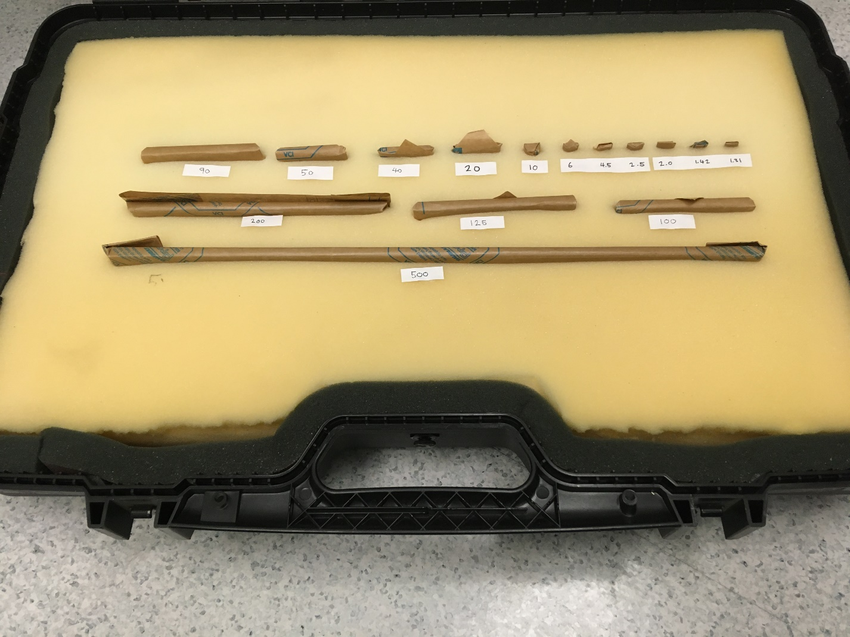
Figure 1: Transport Case
Upon reception of the package, each laboratory must check that the contents are complete and that there is no apparent damage to the box or to any of the standards. The arrival and condition of the standards must be reported immediately to the pilot and to the previous participant who sent the shipment, preferably using the form of Appendix A.
The pilot laboratory will cover the costs of the standards and of the packaging, and the shipping costs to the first laboratory in each loop of the circulation. The pilot laboratory has no insurance for any loss or damage of the standards during the circulation. Each participant is responsible for the costs of shipping the package to the next laboratory in the circulation.Each participant should contact the laboratory that follows them in the circulation to confirm its shipping address (which may change over the course of the comparison). This should be done while measurements are underway, so that the artefacts can be shipped onward as soon as the measurements are completed.
After completing its measurements, each participant must repackage the standards and ship them to the next participant. The steel gauge blocks need to be protected against corrosion when not being measured by means of protective oil. Please coat them with oil before packing them for transportation or when stocked for more than three days.
Each participating laboratory shall cover the costs of shipping and transport insurance against loss or damage. The package should be shipped with a reliable parcel service. Please inform the pilot laboratory and the following participant when the package leaves your installations, indicating all pertinent information such as the carrier and tracking number of the shipment. If the packaging is damaged at any point during circulation, it shall be repaired by the laboratory before onward shipment. In the case that a laboratory or its shipping agent damages one or more artefacts, they may be required by the pilot to replace the artefacts at their own cost (or from the insurance).
The package is accompanied by an ATA carnet. For shipment within the EU the ATA carnet may be shipped inside the box. Outside EU the carnet shall always be shipped with the package, never inside the box, but outside, accessible, and obvious to customs officials. Please be certain, that when receiving the package, you also receive the carnet! For each loop of the circulation, the carnet and package must both return to the pilot within one year of the date of issue of the carnet.

Artefacts

Description of artefacts
The package contains 15 steel gauge blocks. The gauge blocks are of rectangular cross section as specified in ISO 3650, but they are not guaranteed to meet the requirements of any particular grade. The pilot has checked the quality of the gauge faces and their suitability for repeated and reproducible wringing. The 12 short gauges (1.31 mm up to and including 100 mm) were all drawn from a single set. The 3 long gauges (125 mm, 200 mm, and 500 mm) were also drawn from a single set.
Table 3. List of artefacts.
Identification | Nominal length  /mm | Expansion coefficient  /10⁻⁶ K⁻¹ | Manufacturer
- | 1.31 | 10.5 | Hommel Werke
- | 1.42 | 10.5 | Hommel Werke
- | 2 | 10.5 | Hommel Werke
- | 2.5 | 10.5 | Hommel Werke
- | 4.5 | 10.5 | Hommel Werke
- | 6 | 10.5 | Hommel Werke
- | 10 | 10.5 | Hommel Werke
- | 20 | 10.5 | Hommel Werke
- | 40 | 10.5 | Hommel Werke
- | 50 | 10.5 | Hommel Werke
- | 90 | 10.5 | Hommel Werke
- | 100 | 10.5 | Hommel Werke
87058 | 125 | 11.2 | Kolb & Baumann
87405 | 200 | 11.2 | Kolb & Baumann
87981 | 500 | 11.2 | Kolb & Baumann
The coefficients of thermal expansion given in Table 3 are those given by the manufacturer and should be used as such.

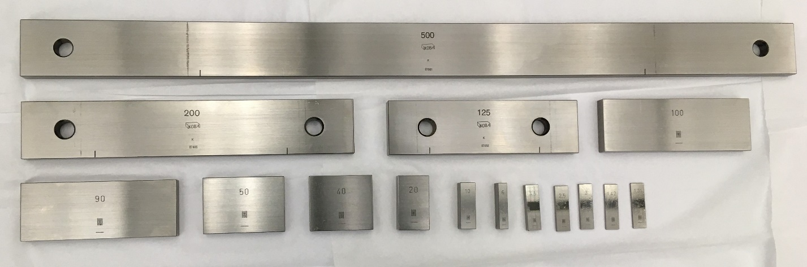
Figure 2: Comparison artifacts

Measuring instructions

Handling the artefact
The gauge blocks should only be handled by authorized persons and stored in such a way as to prevent damage. Before making any measurements, the gauge blocks must be checked to verify that their measuring surfaces are not damaged and do not present severe scratches and/or rust that may affect the measurement result. The condition of the blocks before measurement should be registered in the form provided in appendix B. Laboratories should attempt to measure all gauge blocks unless doing so would damage their equipment. If a gauge block will not wring readily, the participant shall inform the pilot, identifying the affected gauge block and face. No participant shall try to refinish or repair measuring faces by burring, lapping, stoning, or any other method. The measurement of the faces concerned shall be omitted if necessary.
Measurements may only be performed using equipment normally used to offer the relevant CMC service. In case of multiple CMC services in this area, only the service/equipment with the smallest uncertainty should be used, unless the pilot and other participants agree to allow additional instruments to be used; in which case, only the results of the instrument/service with the smallest uncertainty may contribute to the KCRV. No other measurements are to be attempted by the participants and the gauge blocks should not be used for any purpose other than the comparison described in this document. The gauge blocks may not be given to any party other than the participants in the comparison.
The gauge blocks should be examined before despatch and any change in condition during the measurement at each laboratory should be communicated to the pilot laboratory. After the measurements, the gauge blocks must be cleaned and oiled or greased. Ensure that the content of the package is complete before shipment. Always use the original packaging.

Traceability
Length measurements should be traceable to the latest realisation of the metre as set out in the current “Mise en Pratique”. Temperature measurements should be made using the International Temperature Scale of 1990 (ITS-90).

Measurands
The gauge blocks shall be measured based on the standard procedure that the laboratory regularly uses for this calibration service for its customers. The “A” surface is the marked measuring face for gauge blocks with nominal length < 6 mm and the right hand measuring face for gauge blocks with a nominal length ≥ 6 mm, respectively (see Figure 2).
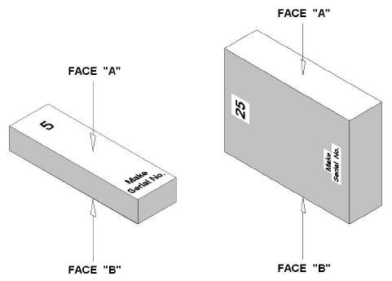
Figure 2 – Nomenclature of faces
The measurand to be reported is the deviation e_{c} of the central length l_{c} from the nominal length l_{n} of a gauge block. In this project the arithmetic mean of the two values for wringing on both faces is considered as representative for e_{c} (see equation (1), the superscripts label the face wrung to the platen). In cases where only one face could be wrung the corresponding value should be reported as the result.
with and (1)
As an optional auxiliary measurand the difference d_{c} of the central lengths measured when the block is wrung to face A and face B, respectively, should be reported according to equation (2). Care has to be taken to use the correct sign.
. (2)

Measurement uncertainty
The uncertainty of measurement shall be estimated according to the ISO Guide to the Expression of Uncertainty in Measurement. The participating laboratories are encouraged to use their usual model for the uncertainty calculation. All measurement uncertainties shall be stated as standard uncertainties. The corresponding effective degree of freedom should be stated by the participants. If none is given, ∞ is assumed.
In the report of the measurement technique (Appendix D) the participant should list any relevant CMC claims for the service(s) related to the comparison.

Optical phase change and roughness correction
The position of the plane where light is reflected from a surface depends on the material and surface finish. As the free measuring face of the gauge block and the platen upon which the gauge block is wrung are in general different in both characteristics, a correction has to be applied. It shall be estimated or determined by each laboratory according to the calibration procedure it usually follows for its customers. Participants should state their technique for estimating this correction in appendix D.

Reference condition
Measurement results should be reported for the reference conditions as set down in the standard ISO 3650. Specifically these conditions include the reference temperature of 20 °C, standard pressure of 101 325 Pa and the orientation in which the blocks are supported for measurement. For temperature corrections the linear thermal expansion coefficient provided in this document (Table 3) should be used.

Reporting of results

Results and standard uncertainties as reported by participants
The measurement results should be communicated to the pilot laboratory as soon as possible, and within six weeks of the completion of measurements at the latest. Results which are not reported in a timely fashion may be dropped from the comparison at the pilot’s discretion.
The measurement report form in appendix C of this document will be sent by e-mail to all participating laboratories as an editable electronic file. It would be appreciated if the forms (in particular the results table) could be completed electronically and returned to the pilot, to reduce the need for error-prone retyping of results. In any case, the signed report must also be sent in paper form by mail or electronically as a scanned pdf document. In case of discrepancies, the signed form will be considered to be the definitive version.
When reporting the results of the comparison, each participant should also report the identifier, range and uncertainty of any existing CMC related to the comparison. This will be used by the pilot when checking whether or not CMC claims are supported by the comparison results.
If the measurement uncertainty reported by a participant is significantly larger than the relevant CMC claim, this should be explained when submitting the results (e.g. air conditioning failure at time of measurements, artefact damage affecting measurements, etc.).
Following receipt of all measurement reports from the participating laboratories, the pilot laboratory will analyse the results and prepare a first draft A.1 report on the comparison. This will be circulated to the participants for comments, additions, and corrections.

Results reported by the pilot
The pilot laboratory will measure the gauge blocks several times throughout the comparison to monitor their stability. However, where the pilot laboratory is acting as a participant in the comparison, only the first set of measurements will be used. This applies in particular to the calculation of KCRVs and to the assessment of the pilot laboratory’s CMC claims.

Analysis of results

Calculation of the KCRV
The key comparison reference value (KCRV) will be calculated separately for each gauge block as the weighted mean of the largest consistent subset of participants’ results [M.G. Cox, Metrologia 44, 187 (2007)]. This procedure is recommended by the CCL [J.E. Decker et al, Metrologia 43, L51 (2006)] and its performance in terms of both statistical confidence and statistical power in detecting inconsistent measurements has been confirmed by recent numerical studies [E. Molloy et al, Metrology 1, 52, (2021)]. The consistency of the comparison results with their associated uncertainties will be checked using the Birge ratio, also known as the reduced $χ^{2}$.

Normalized Errors
Deviations of individual measurement results will be evaluated using normalized errors E_{n}. Two sets of normalized errors will be computed. The first, based on the standard uncertainties and degree-of-freedom estimates reported for the comparison measurements, can serve to support future CMC claims. The second, based on the expanded uncertainties of the participants’ published CMCs (where applicable), can serve to assess participants’ existing CMCs. In both cases, correlations induced by the participants’ contribution to the KCRV will be taken into account [K. Beissner, Metrologia 39, 59, (2002)].

Artefact instability
Some steel gauge blocks exhibit long-term changes in length at a roughly constant rate. Since the rate of contraction or extension of the gauge blocks used in this comparison has not been established in advance, it will be determined over the course of the comparison. For each gauge block, the slope of a linear regression to the pilot laboratory’s check measurements will be used to estimate the drift rate and its uncertainty.
Three cases can be foreseen:
- The linear regression is an acceptable model for the pilot laboratory’s data and the absolute drift rate is smaller than its uncertainty. In this case the gauge block will be considered stable, the KCRV will be a constant value calculated according to the standard evaluation procedure, and the pilot’s additional check measurements will have no influence on the numerical results.
- The linear regression is an acceptable drift model and the absolute drift is larger than its uncertainty, i.e. there is a significant drift of the gauge block length. In this case an analysis similar to [Nien Fan Zhang et al, Metrologia 41, 231 (2004)] will be followed. This treats the KCRV as a linear function of time, with a slope and an offset. The slope will be determined, as above, by the pilot’s check measurements. The offset will still be calculated as a weighted average over all participants (or the largest consistent subset, if there are outliers).
- The pilot’s check measurement results and uncertainties are not adequately described by a linear-drift model. In this case the artefact is unpredictably unstable or the pilot has problems with its measurements. CCL will be consulted to determine how best to proceed in this case.

Note that the absolute lengths measured by the pilot laboratory have no special importance in any of these scenarios; the pilot contributes to the KCRV as a regular participant through its first measurement. Only the differences between the pilot laboratory’s check measurements are used for the determination of the drift rate.

Initial assessment of CMC claims
A given participant’s results will be deemed consistent with their uncertainty claims unless they have at least one result with a normalized error E_{n} > 1 and the ensemble of their normalized errors fails a $χ^{2}$ or Birge-ratio consistency test at the 95% confidence level. If the measurement uncertainty is dominated by fluctuating measurement noise that is uncorrelated between gauge block measurements, then a $χ^{2}$ test provides a global assessment of the participant’s performance that takes into account the likelihood of obtaining normalized error E_{n} > 1 by chance among the 15 measurements [P. Pedone, Measurement 42, 1469 (2009)]. If there are correlations between a single participant’s measurements for different gauge blocks, typically because of a dominant systematic effect, then the $χ^{2}$ test is not justified, but provided the systematic effect was properly included in the uncertainty budget the resulting normalized errors should be below 1. Participants whose results fail both tests will be contacted by the pilot so that the discrepancies may be investigated. The pilot will not reveal the sign or magnitude of discrepancies until the circulation of Draft A.

Correlation between laboratories
Since this is a comparison of primary measurements, correlations between the results of different NMIs are unlikely. A possible exception is the common use of the recommended thermal expansion coefficients (from table 3). A correlation will become relevant only when the gauge blocks are calibrated far from 20 °C which should not be the case. Thus correlations are normally not considered in the analysis of this comparison. However, if a significant drift is measured in some of the artifacts, correlations between institutes may be introduced by the analysis proposed in section 7.2b and will have to be taken into account.

Linking of result to other comparisons
The CCL task group on linking CCL TG-L will set guidelines for linking this comparison to any other key comparison within CCL for the same measurement quantity.

Appendix A – Reception of Standards
To: | Ian D. Leroux, NRC-CNRC  1200 Montreal Road, building M36  Ottawa, ON  K1A 0R6  Canada  e-mail: ian.leroux@nrc-cnrc.gc.ca
From: | NMI: ……………………………… Name: ………………………………  Signature: ……………………………… Date: ………………………………

We confirm receipt of the gauge blocks for the CCL-K1.n01 comparison on the date given above.
After a visual inspection:
The gauges appear undamaged. Their precise state will be reported along with the measurement results using the inspection form in Appendix B.

We have detected significant damage which puts the measurement results at risk. A detailed description of the damage follows. [Include photos and use additional sheets as necessary.]

Appendix B – Condition of Measuring Faces
To: | Ian D. Leroux, NRC-CNRC  1200 Montreal Road, building M36  Ottawa, ON  K1A 0R6  Canada  e-mail: ian.leroux@nrc-cnrc.gc.ca
From: | NMI: ……………………………… Name: ………………………………  Signature: ……………………………… Date: ………………………………
The following significant surface faults (scratches, indentations, corrosion, etc.) were noted after a detailed inspection of the measuring faces.
$l_{n}$ / mm | A face | B face | Comments
1.31
1.42
2.0
2.5
4.5
6
10
20
40
50
90
100
125
200
500

Appendix C – Results Report Form
To: | Ian D. Leroux, NRC-CNRC  1200 Montreal Road, building M36  Ottawa, ON  K1A 0R6  Canada  e-mail: ian.leroux@nrc-cnrc.gc.ca
From: | NMI: ……………………………… Name: ………………………………  Signature: ……………………………… Date: ………………………………
Date of start of measurements: ……………………………… Date of end of measurements: ………………………………
Results:
$l_{n}$ / mm | Identification | e_{c} / nm | u(e_{c}) / nm | ν_{eff} | d_{c} / nm | u(d_{c}) / nm | ν_{eff}
1.31 | -
1.42 | -
2.0 | -
2.5 | -
4.5 | -
6 | -
10 | -
20 | -
40 | -
50 | -
90 | -
100 | -
125 | 87058
200 | 87405
500 | 87981

Appendix D – Description of the measurement instrument
To: | Ian D. Leroux, NRC-CNRC  1200 Montreal Road, building M36  Ottawa, ON  K1A 0R6  Canada  e-mail: ian.leroux@nrc-cnrc.gc.ca
From: | NMI: ……………………………… Name: ………………………………  Signature: ……………………………… Date: ………………………………
Make and type of instrument(s)

Light sources / wavelengths used and traceability path:

Description of measuring technique (mention platen material, method for determining phase correction, other corrections applied such as vertical to horizontal corrections, etc):

Temperature measurement method and range of gauge block temperatures during measurements:

Relevant 95 % CMC uncertainty claim for the service(s) related to this comparison topic (if existing) and identifier of the CMC

If the reported uncertainty is significantly higher than that of the related CMC, explanation for the increased uncertainty

