# Draft B.1

# Report

Comparison of piston-operated volumetric instruments

EURAMET identifier: 1533

BIPM KCDB identifier: EURAMET.M.FF-S16

 

Prepared by:

|  |
| --- |
| Ljiljana Mićića and Elsa Batistab |
| a Directorate of Measures and Precious Metals (DMDM)  Mike Alasa 14, 11000 Belgrade, Republic of Serbia b INSTITUTO PORTUGUÊS DA QUALIDADE (IPQ) Rua António Gião 2, 2829-513 Caparica, Portugal |

**Contents**

1 Document control 3

2 Introduction 3

3 Participants and organisation of the comparison 3

3.1 Coordinator and member of the support 3

3.2 List of participants 4

3.3 Organisation and comparison schedule 5

4 Transfer standards 6

4.1 Stability of the transfer standards 7

5 The measurement procedure 7

6 Equipment, calibration liquid characteristics and ambient conditions of the participants 7

7 Measurement results 8

8 Determination of the reference value 9

9 Results with reference value and RV uncertainty 10

9.1 Results with reference value and RV uncertainty for syringe 10

9.2 Results with reference value and RV uncertainty for piston burette 12

9.3 Results with reference value and RV uncertainty for micropipette 13

10 Uncertainty calculation 18

10.1 Uncertainty components for syringe 18

10.2 Uncertainty components piston burette 19

10.3 Uncertainty components for micropipette 20

11 CMCs 24

12 Conclusions 26

13 References 27

Annex 1- Equipment information for all laboratories 28

Annex 2- Burette results for 5 mL and 25 mL 42

# 1 Document control

|  |  |
| --- | --- |
| Version Draft A.1  Version B | Issued on 18 April 2024  Issued on 20 September 2024 |
| Version B.1 | Issued on 13 November 2024 |

# 2 Introduction

The objective of this comparison is to compare the calibration results of piston – operated volumetric instruments: (0,2 – 10) μL micropipette, 50 mL piston burette and 1 mL glass syringe. Furthermore, this comparison is intended to be used c of the participants in the calibration of piston – operated volumetric instruments.

This comparison has been organized within EURAMET with project number [1533](https://www.euramet.org/technical-committees/tc-projects/details/project/comparison-of-piston-operated-volumetric-instruments) and has been also registered in the BIPM KCDB as [EURAMET.M.FF-S16](https://www.bipm.org/kcdb/comparison?id=1771). The comparison was approved during the online EURAMET TCF volume subgroup meeting 2021 and officially started in January 2022, the final measurements were performed in November 2023 and the last participant’s reports received in April 2024.

This comparison was organized and carried out according to the MRA rules [1].

# 3 Participants and organisation of the comparison

# 3.1 Coordinator and member of the support

The pilot laboratory for the comparison is DMDM (Republic of Serbia).

The co-pilot for the comparison is IPQ (Portugal).

Coordinator:

Ljiljana Mićić (DMDM)

Tel.: +381 11 20 24 423; e-mail: [ljmicic@dmdm.rs](mailto:ljmicic@dmdm.rs)

Support:

Elsa Batista (IPQ)

Tel.: +351212 94 8167, e-mail: [ebatista@ipq.pt](mailto:ebatista@ipq.pt)

# 3.2 List of participants

In May 2022, INM-RO, Romania joined the comparison after it started.

*Table 1*: Participants

|  |  |  |  |
| --- | --- | --- | --- |
| **Participant** | **Contact person** | **e-mail** | **Address** |
| DMDM | Ljiljana Mićić | [ljmicic@dmdm.rs](mailto:ljmicic@dmdm.rs) | Directorate of Measures and Precious metals,  Mike Alasa 14, 11000 Belgrade,  REPUBLIC OF SERBIA |
| UME | Ümit Akçadağ | [umit.akcadag@tubitak.gov.tr](mailto:umit.akcadag@tubitak.gov.tr) | TUBITAK Ulusal Metroloji Enstitusu (TUBITAK UME), TUBİTAK Gebze Yerleşkesi Barış Mah. Dr. Zeki Acar Cad. No:1  41400 Gebze KOCAELİ, TURKEY |
| [IMBiH](http://www.met.gov.ba/) | Ernad Borovac | [ernad.borovac@met.gov.ba](mailto:ernad.borovac@met.gov.ba) | Institute of Metrology of Bosnia and Herzegovina,  Branilaca Sarajeva 25, 71000 Sarajevo,  BOSNIA AND HERZEGOVINA |
| MIRS | Urška Turnšek | [Urska.Turnsek@gov.si](mailto:Urska.Turnsek@gov.si) | Metrology Institute of the Republic of Slovenia,  Tkalska ulica 15, SI-3000 Celje,  SLOVENIA |
| BFKH | Csilla Vámossy | [vamossy.csilla@bfkh.gov.hu](mailto:vamossy.csilla@bfkh.gov.hu) | Budapest Főváros Kormányhivatala  1124 Budapest, Németvölgyi út 37-39.  HUNGARY |
| CMI | Miroslava Benková | [mbenkova@cmi.cz](mailto:mbenkova@cmi.cz) | Czech Metrology Institute, Okružní 31, 638 00 Brno, CZECH REPUBLIC |
| GUM | Ewa Malejczyk | [ewa.malejczyk@gum.gov.pl](mailto:ewa.malejczyk@gum.gov.pl) | Central Office of Measures,  Elektoralna 2, 00-139 Warszawa, POLAND |
| FORCE | Lise-Lotte Grue | [llg@force.dk](mailto:llg@force.dk) | FORCE Technology,  Park Allé 345, 2605 Broendby, DENMARK |
| RISE | Per Wennergren | [per.wennergren@ri.se](mailto:per.wennergren@ri.se) | Research Institutes of Sweden,  Brinellgatan 4, SE-50462 Borås, SWEDEN |
| VSL | Erik Smits | [fsmits@vsl.nl](mailto:fsmits@vsl.nl) | VSL B.V.  Hugo de Grootplein 1, 3314 EG Dordrecht,  NETHERLANDS |
| SASO -NMCC | Abdulkarim A. Al-shahrani | [a.shahrany@saso.gov.sa](mailto:a.shahrany@saso.gov.sa) | * SASO, Riyadh - Imam Saud bin Abdulaziz bin Mohammed Road, the intersection of Prince Turki bin Abdulaziz I Road   BOX 3437 Riyadh 11471, Kingdom of Saudi Arabia |
| BMM | Jasna Mudreša | [jasna.mudresa@metrologija.gov.me](mailto:jasna.mudresa@metrologija.gov.me) | Bureau of Metrology, Arsenija Boljevića bb, 81000 Podgorica, MONTENEGRO |
| INM | Istrate Florin | [florin.istrate@inm.ro](mailto:florin.istrate@inm.ro) | National Institute of Metrology  (INM)  code zip 042 122, Bucuresti  Sos. Vitan-Bârzesti, nr. 11 Sector 4 |
| IPQ | Elsa Batista | [ebatista@ipq.pt](mailto:ebatista@ipq.pt) | Portuguese Institute for Quality  Rua António Gião, 2  2829-513 Caparica, PORTUGAL |

# 3.3 Organisation and comparison schedule

The circulation of the transfer standards started in January 2022 and was completed in November 2023. The detailed time schedule for the comparison is given in Tables 2 and 3.

A period of one month was originally allowed for the measurements in each laboratory, including the time necessary for transportation.

For the transport, the transfer standards were packed in two transportation boxes, the micropipette was in one and the syringe with piston burette was in another transportation box because of different owners and different documentation for import / export. This lead to different calibration period of the transfer standards.

*Table 2*. Period of realisation of comparison for micropipette

|  |  |  |  |
| --- | --- | --- | --- |
| **NMI** | **Country** | **Mean date of**  **measurements** | **Period for measurements and transport** |
| DMDM | Republic of Serbia | September 2021 | 1.9.2021. – 4.3.2022.[1] |
| [IMBIH](http://www.met.gov.ba/) | Bosnia and Herzegovina | March 2022 | 4.3. – 23.3.2022. |
| UME | Turkey | March 2022 | 24.3. – 4.4.2022. |
| MIRS | Republic of Slovenia | April 2022 | 14.4. – 16.5.2022 |
| BFKH | Hungary | not measured | 17.5. – 30.5.2022. |
| ČMI | Czech Republic | June 2022 | 2. – 28.6.2022. |
| GUM | Poland | July 2022 | 30.6 – 29.7.2022. |
| FORCE | Denmark | August 2022 | 15.8. – 22.8.2022. |
| RISE | Sweden | September 2022 | 24.8. – 30.9.2022.[2] |
| BMM | Montenegro | December 2022 | 15.11. – 21.12.2022. |
| INM | Romania | January 2023 | 4.1. – 19.1.2023. |
| DMDM | Republic of Serbia | not measured | 6.2. – 8.2.2023.[3] |
| SASO -NMCC | Saudi Arabia | March 2023 | 26.2. – 28.3.2023. |
| DMDM | Republic of Serbia | not measured | 5.4. – 6.4.2023.[4] |
| IPQ | Portugal | May 2023 | 6.4. – 25.5.2023. |

*Table 3*. Period of realisation of comparison for syringe and piston burette

|  |  |  |  |
| --- | --- | --- | --- |
| **NMI** | **Country** | **Mean date of**  **measurements** | **Period for measurements and transport** |
| DMDM | Republic of Serbia | October 2021 | 1.10.2021. - 31.1.2022. |
| UME | Turkey | February 2022 | 16.2. – 7.3.2022. |
| [IMBIH](http://www.met.gov.ba/) | Bosnia and Herzegovina | March 2022 | 11.3. – 12.4.2022. |
| MIRS | Republic of Slovenia | May 2022 | 19.5. – 10.6.2022.[5] |
| BFKH | Hungary | June 2022 | 19.6. – 6.7.2022. |
| ČMI | Czech Republic | July 2022 | 8.7. – 26.7.2022. |
| GUM | Poland | August 2022 | 28.7. – 14.9.2022. |
| FORCE | Denmark | September 2022 | 16.9. – 30.9.2022. |
| RISE | Sweden | October 2022 | 4.10. – 2.11.2022. |
| VSL | Netherlands | December 2022 | 3.11. – 29.12.2022. |
| SASO - NMCC | Saudi Arabia | January | 29.12. – 22.1.2023. |
| BMM | Montenegro | August 2023 | 13.2. – 7.8.2023.[6] |
| INM | Romania | October 2023 | 3.10. – 8.11.2023.[7] |
| IPQ | Portugal | November 2023 | 10.11. – 30.11.2023. |

There was some delays in the planned circulation scheme that are signed in the table and this was mainly due to customs issues.

# 4 Transfer standards

Three different transfer standards were circulated in this comparison:

1) a variable 1-channel electronic micropipette, measuring range (0,2 – 10) μL, manufacturer Biohit (Sartorius), type Picus, ser. number 13008918 (see figure 1),

2) a glass syringe, measuring range (0 – 1) mL, manufacturer ILS, ser. number S1, inner diameter is 4,607 mm, (see figure 2),

3) a piston burette, measuring range (0 – 50) mL, manufacturer Brand, type Titrette, ser. number, 21F89857 (see figure 3).

The owner of the micropipette is DMDM, Serbia. The owner of the glass syringe and piston burette is IPQ, Portugal.

BIOHIT Picus electronic pipette User Manual was available on website https://solutions.pipette.com/wp-content/uploads/Biohit-Picus-User-Manual.pdf.

The micropipette needs to have attached a removable plastic tip in order to aspirate the liquid. DMDM supplied these tips that were provided from the manufacturer.

The piston burette was supplied with suitable adapters for any liquid container.

The micropipette and piston burette used for this comparison are essentially of plastic material with a cubic coefficient of thermal expansion of 2,4 × 10-4 /ºC [4]. This coefficient is linked to the material and is equal for every participant.

The glass syringe has a cubic coefficient of thermal expansion of 9,9 × 10-6 /ºC [3] and a removable tip is connected to the syringe in order to improve the delivery of liquid, it should not be removed.

|  |  |  |
| --- | --- | --- |
|  |  |  |
| **Figure 1** - Micropipette | **Figure 2** - Glass syringe | **Figure 3** - Piston burette |

# 4.1 Stability of the transfer standards

Two different measurements of micropipette were performed by the pilot laboratory and two different measurements of piston burette and syringe were performed by the co-pilot laboratory during the comparison in order to verify the stability of the standards.

*Table 4*. Stability of the transfer standards

|  |  |  |  |  |  |
| --- | --- | --- | --- | --- | --- |
|  | Measurement | Date | Volume | Uncertainty | ΔV |
| Micropipette | 1 | September 2021. |  L |  L | 0,016 L |
| 2 | June 2023. |  L |  L |
| Piston burette | 1 | August 2021. | 50,0090 mL | 0,0092 mL | 0,0011 mL |
| 2 | November 2023. | 50,0101 mL | 0,0071 mL |
| Syringe | 1 | August 2021. | 1,00308 mL | 0,002 mL | 0,00017 mL |
| 2 | November 2023. | 1,00325 mL | 0,002 mL |

# The variation found in all instruments is smaller than the claimed uncertainty and therefore it is verified that the instruments are stable for the entire comparison.

# 5 The measurement procedure

All the participating NMIs used the gravimetric method, to determine the amount of water that the instruments deliver at reference temperature of 20 ºC, based on ISO standard 4787 [3] and ISO 8655 [2], with equation (1):

 (1)

Where:

*V*20 volume, at the 20 ºC , in µL

*I*I weighing result of the recipient full of liquid, in mg

*I*E weighing result of the empty recipient, in mg

*ρ*W water density, in mg/ µL, at the calibration temperature *t*, in ºC, is advisable to use the Tanaka density formula [7]

*ρ*A air density, in mg/µL

*ρ*B density of masses used during measurement (substitution) or during calibration of the balance, in mg/ µL

** cubic thermal expansion coefficient of the material of the instruments, in °C-1

*t* water temperature used in the calibration, in °C

# 6 Equipment, calibration liquid characteristics and ambient conditions of the participants

All instruments and ambient conditions used by the NMIs are described in Аnnex 1. In general, all participants used the equipment and ambient temperature recommended by the relevant standards.

# 7 Measurement results

The results for all three transfer standards reported by the participating laboratories are included in table 5.

*Table 5*. Laboratory results

|  |  |  |  |  |  |  |
| --- | --- | --- | --- | --- | --- | --- |
| Code | Micropipette | | Piston burette | | Syringe | |
| *V*/µL | *U*/µL | *V*/mL | *U*/mL | *V*/mL | *U*/mL |
| GUM | 10,018  4,988  0,997  0,213 | 0,025  0,025  0,025  0,025 | 50,006  25,0019  5,0008 | 0,007  0,0062  0,0058 | 1,0017 | 0,003 |
| MBM | 10,046  5,002  1,009  0,227 | 0,04  0,04  0,034  0,02 | 49,9999  25,002  4,9997 | 0,007  0,007  0,007 | 1,003031 | 0,003 |
| IPQ | 10,041  4,996  1,001  0,227 | 0.023  0,013  0,011  0,011 | 50,0101  25,008  5,0028 | 0,0071  0,0073  0,0062 | 1,00325 | 0,002 |
| BFKH | -[8] | | 49,987  24,990  4,998 | 0,008  0,007  0,006 | 1,0013 | 0,006 |
| MIRS | 10,024  4,990  1,029  0,226 | 0,02  0,018  0,025  0,013 | 50,0156  25,0042  5,0033 | 0,009  0,008  0,0028 | 1,004 | 0,004 |
| ČMI | 9,998  4,995  1,005  -[9] | 0,028  0,019  0,012  -[10] | 50,010  25,006  5,0037 | 0,021  0,012  0,0066 | -[11] | |
| DMDM | 10,027  4,999  1,005  0,21 | 0,06  0,059  0,058  0,041 | 50,008  25,003  5,002 | 0,008  0,009  0,005 | 1,001 | 0,002 |
| SASO | 10,088  5,031  1,03874  0,238774 | 0,049828  0,029223  0,016278  0,01642 | 50,0018982  25,0033793  5,002559 | 0,0111597  0,007636  0,005909 | 1,0023983 | 0,003114 |
| RISE | 10,027  5,027  1,043  0,253 | 0,046  0,028  0,019  0,009 | 49,9883  24,9899  4,9992 | 0,0096  0,0086  0,0082 | 1,00072 | 0,0058 |
| VSL | -[12] | | 50,0153  25,0115  5,0031 | 0,0094  0,0086  0,0084 | -[13] | |
| FORCE | 10,06  5,025  1,054  -[14] | 0,086  0,084  0,073  -[15] | 50,007  25,001  5,003 | 0,016  0,015  0,012 | 1,0006 | 0,0047 |
| UME | 10,052  5,023  1,032  -[16] | 0,043  0,042  0,041  -[17] | 49,99775  24,99821 4,99961 | 0,00927  0,00687  0,00593 | 1,00142 | 0,002206 |
| INM | 10,0230  4,979  0,9955  -[18] | 0,0183645  0,0162868  0,0146815  -[19] | 50,00581  25,001965  5,000649 | 0,005916754  0,008124627  0,005977712 | 0,999453 | 0,0018857 |
| IMBIH | 10,001  4,982  0,998  -[20] | 0,074  0,073  0,072  -[21] | 50,007  25,004  5,001 | 0,013  0,008  0,006 | 1,000138 | 0,002008 |

# 8 Determination of the reference value

To determine the reference value of this comparison (KCRV) the weighted mean (3) was selected, using the inverses of the squares of the associated standard uncertainties as the weights [7], according to the instructions given by the BIPM:

 (3)

To calculate the standard deviation *u(y)* associated with the volume *y* [7] equation (4) was used:

 (4)

The expanded uncertainty of the reference value is *U(y) =* 2 × *u(y).*

To identify an overall consistency of the results a chi-square test can be applied to all *n* calibration results [7].

 (5)

where the degrees of freedom are: *  *= *n* -1

The consistency check is regarded as failed if: . The function CHIINV(0,05; n-1) in MS Excel was used. The consistency check was failing if CHIINV(0,05; n-1) < χ2obs.

If the consistency check did not fail then *y* was accepted as the KCRV *xref* and *U*(*xref*) was accepted as the expanded uncertainty of the KCRV.

If the consistency check failed then the laboratory with the highest value of is excluded from the next round of evaluation and the new reference value, reference standard uncertainty and chi-squared value is calculated again without the excluded laboratory. When the consistency check passes, for each laboratory results, *xi* the degree of equivalence *di* between each laboratory and the KCRV (*xref*) is calculated using the following formulas [7]:

*di = xI - xref*  (6)

*U(di) = 2* × *u(di)* (7)

where *u(di)* is calculated from

*u 2(di) = u 2(xi) – u 2(xref)* (8)

Discrepancy values can be identify if $\left|d_{i}\right|>2u\left(d_{i}\right)$.

To calculate the degrees of equivalence *dij* between the laboratories the following formulas are used [7]:

*di,j= xi* - *xj* (9)

*U(di,j)* = *2* × *u(di,j)* (10)

Where *u(di,j)* is calculated from

*u 2(di,j)* = *u 2(xi)* + *u 2(xj)* (11)

The factor 2 in equation (7 and 10) corresponds to 95 % coverage under the assumption of normality.

# 9 Results with reference value and RV uncertainty

# 9.1 Results with reference value and RV uncertainty for syringe

The obtained reference value is 1,002 mL. The expanded uncertainty *U* = 2 × *u(y)* of the reference value is: 0,001 mL.

The calculated value **  = 19,68 is larger than the observed value* obs*= 10,44, therefore the set of results are consistent from a statistical point of view and the reference value is accepted.

All the measurement results, the reference value and its uncertainty are presented in the following figure 4:

**Figure 4** – Syringe results with reference value

The degree of equivalence with the RV is presented in figure 5:

**Figure 5** – Degree of equivalence syringe

*Table 6.*  Degree of equivalence with RV

|  |  |  |  |
| --- | --- | --- | --- |
| **Laboratory** | ***d*i(mL)** | ***Ud*i(mL)** | ***E*i** |
| GUM | 0,000 | 0,003 | 0,06 |
| MBM | 0,001 | 0,003 | 0,52 |
| IPQ | 0,002 | 0,002 | 0,93 |
| BFKH | 0,000 | 0,006 | -0,04 |
| MIRS | 0,002 | 0,004 | 0,63 |
| DMDM | -0,001 | 0,002 | -0,29 |
| SASO | 0,001 | 0,003 | 0,29 |
| RISE | -0,001 | 0,006 | -0,14 |
| FORCE | -0,001 | 0,005 | -0,20 |
| UME | 0,000 | 0,002 | -0,06 |
| INM | -0,002 | 0,003 | -0,72 |
| IMBIH | -0,001 | 0,002 | -0,82 |

# 9.2 Results with reference value and RV uncertainty for piston burette

For the burette it was decided to consider only the 50 mL has official results. The value 5 mL and 25 mL results are in Annex 2 and will not serve for CMC validation since the uncertainty of the resolution of the device in more than 50 % of the total uncertainty.

**9.2.1 50 mL**

The obtained reference value is 50,004 mL. The expanded uncertainty *U* = 2 × *u(y)* of the reference value is: 0,002 mL.

The calculated value **  = 22,36 is smaller than observed value*  obs*= 49,84, this means that the chi-square test failed and the results are not consistent.

After removal two outliers, the obtained reference value is 50,007 mL. The expanded uncertainty *U* = 2 × *u(y)* of the reference value is: 0,003 mL.

The calculated value **  = 19,68 is larger than observed value*  obs*= 16,70, therefore the set of results are consistent from a statistical point of view and the reference value is accepted.

**Figure 6** – Piston burette results at 50 mL with reference value

The degree of equivalence with the RV is presented in figure 7.

**Figure 7** – Degree of equivalence burette 50 mL

*Table 7.*  Degree of equivalence with RV

|  |  |  |  |  |
| --- | --- | --- | --- | --- |
| **Laboratory** | ***Di*(mL)** | ***Udi*(mL)** | ***Ei*** | **Info** |
| GUM | -0,001 | 0,007 | -0,09 |  |
| MBM | -0,007 | 0,007 | -1,03 |  |
| IPQ | 0,003 | 0,007 | 0,52 |  |
| BFKH | -0,020 | 0,008 | -2,58 | Excluded |
| MIRS | 0,009 | 0,009 | 1,04 |  |
| ČMI | 0,003 | 0,021 | 0,16 |  |
| DMDM | 0,001 | 0,008 | 0,18 |  |
| SASO | -0,005 | 0,011 | -0,42 |  |
| RISE | -0,018 | 0,009 | -1,98 | Excluded |
| VSL | 0,009 | 0,009 | 0,96 |  |
| FORCE | 0,000 | 0,016 | 0,02 |  |
| UME | -0,009 | 0,009 | -0,99 |  |
| INM | -0,001 | 0,005 | -0,15 |  |
| IMBIH | 0,000 | 0,013 | 0,03 |  |

# 9.3 Results with reference value and RV uncertainty for micropipette

9.3.1 **10 µL**

The obtained reference value is 10,027 µL. The expanded uncertainty *U* = 2 × *u(y)* of the reference value is: 0,009 µL.

The calculated value ** = 19,68 is larger than the observed value* obs*= 15,89, therefore the set of results are consistent from a statistical point of view and the reference value is accepted.

**Figure 8** – Micropipette results at 10 L with reference value

**Figure 9** – Degree of equivalence, micropipette results at 10 L

*Table 8.* Degree of equivalence with RV

|  |  |  |  |
| --- | --- | --- | --- |
| **Laboratory** | ***Di*(L)** | ***Udi*(L)** | ***Ei*** |
| GUM | -0,01 | 0,02 | -0,40 |
| MBM | 0,02 | 0,04 | 0,48 |
| IPQ | 0,01 | 0,02 | 0,64 |
| MIRS | 0,00 | 0,02 | -0,19 |
| ČMI | -0,03 | 0,03 | -1,11 |
| DMDM | 0,00 | 0,06 | -0,01 |
| SASO | 0,06 | 0,05 | 1,24 |
| RISE | 0,00 | 0,05 | -0,01 |
| FORCE | 0,03 | 0,09 | 0,38 |
| UME | 0,02 | 0,04 | 0,58 |
| INM | 0,00 | 0,02 | -0,27 |
| IMBIH | -0,03 | 0,07 | -0,36 |

9.3.2 **5 µL**

The obtained reference value is 4,996 µL. The expanded uncertainty *U* = 2 × *u(y)* of the reference value is: 0,007 µL.

The calculated value ** = 19,68 is larger than the observed value* obs*= 18,24, therefore the set of results are consistent from a statistical point of view and the reference value is accepted.

**Figure 10** - Micropipette results at 5 L with reference value

**Figure 11** – Degree of equivalence micropipette results at 5 L

*Table 9.* Degree of equivalence with RV

|  |  |  |  |
| --- | --- | --- | --- |
| **Laboratory** | ***Di*(L)** | ***Udi*(L)** | ***Ei*** |
| GUM | -0,01 | 0,02 | -0,34 |
| MBM | 0,01 | 0,04 | 0,15 |
| IPQ | 0,00 | 0,01 | -0,02 |
| MIRS | -0,01 | 0.02 | -0,37 |
| ČMI | 0,00 | 0,02 | -0,07 |
| DMDM | 0,00 | 0,06 | 0,05 |
| SASO | 0,.03 | 0,03 | 1,23 |
| RISE | 0,03 | 0,03 | 1,14 |
| FORCE | 0,03 | 0,08 | 0,34 |
| UME | 0,03 | 0,04 | 0,65 |
| INM | -0,02 | 0,01 | -1,16 |
| IMBIH | -0,01 | 0,07 | -0,20 |

9.3.3. **1 µL**

The obtained reference value is 1,012 µL. The expanded uncertainty *U* = 2 × *u(y)* of the reference value is: 0,006 µL.

The calculated value **  = 19,68 is smaller than observed value*  obs*= 37,64, this means that the chi-square test failed and the results are not consistent.

After removal two outliers, the obtained reference value is 1,004 µL. The expanded uncertainty *U* = 2 × *u(y)* of the reference value is: 0,006 µL.

The calculated value **  = 16,92 is larger than observed value*  obs*= 9,84, therefore the set of results are consistent from a statistical point of view and the reference value is accepted.

**Figure 12** - Micropipette results at 1 L with reference value

**Figure 13** – Degree of equivalence micropipette results at 1 µL

*Table 10.* Degree of equivalence with RV

|  |  |  |  |  |
| --- | --- | --- | --- | --- |
| **Laboratory** | ***Di*(L)** | ***Udi*(L)** | ***Ei*** | **Info** |
| GUM | -0,01 | 0,02 | -0,29 |  |
| MBM | 0,00 | 0,03 | 0,15 |  |
| IPQ | 0,00 | 0,01 | -0,34 |  |
| MIRS | 0,02 | 0,02 | 1,03 |  |
| ČMI | 0,00 | 0,01 | 0,09 |  |
| DMDM | 0,00 | 0,06 | 0,02 |  |
| SASO | 0,03 | 0,02 | 2,31 | Excluded |
| RISE | 0,04 | 0,02 | 2,17 | Excluded |
| FORCE | 0,05 | 0,07 | 0,69 |  |
| UME | 0,03 | 0,04 | 0,69 |  |
| INM | -0,01 | 0,01 | -0,64 |  |
| IMBIH | -0,01 | 0,07 | -0,08 |  |

9.3.4 **0,2 µL**

The obtained reference value is 0,236 µL. The expanded uncertainty *U* = 2 × *u(y)* of the reference value is: 0,005 µL. The calculated value ** = 12,59 is smaller than the observed value*  obs*= 25,80, this means that the chi-square test failed and the results are not consistent.

After removal one outlier the obtained reference value is 0,227 µL. The expanded uncertainty *U* = 2 × *u(y)* of the reference value is: 0,006 µL. The calculated value ** = 11,07 is larger than the observed value*  obs*= 4,02, therefore the set of results are consistent from a statistical point of view and the reference value is accepted.

**Figure 14** - Micropipette results at 0,2 L with reference value

**Figure 19** – Degree of equivalence for micropipette results at 0,2 L

*Table 11.* Degree of equivalence with RV

|  |  |  |  |  |
| --- | --- | --- | --- | --- |
| **Laboratory** | ***Di*(L)** | ***Udi*(L)** | ***Ei*** | **Info** |
| GUM | -0,01 | 0,02 | -0,59 |  |
| MBM | 0,00 | 0,02 | -0,01 |  |
| IPQ | 0,00 | 0,01 | -0,03 |  |
| MIRS | 0,00 | 0,01 | -0,11 |  |
| DMDM | -0,02 | 0,04 | -0,43 |  |
| SASO | 0,01 | 0,02 | 0,76 |  |
| RISE | 0,03 | 0,01 | 4,08 | Excluded |

# 10 Uncertainty calculation

It was requested that all participants present their uncertainty calculations based on the GUM [9].

# 10.1 Uncertainty components for syringe

|  |  |  |  |  |  |  |
| --- | --- | --- | --- | --- | --- | --- |
| Quantity *(xi)* | GUM | MBM | IPQ | BFKH | MIRS | DMDM |
| Repeatability measurements (mL) | 0.000093 | 2.54E-04 | 0.000277 | 1.580E-04 | 4.71E-04 | 5.61E-04 |
| Mass (g) | 0.000003 | 1.65E-05 | 4.1056E-06 | 8.529E-05 | 1.00E-05 | 2.77E-05 |
| Air Density (g/mL) | 0.000002 | 1.94E-06 | 9.836E-07 | 1.756E-06 | 9.14E-07 | 3.40E-07 |
| Water Density (g/mL) | -0.000010 | -4.19E-06 | -2.905E-05 | -2.512E-06 | 1.10E-05 | -1.89E-05 |
| Density of the mass pieces (g/mL) | 0.000001 | 1.30E-06 | 6.4951E-07 | 1.116E-05 | 1.30E-06 | 1.36E-06 |
| Cub. coeff. of expansion from the glass syringe material (°C-1) | 0.00000002 | -7.04E-07 | -5.792E-09 | -2.505E-06 | 4.95E-07 | 6.00E-07 |
| Water temperature (ºC) | -0.000001 | -6.08E-07 | -1.625E-06 | 4.900E-08 | 2.07E-06 | -9.81E-07 |
| Meniscus reading (mL) | 0.000833 | 1.44E-03 | 0.0001732 | 2.886E-03 | 5.10E-04 | 8.33E-04 |
| Evaporation (mL) | 0.000004 | - | 2.0785E-06 | 1.0E-04 | 6.87E-07 | - |
| Other | 0.001247 | - | 0.00095 | - | 1.88E-03 | - |
| Combined uncertainty/mL | 0,0015 | 0,0015 | 0.00100496 | 0,003 | 0,002 | 0,001 |
| Expanded uncertainty/mL | 0,003 | 0,003 | 0.002 | 0,006 | 0,004 | 0,002 |

|  |  |  |  |  |  |  |
| --- | --- | --- | --- | --- | --- | --- |
| Quantity *(xi)* | SASO | RISE | FORCE | UME | INM | IMBIH |
| Repeatability measurements (mL) | 1.36E-04 | 4.26E-04 | 0.000861 | 3.054E-04 | 2.569E-04 | 8.140E-05 |
| Mass (g) | 1.75E-04 | 8.52E-05 | 3.51E-05 | 3.683E-05 | 9.006E-04 | 3.570E-05 |
| Air Density (g/mL) | 6.20E-05 | 2.54E-06 | 5.02E-06 | 1.270E-06 | 4.714E-08 | 4.773E-07 |
| Water Density (g/mL) | -1.00E-06 | -2.89E-05 | 5.82E-06 | 3.158E-06 | 2.832E-06 | 1.371E-05 |
| Density of the mass pieces (g/mL) | 1.00E-06 | 5.20E-07 | - | 5.090E-07 | 1.052E-04 | 1.214E-06 |
| Cub. coeff. of expansion from the glass syringe material (°C-1) | -1.00E-07 | -7.51E-07 | 9.25E-07 | 2.519E-08 | 8.500E-06 | 3.506E-07 |
| Water temperature (ºC) | -2.90E-06 | -2.86E-08 | 1.69E-05 | 5.788E-07 | 3.393E-06 | 2.692E-06 |
| Meniscus reading (mL) | 1.54E-03 | 2.89E-03 | 3.72E-06 | 1.059E-03 | 7.506E-03 | - |
| Evaporation (mL) | 2.90E-05 | -2.89E-05 | 5.80E-05 | 3.416E-05 | 2.801E-05 | - |
| Other | - | - | 9.97E-04 | - | - | 1.000E-03 |
| Combined uncertainty/mL | 0.0015 | 0.003 | 0.0023 | 0.001 | 0.001 | 0.001 |
| Expanded uncertainty/mL | 0.003 | 0.006 | 0.005 | 0.002 | 0.002 | 0.002 |

# 10.2 Uncertainty components piston burette

10.2.1 Uncertainty components for 50 mL piston burette

|  |  |  |  |  |  |  |
| --- | --- | --- | --- | --- | --- | --- |
| Quantity *(xi)* | GUM | MBM | IPQ | BFKH | MIRS | ČMI |
| Repeatability measurements (mL) | 0.000366 | 6.71E-04 | 0.0014158 | 2.672E-04 | 1.73E-03 | 0.002 |
| Mass (g) | 0.000217 | 1.32E-04 | 0.000134 | 8.524E-05 | 1.13E-03 | 0.0006 |
| Air Density (g/mL) | 0.000088 | 1.51E-04 | 4.8982E-05 | 8.763E-05 | 4.63E-05 | 0.000065 |
| Water Density (g/mL) | -0.000504 | -2.90E-04 | -0.0014481 | -1.250E-04 | 5.42E-04 | 0.000023 |
| Density of the mass pieces (g/mL) | 0.000032 | 6.58E-05 | 3.2344E-05 | 2.846E-06 | 6.52E-05 | 0.000027 |
| Cub. coeff. of expansion from the piston burette material (°C-1) | 0.000080 | -2.20E-04 | -9.875E-05 | -3.000E-03 | 1.39E-04 | 0.000175 |
| Water temperature (ºC) | -0.000815 | -4.23E-04 | -0.000449 | -6.000E-05 | 9.32E-04 | 0.000202 |
| Resolution of the piston burette (mL) | 0.002887 | 2.89E-03 | 0.0028867 | 2.900E-03 | 2.89E-03 | 0.002887 |
| Other | 0.001680 | 1.44E-03 | - | - | 2.52E-03 | 0.009881 |
| Combined uncertainty/mL | 0.0035 | 0.0034 | 0.0036 | 0.004 | 0.0045 | 0.010 |
| Expanded uncertainty/mL | 0.006 | 0.007 | 0.007 | 0.008 | 0.009 | 0.021 |

|  |  |  |  |  |  |  |
| --- | --- | --- | --- | --- | --- | --- |
| Quantity *(xi)* | DMDM | SASO | RISE | VSL | FORCE | UME |
| Repeatability measurements (mL) | 0.0017 | 1.09E-03 | 0.001717 | 0.0009 | 3.7107E-03 | 1.043E-03 |
| Mass (g) | 2.69E-05 | 1.57E-03 | 0.000085 | 0.0015 | 3.5100E-05 | 1.565E-04 |
| Air Density (g/mL) | 0.0000 | 3.08E-03 | 0.000127 | 0.0000 | 2.5090E-04 | 6.342E-05 |
| Water Density (g/mL) | -0.0005 | -4.63E-05 | -0.001445 | 0.0000 | 2.9060E-04 | 1.580E-04 |
| Density of the mass pieces (g/mL) | 0.0001 | 2.61E-05 | 0.000026 | 0.0000 | [22] | 2.542E-05 |
| Cub. coeff. of expansion from the piston burette material (°C-1) | -0.0001 | -3.20E-04 | -0.000405 | 0.0000 | 7.7270E-04 | 4.521E-05 |
| Water temperature (ºC) | -0.0005 | -3.47E-03 | -0.001039 | 0.0000 | 2.2000E-03 | 3.466E-03 |
| Resolution of the piston burette (mL) | 0.00289 | 2.89E-03 | 0.004082 | 0.0041 | 5.8000E-03 | 2.887E-03 |
| Other | - | - | - | 0.0016 | 2.9004E-03 | - |
| Combined uncertainty/mL | 0.003405 | 0.0057985 | 0.0048 | 0.0047 | 0.00784 | 0.00464 |
| Expanded uncertainty/mL | 0.0068 | 0.0116 | 0.0096 | 0.0094 | 0.016 | 0.0093 |

|  |  |  |
| --- | --- | --- |
| Quantity *(xi)* | INM | IMBIH |
| Repeatability measurements (mL) | 0.001768738 | 6.665E-04 |
| Mass (g) | 0.004748260 | 1.140E-03 |
| Air Density (g/mL) | 0.000001970 | 2.385E-05 |
| Water Density (g/mL) | 0.000266510 | 2.605E-04 |
| Density of the mass pieces (g/mL) | 0.000105255 | 6.066E-05 |
| Cub. coeff. of expansion from the piston burette material (°C-1) | 0.000120402 | 4.533E-04 |
| Water temperature (ºC) | 0.000311385 | 2.756E-03 |
| Resolution of the piston burette (mL) | 0.003023243 | 2.887E-03 |
| Other | - | 5.000E-03 |
| Combined uncertainty/mL | 0.0059 | 0.007 |
| Expanded uncertainty/mL | 0.012 | 0.013 |

# 10.3 Uncertainty components for micropipette

10.3.1 Uncertainty components for 10 L micropipette

|  |  |  |  |  |  |  |
| --- | --- | --- | --- | --- | --- | --- |
| Quantity *(xi)* | GUM | MBM | IPQ | MIRS | ČMI | DMDM |
| Repeatability measurements (µL) | 0.000958 | 3.46E-03 | 0.00833 | 6.01E-03 | 0.012 | 0.016 |
| Mass (mg) | 0.002166 | 1.65E-02 | 0.00274 | 5.06E-03 | 0.003358 | 0.0064 |
| Air Density (mg/ µL) | 0.000018 | 7.53E-06 | 0.00001 | 9.05E-09 | 0.000013 | 3.32E-09 |
| Water Density (mg/ µL) | -0.000101 | -4.04E-05 | -0.00029 | 1.08E-07 | 0.000005 | -0.00032 |
| Density of the mass pieces (mg/ µL) | 0.000006 | 1.32E-05 | 0.00001 | 1.29E-08 | 0.000005 | 0.000013 |
| Cub. coeff. of expansion from the micropipette material (°C-1) | 0.000010 | -9.47E-05 | -0.00013 | 3.61E-08 | 0.000005 | -3.55E-08 |
| Water temperature (ºC) | -0.000245 | -3.75E-05 | -0.00075 | 3.34E-07 | 0.000041 | 3.52E-07 |
| Handling of micropipette (µL) | 0.010000 | 0.01 | 0.00580 | 4.04E-03 | 0.005772 | 0.0058 |
| Evaporation (µL) | 0.001200 | - | 0.00069 | 7.63E-05 | 0 | 0.01 |
| Other | 0.007412 | - | 0.00289 | 3.34E-03 | 0.002775 | 0.02 |
| Combined uncertainty/ µL | 0.013 | 2.0E-02 | 0.011 | 0.0095 | 0.014 | 0.03 |
| Expanded uncertainty/ µL | 0.025 | 0.04 | 0.023 | 0.02 | 0.028 | 0.06 |

|  |  |  |  |  |  |  |
| --- | --- | --- | --- | --- | --- | --- |
| Quantity *(xi)* | SASO | RISE | FORCE | UME | INM | IMBIH |
| Repeatability measurements (µL) | 6.33E-03 | 0.021550 | 0.023300 | 0.006 | 0.0012687 | 3.36E-03 |
| Mass (mg) | 1.85E-03 | 0.001630 | 3.5106E-05 | 0.020 | 0.0064022 | 3.569E-02 |
| Air Density (mg/ µL) | 1.43E-03 | 0.000025 | 5.0469E-08 | 1.294E-05 | -1.231E-10 | 4.918E-06 |
| Water Density (mg/ µL) | -8.00E-06 | -0.000289 | 5.8474E-08 | 3.153E-05 | -5.612E-09 | 5.195E-05 |
| Density of the mass pieces (mg/ µL) | 5.00E-06 | 5.20E-06 | [23] | 5.186E-06 | 1.3136E-06 | 1.251E-05 |
| Cub. coeff. of expansion from the micropipette material (°C-1) | -5.40E-05 | -0.0006647 | 7.29465E-08 | 1.254E-06 | 9.3619E-10 | 3.006E-05 |
| Water temperature (ºC) | -7.00E-04 | -0.000006936 | 3.45935E-07 | 0.00014 | -1.910E-05 | 1.281E-03 |
| Handling of micropipette (µL) | 5.77E-03 | 0.00577 | 5.02E-06 | 0.00577 | 0.0057735 | 1.000E-02 |
| Evaporation (µL) | 2.33E-02 | -0.00289 | 5.8357E-06 | 0.000637 | 0.002895070 | - |
| Other | - | - | - | - | 4.4323E-07 | - |
| Combined uncertainty/ µL | 0.024914 | 0.023 | 0.043 | 0.022 | 0.0091822 | 0.037 |
| Expanded uncertainty/ µL | 0.0498 | 0.046 | 0.086 | 0.043 | 0.0184 | 0.074 |

10.3.2 Uncertainty components for 5 L micropipette

|  |  |  |  |  |  |  |
| --- | --- | --- | --- | --- | --- | --- |
| Quantity *(xi)* | GUM | MBM | IPQ | MIRS | ČMI | DMDM |
| Repeatability measurements (µL) | 0.001574 | 2.55E-03 | 0.00360 | 4.98E-03 | 0.0086 | 0.0097 |
| Mass (mg) | 0.002166 | 1.65E-02 | 0.00273 | 5.04E-03 | 0.003358 | 0.0064 |
| Air Density (mg/ µL) | 0.000009 | 9.81E-06 | 0.00000 | 4.52E-09 | 0.000006 | 2.0E-09 |
| Water Density (mg/ µL) | -0.000050 | -2.00E-05 | -0.00025 | 5.41E-08 | 0.000002 | -1.21E-07 |
| Density of the mass pieces (mg/ µL) | 0.000003 | 6.56E-06 | 0.00000 | 6.44E-09 | 0.000003 | 7E-09 |
| Cub. coeff. of expansion from the micropipette material (°C-1) | 0.000005 | -4.33E-05 | -0.00007 | 7.62E-09 | 0.000003 | -0.000008 |
| Water temperature (ºC) | -0.000121 | -1.87E-05 | -0.00036 | 2.35E-07 | 0.000021 | -0.00013 |
| Handling of micropipette (µL) | 0.005000 | 0.005 | 0.00290 | 2.02E-03 | 0.002884 | 0.00288 |
| Evaporation (µL) | 0.001200 | - | 0.00121 | 3.82E-05 | 0 | 0.02 |
| Other | 0.011099 | - | 0.00289 | 5.17E-03 | 0.001387 | 0.017 |
| Combined uncertainty/ µL | 0.013 | 2E-02 | 0.006 | 0.0090 | 0.0095 | 0.029 |
| Expanded uncertainty/ µL | 0.025 | 0.04 | 0.013 | 0.018 | 0.019 | 0.059 |

|  |  |  |  |  |  |  |
| --- | --- | --- | --- | --- | --- | --- |
| Quantity *(xi)* | SASO | RISE | FORCE | UME | INM | IMBIH |
| Repeatability measurements (µL) | 1.46E-03 | 0.01318 | 0.022900 | 0.006 | 0.0026722 | 3.897E-03 |
| Mass (mg) | 8.29E-04 | 0.00173 | 3.5106E-05 | 0.020 | 0.0064833 | 3.569E-02 |
| Air Density (mg/ µL) | 0.000715 | 1.272E-05 | 2.5210E-08 | 6.463E-06 | -1.037E-07 | 2.452E-06 |
| Water Density (mg/ µL) | -4.00E-06 | -1.445E-04 | 2.92E-08 | 1.575E-05 | -4.017E-06 | 2.589E-05 |
| Density of the mass pieces (mg/ µL) | 3.00E-06 | 2.601E-06 | [24] | 2.591E-06 | 0.0006526 | 6.235E-06 |
| Cub. coeff. of expansion from the micropipette material (°C-1) | -4.20E-05 | -0.0003468 | 9.37E-16 | 6.263E-07 | -1.998E-06 | 2.097E-05 |
| Water temperature (ºC) | -3.49E-04 | 3.47E-06 | 1.26E-07 | 0.00007 | -9.548E-06 | 5.760E-04 |
| Handling of micropipette (µL) | 2.88E-03 | 2.89E-03 | 0.0000029 | 0.00289 | 0.0028868 | 5.000E-03 |
| Evaporation (µL) | 0.014203 | -2.89E-03 | 0.0000029 | 0.000811 | 0.0028950 | - |
| Other | - | - | - | - | 1.1644E-07 | - |
| Combined uncertainty/ µL | 0.014612 | 0.014 | 0.042 | 0.021 | 0.0081434 | 0.036 |
| Expanded uncertainty/ µL | 0.029 | 0.028 | 0.084 | 0.042 | 0.0163 | 0.073 |

10.3.3 Uncertainty components for 1 L micropipette

|  |  |  |  |  |  |  |
| --- | --- | --- | --- | --- | --- | --- |
| Quantity *(xi)* | GUM | MBM | IPQ | MIRS | ČMI | DMDM |
| Repeatability measurements (µL) | 0.001723 | 2.74E-03 | 0.00360 | 3.43E-03 | 0.0047 | 0.009 |
| Mass (mg) | 0.002166 | 1.65E-02 | 0.00274 | 5.02E-03 | 0.003358 | 0.0064 |
| Air Density (mg/ µL) | 0.000002 | 5.24E-07 | 0.00000 | 9.40E-10 | 0.000001 | 3E-10 |
| Water Density (mg/ µL) | -0.000010 | -4.04E-06 | -0.00005 | 1.12E-08 | 0.0000005 | -2.6E-08 |
| Density of the mass pieces (mg/ µL) | 0.000001 | 1.32E-06 | 0.00000 | 1.34E-09 | 0.000001 | 1.3E-09 |
| Cub. coeff. of expansion from the micropipette material (°C-1) | 0.000001 | -8.50E-06 | -0.00001 | 4.46E-09 | 0.000001 | -1.36E-06 |
| Water temperature (ºC) | -0.000028 | -3.77E-06 | -0.00007 | 4.09E-08 | 0.000004 | -2.94E-05 |
| Handling of micropipette (µL) | 0.001000 | 0.001 | 0.00059 | 4.04E-03 | 0.00058 | 0.0006 |
| Evaporation (µL) | 0.001200 | - | 0.00115 | 7.63E-05 | 0 | 0.02 |
| Other | 0.012176 | - | 0.00289 | 1.00E-02 | 0.0002788 | 0.018 |
| Combined uncertainty/ µL | 0.013 | 1.7E-02 | 0.006 | 0.0125 | 0.006 | 0.029 |
| Expanded uncertainty/ µL | 0.025 | 0.034 | 0.011 | 0.025 | 0.012 | 0.058 |

|  |  |  |  |  |  |  |
| --- | --- | --- | --- | --- | --- | --- |
| Quantity *(xi)* | SASO | RISE | FORCE | UME | INM | IMBIH |
| Repeatability measurements (µL) | 2.19E-03 | 8.49E-03 | 0.009900 | 0.003 | 0.001767 | 3.082E-03 |
| Mass (mg) | 5.90E-04 | 1.63E-03 | 3.511E-05 | 0.020 | 0.006483 | 3.569E-02 |
| Air Density (mg/ µL) | 1.48E-04 | 2.66E-06 | 5.289E-09 | 1.328E-06 | -4.681E-08 | 4.917E-07 |
| Water Density (mg/ µL) | -1.00E-06 | -2.89E-05 | 6.127E-09 | 3.237E-06 | -7.087E-07 | 5.188E-06 |
| Density of the mass pieces (mg/ µL) | 1.00E-06 | 5.49E-07 | [25] | 5.324E-07 | 0.0001305 | 1.251E-06 |
| Cub. coeff. of expansion from the micropipette material (°C-1) | 3.00E-06 | -7.51E-05 | 6.115E-09 | 1.287E-07 | -7.932E-07 | 5.076E-06 |
| Water temperature (ºC) | -7.20E-05 | -7.23E-07 | -1.817E-08 | 0.00001 | -1.906E-06 | 7.985E-05 |
| Handling of micropipette (µL) | 5.77E-04 | 5.77E-04 | 0.00000061 | 0.00058 | 0.000577 | 1.000E-03 |
| Evaporation (µL) | 7.79E-03 | -2.89E-03 | 6.115E-07 | 0.000811 | 0.002895 | - |
| Other | - | - | - | - | 1.1732E-08 | - |
| Combined uncertainty/ µL | 0.0082 | 0.0091 | 0.036 | 0.020 | 0.0073 | 0.036 |
| Expanded uncertainty/ µL | 0.016 | 0.019 | 0.073 | 0.041 | 0.015 | 0.072 |

10.3.4. Uncertainty components for 0,2 L micropipette

|  |  |  |  |  |
| --- | --- | --- | --- | --- |
| Quantity *(xi)* | GUM | MBM | IPQ | MIRS |
| Repeatability measurements (µL) | 0.0008970 | 1.30E-03 | 0.00267 | 1.32E-03 |
| Mass (mg) | 0.0021664 | 7.92E-03 | 0.00273 | 5.02E-03 |
| Air Density (mg/ µL) | 0.0000004 | 1.15E-07 | 0.00000 | 1.99E-10 |
| Water Density (mg/ µL) | -0.000002 | -9.17E-07 | -0.00001 | 2.38E-09 |
| Density of the mass pieces (mg/ µL) | 0.0000001 | 2.98E-07 | 0.00000 | 2.83E-10 |
| Cub. coeff. of expansion from the micropipette material (°C-1) | 0.0000003 | -2.34E-06 | 0.00000 | 2.43E-10 |
| Water temperature (ºC) | -0.000005 | -8.47E-07 | -0.00001 | 3.94E-09 |
| Handling of micropipette (µL) | 0.0002000 | 0.0002 | 0.00013 | 8.08E-05 |
| Evaporation (µL) | 0.0012000 | - | 0.00115 | 7.63E-05 |
| Other | 0.0122586 | - | 0.00289 | 3.67E-03 |
| Combined uncertainty/ µL | 0.013 | 0.01 | 0.005 | 0.0064 |
| Expanded uncertainty/ µL | 0.025 | 0.02 | 0.010 | 0.013 |

|  |  |  |  |
| --- | --- | --- | --- |
| Quantity *(xi)* | DMDM | SASO | RISE |
| Repeatability measurements (µL) | 0.005 | 2.68E-03 | 2.9738E-03 |
| Mass (mg) | 6.4E-03 | 5.78E-04 | 1.6300E-03 |
| Air Density (mg/ µL) | 7E-11 | 3.40E-05 | 6.3580E-06 |
| Water Density (mg/ µL) | 5E-09 | -2.00E-07 | -7.2250E-06 |
| Density of the mass pieces (mg/ µL) | 2.8E-10 | 1.00E-07 | 1.3005E-07 |
| Cub. coeff. of expansion from the micropipette material (°C-1) | -2E-07 | -1.00E-06 | -1.7340E-05 |
| Water temperature (ºC) | -5.73E-06 | -1.70E-05 | -1.7629E-07 |
| Handling of micropipette (µL) | 1.15E-04 | 1.32E-04 | 1.7300E-04 |
| Evaporation (µL) | 1.5E-02 | 7.74E-03 | -2.8900E-03 |
| Other | 1.1E-02 | - | - |
| Combined uncertainty/ µL | 0.02 | 0.00821 | 0.0045 |
| Expanded uncertainty/ µL | 0.041 | 0.0164 | 0.009 |

# 11 CMCs

The following table summarizes the uncertainty claims as published in the KCDB and those given by the participants of this comparison.

|  |
| --- |
| *Table 12.*Expandedstandard uncertainty claims as stated by the participants for this comparison and as published in the KCDB (CMCs). |

|  |  |  |  |  |  |  |  |  |
| --- | --- | --- | --- | --- | --- | --- | --- | --- |
|  | |  | This comparison | | | Published in the KCDB | | |
|  | |  | *U* | | *U* / % | CMCs (%) | | |
| **GUM** | Syringe, 1 mL | | | 0,003 mL | 0,3 | | - |
| Piston burette, 5 mL | | | 0,0058 mL | 0,11 | | - |
| Piston burette, 25 mL | | | 0,0062 mL | 0,025 | |
| Piston burette, 50 mL | | | 0,007 mL | 0,014 | |
| Micropipette, 0,2 µL | | | 0,025 µL | 12,5 | | - |
| Micropipette, 1 µL | | | 0,025 µL | 2,5 | |
| Micropipette, 5 µL | | | 0,025 µL | 0,5 | |
| Micropipette, 10 µL | | | 0,025 µL | 0,25 | |
| **MBM** | Syringe, 1 mL | | | 0,003 mL | 0,3 | | - |
| Piston burette, 5 mL | | | 0,007 mL | 0,14 | | - |
| Piston burette, 25 mL | | | 0,007 mL | 0,028 | |
| Piston burette, 50 mL | | | 0,007 mL | 0,014 | |
| Micropipette, 0,2 µL | | | 0,02 µL | 10 | | - |
| Micropipette, 1 µL | | | 0,034 µL | 3,4 | |
| Micropipette, 5 µL | | | 0,04 µL | 0,8 | |
| Micropipette, 10 µL | | | 0,04 µL | 0,4 | |
| **IPQ** | Syringe, 1 mL | | | 0,002 mL | 0,2 | | 0,02 |
| Piston burette, 5 mL | | | 0,0062 mL | 0,124 | | 0,02 |
| Piston burette, 25 mL | | | 0,0073 mL | 0,03 | | 0,02 |
| Piston burette, 50 mL | | | 0,0071 mL | 0,0142 | | 0,02 |
| Micropipette, 0,2 µL | | | 0,01 µL | 5 | | - |
| Micropipette, 1 µL | | | 0,011 µL | 1,1 | | 0,3 |
| Micropipette, 5 µL | | | 0,013 µL | 0,26 | | 0,3 |
| Micropipette, 10 µL | | | 0,023 µL | 0,23 | | 0,3 |
| **BFKH** | | Syringe, 1 mL | 0,006 mL | | 0,6 | - | | |
| Piston burette, 5 mL | 0,006 mL | | 0,12 | - | | |
| Piston burette, 25 mL | 0,007 mL | | 0,028 |
| Piston burette, 50 mL | 0,008 mL | | 0,016 |
| Micropipette, 0,2 µL | Not measured | | | - | | |
| Micropipette, 1 µL |
| Micropipette, 5 µL |
| Micropipette, 10 µL |
| **MIRS** | | Syringe, 1 mL | 0,004 mL | | 0,4 | - | | |
| Piston burette, 5 mL | 0,0028 mL | | 0,056 | - | | |
| Piston burette, 25 mL | 0,008 mL | | 0,032 |
| Piston burette, 50 mL | 0,009 mL | | 0,018 |
| Micropipette, 0,2 µL | 0,013 µL | | 6,5 | - | | |
| Micropipette, 1 µL | 0,025 µL | | 2,5 | - | | |
| Micropipette, 5 µL | 0,018 µL | | 0,36 | - | | |
| Micropipette, 10 µL | 0,02 µL | | 0,2 | 0,6 | | |
| **ČMI** | | Syringe, 1 mL | Not measured | | | 0,3 | | |
| Piston burette, 5 mL | 0,0066 mL | | 0,1324 | 0,3 | | |
| Piston burette, 25 mL | 0,012 mL | | 0,048 |
| Piston burette, 50 mL | 0,021 mL | | 0,042 |
| Micropipette, 0,2 µL | Not measured | | | - | | |
| Micropipette, 1 µL | 0,012 µL | | 1,2 | 0,3 | | |
| Micropipette, 5 µL | 0,019 µL | | 0,38 |
| Micropipette, 10 µL | 0,028 µL | | 0,28 |
| **DMDM** | | Syringe, 1 mL | 0,002 mL | | 0,2 | - | | |
| Piston burette, 5 mL | 0,005 mL | | 0,1 | 0,06 | | |
| Piston burette, 25 mL | 0,009 mL | | 0,036 | 0,06 | | |
| Piston burette, 50 mL | 0,008 mL | | 0,016 | 0,06 | | |
| Micropipette, 0,2 µL | 0,041 µL | | 20,5 | - | | |
| Micropipette, 1 µL | 0,058 µL | | 5,8 | - | | |
| Micropipette, 5 µL | 0,059 µL | | 1,18 | - | | |
| Micropipette, 10 µL | 0,06 µL | | 0,6 | 0,6 | | |
| **SASO** | | Syringe, 1 mL | 0,003114 mL | | 0,31 | - | | |
| Piston burette, 5 mL | 0,005909 mL | | 0,118 | - | | |
| Piston burette, 25 mL | 0,007636 mL | | 0,03 |
| Piston burette, 50 mL | 0,011597 mL | | 0,023 |
| Micropipette, 0,2 µL | 0,01642 µL | | 8,21 | - | | |
| Micropipette, 1 µL | 0,016278 µL | | 1,628 |
| Micropipette, 5 µL | 0,029223 µL | | 0,584 |
| Micropipette, 10 µL | 0,049828 µL | | 0,498 |
| **RISE** | | Syringe, 1 mL | 0,0058 mL | | 0,58 | - | | |
| Piston burette, 5 mL | 0,0082 mL | | 0,164 | - | | |
| Piston burette, 25 mL | 0,0086 mL | | 0,034 |
| Piston burette, 50 mL | 0,0096 mL | | 0,019 |
| Micropipette, 0,2 µL | 0,009 µL | | 4,5 | - | | |
| Micropipette, 1 µL | 0,019 µL | | 1,9 | 0,4 | | |
| Micropipette, 5 µL | 0,028 µL | | 0,56 | 0,4 | | |
| Micropipette, 10 µL | 0,046 µL | | 0,46 | 0,4 | | |
| **VSL** | | Syringe, 1 mL | Not measured | | | - | | |
| Piston burette, 5 mL | 0,0084 mL | | 0,168 | Not clearly specified. | | |
| Piston burette, 25 mL | 0,0086 mL | | 0,034 |
| Piston burette, 50 mL | 0,0094 mL | | 0,019 |
| Micropipette, 0,2 µL | Not measured | | |
| Micropipette, 1 µL |
| Micropipette, 5 µL |
| Micropipette, 10 µL |
| **FORCE** | | Syringe, 1 mL | 0,0047 mL | | 0,47 | Not clearly specified. | | |
| Piston burette, 5 mL | 0,012 mL | | 0,24 |
| Piston burette, 25 mL | 0,015 mL | | 0,06 |
| Piston burette, 50 mL | 0,016 mL | | 0,032 |
| Micropipette, 0,2 µL | Not measured | | |
| Micropipette, 1 µL | 0,073 µL | | 7,3 |
| Micropipette, 5 µL | 0,084 µL | | 1,68 |
| Micropipette, 10 µL | 0,086 µL | | 0,86 |
| **UME** | | Syringe, 1 mL | 0,002206 mL | | 0,221 |  | | |
| Piston burette, 5 mL | 0,00593 mL | | 0,119 | - | | |
| Piston burette, 25 mL | 0,00687 mL | | 0,027 |
| Piston burette, 50 mL | 0,00927 mL | | 0,0185 |
| Micropipette, 0,2 µL | Not measured | | | - | | |
| Micropipette, 1 µL | 0,041 µL | | 4,1 |
| Micropipette, 5 µL | 0,042 µL | | 0,84 |
| Micropipette, 10 µL | 0,043 µL | | 0,43 | 0,8 | | |
| **INM** | | Syringe, 1 mL | 0,001886 mL | | 0,189 | - | | |
| Piston burette, 5 mL | 0,00598 mL | | 0,120 | - | | |
| Piston burette, 25 mL | 0,00812 mL | | 0,033 |
| Piston burette, 50 mL | 0,00592 mL | | 0,012 |
| Micropipette, 0,2 µL | Not measured | | | - | | |
| Micropipette, 1 µL | 0,01468 µL | | 1,468 |
| Micropipette, 5 µL | 0,01629 µL | | 0,326 |
| Micropipette, 10 µL | 0,0184 µL | | 0,184 |
| **IMBIH** | | Syringe, 1 mL | 0,002008 mL | | 0,201 | - | | |
| Piston burette, 5 mL | 0,006 mL | | 0,12 | 0,3 | | |
| Piston burette, 25 mL | 0,008 mL | | 0,032 | - | | |
| Piston burette, 50 mL | 0,013 mL | | 0,026 |
| Micropipette, 0,2 µL | Not measured | | | - | | |
| Micropipette, 1 µL | 0,072 µL | | 7,2 |
| Micropipette, 5 µL | 0,073 µL | | 1,46 |
| Micropipette, 10 µL | 0,074 µL | | 0,74 |

# 12 Conclusions

Apart from the delays and some other organization issues, the piston – operated volumetric apparatus have shown an enough good stability to consider this comparison useful to support the CMCs of the participants.

The syringe was tested by 12 laboratories.

All laboratories present results that are consistent with the reference value and with each other, and with En<1.

The piston burette was tested by 14 laboratories.

Regarding 5 mL measurements, all laboratories present results that are consistent with the reference value and with each other, and with En<1.

Regarding 25 mL measurements, result from one NMI was not used to calculate reference value. There is one laboratory that presented slightly discrepant value when compared with the reference value and one laboratory that has inconsistent result.

Regarding 50 mL measurements, results from two NMIs were not used to calculate reference value.

There are two laboratory that presented slightly discrepant values when compared with the reference value.

The micropipette in range from (1 - 10) µL was tested by 12 laboratories. 7 laboratories performed measurements in 0,2 µL nominal value.

Regarding 10 µL measurements, all laboratories present results that are consistent with the reference value, and with each other. There are two laboratories that presents slightly discrepant values when compared with the reference value.

Regarding 5 µL measurements, all laboratories present results that are consistent with the reference value, and with each other. There are three laboratories that presents slightly discrepant value when compared with the reference value.

Regarding 1 µL measurements, results from two NMIs were not used to calculate reference value. There is one laboratory that presents slightly discrepant value when compared with the reference value.

Regarding 0,2 µL measurements, results from one NMI was not used to calculate reference value. All other laboratories present results that are consistent with the reference value, with each other and with En<1.

The uncertainty values presented are quite similar for all laboratories in all instruments.

# 13 References

1. [CIPM MRA-G-11](https://www.bipm.org/documents/20126/43742162/CIPM-MRA-G-11.pdf/9fe6fb9a-500c-9995-2911-342f8126226c), Version 1.1, 2021 Measurement comparisons in the CIPM MRA - Guidelines for organizing, participating and reporting;
2. ISO 8655-1/2/3/6/9:2022, Piston-operated volumetric apparatus[26];
3. ISO 4787:2021; Laboratory glass and plastic ware. Volumetric instruments. Methods for testing of capacity and for use;
4. ASTM E542:2000 – Standard practice for calibration of laboratory volumetric apparatus;
5. Guideline DKD-R 8-1; Calibration of piston-operated pipettes with air cushion, 12/2011;
6. Guideline DKD-R 8-3; Calibration of single stroke dispensers and piston burettes, 03/2020;
7. Guidelines on the Determination of Uncertainty in Gravimetric Volume Calibration, EURAMET Calibration Guide No. 19, Version 3.0, 09/2018;
8. Tanaka, M., et. al; Recommended table for the density of water between 0 °C and 40 °C based on recent experimental reports, Metrologia, 2001, Vol.38, 301-309;
9. JCGM 100:2008; Evaluation of measurement data – Guide to the expression of uncertainty in measurement;
10. M.G. Cox, The evaluation of key comparison data, Metrologia, 2002, Vol. 39, 589-595.

# Annex 1- Equipment information for all laboratories

# GUM, Glass syringe

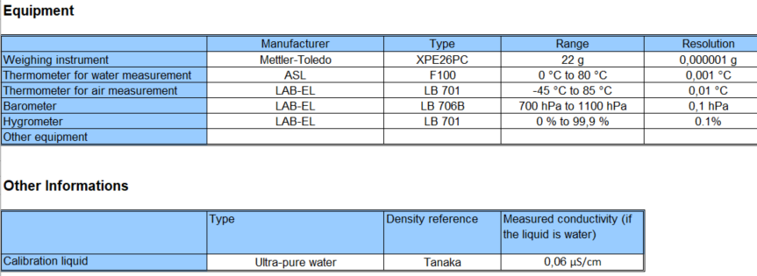

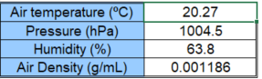

GUM, Micropipette

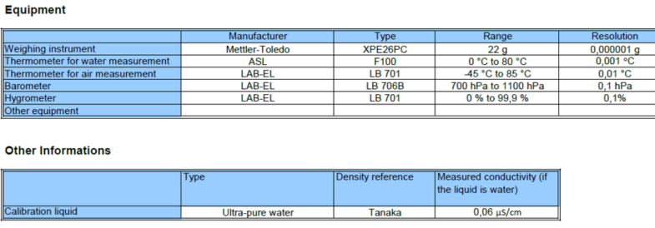

|  |  |  |  |
| --- | --- | --- | --- |
| 10 µL | 5 µL | 1 µL | 0,2 µL |
|  |  |  |  |

GUM, Piston burette

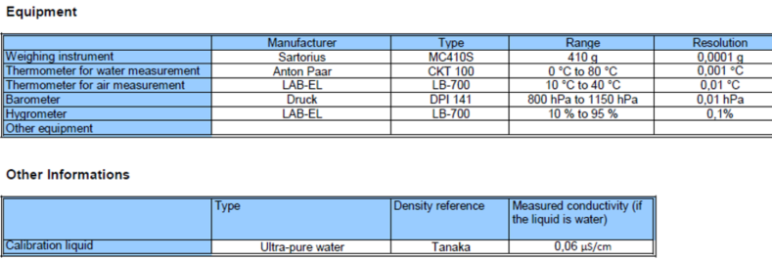

|  |  |  |
| --- | --- | --- |
| 50 mL | 25 mL | 5 mL |
|  |  |  |

# MBM, Syringe

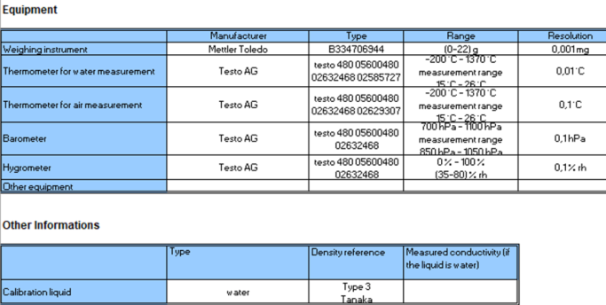

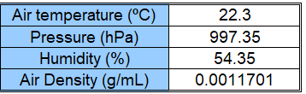

MBM, Micropipette

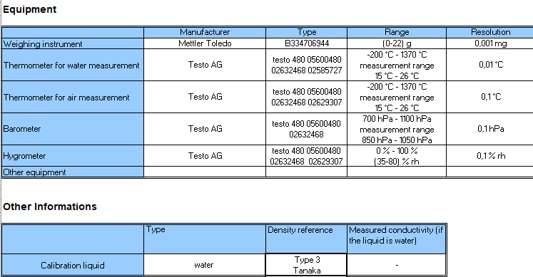

|  |  |  |  |
| --- | --- | --- | --- |
| 10 µL | 5 µL | 1 µL | 0,2 µL |
|  |  |  |  |

MBM, Piston burette

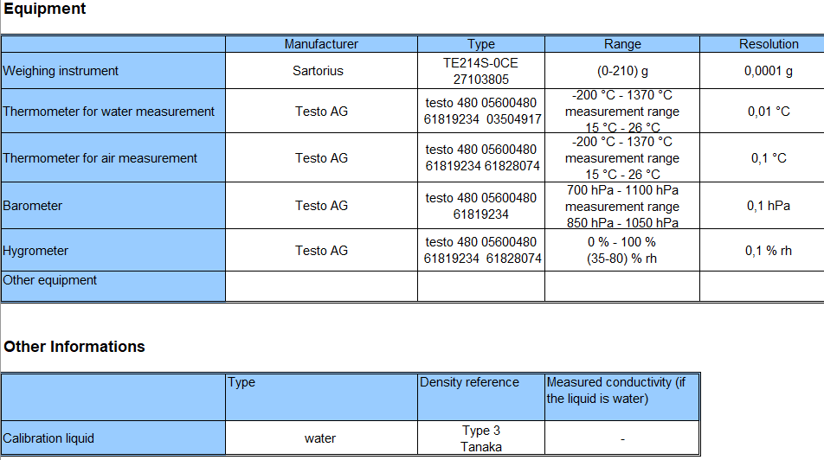

|  |  |  |
| --- | --- | --- |
| 50 mL | 25 mL | 5 mL |
|  |  |  |

IPQ, Syringe

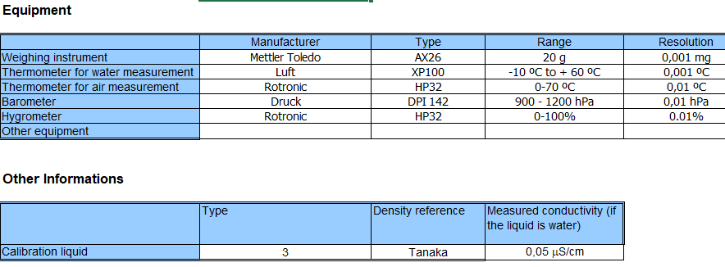

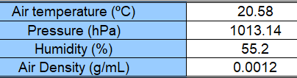

IPQ, Micropipette

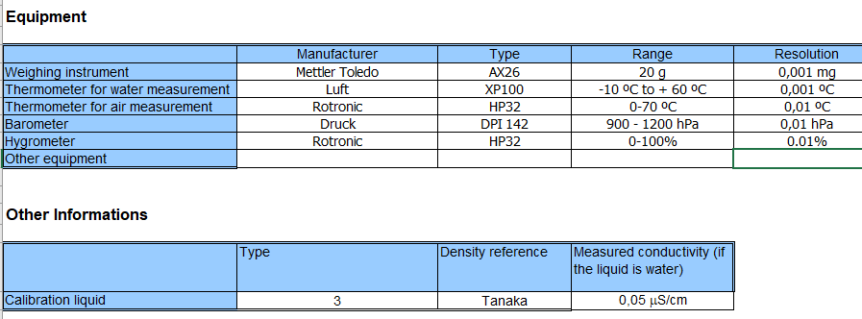

|  |  |  |  |
| --- | --- | --- | --- |
| 10 µL | 5 µL | 1 µL | 0,2 µL |
|  |  |  |  |

IPQ, Piston burette

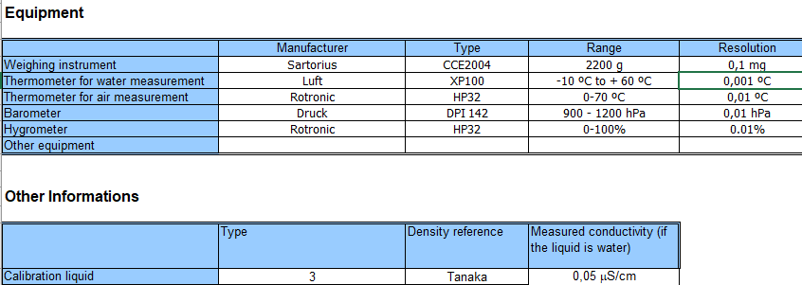

|  |  |  |
| --- | --- | --- |
| 50 mL | 25 mL | 5 mL |
|  |  |  |

BFKH, Syringe

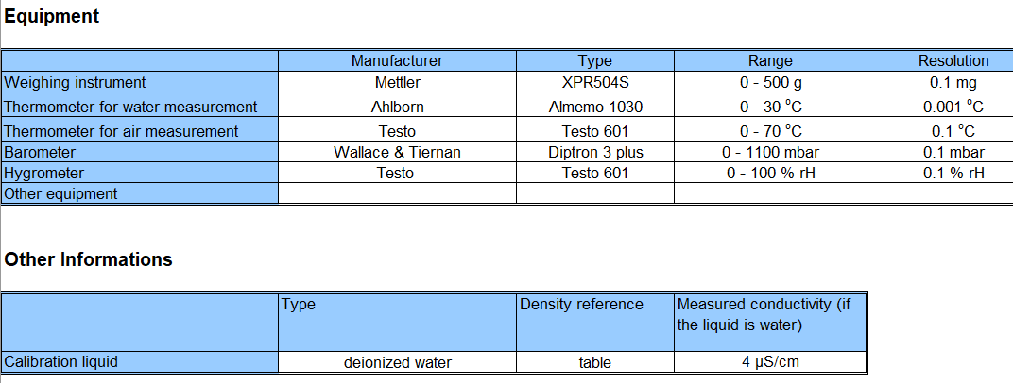

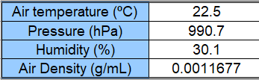

BFKH, Micropipette[27]

BFKH, Piston burette

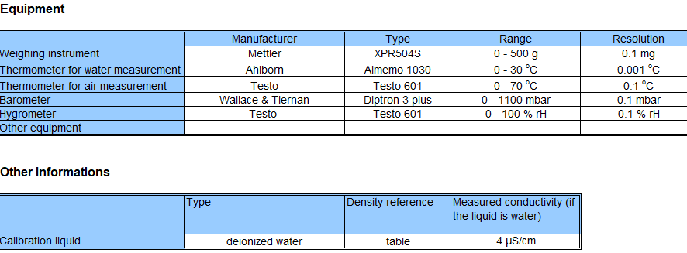

|  |  |  |
| --- | --- | --- |
| 50 mL | 25 mL | 5 mL |
|  |  |  |

MIRS, Syringe

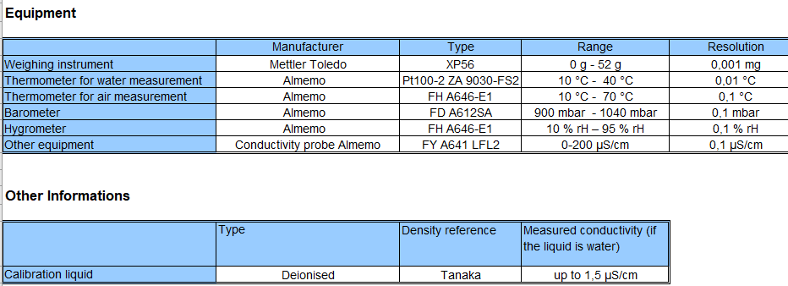

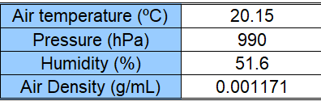

MIRS, Micropipette

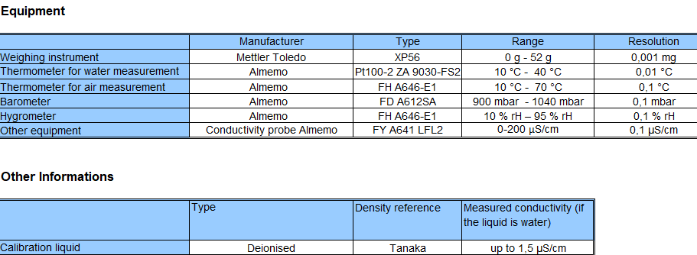

|  |  |  |
| --- | --- | --- |
| 10 µL | 5 µL | 1 µL |
|  |  |  |

MIRS, Piston burette

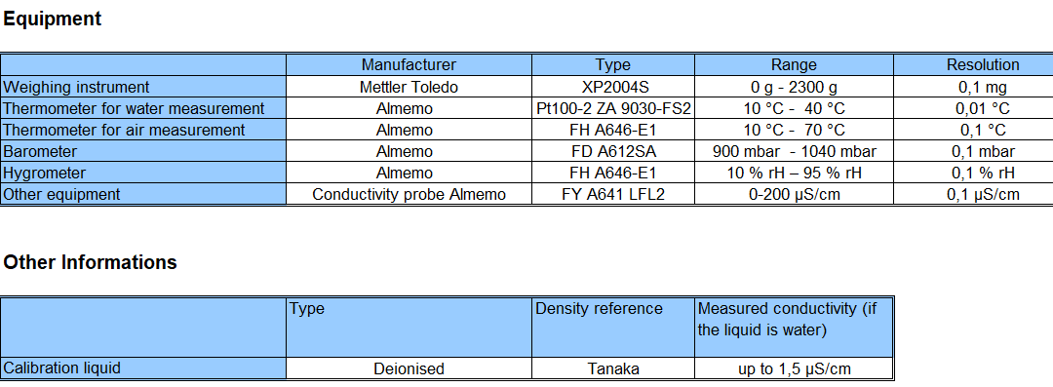

|  |  |  |
| --- | --- | --- |
| 50 mL | 25 mL | 5 mL |
|  |  |  |

ČMI, Syringe[28]

ČMI, Micropipette

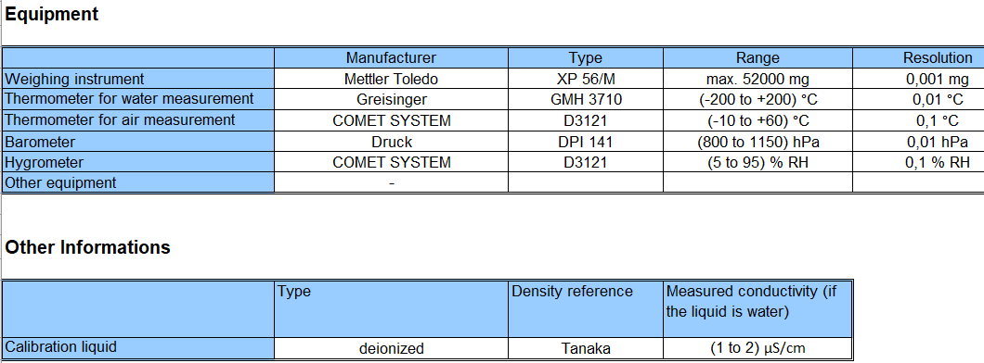

|  |  |  |
| --- | --- | --- |
| 10 µL | 5 µL | 1 µL |
|  |  |  |

ČMI, Piston burette

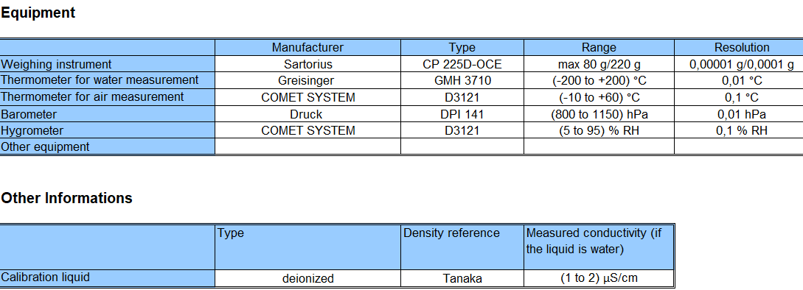

|  |  |  |
| --- | --- | --- |
| 50 mL | 25 mL | 5 mL |
|  |  |  |

DMDM, Syringe

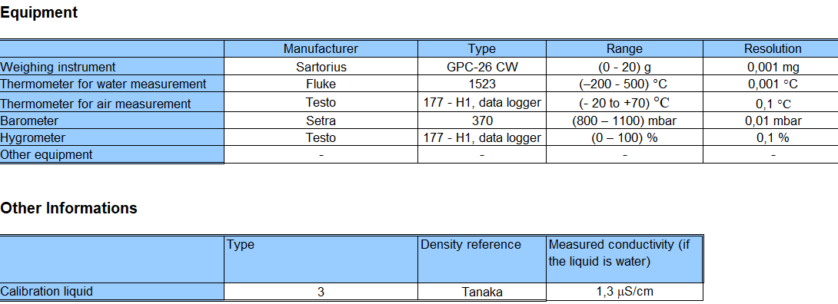

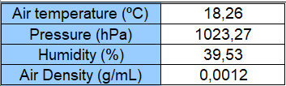

DMDM, Micropipette

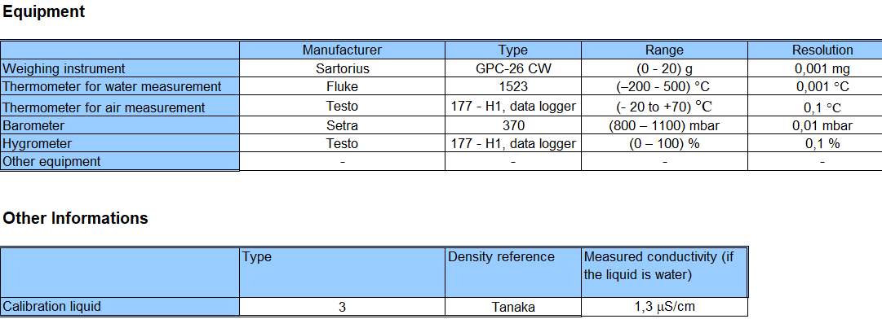

|  |  |  |  |
| --- | --- | --- | --- |
| 10 µL | 5 µL | 1 µL | 0,2 µL |
|  |  |  |  |

DMDM, Piston burette

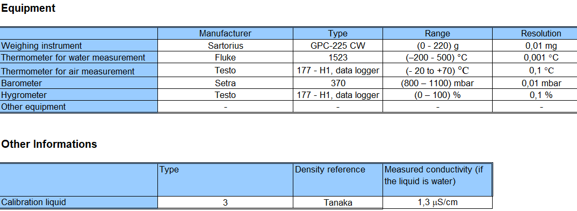

|  |  |  |
| --- | --- | --- |
| 50 mL | 25 mL | 5 mL |
|  |  |  |

SASO, Syringe

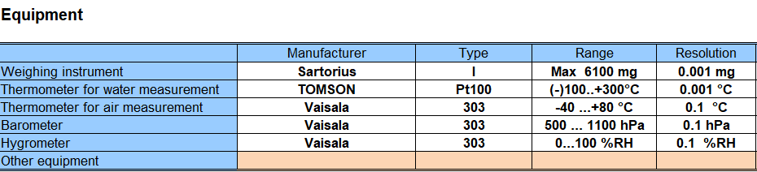

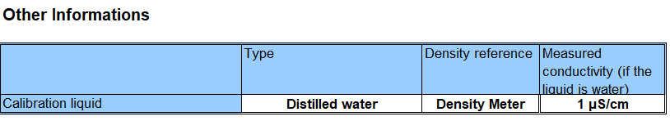

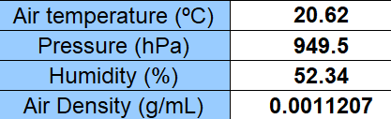

SASO, Micropipette

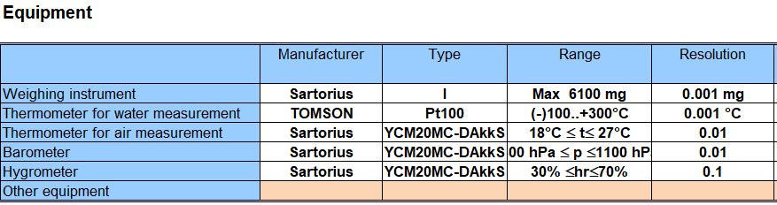

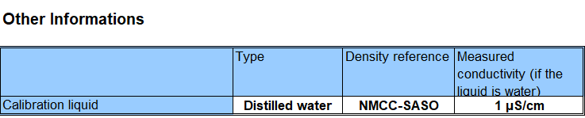

|  |  |  |  |
| --- | --- | --- | --- |
| 10 µL | 5 µL | 1 µL | 0,2 µL |
|  |  |  |  |

SASO, Piston burette

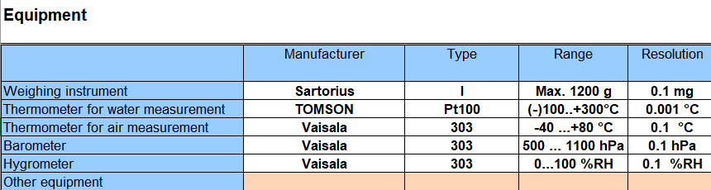

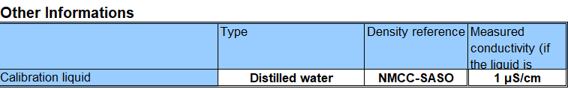

|  |  |  |
| --- | --- | --- |
| 50 mL | 25 mL | 5 mL |
|  |  |  |

RISE, Syringe

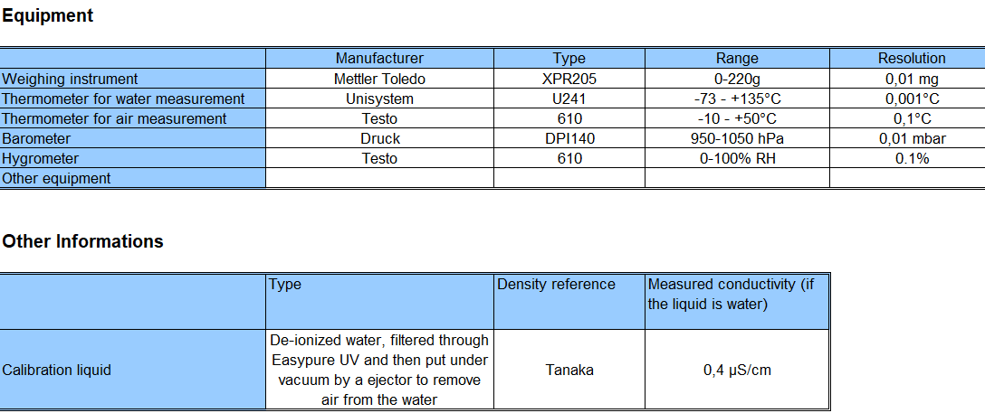

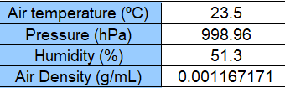

RISE, Micropipette

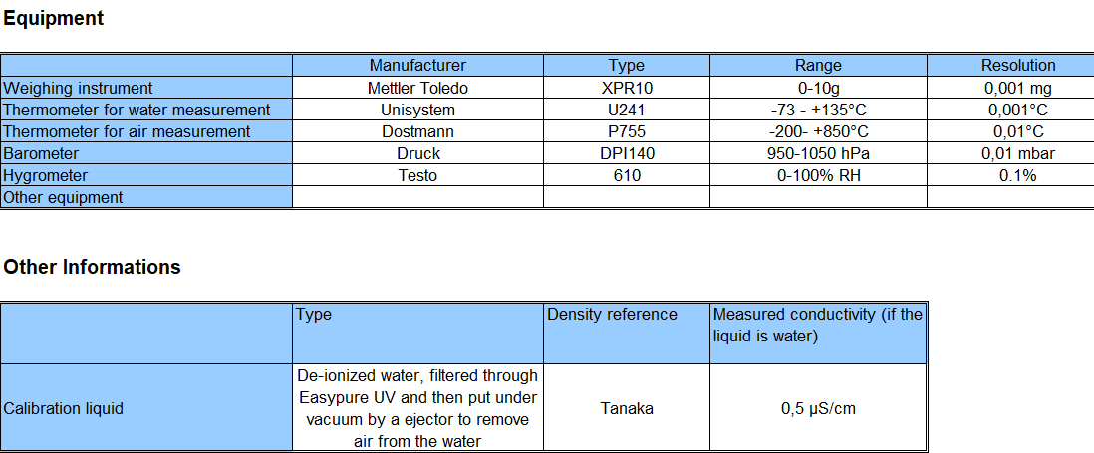

|  |  |  |  |
| --- | --- | --- | --- |
| 10 µL | 5 µL | 1 µL | 0,2 µL |
|  |  |  |  |

RISE, Piston burette

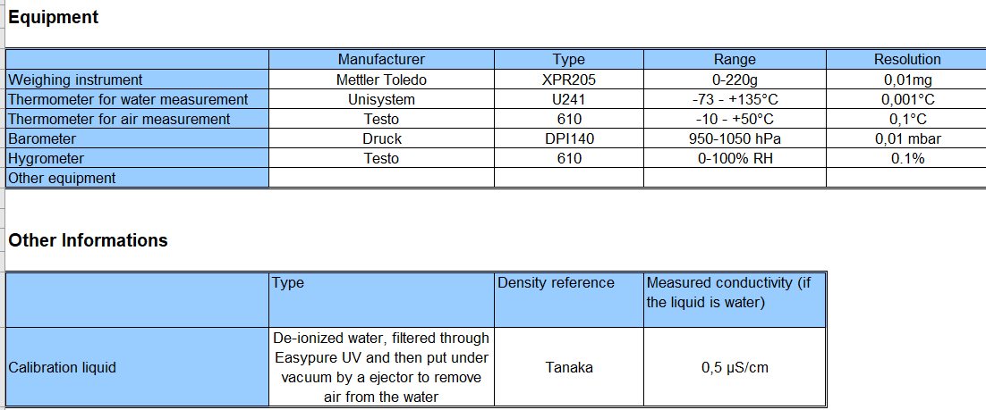

|  |  |  |
| --- | --- | --- |
| 50 mL | 25 mL | 5 mL |
|  |  |  |

VSL, Syringe[29]

VSL, Micropipette[30]

VSL, Piston burette

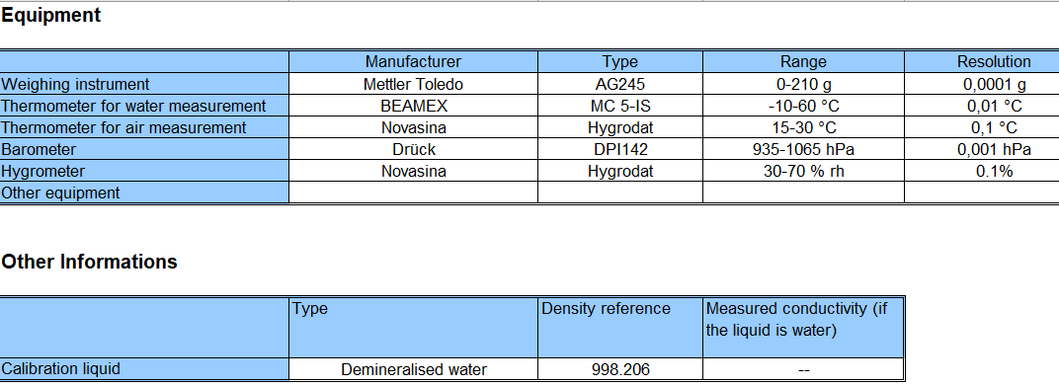

|  |  |  |
| --- | --- | --- |
| 50 mL | 25 mL | 5 mL |
|  |  |  |

FORCE, Syringe

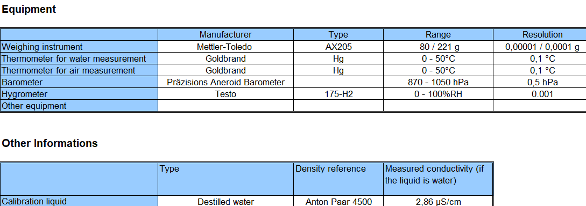

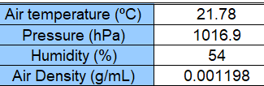

FORCE, Micropipette

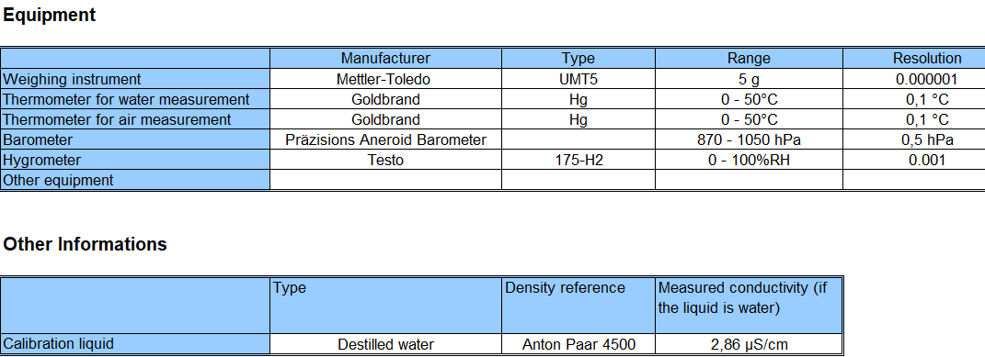

|  |  |  |
| --- | --- | --- |
| 10 µL | 5 µL | 1 µL |
|  |  |  |

FORCE, Piston burette

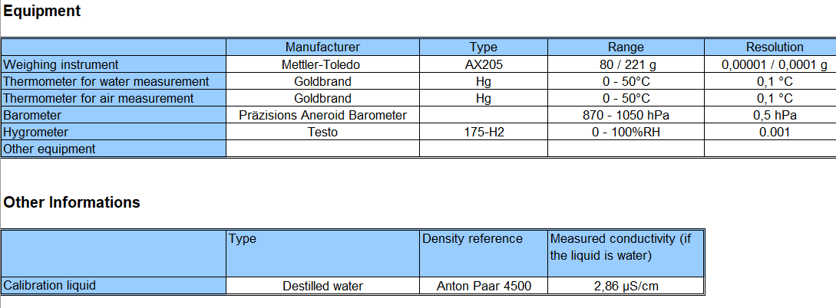

|  |  |  |
| --- | --- | --- |
| 50 mL | 25 mL | 5 mL |
|  |  |  |

UME, Syringe

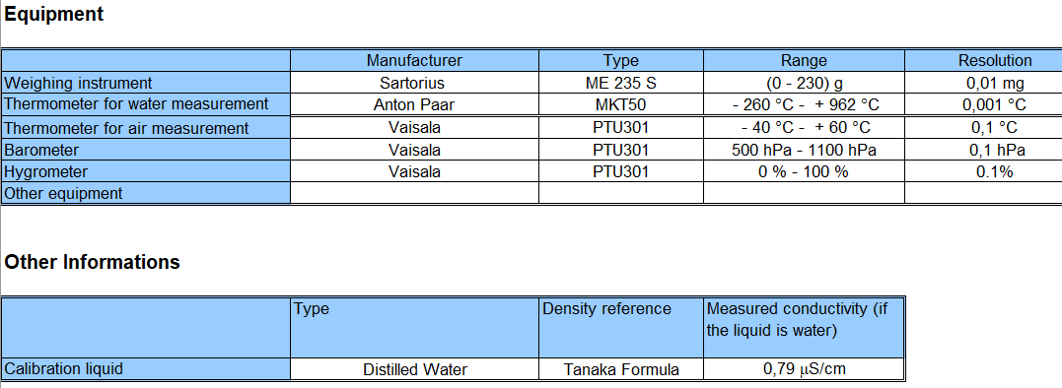

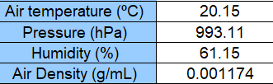

UME, Micropipette

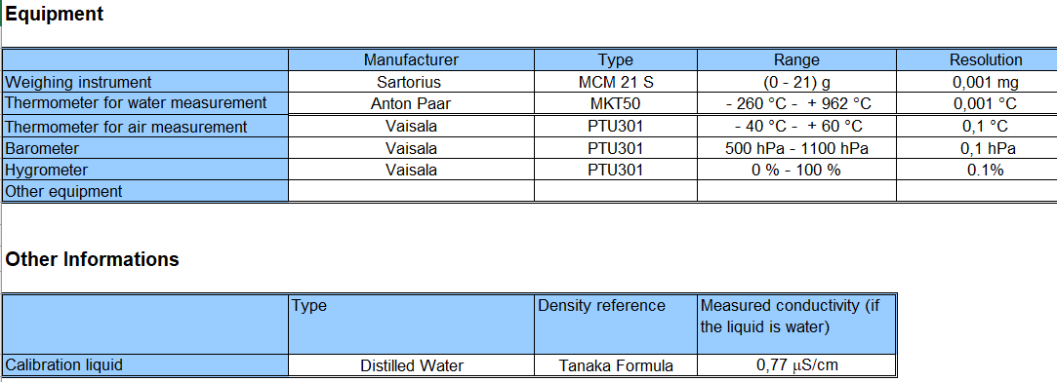

|  |  |  |
| --- | --- | --- |
| 10 µL | 5 µL | 1 µL |
|  |  |  |

UME, Piston burette

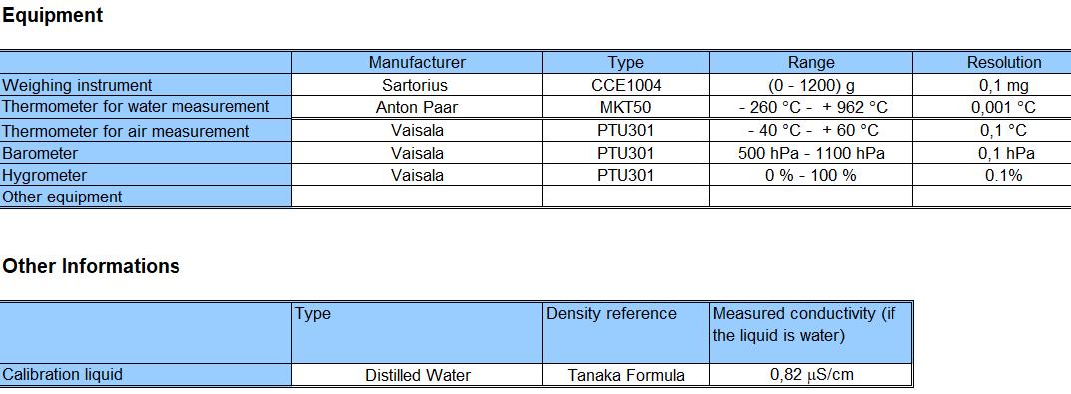

|  |  |  |
| --- | --- | --- |
| 50 mL | 25 mL | 5 mL |
|  |  |  |

INM, Syringe

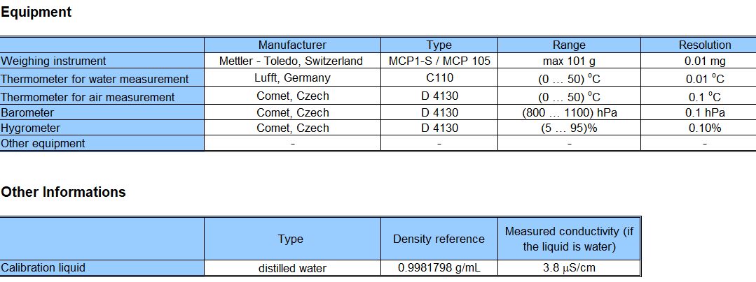

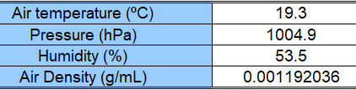

INM, Micropipette

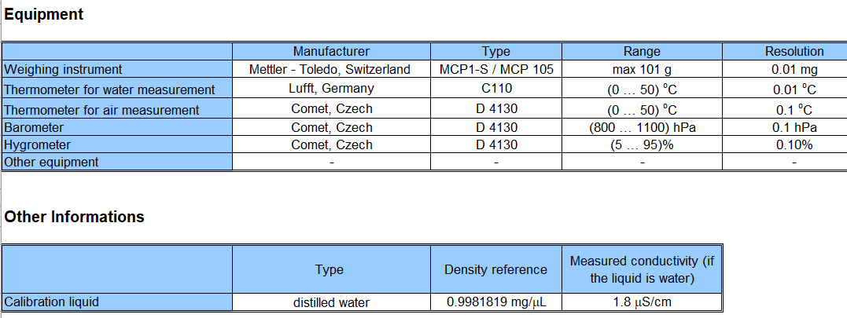

|  |  |  |
| --- | --- | --- |
| 10 µL | 5 µL | 1 µL |
|  |  |  |

INM, Piston burette

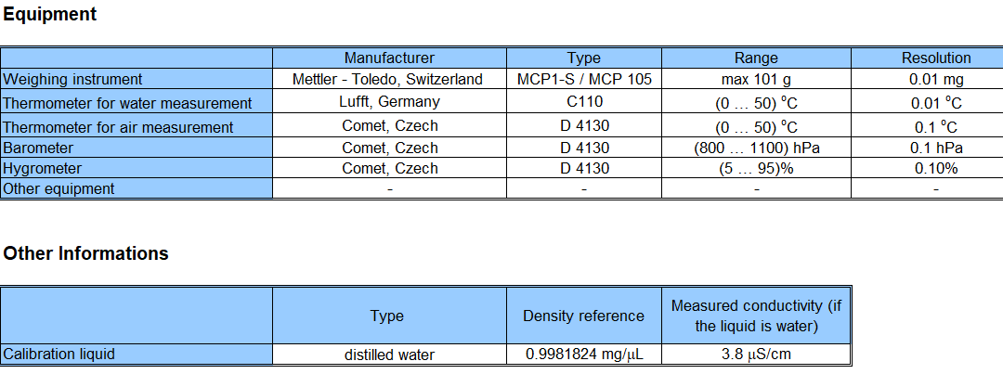

|  |  |  |
| --- | --- | --- |
| 50 mL | 25 mL | 5 mL |
|  |  |  |

IMBIH, Syringe

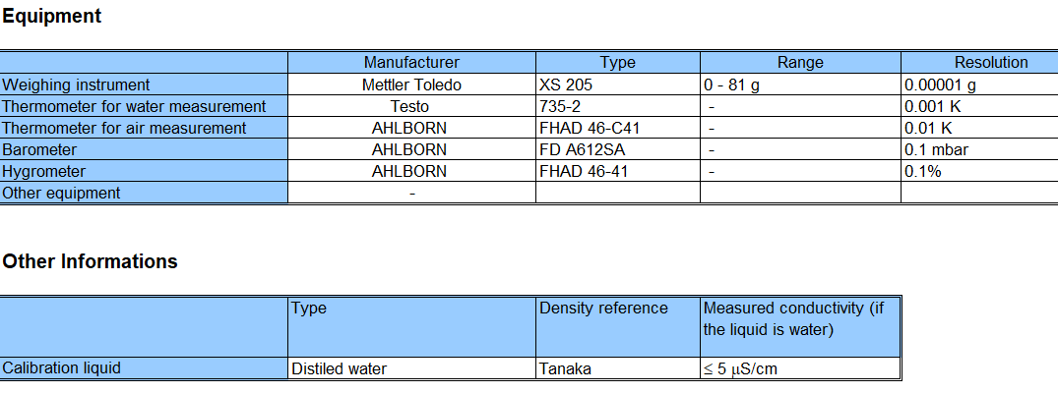

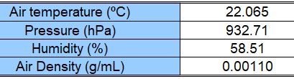

IMBIH, Micropipette

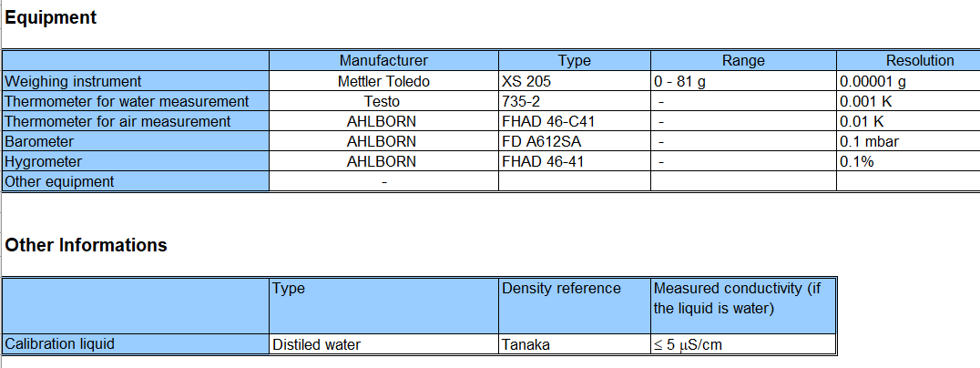

|  |  |  |
| --- | --- | --- |
| 10 µL | 5 µL | 1 µL |
|  |  |  |

IMBIH, Piston burette

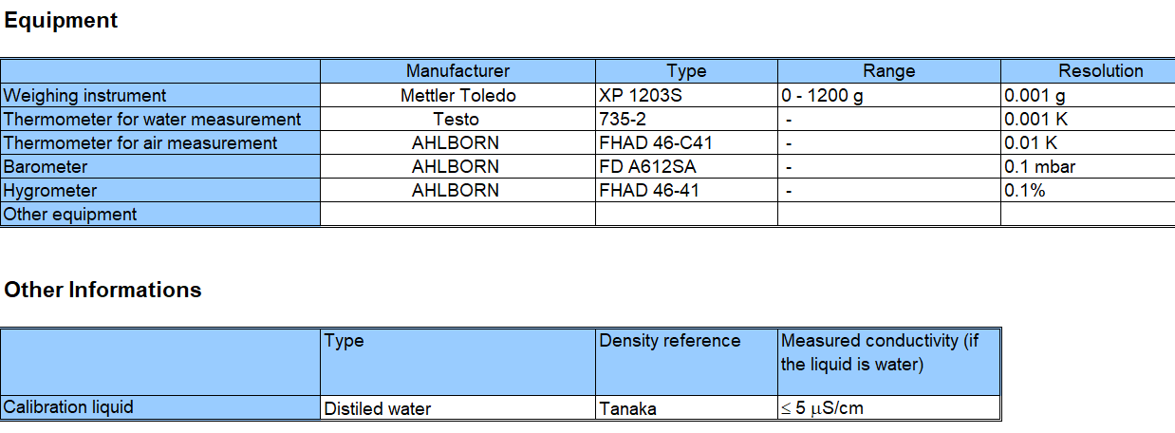

|  |  |  |
| --- | --- | --- |
| 50 mL | 25 mL | 5 mL |
|  |  |  |

# Annex 2- Burette results for 5 mL and 25 mL

**5 mL**

The obtained reference value is 5,002 mL. The expanded uncertainty *U* = 2 × *u(y)* of the reference value is: 0,002 mL.

The calculated value **  = 22,36 is larger than observed value* obs*= 5,04, therefore the set of results are consistent from a statistical point of view and the reference value is accepted.

All the measurement results, the reference value and its uncertainty are presented in the following figure A1:

**Figure A1** – Piston burette results at 5 mL with reference value

The degree of equivalence with the RV is presented in figure A2:

**Figure A2** – Degree of equivalence burette 5 mL

*Table A1.* Degree of equivalence with RV

|  |  |  |  |
| --- | --- | --- | --- |
| **Laboratory** | ***Di*(mL)** | ***Udi*(mL)** | ***Ei*** |
| GUM | -0,001 | 0,006 | -0,17 |
| MBM | -0,002 | 0,007 | -0,30 |
| IPQ | 0,001 | 0,006 | 0,17 |
| BFKH | -0,004 | 0,006 | -0,65 |
| MIRS | 0,002 | 0,002 | 0,65 |
| ČMI | 0,002 | 0,006 | 0,30 |
| DMDM | 0,000 | 0,005 | 0,05 |
| SASO | 0,001 | 0,006 | 0,14 |
| RISE | -0,003 | 0,008 | -0,32 |
| VSL | 0,001 | 0,008 | 0,16 |
| FORCE | 0,001 | 0,012 | 0,10 |
| UME | -0,002 | 0,006 | -0,38 |
| INM | -0,001 | 0,006 | -0,19 |
| BFKH | -0,001 | 0,006 | -0,13 |

**25 mL**

The obtained reference value is 25,001 mL. The expanded uncertainty *U* = 2 × *u(y)* of the reference value is: 0,002 mL.

The calculated value **  = 22,36 is smaller than observed value* obs*= 29,38, this means that the chi-square test failed and the results are not consistent.

After removal one outlier, the obtained reference value is 25,003 mL. The expanded uncertainty *U* = 2 × *u(y)* of the reference value is: 0,002 mL.

The calculated value **  = 21,03 is larger than observed value* obs*= 17,63, therefore the set of results is now consistent from a statistical point of view and the reference value is accepted.

All the measurement results, the reference value and its uncertainty are presented in the following figure :

**Figure A3** – Burette results at 25 mL with reference value

The degree of equivalence with the RV is presented in figure A4:

**Figure A4** – Degree of equivalence burette 25 mL

*Table A2*. Degree of equivalence with RV

|  |  |  |  |  |
| --- | --- | --- | --- | --- |
| **Laboratory** | ***Di*(mL)** | ***Udi*(mL)** | ***Ei*** | **Info** |
| GUM | -0,001 | 0,006 | -0,12 |  |
| MBM | -0,001 | 0,007 | -0,09 |  |
| IPQ | 0,005 | 0,007 | 0,78 |  |
| BFKH | -0,013 | 0,007 | -1,90 | Excluded |
| MIRS | 0,002 | 0,008 | 0,21 |  |
| ČMI | 0,003 | 0,012 | 0,29 |  |
| DMDM | 0,000 | 0,009 | 0,05 |  |
| SASO | 0,001 | 0,007 | 0,11 |  |
| RISE | -0,013 | 0,008 | -1,53 |  |
| VSL | 0,009 | 0,008 | 1,07 |  |
| FORCE | -0,002 | 0,015 | -0,11 |  |
| UME | -0,004 | 0,006 | -0,67 |  |
| INM | -0,001 | 0,008 | -0,08 |  |
| IMBIH | 0,001 | 0,008 | 0,18 |  |

Uncertainty components for 5 mL piston burette

|  |  |  |  |  |  |  |
| --- | --- | --- | --- | --- | --- | --- |
| Quantity *(xi)* | GUM | MBM | IPQ | BFKH | MIRS | ČMI |
| Repeatability measurements (mL) | 0.000356 | 6.71E-04 | 0.001126 | 5.070E-04 | 1.73E-03 | 0.001 |
| Mass (g) | 0.000217 | 1.07E-04 | 5.6057E-05 | 8.524E-05 | 1.13E-03 | 3.14E-05 |
| Air Density (g/mL) | 0.000009 | 4.78E-06 | 9.8291E-07 | 8.760E-06 | 4.63E-05 | 0.000007 |
| Water Density (g/mL) | -0.000050 | -2.96E-05 | -0.0002511 | -1.254E-05 | 5.42E-04 | 0.000002 |
| Density of the mass pieces (g/mL) | 0.000003 | 6.57E-06 | 3.2321E-06 | 6.600E-08 | 6.52E-05 | 0.000003 |
| Cub. coeff. of expansion from the piston burette material (°C-1) | 0.000005 | -3.67E-05 | -1.342E-05 | -3.000E-04 | 1.39E-04 | 0.000018 |
| Water temperature (ºC) | -0.000111 | -9.51E-05 | -7.821E-05 | -6.000E-06 | 9.32E-04 | 0.00002 |
| Resolution of the piston burette (mL) | 0.002887 | 2.89E-03 | 0.0028867 | 2.900E-03 | 2.89E-03 | 0.002887 |
| Other | 0.000168 | 1.44E-03 | - |  | 2.52E-03 | 0.001246 |
| Combined uncertainty/mL | 0.003 | 3.30E-03 | 0.0031 | 0.003 | 0.0045 | 0.0033 |
| Expanded uncertainty/mL | 0.006 | 0.007 | 0.006 | 0.006 | 0.009 | 0.007 |

|  |  |  |  |  |  |  |
| --- | --- | --- | --- | --- | --- | --- |
| Quantity *(xi)* | DMDM | SASO | RISE | VSL | FORCE | UME |
| Repeatability measurements (mL) | 0.0018 | 1.09E-03 | 3.499E-04 | 0.0005 | 3.7107E-03 | 5.52E-04 |
| Mass (g) | 2.69E-05 | 1.57E-03 | 8.520E-05 | 0.0002 | 3.5100E-05 | 1.57E-04 |
| Air Density (g/mL) | 1.66E-06 | 3.08E-03 | 1.272E-05 | 0.0000 | 2.5090E-04 | 6.34E-06 |
| Water Density (g/mL) | -4.63E-05 | -4.63E-05 | -1.445E-04 | 0.0000 | 2.9060E-04 | 1.58E-05 |
| Density of the mass pieces (g/mL) | 6.63E-06 | 2.61E-05 | 2.629E-06 | 0.0000 | [31] | 2.54E-06 |
| Cub. coeff. of expansion from the piston burette material (°C-1) | -6.35E-06 | -3.20E-04 | -4.046E-05 | 0.0000 | 7.7270E-04 | 4.45E-06 |
| Water temperature (ºC) | -4.45E-05 | -3.47E-03 | 1.0392E-04 | 0.0000 | 2.2000E-03 | 3.47E-04 |
| Resolution of the piston burette (mL) | 0.00289 | 2.89E-03 | 4.0825E-03 | 0.0041 | 5.8000E-03 | 2.89E-03 |
| Other | - | - | - | 0.0002 | 2.9004E-03 | - |
| Combined uncertainty/mL | 0.0034 | 0.0057985 | 0.0041 | 0.0042 | 0.00784 | 0.00296 |
| Expanded uncertainty/mL | 0.0068 | 0.011597 | 0.0082 | 0.0084 | 0.016 | 0.0059 |

|  |  |  |
| --- | --- | --- |
| Quantity *(xi)* | INM | IMBIH |
| Repeatability measurements (mL) | 0.000789096 | 6.173E-04 |
| Mass (g) | 0.002496970 | 1.140E-03 |
| Air Density (g/mL) | 0.000000344 | 2.386E-06 |
| Water Density (g/mL) | 0.000008676 | 2.606E-05 |
| Density of the mass pieces (g/mL) | 0.000105604 | 6.068E-06 |
| Cub. coeff. of expansion from the piston burette material (°C-1) | 0.000043710 | 4.943E-05 |
| Water temperature (ºC) | 0.000103796 | 2.731E-04 |
| Resolution of the piston burette (mL) | 0.001432415 | 2.887E-03 |
| Other | - | 5.000E-04 |
| Combined uncertainty/mL | 0.00299 | 0.003 |
| Expanded uncertainty/mL | 0.00598 | 0.006 |

Uncertainty components for 25 mL piston burette

|  |  |  |  |  |  |  |
| --- | --- | --- | --- | --- | --- | --- |
| Quantity *(xi)* | GUM | MBM | IPQ | BFKH | MIRS | ČMI |
| Repeatability measurements (mL) | 0.000412 | 7.29E-04 | 0.00173772 | 2.451E-04 | 1.56E-03 | 0.001 |
| Mass (g) | 0.000217 | 1.32E-04 | 0.00008485 | 8.524E-05 | 1.07E-03 | 5.95E-05 |
| Air Density (g/mL) | 0.000044 | 1.95E-05 | 2.4441E-05 | 4.377E-05 | 2.28E-05 | 0.000033 |
| Water Density (g/mL) | -0.000252 | -1.47E-04 | -0.001255 | -6.269E-05 | 2.72E-04 | 0.000011 |
| Density of the mass pieces (g/mL) | 0.000016 | 3.29E-05 | 1.616E-05 | 3.330E-07 | 3.25E-05 | 0.000014 |
| Cub. coeff. of expansion from the piston burette material (°C-1) | 0.000033 | -1.49E-04 | -6.429E-05 | -1.500E-03 | 2.40E-04 | 0.000087 |
| Water temperature (ºC) | -0.000585 | -3.16E-04 | -0.0003499 | -3.000E-05 | 1.06E-03 | 0.000101 |
| Resolution of the piston burette (mL) | 0.002887 | 2.89E-03 | 0.0028868 | 2.900E-03 | 2.89E-03 | 0.002887 |
| Other | 0.000840 | 1.44E-03 | - | - | 1.59E-03 | 0.005162 |
| Combined uncertainty/mL | 0.0031 | 3.33E-03 | 0.0036 | 0.0035 | 0.0040 | 0.006 |
| Expanded uncertainty/mL | 0.006 | 0.007 | 0.0073 | 0.007 | 0.008 | 0.012 |

|  |  |  |  |  |  |  |  |  |  |
| --- | --- | --- | --- | --- | --- | --- | --- | --- | --- |
| Quantity *(xi)* | DMDM | | SASO | RISE | | VSL | | FORCE | UME |
| Repeatability measurements (mL) | 0.0033 | | 4.52E-04 | 9.6815E-04 | | 0.0008 | | 4.1983E-03 | 6.605E-04 |
| Mass (g) | 2.69E-05 | | 7.87E-04 | 8.5200E-05 | | 0.0008 | | 3.5100E-05 | 1.565E-04 |
| Air Density (g/mL) | 0.0000 | | 1.55E-03 | 6.3580E-05 | | 0.0000 | | 1.2540E-04 | 3.169E-05 |
| Water Density (g/mL) | -0.0004 | | -2.20E-05 | -7.225E-04 | | 0.0000 | | 1.4500E-04 | 7.922E-05 |
| Density of the mass pieces (g/mL) | 0.0000 | | 1.32E-05 | 1.3294E-05 | | 0.0000 | | [32] | 1.270E-05 |
| Cub. coeff. of expansion from the piston burette material (°C-1) | -0.0001 | | -4.35E-05 | -1.9941E-04 | | 0.0000 | | 4.2110E-04 | 3.256E-05 |
| Water temperature (ºC) | -0.0005 | | -1.73E-03 | -5.1960E-04 | | 0.0000 | | 1.1555E-03 | 1.733E-03 |
| Resolution of the piston burette (mL) | 0.00289 | | 2.89E-03 | 4.0825E-03 | | 0.0041 | | 5.8000E-03 | 2.887E-03 |
| Other | - | | - | - | | 0.0008 | | 1.4501E-03 | - |
| Combined uncertainty/mL | 0.004396 | | 0.0038179 | 0.0043 | | 0.0043 | | 0.00741 | 0.00344 |
| Expanded uncertainty/mL | 0.0088 | | 0.0076 | 0.0086 | | 0.0086 | | 0.015 | 0.0069 |
| Quantity *(xi)* | | INM | | | IMBIH | |
| Repeatability measurements (mL) | | 0.001095315 | | | 7.498E-04 | |
| Mass (g) | | 0.003218630 | | | 1.140E-03 | |
| Air Density (g/mL) | | 0.000000907 | | | 1.194E-05 | |
| Water Density (g/mL) | | 0.000103091 | | | 1.303E-04 | |
| Density of the mass pieces (g/mL) | | 0.000105255 | | | 3.035E-05 | |
| Cub. coeff. of expansion from the piston burette material (°C-1) | | 0.000120402 | | | 2.276E-04 | |
| Water temperature (ºC) | | 0.000121089 | | | 1.092E-03 | |
| Resolution of the piston burette (mL) | | 0.002211838 | | | 2.887E-03 | |
| Other | | - | | | 2.500E-03 | |
| Combined uncertainty/mL | | 0.0041 | | | 0.004 | |
| Expanded uncertainty/mL | | 0.0082 | | | 0.008 | |

1. Delay (custom issues)
2. Delay (custom issues)
3. Returned to the pilot due to custom issues
4. Returned to the pilot due to custom issues
5. Delay (custom issues)
6. Delay (purchasing of recirculation tube for piston burette takes 5 months)
7. Delay (custom issues)
8. Not measured
9. Not measured
10. Not measured
11. Not measured
12. Not measured
13. Not measured
14. Not measured
15. Not measured
16. Not measured
17. Not measured
18. Not measured
19. Not measured
20. Not measured
21. Not measured
22. Included in mass
23. Included in mass
24. Included in mass
25. Included in mass
26. NMI´s and Accredited laboratories are advised to use part 6 for calibration method since it’s the reference method.
27. Not measured
28. Not measured
29. Not measured
30. Not measured
31. Included in mass
32. Included in mass