Call for Participants for EURAMET.QM-S14: Comparison of Measurement Capabilities for the quantification of ethanol in water

Introduction
The comparison, agreed by EURAMET, is being organized to support NMIs that have developed capabilities for forensic alcohol in water reference materials in demonstrating the compatibility of their measurement services.
NMIs that deliver measurement services for forensic alcohol in water reference materials are invited to participate in this comparison.
The intercomparison is part of the EMPIR ALCOREF project. The project was designed to allow European NMIs to work together to strengthen forensic alcohol reference materials metrology infrastructure; provide knowledge transfer to scientists developing capabilities in this area and enable NMIs to provide reference materials for the calibration and type approval of evidential breath alcohol analysers.
This comparison will allow NMIs participating in the ALOCREF project to demonstrate their measurement capabilities for the quantification of ethanol in water in the mass fraction range 0.1 mg/g to 5 mg/g. This range is relevant for the verification of evidential breath alcohol analysers according to OIML recommendation R 126 [1].

Study Materials
Materials will be prepared at BAM by gravimetric spiking of commercial high purity ethanol into demineralised water following an accredited procedure that is used for the preparation of the BAM ethanol in water certified reference materials. Two different levels in the range 0.1 mg/g to 5 mg/g will be delivered to participants. Sample volume will be 1 L. Participants will receive two 1 L bottles of each level. Materials shall be stored at room temperature. Materials are assessed for homogeneity and stability. The ethanol used is assessed for purity.
Coordinating Laboratory: BAM
Contact at the Coordinating Laboratory: rosemarie.philipp@bam.de

Participation
To participate, please:
1) E-mail rosemarie.philipp@bam.de and beatrice.lalere@lne.fr & fanny.gantois@lne.fr stating your intent to participate and the name and contact information for your institute.
The study proposal/project plan is attached. If you have any comments or concerns regarding the design or proposed conduct of this comparison, please contact rosemarie.philipp@bam.de and beatrice.lalere@lne.fr & fanny.gantois@lne.fr .

Schedule
Call for participation | 1-August-2019
Final date to register to participate | 26-August-2019
Sample dispatch  Reporting of results | Aug-September-2019  31-Oct-2019
Initial report of results to participants | Dec-2019

Project Plan for Euramet. QM-S14

Comparison of Measurement Capabilities for the quantification of ethanol in water

Introduction
The European status report on road safety of the WHO Regional Office for Europe [2] demands better enforcement of drink-driving legislation in several European countries. The research in the EMPIR project 16RPT02 ALCOREF will address this need by building up long term capacities for the production and certification of forensic alcohol reference materials suitable for calibration of evidential breath alcohol analysers as defined by recommendation R 126 [] of the International Organization of Legal Metrology (OIML). Certification includes characterisation of the materials, assessment of homogeneity, stability, and uncertainty.
The project aims to develop the capacity to regularly produce certified forensic alcohol reference materials at NMIs/DIs for breath analyser type approval and calibration. By the end of the project, new production capabilities for ethanol in water reference materials will be available at NMIs/DIs. State of the art analytical methods for purity assessment of ethanol and for the accurate quantification of ethanol in aqueous media will be implemented at institutes that had no access to these methods before. The project partners will maintain newly established or improved quality assurance systems according to ISO Standard 17034 and ISO Guides 30 to 35 which will allow the reproducible production of the certified materials. Standard operating procedures (SOPs), draft certificates and certification reports will be further important outcomes of the project. Certified values will be traceable to the SI and will be produced via validated methods and reported with an uncertainty budget to fulfil the requirements of the OIML.
Intercomparisons organised during the project will demonstrate the metrological equivalence of the materials developed and the analytical methods established. Results of the intercomparisons should be suitable to submit CMC claims or underpin existing CMC claims in the BIPM key comparison database KCDB. This will create a larger and more established network of ethanol reference materials and measurement capabilities.
This comparison is planned to demonstrate the metrological equivalence of the analytical methods used for the quantification of ethanol in water in the participating institutes.
BAM was tasked with preparing the samples and coordinating this comparison. BAM has successfully participated in the CCQM-K27 series “Ethanol in aqueous matrix” and served as the measurement laboratory in CCQM-K79 “Value assignment of CRMs and PT materials, Ethanol in aqueous matrix”. BAM holds CMC claims for ethanol in water CRMs and measurement capabilities.

Participants and Their Responsibilities
Participants are requested to quantify the ethanol in the intercomparison samples and report the mass fractions together with their standard and expanded uncertainty. A full uncertainty budget should be established and submitted.
Participants may use commercial pure ethanol as calibrant for their measurements. In that case prior in-house purity assessment of the calibrant is required in order to establish traceability. The purity value and the method(s) for purity assessment should be reported. Alternatively, participants may use a certified ethanol in water CRM from another NMI/DI, see Section 6 below.
For technical reasons, the number of participants in the study is limited to 20.

Coordinating Laboratory and Its Responsibilities
BAM, the coordinating laboratory will prepare and ship the samples. It will provide a sheet for reporting. BAM in collaboration with their JRP partners will draft the comparison Report and suggest appropriate degrees of equivalence for the participating Institutes. If significant data analysis issues arise, appropriate expertise will be solicited from other Institutes and from the LNE Statistical Engineering Division.
As with all EURAMET Comparisons, the draft results will be discussed in detail at an TC-MC SCBOA meeting and the various iterations of the report will be distributed for participant and for WG comment/input.

Samples and Comparison Participant Instructions
Samples will be prepared by gravimetric spiking of commercial high purity ethanol into bottles prefilled with demineralised water following an accredited procedure that is used for the preparation of the BAM ethanol in water certified reference materials. The ethanol is purchased from a commercial supplier but assessed for purity by Karl-Fischer titration and GC-FID by BAM. The purity of the water is controlled continuously by coulometry. The expanded uncertainty of the certified values of the CRMs is in the range 0.1 % to 0.5 %. The equivalence of the BAM CRMs with CRMs from other NMIs/DIs was demonstrated in CCQM-K79 “Comparison of value-assigned CRMs and PT materials: Ethanol in aqueous matrix”. Some representative homogeneity and stability data of the CRMs obtained recently in the couse of the ALCOREF project are displayed below.
Homogeneity: Within bottle homogeneity is not an issue since the samples are liquid and the ethanol mass fraction is high enough to prevent adsorption on the container walls. To assess between bottle homogeneity, three replicates out of 19 bottles were measured by GC-FID. All results are within the range ± 0.1 % (dashed lines) from the target value (solid line). No trends were observed with bottle number or order of measurement.
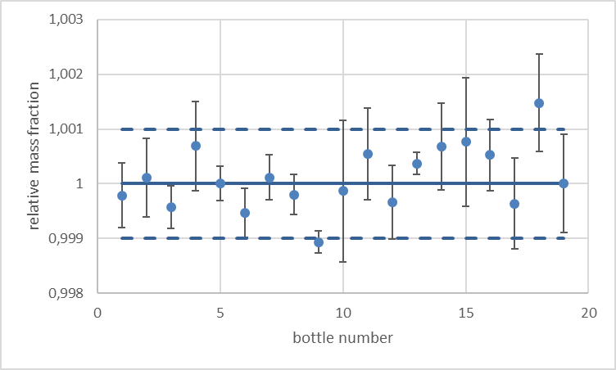
Fig. 1: Homogeneity data for BAM CRM K001 (1.0292 g/L at 20 ºC). Data points: mean of three replicate measurements; error bars: expanded uncertainty of the mean; dashed lines: ± 0.1 % deviation from the normalised mass fraction
Short term stability: Short term stability was assessed at 50 ºC for a period of 7 days according to an isochronous scheme. Reference temperature was 4 ºC. Four bottles were selected at each time point. Three replicates per bottle were measured. All results are within the range ± 0.1 % (dashed lines) from the certified value (solid line), i.e. within the uncertainty range of the certified value.
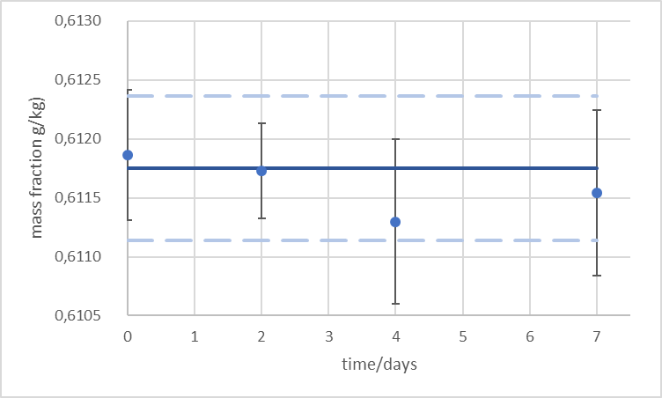
Fig. 2: Short term stability data at 50 ºC for BAM CRM K003 (0.610 g/L at 20 ºC). Data points: mean of means of three replicate measurements of 4 bottles; error bars: expanded uncertainty; dashed lines: ± 0.1 % deviation from the certified value
Long term stability: Long term stability was assessed at room temperature for a period of 7 months according to an isochronous scheme. Reference temperature was 4 ºC. Four bottles were selected at each time point. Three replicates per bottle were measured. All results are within the range ± 0.1 % (dashed lines) from the certified value (solid line), i.e. within the uncertainty range of the certified value.
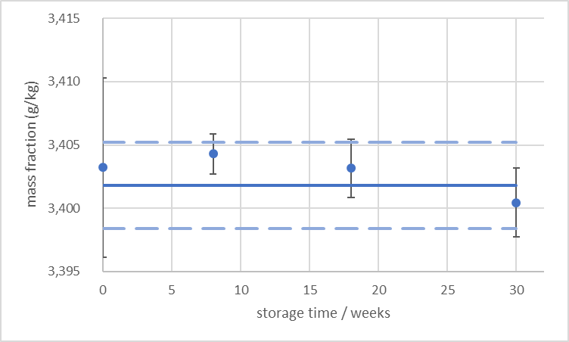
Fig. 3: Long term stability data at room temperature for BAM CRM K007 (3.390 g/L at 20 ºC). Data points: mean of means of three replicate measurements of 4 bottles; error bars: expanded uncertainty; dashed lines: ± 0.1 % deviation from the certified value
The intercomparison samples will be prepared shortly before shipment. Two different levels in the range 0.1 mg/g to 5 mg/g will be delivered to participants in 1 L glass bottles with screw cap. Participants will receive two bottles of each level.
Materials shall be stored at room temperature away from direct sunlight. Before removing a subsample, the bottle shall be shaken well. Afterwards, it should be closed as quickly as possible. The minimum sample intake should be 10 mL since this is the volume used for homogeneity and stability assessment.

How far the light shines
Successful participation in the intercomparison demonstrates the laboratory’s capabilities in determining the mass fraction of ethanol in aqueous matrices in the mass fraction range of 0.1 mg/g to 8 mg/g.

SI traceability
All the results of the comparison will be evaluated against the comparison reference value (KCRV). There are two options for the KCRV, the BAM gravimetric preparation value verified by GC-FID or the KCRV determined from the results of all NMIs/DIs participating in the comparison that have used appropriately validated methods with demonstrated metrological traceability. The final KCRV will be agreed after discussion of the results by EURAMET SCOA and CCQM OAWG.
Some potential CRMs to use as calibrators and to provide adequate SI traceability in this study are identified in the next table. There are other suitable CRMs from other NMIs on the market, if you wish to use one of them please contact the coordinators so that they could review their certificates and check that they meet the CIPM traceability requirements.

Producer | Certified value(s) | Item No.
NIST | from 0.02 to 0.3 % (nominal mass fraction) | SRM-1828c
 | 0.08 % (nominal mass fraction) | SRM-2893a
 | 2 % (nominal mass fraction) | SRM-2897a
LGC(ERM) | 20 mg /100 mL | ERM-AC409
 | 50 mg / 100 mL | ERM-AC510
 | 67 mg / 100 mL | ERM-AC511a
 | 80 mg / 100 mL | ERM-AC401
 | 107 mg / 100 mL | ERM-AC402
NMISA | 62 mg/ 100 g | NML-ORG-001 – B0432/18
 | 208 mg/ 100 g | NML-ORG-001 – B0431/18
 | 502 mg/ 100 g | NML-ORG-001 - 0496/19

OIML R 126:2012 Evidential breath analyzers, https://www.oiml.org/en/files/pdf_r/r126-e12.pdf, accessed 10.07.2016. ² European status report on road safety: towards safer roads and healthier transport choices. Copenhagen, WHO Regional Office for Europe, Copenhagen, 2009. http://www.euro.who.int/__data/assets/pdf_file/0015/43314/E92789.pdf , assessed 10.07.2016.

