Technical protocol for the APMP key comparison of air kerma standards in mammography X-rays, APMP.RI(I)-K7
- Introduction
Breast cancer is the most common cancer diagnosed in women. Mammography, a special x-ray of the breast, is the mean test to screen for possible tumours. It can help reduce the number of deaths from breast cancer among women ages from 40 to 70. So there are a great deal of mammography machines in the Asia-Pacific region. However, it exposes the people to X-ray radiation and measurements of radiation dose are important.
The APMP Key Comparison of air kerma standards in mammography X-rays, APMP.RI(I)-K7, will compare regional standards laboratories’ measurements of air kerma in Mo/Mo mammography beams in the X-ray range from 25 kV to 35 kV, to establish the degrees of equivalence in APMP.
NIM and NMIJ will be the pilot laboratory, NIM and NMIJ will be the linking laboratories. The comparison will be linked to the BIPM.RI(I)-K7 Key Comparison in which NIM participated in 2018 and NMIJ in 2009.
- Participants
The participants are listed in Table 1.
Table 1. Participants in the comparison
Participant | Institute | Economic | Contact person (E-mail)
1 | NMIJ | Japan | Takahiro Tanaka (takahiro-tanaka@aist.go.jp)
2 | NIS | Egypt | Eman Sayed Abdel Fattah (eman_sayed_a@yahoo.com)
3 | INER | Chinese Taipei | Huang, Tseng-Te (huangtt@iner.gov.tw)
4 | NMISA | South Africa | Sibusiso Jozela (sjozela@nmisa.org)
5 | OAP | Thailand | Vithit Pungkun (vithit.p@oap.go.th)
6 | NIM | China | GUO Siming (gsm@nim.ac.cn)

- Comparison procedure
  - Transfer chambers
Two ionization chambers will be used as transfer standards. These chambers will be calibrated by each of the participating laboratories for a number of previously selected radiation qualities. The transfer instruments are used for this comparison: RC6M(10164), RC6M(10257), TW23344(001021).
Supplier | Model | Serial number | Volume/(cm³) | HV/(V) | Cable length/(m) | Cable connection
NIM | RC6M | 10164 | 6 | +300 | 10 | TNC
NIM | RC6M | 10257 | 6 | +300 | 10 | TNC
NIM | 23344 | 001021 | 0.2 | +400 | 10 | TNC
Table 2. Main characteristics of the transfer chamber

  - Reference conditions
The reference conditions for the chamber calibrations are as follows:
1). Distance from the focal spot to the reference plane (the positioning mark surface of the chamber): 600 mm.
2). Field size at the reference plane: 8 cm in diameter.
3). Air temperature, pressure and relative humidity of T = 293.15 K, P = 1013.25 hPa and h = 50%.
4). The calibration coefficients for the transfer chambers should be given in terms of air kerma per charge, in units of GyC⁻¹.
The air-kerma calibration coefficient N_{K} for the chamber is given by the equation
$N_{K}=\frac{\overset{.}{K}}{I_{tr}}$ (1)
Where
1）$\overset{.}{K}$ is the air-kerma rate determined by the standard.
2) $I_{tr}$ is the ionization current measured by RC6M or the signal measured by transfer chamber.
3) $N_{k}$is the calibration coefficients.
Note: For RC6M the current $I_{T}$ should be corrected to the reference conditions of ambient air temperature, pressure and relative humidity chosen for the comparison(T=293.15K, P=101.325 kPa and h= 30%-70%).
  - Radiation qualities
The radiation qualities to be used for the comparison are the reference conditions recommended by the CCRI for the Mammography x-rays range (25 kV, 28 kV, 30 kV, 35 kV).
Table 4. The radiation qualities for calibration
Radiation qualities | Mo-25 | Mo-28 | Mo-30 | Mo-35
Generating potential / kV | 25 | 28 | 30 | 35
Additional filtration | 30 μmMo
Reference distance / mm | 600

  - Course of measurement
There will be a petal-shaped circulation of the transfer chambers between the NIM and the participants. Each participant will pay for the transport of the chambers to the next participant. The chambers should stay at the participants’ site for no longer than 3 weeks.
Measurements at NIM throughout the comparison will form the basis of the uncertainty estimate for chamber stability entering in the data analysis.

  - Schedule
The comparison is scheduled to commence at the beginning of 2021 and expected to be completed within 1 year. The proposed schedule is shown in Table 5.
Table 5. Proposed schedule for the comparison
Participant | Measurement period at the laboratory | Date of chambers leaving participant for next participant
Pilot(NIM) | 21-Nov-2021 to 9-Dec-2021 | 10-Dec-2021
NIS | 10-Jan-2022 to 1-Feb-2022 | 2-Feb-2022
NMISA | 1-Mar-2022 to 20-Mar-2022 | 21-Mar-2022
Pilot(NIM) | 19-Apr-2022 to 10-May-2022 | 11-May-2022
NMIJ | 10-Jun-2022 to 1-Jul-2022 | 2-Jul-2022
OAP | 1-Aug-2022 to 20-Aug-2022 | 21-Aug-2022
INER | 21-Sept-2022 to 11-Oct-2022 | 12-Oct-2022
Pilot(NIM) | 9-Nov-2022 to 29-Nov-2022
NOTES:
- The time allowed for measurements for each participant is about three weeks.
- Allowance is made for a transportation time for the chambers of about three weeks.
- The time allowed for constancy measurements at the NIM is about three weeks.

  - Submission of the results
It is expected that all participating laboratories will submit their calibration results within 6 weeks of calibration. An MS-Excel sheet will be provided by the pilot laboratory in which information on the participants’ radiation qualities, primary standards and calibration results can be submitted.

  - Evaluation of measurement uncertainty
All participating laboratories are required to evaluate the uncertainty of their calibration coefficients as Type A and Type B according to the criteria given in the “Guide to The Expression of Uncertainty in Measurement” issued by the International Organization for Standardization (ISO) in 1995.
The Type A uncertainty is obtained by the statistical analysis of a series of observations; the Type B uncertainty is obtained by means other than the statistical analysis of series’ of observations.
An MS-Excel sheet will be provided by the pilot laboratory in which the participants can detail the uncertainty. The sheet should be submitted together with the calibration results.
  - Comparison Report
The pilot laboratory will prepare a draft report for circulation to all participants for comments and discussion of the results. A revised final report will be submitted to the APMP/TCRI Chairman. After the agreement of the APMP and the CCRI(I), the report will be published as the Technical Supplement in Metrologia. In addition, the comparison results will be sent to the BIPM for inclusion in the key comparison database (KCDB).

- Linking of regional comparisons to international comparisons

To link the APMP/TCRI comparison (a regional comparison) to the results of the international comparison at the BIPM, two participating laboratories (NIM[1] and NMIJ[2]) that have made a key comparison with the BIPM for the measurement of air kerma in mammography X-rays is used as a “linking laboratory.” Then, through the following equation, the measured calibration coefficients for each laboratory, and for each of the CCRI reference radiation qualities, will be converted to ratios relative to the BIPM. The ratio of the calibration coefficient reported by the i-th participating laboratory to the KCRV[3], R_{i}, was determined as[4]:

$R_{i}=\frac{N_{K,i}}{N_{K,LINK}}R_{LINK,BIPM}$ (2)

where N_{K,i (or LINK)} is the air kerma calibration coefficient reported by the i-th participating laboratory (or the LINK); R_{LINK,BIPM} represents the result of the LINK in the BIPM international comparison BIPM.RI(I)-K7. In this study, the NIM and the NMIJ played the role of the linking laboratories. They made direct comparisons of their standards for air kerma with the BIPM respectively. R_{LINK,BIPM} of each LINK was calculated as:
$R_{LINK,BIPM}=\frac{K_{LINK}^{inter}}{K_{BIPM}}$ (3)
where $K_{LINK}^{inter}$ is the air kerma rate reported by the LINK in the BIPM.RI(I)-K7. In this case (with two links laboratories), equation (2) gives rise to two values of R_{i} for each participating laboratory i = 1 to (n-2), not acting as a link laboratory. Denoting these values as R_{i,NIM} and R_{i,NMIJ}, the R_{i} values for these laboratories were calculated as[4]:

$R_{i}=\frac{R_{i,NIM} + R_{i,NMIJ}}{2}$ (4)

- References
- Key comparison BIPM.RI(I)-K7 of the air-kerma standards of the NIM, China and the BIPM in mammography x-rays[J]. Metrologia, 2020, 57(1A):06007-06007.
- Kessler C , Burns D T , Tanaka T , et al. Key comparison BIPM.RI(I)-K7 of the air-kerma standards of the NMIJ, Japan and the BIPM in mammography x-rays[J]. Metrologia, 2010, 47(1A):6024-06024.
- P.J. Allisy, D.T. Burns and P. Andreo, “International framework of traceability for radiation dosimetry quantities,” Metrologia, 46, S1-S8 (2009).
- D.T. Burns and D. Butler, “Updated report on the evaluation of degree of equivalence in regional dosimetry comparisons”, CCRI(I)/17-09 (2017).
APPENDIX A. Participants Data
  - Pilot laboratory
    - NIM
National Institute of Metrology (NIM)
No.18, Bei San Huan Dong Lu, Chaoyang Dist, Beijing, P.R.China,100029
Contact person : Dr. Guo Siming
Tel: +86 10 64525031
E-mail: gsm@nim.ac.cn
  - Participants
    - NMIJ
Shipping address _Central 2, 1-1-1 Umezono, Tsukuba, 305-8568, Japan
Contact person _Takahiro Tanaka
Phone number, +81-29-861-4151_
Fax number and _+81-29-861-5673
E-mail address takahiro-tanaka@aist.go.jp
    - NIS
Ionizing Radiation Metrology Lab (IRML), Nation Institute of Standards, Tersa St., El-Haram, Giza, Egypt.
Contact person Prof. Dr Eman Sayed Abdel Fattah
Phone number, 0021005314534
Fax number and 0020233867451
E-mail address: eman_sayed_a@yahoo.com
    - INER
1000 Wenhua Rd. Jiaan Village, Longtan District, Taoyuan City 32546, Taiwan (ROC)
Contact person Huang, Tseng-Te
Phone number, 886-3-4711400 ext.7721
Fax number 886-3-4713489
E-mail address huangtt@iner.gov.tw
    - NMISA
Shipping address: CSIR Campus, Building 5 Meiring Naude’ Road Brummeria
Contact person: S. Jozela
Phone number: +27 12 841 4229
E-mail address: sjozela@nmisa.org，ilourens@nmisa.org
    - OAP
Shipping address: Office of Atoms for Peace, 16 Vibhavadi-Rangsit Road, Lardyao, Chatuchak, Bangkok 10900 Thailand
Contact person: Dr.Vithit Pungkun
Phone number: 662 5620096
E-mail address: vithit.p@oap.go.th

APPENDIX B. Transfer Chambers
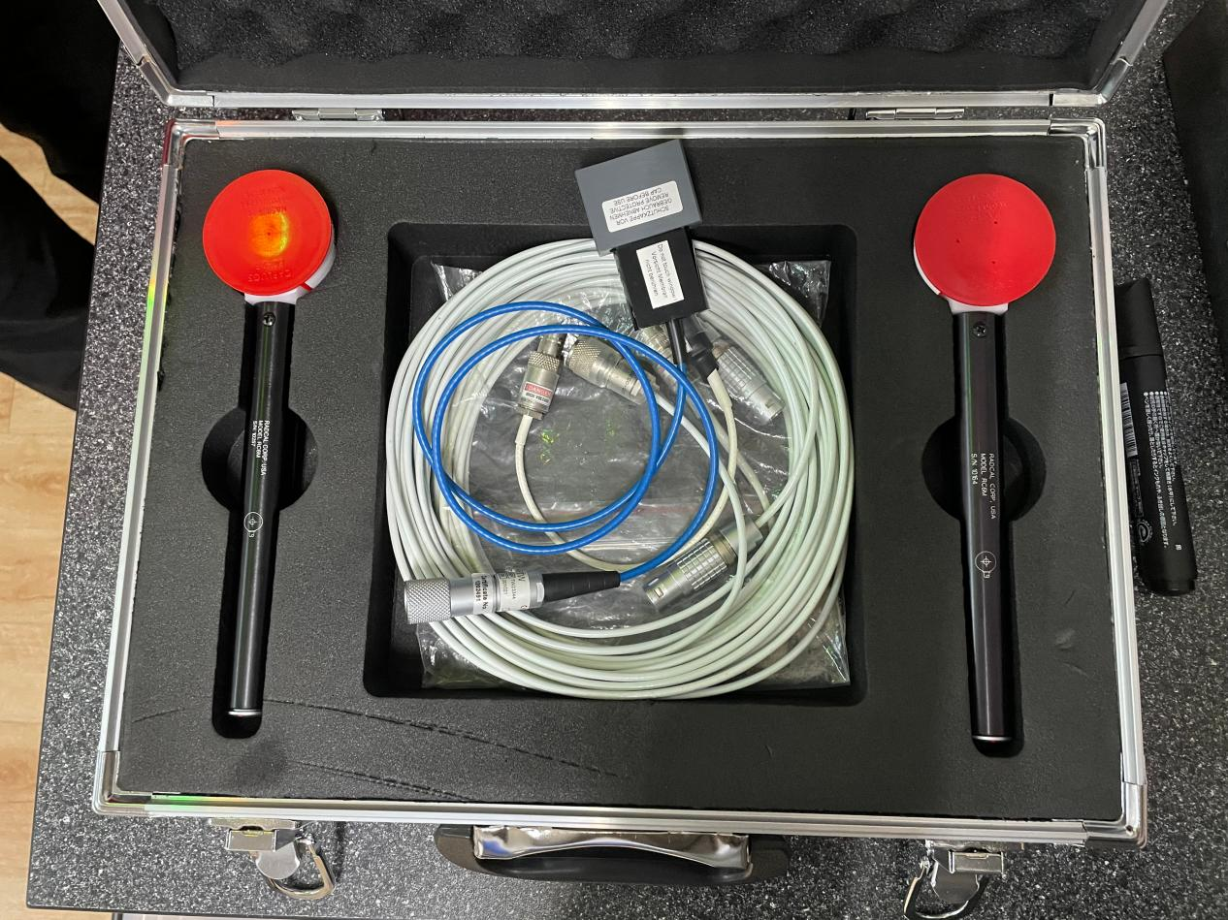
RC6M&TW23344

