CCL Key Comparison CCL-K3.n01
Calibration of Polygon Angle Standards

Technical protocol

Brian J. Eves (NRC-CNRC)

Ottawa, February 2023
Contents
1 Document Control 4
2 Introduction 4
2.1 Comparison topic 4
2.2 General Procedures 4
2.3 Support for CMCs/service categories 4
3 Organization 5
3.1 Participants 5
3.2 Schedule 6
3.3 Reception, transportation, insurance, costs 7
4 Artefacts 9
4.1 Description of artefacts 9
5 Measuring instructions 10
5.1 Handling the artefact 10
5.2 Traceability 10
5.3 Measurands 10
5.4 Measurement uncertainty 12
5.5 Measurement Methods 12
5.5.1 10-sided polygon 12
5.5.2 12-sided polygon 12
6 Reporting of results 12
6.1 Results and standard uncertainties as reported by participants 12
6.2 Results reported by the pilot 13
7 Analysis of results 13
7.1 Calculation of the KCRV 13
7.2 Normalized Errors 13
7.3 Artefact instability 14
7.4 Initial assessment of CMC claims 14
7.5 Correlation between laboratories 14
7.6 Linking of result to other comparisons 15
Appendix A – Reception of Standards 16
Appendix B – Condition of Measuring Faces 17
Appendix C – Results Report Form 19
Appendix D – Description of the measurement instrument 21

Document Control
Version Draft A.3 issued by NMISA.
Version Draft A.4 issued on 2022-12-07. NMISA no longer piloting the comparison. NRC accepted role of pilot. Modified protocol to use updated key comparison templates. Added additional 10-sided polygon to the artifact list.
Version Draft A.5 issued on 2023-02-27. Added artifact figures and explicit handling instructions for the different polygons. Updated contact information for participants.
Version Draft A.6 issued on 2023-03-21. Added shipping case figure and created initial schedule. Expanded the results reported by the pilot to include the PSI measurement. NMISA has withdrawn from the comparison.
Version A.7 issued on 2024-09-05. Changed comparison name according to new naming scheme. Amended measurement dates for the second loop.

Introduction
The metrological equivalence of national measurement standards and of calibration certificates issued by national metrology institutes is established by a set of key and supplementary comparisons chosen and organized by the Consultative Committees of the CIPM or by the regional metrology organizations in collaboration with the Consultative Committees.

Comparison topic
At its meeting in 2014, the Consultative Committee for Length (CCL) WG-MRA decided upon a key comparison on the measurement of angle standards with NMISA as the pilot Laboratory. The initial scope of the comparison included the calibration of polygons and angle encoders. After extensive discussion the scope was limited to polygon standards. In 2022 NMISA announced they could not continue as the pilot laboratory and NRC-CNRC volunteered to assume the role of pilot. The comparison was registered in 2020 with the identifier CCL-K3.2020, and artefact circulation is planned to start in April 2023.

General Procedures
The procedures outlined in this document cover the technical procedure to be followed during the measurements. A goal of the key and supplementary comparisons for topics in dimensional metrology is to demonstrate the equivalence of routine calibration services offered by NMIs to clients, as listed in Appendix C of the Mutual Recognition Arrangement (MRA). To this end, participants in this comparison agree to use the same apparatus and methods as routinely applied to client artefacts.
By their declared intention to participate in this key comparison, laboratories accept the general instructions and to strictly follow the technical protocol of this document. Due to the large number of participants, it is very important that participating NMIs perform their measurements during assigned dates. Participants should keep in mind that the allocated time period is not only for measurements, but transportation and customs clearance as well. Once the protocol and list of participants have been agreed, no change to the protocol or list of participants may be made without the agreement of all participants.

Support for CMCs/service categories
This comparison directly tests CMCs linked to the measurand “face angle” of service category 3.1.1 (optical polygon) in the DimVIM. Other service categories and CMCs supported by this comparison can be found by looking up key comparison topic CCL-K3 in the Competence Matrix as part of the CCL Strategy Document.

Organization

Participants
Table 1. List of participant laboratories and their contacts.
Lab Code | Institute and address | Contact person, phone, email
NMC,A*STAR | National Metrology Centre  8 CleanTech Loop Unit 01-20  Singapore 637145 | Wang Shihua  +65 6714 9264  wang_shihua@nmc.a-star.edu.sg
CEM | Centro Español de Metrología  Alfar 2,  28760 Tres Cantos, Madrid  España | M del Mar Perez Hernandez  +34 91 8074716  mmperezh@cem.es
CENAM | CENAM  km 4,5 Carretera de los Cués  El Marqués, Queretaro, México. | Miguel Viliesid Alonso  +52 442 2110500 Ext. 3277  mviliesi@cenam.mx  Francisco Huerta Yshikawa  +52 442 2110500 Ext. 3283  fhuerta@cenam.mx
INMETRO | National Institute of Metrology, Quality and Technology  Av. N. Sra. das Graças, 50  Xerém - Duque de Caxias - RJ  20.250-020 - Brazil | Luiz Henrique Brum Vieira  +55 21 2679 9020/9024  lhvieira@inmetro.gov.br
INRIM | Istituto Nazionale di Ricerca Metrologica  str. delle cacce, 91  10135 Torino  Italia | Marco Pisani  +39 011 3919 966  m.pisani@inrim.it  Milena Astrua  +39 011 3919 963  m.astrua@inrim.it
KRISS | Korea Research Institute of Standards and Science  267 Gajeong-ro  Yuseong-gu, Daejeon  34113  Republic of Korea | Jae Yong Lee  +82 42 868 5226  +82 10 5431 8690 (mobile)  jaeyong@kriss.re.kr
NIM | National Institute of Metrology (NIM)  No.18, Bei San Huan Dong Lu  Chaoyang District.  Beijing 100029  P.R. of China | Zi Xue  +86‐10‐64524916  xuez@nim.ac.cn
NMIJ | National Metrology Institute of Japan  National Institute of Advanced Industrial Science and Technology  Central3 1-1-1 Umezono,  Tsukuba, Ibaraki,  3058563, Japan | Tsukasa Watanabe  +81 29 8614291  t.watanabe@aist.go.jp
NRC-CNRC | Metrology  National Research Council Canada  1200 Montreal Road, building M36  Ottawa, ON K1A 0R6  Canada | Brian J. Eves  +1 613 991 3279  brian.eves@nrc-cnrc.gc.ca
TUBITAK UME | Dimensional Group Labs  TÜBİTAK Gebze Yerleşkesi  Barış Mah. Dr.Zeki Acar Cad. No:1  41470 Gebze KOCAELİ TURKEY | Tanfer YANDAYAN  +90 262 679 5000 ext. 5312  tanfer.yandayan@tubitak.gov.tr  S. Asli AKGOZ  +90 262 679 5000 ext. 5301  asli.akgoz@tubitak.gov.tr

Note that while multiple contacts are listed for certain participant laboratories in order to simplify communications during the comparison, only one person from each participating laboratory can be included as an author in the final comparison report. Participants with multiple contacts should notify the pilot of their choice of primary contact for reporting purposes.

Schedule
Each laboratory has six weeks that include customs clearance, calibration and transportation of the artefacts to the following participant. By confirming its participation, each laboratory commits to performing the measurements and shipping the artefacts to the next participant in the allotted period, allowing enough transportation time that the next participant will receive the artefacts at the beginning of their own measurement period. If a laboratory cannot complete its measurements in time, whether due to technical problems, delays in customs, or other difficulties, the laboratory must contact the pilot as soon as possible. The laboratory may, at the pilot’s discretion, be required to send the artefacts directly to the next participant before completing its own measurements.
Table 2. Planned schedule of the comparison.
RMO | Laboratory | Starting date | Remarks
SIM | NRC-CNRC | 2023-03-01 | Pilot opening measurements
EURAMET | INRIM | 2023-05-24 | ATA Carnet
APMP | NIM | 2023-07-05 | ATA Carnet
APMP | NMIJ | 2023-08-16 | ATA Carnet
SIM | CENAM | 2023-09-27 | ATA Carnet or tempory import
- | NRC-CNRC | 2023-10-08 | Pilot interim check & ATA Carnet renewal
EURAMET | TUBITAK UME | 2024-03-14 | ATA Carnet – delays shipping into country
EURAMET | CEM | 2024-05-02 | ATA Carnet – delays due to lab repair
APMP | KRISS | 2024-10-01 | ATA Carnet
APMP | NMC,A*STAR | 2024-11-12 | ATA Carnet
SIM | NRC | 2024-12-24 | Temporary shipping destination to return ATA Carnet to Canada
SIM | INMETRO | 2025-02-19 | Temporary import
- | NRC-CNRC | 2025-04-02 | Pilot closing check

Reception, transportation, insurance, costs
The gauges will be transported in a single hard-walled foam-filled travel case, with each polygon contained in their cases and seated in its own cavity in the foam (Figure 1).
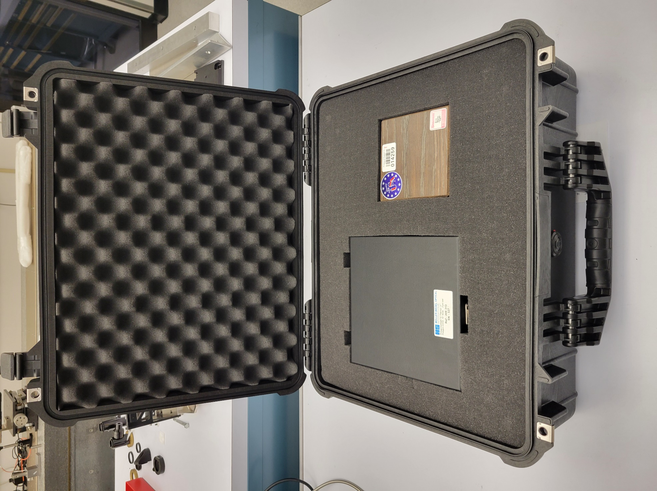
Figure 1: Transport Case
Upon reception of the package, each laboratory must check that the contents are complete and that there is no apparent damage to the box or to any of the standards. The arrival and condition of the standards must be reported immediately to the pilot and to the previous participant who sent the shipment, preferably using the form of Appendix A.
The pilot laboratory will cover the costs of the standards and of the packaging, and the shipping costs to the first laboratory in each loop of the circulation. The pilot laboratory has no insurance for any loss or damage of the standards during the circulation.
After completing its measurements, each participant must repackage the standards and ship them to the next participant.
Each participating laboratory shall cover the costs of shipping and transport insurance against loss or damage. Each participant should contact the laboratory that follows them in the circulation to confirm its shipping address (which may change over the course of the comparison). This should be done while measurements are underway, so that the artefacts can be shipped onward as soon as the measurements are completed. The package should be shipped with a reliable parcel service. Please inform the pilot laboratory and the following participant when the package leaves your installations, indicating all pertinent information such as the carrier and tracking number of the shipment. If the packaging is damaged at any point during circulation, it shall be repaired by the laboratory before onward shipment. In the case that a laboratory or its shipping agent damages one or more artefacts, they may be required by the pilot to replace the artefacts at their own cost (or from the insurance).
The package is accompanied by an ATA carnet. For shipment within the EU the ATA carnet may be shipped inside the box. Outside EU the carnet shall always be shipped with the package, never inside the box, but outside, accessible, and obvious to customs officials. Please be certain, that when receiving the package, you also receive the carnet! For each loop of the circulation, the carnet and package must both return to the pilot within one year of the date of issue of the carnet.

Artefacts

Description of artefacts
The package contains two polygons: a 10-sided and a 12-sided polygon.
The 10-sided polygon, serial number 31391.15, is manufactured by Starrett-Webber and is made of chrome carbide. The measuring faces have a rectangular cross-section of approximately 14 mm by 16 mm. The polygon has a center hole of 25.4 mm for mounting and a height of 17.5 mm. The normal orientation of the polygon is defined as the orientation in which the face numbers are visible on the top surface of the polygon. The inverted orientation has the serial number visible on the top surface of the polygon. The polygon is shown on the right-hand side of figure 2.
The 12-sided polygon, serial number 327, is manufactured by Mӧller-Wedel and comprises a Zerodur polygon mounted upon a stainless steel base. The measuring faces have a diameter of approximating 25 mm. The polygon has a center hole of 15 mm for mounting and a height of 60 mm. The polygon should only be measured in the normal orientation, i.e. with the steel base plate below the Zerodur component. The polygon is shown on the left-hand side of figure 2.
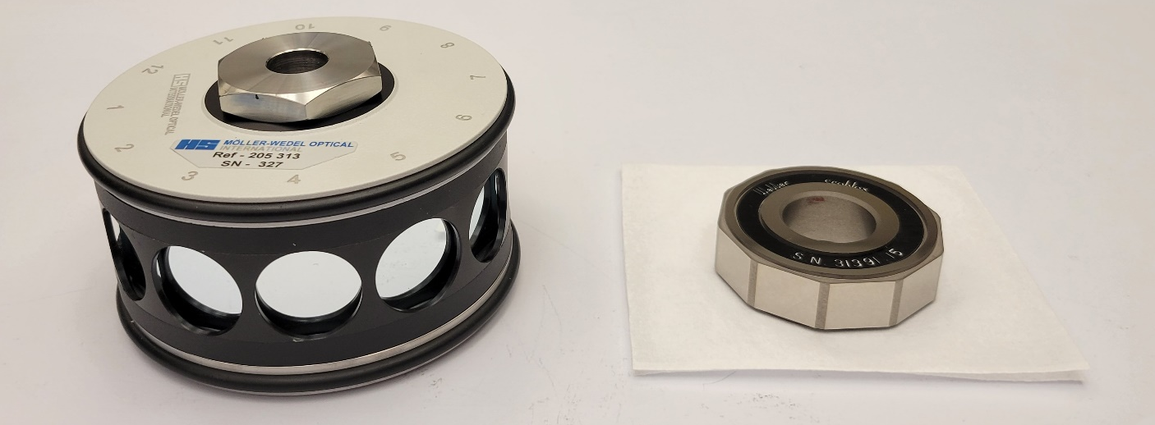
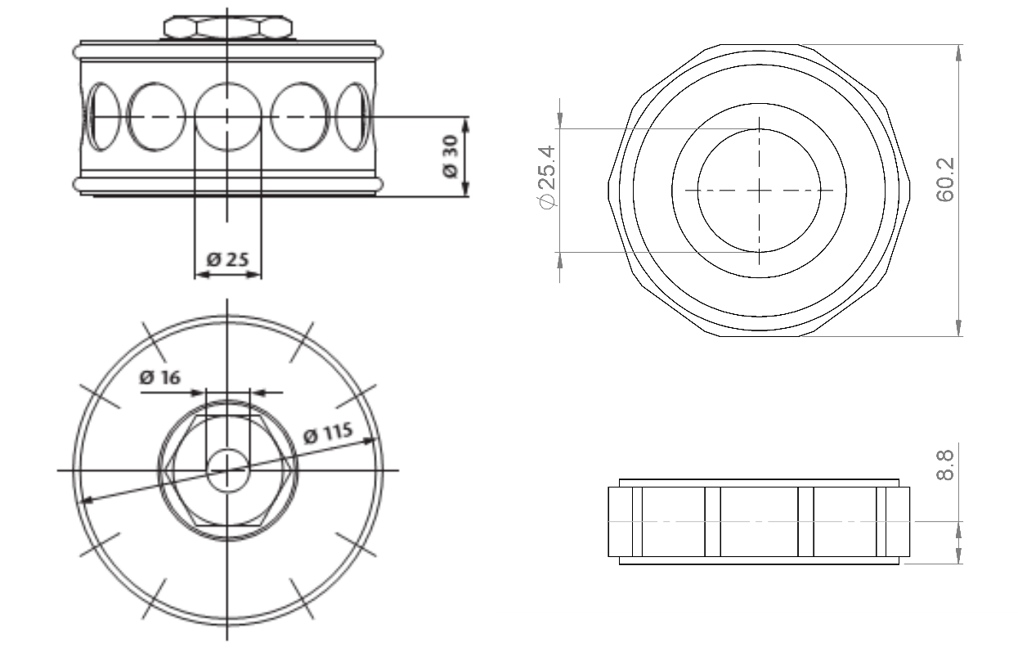
Figure 2: Comparison artifacts. Units are in mm.

Measuring instructions

Handling the artefact
The polygons should only be handled by authorized persons and stored in such a way as to prevent damage. Before making any measurements, the polygons should be inspected to verify that their measuring surfaces are not damaged and do not present severe scratches and/or dirt that may affect the measurement result. The condition of the polygons before measurement should be registered in the form provided in appendix B. No participant shall try to refinish or repair measuring faces by burring, lapping, stoning, or any other method.
Measurements may only be performed using equipment normally used to offer the relevant CMC service. In case of multiple CMC services in this area, only the service/equipment with the smallest uncertainty should be used, unless the pilot and other participants agree to allow additional instruments to be used; in which case, only the results of the instrument/service with the smallest uncertainty may contribute to the KCRV. No other measurements are to be attempted by the participants and the polygons should not be used for any purpose other than the comparison described in this document. The polygons may not be given to any party other than the participants in the comparison.
The polygons should be examined before despatch and any change in condition during the measurement at each laboratory should be communicated to the pilot laboratory. After the measurements, the polygons must be returned to the original packaging before shipment to the next laboratory. Ensure that the contents of the package is complete before shipment.
Dust can be removed from the mirror faces of either polygon using a gentle flow of clean dry air. Note that compressed air at high pressures (commonly purchased in a disposable can for cleaning electronics) should not be used due to the risk of water condensation caused by the rapid cooling of the mirror faces. Specific handling instructions are as follows:
10-sided polygon, serial number 31391.15
Only handle using powder free nitrile or similar gloves, and avoid touching the measurement faces if possible. If you see any finger prints or dirt then inform the pilot via the form in appendix B as part of the inspection process. If possible, provide photographic evidence. If the pilot agrees the chrome carbide surfaces can be cleaned with lint free tissue paper, and alcohol (follow similar cleaning protocols for gauge blocks). After cleaning record the quality of the faces and inform the pilot.
12-sided polygon, serial number 327
Only handle using powder free nitrile or similar gloves, and do not touch the optical faces. If you see any finger prints or dirt then inform the pilot via the form in appendix B as part of the inspection process. Provide photographs if possible. Do not attempt to clean the polygon faces.

Traceability
Plane-angle measurements should be traceable to the simple fact that one revolution equals either 2π radians or 360 degrees.

Measurands
The polygons shall be measured based on the standard procedure that the laboratory regularly uses for this calibration service for its customers.
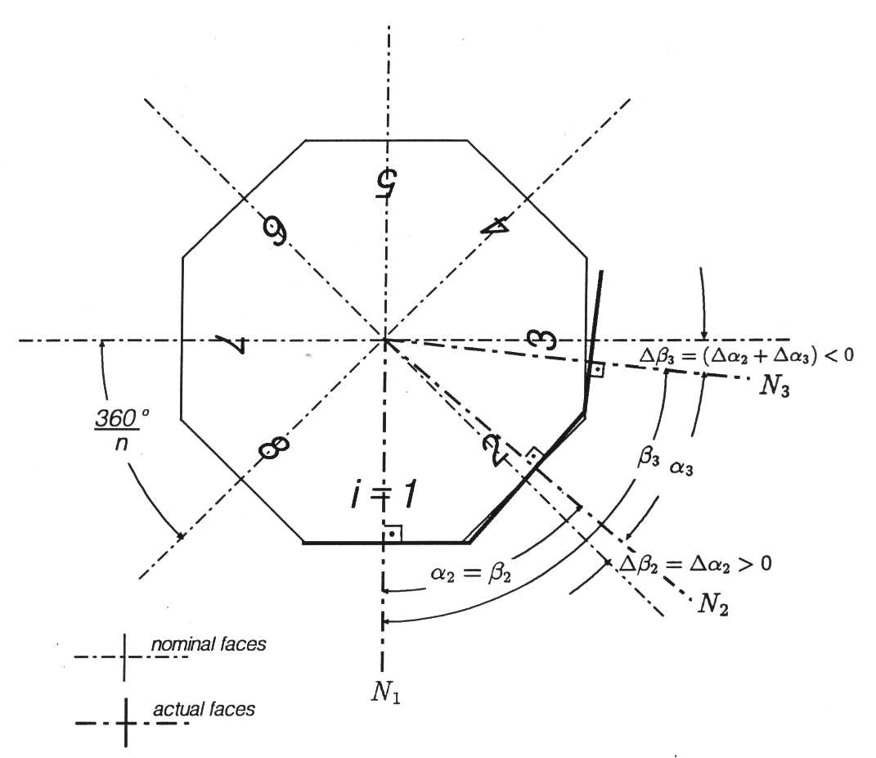
Figure 2 – Definition of pitch angle and pitch angle deviations.
The measurand to be reported for the polygons is the pitch angles between the projections of two adjacent surface normals N_{i-1} and N_{i} in the measuring plane with the face counting index (i=1,2,...,n). The deviations of the pitch angles from their nominal values of 360°/n are referred to as pitch angle deviations.
$Δα_{i}=α_{i}-\frac{360}{n}$ (i = 2,3,…,n) (1)
The positive count direction of the polygon angle corresponds to the count direction of the face index i indicated on the polygon. In ideal conditions the individual measuring faces are perpendicular to the measuring plane. In practice, the measuring faces are not perpendicular to the measuring plane by small tilts referred to as pyramidal errors. In that case, the measuring plane is defined as the plane for which the sum of the squares of the pyramidal errors of all measuring faces is a minimum.
The measurand definition for the plane angle of a single polygon face is the component of the average surface normal of the mirrored surface under the assumption of uniform light intensity that lies within the measuring plane. The entire surface of the target polygon face, i.e. no masking other than that intrinsically provided by the polygon, shall contribute to the average surface normal.

Measurement uncertainty
The uncertainty of measurement shall be estimated according to the ISO Guide to the Expression of Uncertainty in Measurement. The participating laboratories are encouraged to use their usual model for the uncertainty calculation. All measurement uncertainties shall be stated as standard uncertainties. The corresponding effective degree of freedom should be stated by the participants. If none is given, ∞ is assumed.
In the report of the measurement technique (Appendix D) the participant should list any relevant CMC claims for the service(s) related to the comparison.

Measurement Methods
The laboratory must measure the polygon according to its’ internal procedure. The following methods can be used but are not prescribed;
a) The use of an autocollimator and an index table or angle measuring table.
b) The method of comparison with the fixed pitch angle formed by two autocollimators.
c) Where the autocollimator in method a) is replaced with an interferometer (phase shifting). The interferometer then measures the difference in angle from the index table.
Any alternative non-contact method can be used.

10-sided polygon
The 10-sided Starrett-Webber polygon is to be measured in both the normal and inverted positions. The average of the pitch angle deviations for a particular face pair, one for each orientation, will be reported as the pitch angle deviations for that face pair.

12-sided polygon
The 12-sided Möller-Wedel polygon is to be measured in the normal orientation.

Reporting of results

Results and standard uncertainties as reported by participants
All results shall be reported using combined standard uncertainties.
The measurement results should be communicated to the pilot laboratory as soon as possible, and within six weeks of the completion of measurements at the latest. Results which are not reported in a timely fashion may be dropped from the comparison at the pilot’s discretion.
The measurement report form in appendix C of this document will be sent by e-mail to all participating laboratories as an editable electronic file. It would be appreciated if the forms (in particular the results table) could be completed electronically and returned to the pilot, to reduce the need for error-prone retyping of results. In any case, the signed report must also be sent in paper form by mail or electronically as a scanned pdf document. In case of discrepancies, the signed form will be considered to be the definitive version.
When reporting the results of the comparison each participant shall also submit via e-mail the form in appendix D which provides a description of the measurement method and instrument used. The form also reports the identifier, range and uncertainty of any existing CMC related to the comparison. This will be used by the pilot when checking whether or not CMC claims are supported by the comparison results. If the measurement uncertainty reported by a participant is significantly larger than the relevant CMC claim the rationale for the difference should also be explained in this form (e.g. air conditioning failure at time of measurements, artefact damage affecting measurements, etc.).
Following receipt of all measurement reports from the participating laboratories, the pilot laboratory will analyse the results and prepare a first draft A.1 report on the comparison. This will be circulated to the participants for comments, additions, and corrections.

Results reported by the pilot
The pilot will use both an autocollimator and a phase-shifting interferometer (PSI) to measure the polygons. Both instruments report independent angle measurements for the artifacts. In addition to the angle measurements the PSI will provide surface form measurements of the polygon faces.
The pilot laboratory will measure the polygons several times throughout the comparison to monitor their stability. Only the autocollimator measurements will be used to evaluate the stability of the artifacts. Where the pilot laboratory is acting as a participant in the comparison, only the first set of autocollimator measurements will be used. This applies in particular to the calculation of KCRVs and to the assessment of the pilot laboratory’s CMC claims.

Analysis of results

Calculation of the KCRV
The key comparison reference value (KCRV) will be calculated separately for each pitch angle deviation as the weighted mean of the largest consistent subset of participants’ results [M.G. Cox, Metrologia 44, 187 (2007)]. This procedure is recommended by the CCL [J.E. Decker et al, Metrologia 43, L51 (2006)] and its performance in terms of both statistical confidence and statistical power in detecting inconsistent measurements has been confirmed by recent numerical studies [E. Molloy et al, Metrology 1, 52, (2021)]. The consistency of the comparison results with their associated uncertainties will be checked using the Birge ratio, also known as the reduced $χ^{2}$.

Normalized Errors
Deviations of individual measurement results will be evaluated using normalized errors E_{n}. Two sets of normalized errors will be computed. The first, based on the standard uncertainties and degree-of-freedom estimates reported for the comparison measurements, can serve to support future CMC claims. The second, based on the expanded uncertainties of the participants’ published CMCs (where applicable), can serve to assess participants’ existing CMCs. In both cases, correlations induced by the participants’ contribution to the KCRV will be taken into account [K. Beissner, Metrologia 39, 59, (2002)].

Artefact instability
In general polygons are not expected to exhibit long-term linear changes in angle pitch deviation, and the pilot laboratory’s check measurements will be used to determine if the polygons have been mishandled during transportation and/or measurement. In the unlikely case that a linear drift in the artefact is detected three cases can be foreseen:
- The linear regression is an acceptable model for the pilot laboratory’s data and the absolute drift rate is smaller than its uncertainty. In this case the polygon will be considered stable, the KCRV will be a constant value calculated according to the standard evaluation procedure, and the pilot’s additional check measurements will have no influence on the numerical results.
- The linear regression is an acceptable drift model and the absolute drift is larger than its uncertainty, i.e. there is a significant drift of the angle pitch deviation. In this case an analysis similar to [Nien Fan Zhang et al, Metrologia 41, 231 (2004)] will be followed. This treats the KCRV as a linear function of time, with a slope and an offset. The slope will be determined, as above, by the pilot’s check measurements. The offset will still be calculated as a weighted average over all participants (or the largest consistent subset, if there are outliers).
- The pilot’s check measurement results and uncertainties are not adequately described by a linear-drift model. In this case the artefact is unpredictably unstable or the pilot has problems with its measurements. CCL will be consulted to determine how best to proceed in this case.

Note that the angle pitch deviations measured by the pilot laboratory have no special importance in any of these scenarios; the pilot contributes to the KCRV as a regular participant through its first measurement. Only the differences between the pilot laboratory’s check measurements are used for the determination of the drift rate.

Initial assessment of CMC claims
A given participant’s results will be deemed consistent with their uncertainty claims unless they have at least one result with a normalized error E_{n} > 1 and the ensemble of their normalized errors fails a $χ^{2}$ or Birge-ratio consistency test at the 95% confidence level. If the measurement uncertainty is dominated by fluctuating measurement noise that is uncorrelated between measurements, then a $χ^{2}$ test provides a global assessment of the participant’s performance that takes into account the likelihood of obtaining normalized error E_{n} > 1 by chance among the 22 measurements [P. Pedone, Measurement 42, 1469 (2009)]. Since a small correlation exists between a single participant’s measurements of the angle pitch deviations for a polygon due to the fact that the sum of the pitch angles must equal zero, the effective degrees of freedom for the $χ^{2}$ test must be reduced by one for each set of polygon data used in the test, i.e. for participants that measure both polygons the effective degrees of freedom used for the $χ^{2}$ test will be 20. Participants whose results fail both tests will be contacted by the pilot so that the discrepancies may be investigated. The pilot will not reveal the sign or magnitude of discrepancies until the circulation of Draft A.

Correlation between laboratories
Since this is a comparison of primary measurements, correlations between the results of different NMIs are unlikely.

Linking of result to other comparisons
The CCL task group on linking CCL TG-L will set guidelines for linking this comparison to any other key comparison within CCL for the same measurement quantity.

Appendix A – Reception of Standards
To: | Brian J. Eves, NRC-CNRC  1200 Montreal Road, building M36  Ottawa, ON  K1A 0R6  Canada  e-mail: brian.eves@nrc-cnrc.gc.ca
From: | NMI: ……………………………… Name: ………………………………  Signature: ……………………………… Date: ………………………………

We confirm receipt of the polygons for the CCL-K3.2020 comparison on the date given above.
After a visual inspection:
The polygons appear undamaged. Their precise state will be reported along with the measurement results using the inspection form in Appendix B.

We have detected significant damage which puts the measurement results at risk. A detailed description of the damage follows. [Include photos and use additional sheets as necessary.]

Appendix B – Condition of Measuring Faces
To: | Brian J. Eves, NRC-CNRC  1200 Montreal Road, building M36  Ottawa, ON  K1A 0R6  Canada  e-mail: brian.eves@nrc-cnrc.gc.ca
From: | NMI: ……………………………… Name: ………………………………  Signature: ……………………………… Date: ………………………………
The following significant surface faults (scratches, indentations, corrosion, etc.) were noted after a detailed inspection of the measuring faces.
10-sided Starrett-Webber Polygon: Serial No. 31391.15
Face | Sketch | Comments
1
2
3
4
5
6
7
8
9
10

12-sided Starrett-Webber Polygon: Serial No. 31391.15
Face | Sketch | Comments
1
2
3
4
5
6
7
8
9
10
11
12

Appendix C – Results Report Form
To: | Brian J. Eves, NRC-CNRC  1200 Montreal Road, building M36  Ottawa, ON  K1A 0R6  Canada  e-mail:brian.eves@nrc-cnrc.gc.ca
From: | NMI: ……………………………… Name: ………………………………  Signature: ……………………………… Date: ………………………………
Date of start of measurements: ……………………………… Date of end of measurements: ………………………………
Results:
10-sided Starrett-Webber Polygon: Serial No. 31391.15
Note: Δα_{i} is the average of the normal and inverted pitch angle deviations
Face Pair | Δα_{i} / arc sec | u(Δα_{i}) / arc sec | ν_{eff} | normal Δα_{i} / arc sec | inverted Δα_{i} / arc sec
1:2
2:3
3:4
4:5
5:6
6:7
7:8
8:9
9:10
10:1

Eccentricity Range: ………………………………
Pyramid Angle Range: ………………………………
12-sided Mӧller-Wedel Polygon: Serial No. 327
Face Pair | Δα_{i} / arc sec | u(Δα_{i}) / arc sec | ν_{eff}
1:2
2:3
3:4
4:5
5:6
6:7
7:8
8:9
9:10
10:11
11:12
12:1

Eccentricity Range: ………………………………
Pyramid Angle Range: ………………………………

Appendix D – Description of the measurement instrument
To: | Brian J. Eves, NRC-CNRC  1200 Montreal Road, building M36  Ottawa, ON  K1A 0R6  Canada  e-mail: brian.eves@nrc-cnrc.gc.ca
From: | NMI: ……………………………… Name: ………………………………  Signature: ……………………………… Date: ………………………………
Make and type of instrument(s)

Traceability path:

Description of measuring technique (mention alignment methods, measurement scheme, i.e. full closure, method for determining impact of surface form, etc):

Relevant 95 % CMC uncertainty claim for the service(s) related to this comparison topic (if existing) and identifier of the CMC

If the reported uncertainty is significantly higher than that of the related CMC, explanation for the increased uncertainty

