NOTICE TO USERS
This document is intended to be used as a template for the generation of reports for CIPM Key comparison studies undertaken within the CCQM IAWG. It can be used for other IAWG studies, such as pilot studies; however, the requirements for these reports may not be as stringent.
This template can be used to generate Draft A, Draft B and eventual Final Reports. In general, the Draft A report should contain all technical details, and may include pilot study data and possible KCRV estimators. The Draft B report should contain the proposed KCRV and should not include pilot study data. The Final Report is the final version that will be provided for the KCDB and will serve as the permanent record for the study.
The design of the template is two-fold: 1) black text denotes language and content that may be maintained, and 2) blue text that is expected to be replaced by the user.
A few select tables and figures have been maintained within the template as examples only, and represent the types of illustrations that should be provided within these reports. It is the study coordinator’s responsibility to generate the needed tables and figures for the particular study at hand. Additional graphics and data summaries should be added as needed.
It is incumbent on the user to ensure that the content of the final report is accurate and reflective of the current key comparison.
This page should be deleted from the final report!

[CCQM-KXXX]
[Analyte(s) in a XXX Matrix: Subtitle]

Key Comparison

[Month 20XX]

Author 1, Author 2, and Author 3
NMI/DI Full Name
City, State/Province Postal Code Country

With contributions from:

Additional Authors
NMI/DI Full Name (NMI/DI Abbreviation)
City, State/Province, Country

Additional Authors
NMI/DI Full Name (NMI/DI Abbreviation)
City, State/Province, Country
Additional Authors
NMI/DI Full Name (NMI/DI Abbreviation)
City, State/Province, Country

SUMMARY

(to be used as the Metrologia abstract)
Provide a brief description of the relevancy of the measurand/study material measurement challenge, with an emphasis on its international importance. Include a brief description of the relevant or typically encountered measurement ranges. Add in any other notable statements for why the CCQM-IAWG supports this Key Comparison. Evidence of successful participation in formal, relevant international comparisons is needed to document calibration and measurement capability claims (CMCs) made by national metrology institutes (NMIs) and designated institutes (DIs).
[Number] of National Metrology Institutes and Designated Institutes participated in the Key Comparison [CCQM-KXXX] [Main Title]. Participants were requested to evaluate the mass fractions (or mass concentration or other relevant measurand), expressed in [units], of Measurand 1, Measurand 2, and Measurand 3 in [description of materials]. Also include statement referring to the study protocol that states how the Key Comparison Reference Values (KCRVs) are assigned to the various measurands. Provide a statement about any requested method specifics or analytical considerations. Add a statement that summarizes the methods and techniques employed by the participants. Also include a statement that details the consensus summary mass fractions (range) with relative standard deviations. For the Final Report, a summary of the KCRVs can be included.
Successful participation in [CCQM-KXXX] demonstrates measurement capabilities in determining mass fraction (or mass concentration or other relevant measurand) of XXX, in mass fraction (or mass concentration or other relevant measurand) range from 0.00 [units] to 0.00 [units] in a [description of types matrix].
TABLE OF CONTENTS
INTRODUCTION 1
TIMELINE 1
MEASURANDS 1
STUDY MATERIALS 1
PARTICIPANTS AND INSTRUCTIONS 1
RESULTS 1
DEGREES OF EQUIVALENCE (DoE) 1
USE OF [CCQM-KXXX] IN SUPPORT OF CALIBRATION AND MEASUREMENT CAPABILITY (CMC) CLAIMS 1
How Far the Light Shines 1
Core Capability Table 1
CONCLUSIONS 1
ACKNOWLEDGEMENTS 1
REFERENCES 1

Example LIST OF TABLES
Table X: Timeline for [CCQM-KXXX] 1
Table X. Results of the homogeneity assessment for [measurand in matrix] 1
Table X: Institutions Receiving [CCQM-KXXX] Sample Materials 1
Table X: Certified Reference Materials Used…………………………………………………….1
Table X: Metrological Traceability of Participants’ Results …………………………………….1
Table X: Reported Results for Moisture (if applicable), Measurand 1, and Measurand 2 1
Table X: Key Comparison Reference Values for Measurand 1 and Measurand 2 1
Table X: Degrees of Equivalence for Measurand 1 and Measurand 2 1

Example LIST OF FIGURES
Figure X: Dot-and-Bar Display of Reported Results for Measurand 1 and Measurand 2, 1
Figure X: KCRVs 10
Figure X: Degrees of Equivalence Associated with the KCRVs 12

Example LIST OF APPENDICES
Appendix A: Call for Participation and Protocol A1
Appendix B: Registration Form B1
Appendix C: Reporting Form C1
Appendix D: Summary of Participants’ Analytical Information D1
Table D-1: Summary of Analytical Techniques for [CCQM-KXXX]
Table D-2: Summary of Calibrants and Standards for [CCQM-KXXX]
Appendix E: Summary of Participants’ Uncertainty Estimation Approaches
Appendix F: Prototype Broad Scope CMC Claim

ACRONYMS

INTRODUCTION
Include a paragraph that describes why the IAWG has decided to perform this study. Examples of things to include are the international importance of the study, how it will underpin core competencies, and any reference to regulatory drivers and relevancy. [A list of relevant competencies for this study] [measurement level and complex matrix type] are important challenges for reference material producers, providers of other measurement services, such as proficiency testing schemes. Evidence of successful participation in formal, relevant international comparisons is needed to document calibration and measurement capability claims (CMCs) made by national metrology institutes (NMIs) and designated institutes (DIs).
In [Month 20XX], the Consultative Committee for Amount of Substance: Metrology in Chemistry and Biology (CCQM) approved the Key Comparison (KC) [CCQM-KXXX] “Title of Key Comparison” []. [CCQM-KXXX] was designed to assess participants’ capabilities for [a description of the measurement challenge]. Describe how the KC fits into the IAWG strategy, the 5-year plan and the Core Capability approach. Describe why the analyte/matrix was selected. Describe any previous comparisons that underpin similar competencies, or which complement this KC.
Include a paragraph that describes the analytical challenges and competencies that this study addresses. Include a description of the methods and how they can be used to represent the way they deliver measurement services to their customers.
The following sections of this report document the timeline of [CCQM-KXXX], the measurands, study material, participants, results, and the measurement capability claims that participation in [CCQM-KXXX] can support. The Appendices reproduce the official communication materials and summaries of information about the results provided by the participants.

TIMELINE
Example Table X lists the timeline for [CCQM-KXXX].

Example Table X: Timeline for [CCQM-KXXX]
Date | Action
Month 20XX | Proposed to CCQM
Month 20XX | Draft protocol presented to IAWG
Month 20XX | IAWG authorized [CCQM-KXXX]
Month 20XX | Call for participation to IAWG members
Month 20XX | Study samples shipped to participants. The range in shipping times reflects delays from shipping and customs.
Month 20XX | Results due to coordinating laboratory
Month 20XX | Draft A report distributed to IAWG
Month 20XX | Draft B report distributed to IAWG
TBD | Final report approved by IAWG

MEASURANDS
Include a paragraph describing the measurand(s) and the mass fractions (or mass concentrations or other, as appropriate) (on a dry mass basis/as received), in what particular matrix (e.g., freshwater, sediment, …) and with stated units.

STUDY MATERIALS
Include background on the study materials, including source, processing and grinding, particle size, etc. Also, include a description on how the samples are packed and the unit size.
Each participant received [number and type of materials]: [details on samples and materials as necessary]. The recommended minimum sample amount for analysis was at least 00.0 [units]. Measurement results were to be reported on a [dry-mass or as received basis].

Dry Mass Determination (where relevant)
Add relevant description of methods that were to be used for determination of moisture/dry mass, with details on subsampling, number of subsamples, minimal sample size, etc. All participants were required to follow the method outlined in the protocol.

Homogeneity Assessment of Study Material
Use this section to describe how the homogeneity (or heterogeneity) was determined for the material. Include a description of the laboratory analysis method that was used to evaluate any significant differences between-packet or within-packet. Also include a description of any statistical procedures applied, such as the typical one-way ANOVA. Include any summary of the coefficient(s) of variation and any expected measurement standard uncertainties.

Example Table X. Results of the homogeneity assessment for [details on measurand/matrix].
ANOVA Estimate | Measurand 1 | Measurand 2
Within-packet, CV_{wth}: | 0.0 % | 0.0 %
Between-packet, CV_{btw}: | 0.0 % | 0.0 %
Total analytical variability, CV: | 0.0 % | 0.0 %
Probability of falsely rejecting the hypothesis  that all samples have the same measurand value: | 00 % | 00 %

Stability Assessment of Study Material
Provide a detailed description of formal stability studies for the material(s), which should include a discussion on long term and transport stability. The latter may not be always necessary, but the reason for omitting it should be justified. Details on any freeze-thaw stability evaluations can also be useful, especially for any biological materials.
Graphs of any stability data (short-term and long-term, if possible) for individual measurand/matrix combinations can also be provided.

PARTICIPANTS, INSTRUCTIONS AND SAMPLE DISTRIBUTION
The call for participation was distributed in [Month 20XX] with the intent to distribute samples in [Month 20XX], receive results in [Month 20XX], and discuss results at the [specific details of meeting location, etc.] IAWG meeting, [Month 20XX]. See Table X for study timeline. Appendix A reproduces the Call for Participation and the study Protocol.
Table X lists the institutions that registered for [CCQM-KXXX] [Please remove email addresses, or any other specific contact information from the table prior to generating the Final Report, because the Final Report will become publicly accessible.]

Example Table X: Institutions Registered for [CCQM-KXXX]
NMI or DI | Code | Country | Contact
NMI 1 Full Name | NMI 1 | Country1 | First Name Last Name  email_address@nmi.country
NMI 2 Full Name | NMI 2 | Country2 | First Name Last Name  email_address@nmi.country
NMI 3 Full Name | NMI 3 | Country3 | First Name Last Name  email_address@nmi.country
NMI 4 Full Name | NMI 4 | Country4 | First Name Last Name  email_address@nmi.country
NMI 5 Full Name | NMI 5 | Country5 | First Name Last Name  email_address@nmi.country

Describe the sample distribution and add further information as required on any notable shipping delays, issues, etc. If temperatures were monitored during transport, describe results. Outline any participants who did not receive samples.
Describe if any participants withdrew, at what stage, and (if the participant approves) the reason for withdrawal.
Describe reporting requirements, e.g., if data were requested from two subsamples and the overall mean was to be reported. Outline that results were reported in what specific units and with the standard uncertainty, expanded uncertainty at 95 % level of confidence, and the coverage factor. Provide adequate details of the calibrants and their traceability, techniques and calibration approaches, calculation of results, and uncertainty budgets, as they were reported.

RESULTS
Participants were requested to report a [single] estimate of the mass fraction (or mass concentration or other, as appropriate) [units] for [description of the measurand and any subsamples or replication from the sample units.]
In addition to the quantitative results, participants were instructed to describe their analytical methods and approach to uncertainty estimation. Appendix X reproduces the report form.
[CCQM-KXXX] results were received from [00] of the [00] institutions that received samples.

Methods Used by Participants
Describe methodologies employed by participants and include a table summarizing main attributes, if necessary. Outline any obvious issues/trends that were observed in the study.
Include full descriptions of the analytical methods used by the participants, including sample preparation, analytical technique, and quantification approach. This may be summarized in Appendix X. The participants’ approaches to estimating uncertainty are provided in Appendix X.
Table X summarizes the measurement methods used by the participating NMIs/DIs for CCQM-KXXX
Example Table X: summary of measurement methods used
Participating NMI/DI | Measurand | Sample preparation method | Calibration method | Analytical instrument | Reference material used for calibration (traceability)

Calibration Materials Used by Participants
Participants were allowed to establish the metrological traceability of their results to the SI using a direct realization via a primary method, certified reference materials (CRMs) from an NMI/DI having the required CMC claims, or by preparing their own calibration standards using commercially available high purity materials for which they determined the purity themselves.

Describe how SI traceability was established by the participants. If any participants established traceability by preparing their own calibration standards, describe how that was done, especially how the purity of the calibration materials was evaluated.

Discuss any issues with the traceability of the calibrants or with the evidence to support the technique used to carry out an in-house assessment. Clarify if any results were not included in the KCRV calculation as a result of insufficient metrological traceability.

Participant Results for [Measurand 1 and Measurand X]
Use this section to describe any trends in the results, or any general observations for the reported datasets.
The results for [CCQM-KXXX] for the determination of [measurand 1 and measurand 2] are detailed in Table X and presented graphically in Figure X.
Table x. Reported results for [Measurand X]

Participating NMI/DI | Reported mass fraction (or mass concentration or other) (Units) | Reported standard uncertainty (Units) | Coverage factor, k | Expanded uncertainty (Units)

Example Figure X: Illustrated Reported Results for Measurand 1, units

Table x. Reported results on matrix CRMs used for QC

Participating NMI/DI | CRM | Measurand | Certified value (Units) | Expanded uncertainty of the certified value (Units) | Found mass fraction (Units) | Found standard uncertainty (Units) | Expanded uncertainty (Units)

Discussion of Results
Describe any issues and outline any further work carried out by participants following the original presentation of the results. Often some participants will have carried out specific further investigations. Include tables of revised data where relevant.
Outline any issues raised with respect to methods used.
Also outline any issues in relation to any uncertainties that may be over or underestimated. In some cases, a specific section on uncertainty may be justified.

KEY COMPARISON REFERENCE VALUE (KCRV)
Use this section to describe any observations of agreement between values, or lack of overlap between values and within the expanded uncertainties. Clearly articulate which data are being included in the KCRV calculation and why.
The study Coordinators may refer to CCQM/XX Guidance note: Decision tree for key comparisons [1], or equivalent documentation on KCRV estimations. The choice of appropriate estimators for the KCRV depends upon whether or not the reported measurement uncertainties are deemed credible for the purpose of establishing the KCRV: 1) if not all are credible, the simplest appropriate estimator is the equally-weighted arithmetic mean and its standard deviation-based uncertainty (Mean) and 2) if most are considered credible, a recommended estimator that properly accounts for excess variance is the DerSimonian-Laird variance-weighted mean (DL-mean) [1]. For study data that may contain values as outliers or have a multi-modal data structure, the use of robust estimators of location and dispersion – such as the median and adjusted median absolute deviation from the median (MAD_{E}) – is a plausible choice. Like the mean, the median does not use reported measurement uncertainties in any way.]
Use a table, such as Example Table X below, to list the candidate KCRVs, X, and standard uncertainties, u(X), calculated using the relevant equations in reference 1 for the arithmetic mean, median and DL-mean. The approximate 95 % expanded uncertainties, U₉₅(X), on the mean, median and DL-mean are estimated as: U₉₅(X) = t_{s} × u(X), where t_{s} ≈ 0.00 is the Student’s t two-tailed expansion factor for [0] degrees of freedom and 95 % coverage.

Example Table X: Candidate Key Comparison Reference Values for Measurand 1 and Measurand 2
 |  |  | Measurand 1, units |  |  |  | Measurand 2, units
Estimator | u?ª |  | X | u(X) | U₉₅(X)^{b} |  | X | u(X) | U₉₅(X)^{b}
Mean | No |  | 00.0 | 0.00 | 0.0 |  | 00.0 | 0.00 | 0.0
Median | No |  | 00.0 | 0.00 | 0.0 |  | 00.0 | 0.00 | 0.0
DL-Mean | Yes |  | 00.0 | 0.00 | 0.0 |  | 00.0 | 0.00 | 0.0

- Does the estimator utilize the information in the reported uncertainties?
- U₉₅(X) = t_{s}·u(X), where t_{s} is the appropriate two-tailed Student’s t critical value for 95 % coverage.

Use a figure, such as Example Figure X below, to display the application of the candidate KCRVs to the reported data.

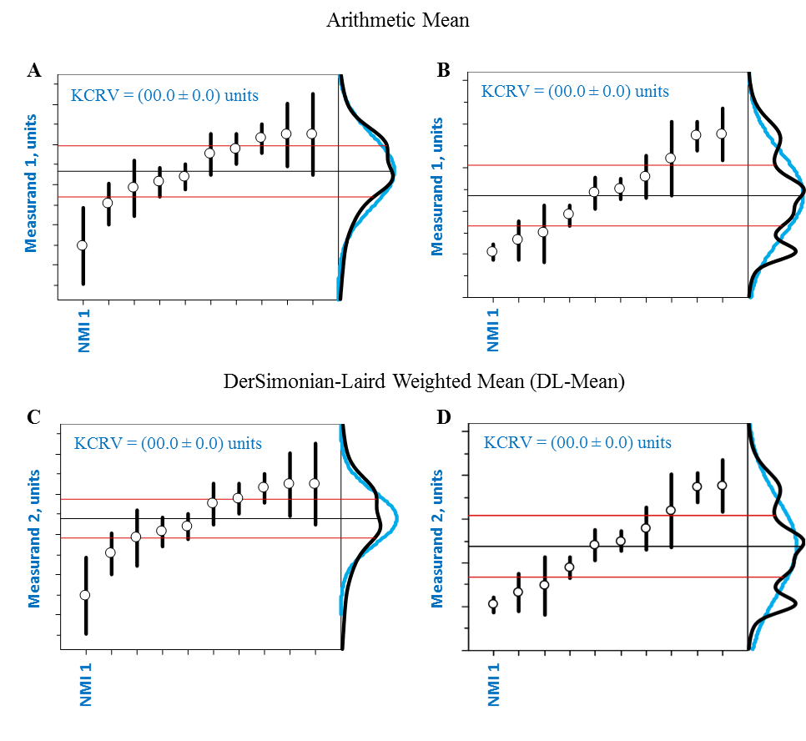

Example Figure X: Candidate KCRVs
Panels A and C display the Mean and DL-Mean candidate KCRVs relative to the reported results for Measurand 1. Panels B and D display the Mean and DL-Mean candidate KCRVs relative to the reported results for Measurand 2. In all panels, the results are sorted by increasing reported value. Dots represent the reported mean values, x; bars their standard uncertainties, u(x). The black horizontal line denotes the candidate KCRV. The bracketing red lines denote the standard uncertainty of the candidate KCRV. A probability density function for the reported values *black curve) and the normal distribution (blue curve) can be included as shown where this adds value.

Outline any difference in the various estimators for the KCRVs and clearly articulate the final choice and justification.
In the Draft B report, please provide the final figures of the selected KCRVs (with results and KCRV all presented with standard uncertainties) for each measurand and highlight any results not included in the KCRV calculation on the graph.

DEGREES OF EQUIVALENCE (DoE)
Use this section to discuss the Degrees of Equivalence for the participants. It is important to note that a Draft A version may provide different options for the DoEs, as determined by various KCRV scenarios. For the Draft B version, however, only the DoE for the final selected KCRV should be presented.
The absolute degrees of equivalence for the participants in [CCQM-KXXX] are estimated as the signed difference between the combined value and the KCRV: d_{i} = x_{i} – KCRV.
The study Coordinators may refer to CCQM/13-22 Guidance note: Estimation of a consensus KCRV and associated Degrees of Equivalence, 11-Apr-2013 [1], or equivalent documentation on DoE estimations.
The following paragraph provides an explanation of how the uncertainty of the DoE (U_{k=2}(d_{i})) is determined with the inclusion of covariance [1]. Since the KCRV is estimated from consensus of all results, the nominal k=2 expanded uncertainty on the d_{i}, U_{k=2}(d_{i}), is estimated as twice the square root of the sum of the squares of the standard uncertainties of the two components minus twice the covariance between the x_{i} and the KCRV:
$U_{k=2}\left(d_{i}\right)=2\sqrt{u^{2}\left(x_{i}\right)+u^{2}\left(KCRV\right)-2cov\left(x_{i},KCRV\right)}$.
To enable comparison with the degrees of equivalence estimates from other studies, it is convenient to express the d_{i} and U_{k=2}(d_{i}) as percentages relative to the KCRV: %d_{i} = 100·d_{i}/KCRV and U _{k=2}(%d_{i}) = 100·U_{k=2}(d_{i})/KCRV.
Example Table X below lists the numeric values of d_{i}, U₉₅(d_{i}), d_{i}, and U₉₅(d_{i}) for all participants in [CCQM-KXXX] for Measurand 1, Measurand 2 and Measurand X.

Example Table X: Degrees of Equivalence for Measurands X and X
Participating NMI/DI | Reported mass fraction, x_{i} (Units) | Reported standard uncertainty, u(x_{i}) (Units) | Relative standard uncertainty %(x_{i}) | Difference from KCRV, d_{i} (Units) | Expanded uncertainty of the difference, U(d_{i}) (Units) | d_{i} / U(d_{i})
This Table X will be filled in once there is agreement on which candidate KCRVs are to be used.
Example Figure X below graphically illustrates the preferred presentation of both the absolute and relative DoEs for two measurands using the Mean and DL-Mean candidate KCRVs. Note that the display of multiple estimators for DoEs are only appropriate for a Draft A document version.
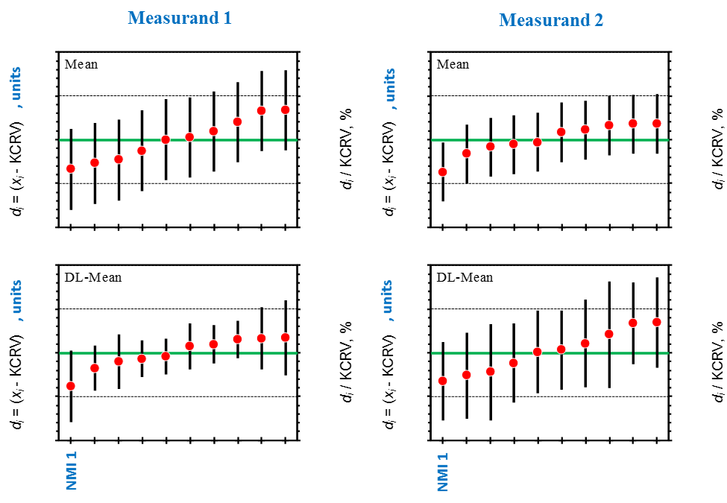

Example Figure X: Degrees of Equivalence Associated with the Candidate KCRVs
Panels A and C display the DoE for the Mean and DL-Mean candidate KCRVs for Measurand 1; panels B and D display them for Measurand 2. All results are sorted by increasing x. The axis to the left edge of each panel displays the absolute DoE, d, in units [list units]. The axis to the right edge of each graph displays the relative DoE, 100·d/KCRV, as percent. Dots represent the d, bars their approximate 95 % expanded uncertainties, U₉₅(d). The thick green horizontal line denotes perfect agreement with the candidate KCRV.

USE OF [CCQM-KXXX] IN SUPPORT OF CALIBRATION AND MEASUREMENT CAPABILITY (CMC) CLAIMS

How Far the Light Shines, Core Capability Statements and CMC support

Successful participation in [CCQM-KXXX] demonstrates the following measurement capabilities in determining mass fraction (or mass concentration or other, as appropriate) of [elements], in mass fraction range from 0.00 [units] to 0.00 [units] in a [description of types matrix].
Use this section to flag the level of agreement with the KCRV, e.g. if all DoE cross zero then everyone has demonstrated their competency within their level of uncertainty and CMCs that align with the HFTLS and with uncertainties aligned with the DoE are supported.

Core Capability Table
Insert here the CC table showing the measurement space covered by the study.

CONCLUSIONS
The conclusions are to be determined after agreement reached on which of the candidate KCRV models to use.

ACKNOWLEDGEMENTS
The study coordinators thank the participating laboratories for providing the requested information used in this study.

REFERENCES

APPENDIX A: Call for Participation and Technical Protocol
Use this section to provide text copies of the Call for Participation and Technical Protocol. Please remove any lists of email addresses or any other specific contact information of the participants, because this Final Report will become publicly accessible.

APPENDIX B: Registration Form
Use this section to provide text copies of any registration forms that were distributed to either the IAWG at large, or to individual participants of the study.

APPENDIX C: Reporting Form
Use this section to provide text copies of any reporting forms that were distributed to the participants of the study.
It is strongly recommended that all reporting forms be created in a document form, and all data should be entered as individual values (or as text). If an excel sheet must be used, all data should be entered as individual values and NOT to include formulas.

APPENDIX D: Summary of Participants’ Analytical Information
The following Tables summarize the detailed information about the analytical procedures each participant provided in their “Analytical Information” worksheets. The presentation of the information in many entries has been consolidated and standardized.
The participant’s measurement uncertainty statements are provided verbatim in Appendix E.
Use this section to also include any relevant institutional disclaimers.

APPENDIX E: Summary of Participants’ Uncertainty Estimation Approaches
The following are text excerpts and/or pictures of the uncertainty-related information provided by the participants in the reporting form. Information is grouped by participant and presented in alphabetized acronym order.

Uncertainty Information from NMI 1

Use this section to document the uncertainty information provided from the individual NMIs. It should at least include the following information: 1) measurement or observation equation, 2) definition of parameters and their associated values, 3) uncertainty budget for the various terms, and for all the measurands in the study, and 4) a summary of the uncertainties associated with the measurement or observation equation (step 1).
The layout for this information will be dictated by the study protocol and its associated reporting form(s).

