NOTICE TO USERS
This document is intended to be used as a template for the generation of technical protocols for CIPM key comparison studies undertaken within the CCQM IAWG. It can be used for other IAWG studies, such as pilot studies; however, the requirements for these protocols may not be as stringent.
The design of the protocol template is two-fold: 1) black text denotes language and content that may be maintained, and 2) blue text that is expected to be replaced by the user.
A few select tables and figures have been maintained within this template as examples only. It is the study coordinator’s responsibility to generate the needed tables and figures for the particular study at hand. Additional graphics and data summaries should be added as needed.
It is incumbent on the user of this template to ensure that the content of the study protocol is accurate and reflective of the current key comparison.
This page should be deleted from the final protocol document!

[CCQM-KXXX]
[Analyte(s) in a XXX Matrix: Subtitle]

Key Comparison

Study Protocol
[Month 20XX]

Author 1, Author 2, and Author 3
NMI/DI Full Name
City, State/Province Postal Code Country

INTRODUCTION
Include a paragraph that describes why the IAWG has decided to perform this study. Examples of things to include are the international importance of the study, how it will underpin core competencies, and any reference to regulatory drivers and relevancy. [A list of relevant competencies for this study] [measurement level and complex matrix type] are important challenges for reference material producers, providers of other measurement services, such as proficiency testing schemes. Evidence of successful participation in formal, relevant international comparisons is needed to document calibration and measurement capability claims (CMCs) made by national metrology institutes (NMIs) and designated institutes (DIs).
Describe how this study fits into the IAWG core capability approach and in the IAWG 5-year plan.

TIMELINE
Example Table X lists the timeline for the proposed study.

Example Table X:
Date | Action
Month 20XX | Sample Preparation
Month 20XX | Homogeneity and Stability Testing
Month 20XX | Sample Distribution
Month 20XX | Call for participation to IAWG members
Month 20XX | Deadline for Submission of Results
Month 20XX | Preliminary Discussion of Results

MEASURANDS
Include a paragraph describing the measurand(s) for the proposed study, and the mass fractions (on a dry mass basis/as received), in what particular matrix (e.g., freshwater, sediment, etc., study material) and with stated units. Any relevant description of the individual measurands for the comparison, this can be in figure or table form, as appropriate. Ensure that the measurand(s) is/are specifically defined. Outline expected mass fraction range(s), if relevant.

STUDY MATERIALS
Include background on the study materials (source, processing and grinding, particle size, etc.). Also, include a description on how the samples are packed and the unit size.
Each participant will receive [number and type of materials]: [details on samples and materials as necessary]. Measurement results are to be reported on a [dry-mass or as-received basis].
Recommended Minimum Sample Amount
The recommended minimum sample amount for analysis is at least 00.0 [units]. If relevant, describe any specific minimum sample size requirements for any explicit methods that will be applied for analysis.

Dry Mass Determination (where relevant)
Add relevant description of method(s) to be used for determination of moisture/dry mass, with details on subsampling, number of subsamples to be dried, minimal subsample size, etc. All participants are required to follow the method outlined in the protocol.

Homogeneity Assessment of Study Material
Use this section to describe how the homogeneity (or heterogeneity) has been determined for the material. Describe any further homogeneity testing that may be required before samples are to be shipped to participants.
Include a description of the laboratory analysis method that was used to evaluate any significant differences between-packet or within-packet. Also include a description of any statistical procedures applied, such as the typical one-way ANOVA. Include any summary of the coefficient(s) of variation and any expected measurement standard uncertainties.

Example Table X. Results of the homogeneity assessment for [details on measurand(s)/matrix].
ANOVA Estimate | Measurand 1 | Measurand 2
Within-packet, CV_{wth}: | 0.0 % | 0.0 %
Between-packet, CV_{btw}: | 0.0 % | 0.0 %
Total analytical variability, CV: | 0.0 % | 0.0 %
Probability of falsely rejecting the hypothesis  that all samples have the same measurand value: | 00 % | 00 %

Graphs of any homogeneity data for individual measurand(s)/matrix combinations across units (i.e., bottles, packets) can also be provided. Plot the measurand data as relative to a mean value.

Example Figure X. Homogeneity evaluation for [measurand(s)/matrix].
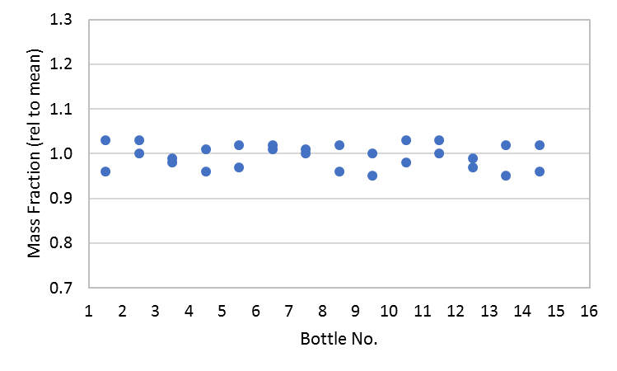

Stability Assessment of Study Material
Provide a detailed description of formal stability studies for the material(s), which should include a discussion on long term and transport stability. The latter may not be always necessary, but the reason for omitting it should be justified. Details on any freeze-thaw stability evaluations can also be useful, especially for any biological materials.
Graphs of any stability data (short-term and long-term, if possible) for individual measurand/matrix combinations can also be provided. If stability testing will continue after the study has begun, this should be stated.

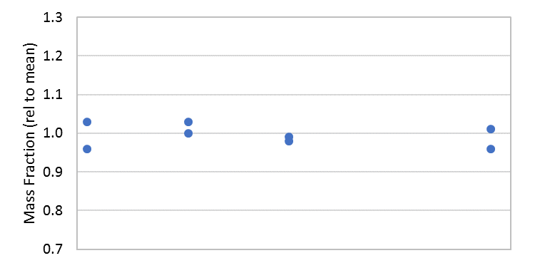

Available Calibration Materials
Participants may establish the metrological traceability of their results to the SI using a direct realization via a primary method, certified reference materials (CRMs) from an NMI/DI having the required CMC claims, or by preparing their own calibration standards using commercially available high purity materials for which they have determined the purity themselves. Table X lists the CRMs that are available for use for this study and known to the study coordinator at the time of preparation of this protocol (if relevant).

Example Table X: Certified Reference Materials Available for Use
CRM | Provider | Measurand
CRM XXX | NMI 1 | Abbr 1  Abbr 2
CRM XXX | NMI 2 | Abbr 1  Abbr 2
CRM XXX | NMI 3 | Abbr 1

INSTRUCTIONS AND SAMPLE DISTRIBUTION
Describe the sample distribution, and add further information as required on any notable shipping delays, issues, etc. If temperatures are to be monitored during transport, then describe how this is to be recorded and analyzed.

SAFETY
Describe safety procedures for the handling and disposal of the material.

RESULTS
The final results, from a minimum of [X] independent replicates, should be returned to the coordinator by [date], using the supplied reporting template. All participants must include:
- Final results and uncertainty budget, reported as [Units] [on a dry mass/as received basis, as appropriate], from at least [X] independent replicate measurements
- A detailed description of the sample preparation methods, analytical techniques, calibration approach and any corrections applied
- Participants are encouraged to provide any results they produced for matrix CRMs used for QC.

USE OF [This Study] IN SUPPORT OF CALIBRATION AND MEASUREMENT CAPABILITY (CMC) CLAIMS

How Far the Light Shines

Successful participation will help demonstrate capabilities for [e.g. sample preparation (dissolution)] and accurate analysis for challenging matrices and measurands. Considering the IAWG Core Capability Matrix, this material falls into the matrix category of [XXX], and so will support CMCs for the analyte groups of [“XXX” (Xx, Xx, Xx)], [“XXX” (Xx, Xx)] and some [“XXX” (Xx, Xx, Xx)], [“XXX” (Xx, Xx)], at the [mass fraction units] level.

Core Capability table
Include as appropriate.

Contact Details
[XXX]

Publications
CCQM policy concerning external publications (e.g., journal papers) about a CIPM pilot study or key comparison include the following guidelines:

- The coordinating institute(s) holds the first right to publish.
- Publication requires the consent of all institutes that participate in the study.
- The author list for such a publication will usually include all participants.

The IAWG is reminded that these guidelines must be followed.

REFERENCES
Include as necessary.

