International comparison of activity measurements of radon 222
CCRI(II)-S14-Rn-222

Sylvie Pierre¹, Frédéric Juget², Juncheng Liang³, Philipe Cassette¹, Carole Fréchou¹, Benoît Sabot¹
¹ CEA, LIST, Laboratoire National Henri Becquerel, LNE-LNHB, CEA-Saclay, 91191 Gif sur Yvette Cedex, France.
² Institut de Radiophysique, IRA-METAS, Lausanne, Switzerland
³ Division of Ionizing Radiation Metrology, National Institute of Metrology, Beijing 100029, China

Abstract:

An international comparison of activity measurements of radon-222, CCRI(II)-S14-Rn-222, was organised and piloted in 2018 by the LNE-LNHB. The same sample of radon-222, provided by the LNE-LNHB, was measured using the same technique by the three laboratories.
In the Defined Solid Angle (DSA) method for realizing primary standards of radon, the radon gas from a radium source is frozen onto a surface where it becomes a solid source. The activity is determined by solid angle alpha counting, after which the surface is heated, the radon returns to gaseous form and is transferred to a container. This radon inside the container is a standard. Previous studies have shown that the radon loss in this transfer process is negligible.
The results from the measurements are reported and analysed using the power moderated weighted mean method [1].
1. Introduction
Radon-222 is a radioactive noble gas which undergoes alpha decay to short half-life solid decay products and is one of the main sources of natural radioactivity. It can be monitored with commercial instruments to evaluate the radon activity concentration in individual rooms, water or soil. National standards of radon-222 are available in several countries and comparison of these standards is necessary to ensure the international traceability of this radionuclide and to support the CMC’s of the National Metrology Institutes.
A round-robin international comparison of activity measurements of radon-222 was organised under the auspices of the Consultative Committee for Ionizing Radiation CCRI(II) in 2018, comparison CCRI(II)-S14-Rn-222. The sample was prepared at the LNE-LNHB and was circulated amongst the participants.
The measurement method used by all the participants was defined solid-angle alpha counting ([2, 3, 4]) which is a primary measurement method. Three results were reported.
2. Relevant information about the comparison
The list of the participating institutions, including information of the people who carried out the measurements, is shown in Table 1.
Table 1 - List of participants
IRA-METAS | Institut de Radiophysique, Lausanne, Switzerland (F. Juget)
NIM | Division of Ionizing Radiation, National Institute of Metrology, Beijing, China (J. Liang)
LNE-LNHB | Laboratoire National de métrologie et d’Essais - Laboratoire National Henri Becquerel,  Gif-sur-Yvette, France (S. Pierre, B. Sabot)

Initially, radon gas emanated from a radium source is frozen onto a cold finger, the activity measured, the temperature on the cold finger is increased so that the radon returns to gaseous form and is transferred into a container. The radon residue in the tubes between the measurement chamber and the container is measured and subtracted. This process is well established as a method of realizing a radon standard.
When a laboratory receives the container, the radon is transferred from the container to the measurement chamber during a time long enough in order to be sure that any radon which could stay in the tubes is insignificant. Previous tests in each laboratory have evaluated this time. Of course if there is a leak, radon can be lost but in this case, it is a significant loss and no measurement is possible.
If a laboratory suspects a leak, after a first measurement, it can transfer the radon several times from the container to the chamber and re-measure the activity in the chamber to check if the same result is found.
One metal container filled with radon-222 at low pressure (below 10⁻³ hPa) was prepared and sent to IRA-METAS by the LNE-LNHB. After measurement, radon was transferred back to the container and IRA-METAS sent it to NIM. After measurement at NIM, the radon sample was again transferred in the container and was sent to LNE-LNHB where it was re-measured in order to check that no gas was lost during the exercise. Even if a decrease of activity can be observed, the two measurements at LNE-LNHB are consistent, as shown in Figure 1.
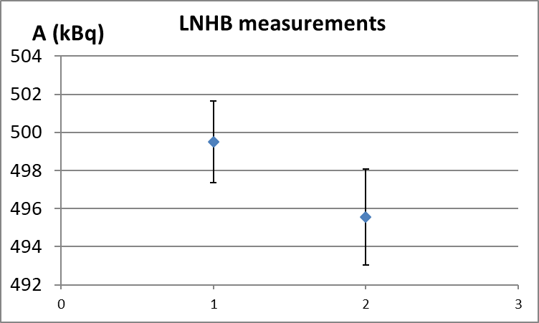

Figure 1 – Results of the LNHB measurements before the shipment (measurement 1) and when the sample is back (measurement 2), relative uncertainties k = 1.
The uncertainty of the second measurement is larger than the first measurement, because it takes into account the uncertainties due to the transfer for IRA and NIM. The uncertainty in the half life is also taken into account.
When a laboratory prepares a standard, the radon activity is measured and the residue in the tubes is measured too. So, there is no uncertainty due to the amount of radon which could stay in the tubes. However, when radon is transferred from a container to the chamber, there is no possibility to measure the amount of radon which could stay in the tubes. That is why we add an uncertainty which has been estimated after many assays. This explains why the second measurement in LNHB, which is a transfer from the container to the chamber, has an uncertainty higher than the first measurement in LNHB.
The half-life value T_{1/2} = 3.8232 (0.0008) d [5] was used and the results were evaluated on the reference date 1st of September 2018 12 h UTC. Table 2 defines the method used by the three laboratories.
Table 2 –Method used
Method acronym | Description of the method | Laboratories using this method
SA-PS-AP-00-00-00 | Alpha Counting in Defined Solid Angle | LNHB, IRA, NIM
The acronym of the method is given according to the CCRI(II) rules. The facilities used by the three participants are well described in published papers ([2], [3], [4]).
3. Results and discussion
The results, expressed in terms of radon activity in the sample at the reference date, are shown in Table 3 which also presents the associated uncertainties provided by the participants. All the results in this paper take into account the decay correction.
Table 3 – Results evaluated on the 1st of September 2018 12 h UTC in kBq, as given by the participants.
Laboratory | Activity  (kBq ) | Combined standard  uncertainty (kBq) | Combined relative  standard uncertainty (%, k = 1)
IRA | 503.8 | 2.2 | 0.43
NIM | 493.8 | 2.5 | 0.5
LNE-LNHB | 499.5 | 2.0 | 0.4
Table 4 presents the detailed uncertainties, as provided in the reporting forms of the participants for all individual parameters included in the measurement process.
Table 4 – Uncertainty components, in % of the activity for k = 1
 | Laboratories
 | NIM | LNHB | IRA
Uncertainty components | Relative standard uncertainty (%) | Relative standard uncertainty (%) | Relative standard uncertainty (%)
Counting statistic |  | 0.11 | 0.18
Dead time |  | 0.001
Background | 0.03 | 0.001 | 0.03
Pile-up |  | 0.001
Geometrical factor | 0.19 | 0.32
Repeatability | 0.30 | 0.05
Reproducibility |  | 0.18
Residue activity | 0.34 | 0.05
α scattering | 0.09
Half-life of Rn-222 | 0.01
Energy peak determination | 0.02
Counting method |  |  | 0.05
Transfer |  |  | 0.38
Decay correction |  | 0.01 | 0.01
Decay correction during measurement |  | 0.006 | 0.04
TOTAL | 0.5 | 0.4 | 0.43
Due to the small number of participants, the use of statistical tools is not justified and no statistical test was performed to evaluate the coherence of the results. The results are reported in Figure 2, together with average indicators such as the arithmetic mean, the median, the weighed mean and the Power-Moderated Mean (PMM) [1].
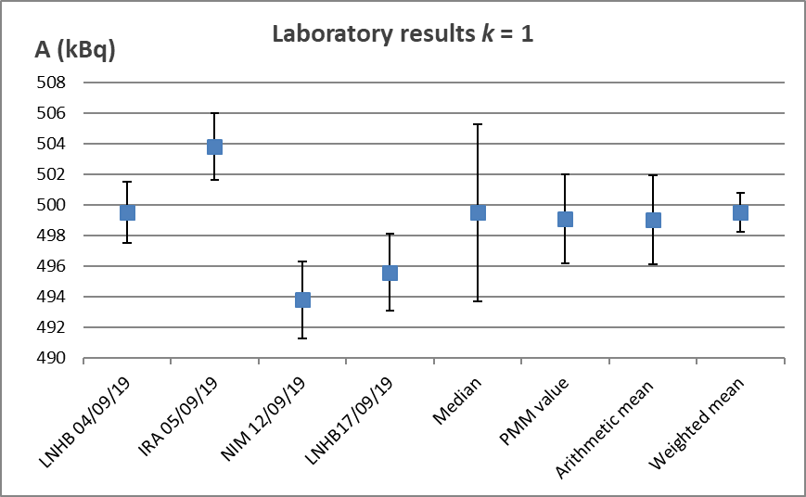

Figure 2 - Individual results of the international comparison of activity of the sample (3 individual results) in kBq, median, PMM value, weighted mean and average value, absolute uncertainties k = 1.

Following the policy of CCRI(II), the reference value of this comparison is the PMM value of 499.1 (29) kBq. As the uncertainties reported by the three laboratories are similar, this PMM value is very close to the arithmetic mean, the weighed mean and the median (Cf. Table 5).
Table 5 – Median, PMM value, arithmetic mean, weighted mean.
 | A (kBq) | u (kBq)
Median | 499.5 | 5.8
PMM value | 499.1 | 2.9
Arithmetic mean | 499.0 | 2.9
Weighted mean | 499.5 | 1.3
One can notice the good agreement (with k = 1) between NIM measurement and LNHB 17/09/19 measurement when the sample is returned (ratio 0.4%), and the good agreement (with k = 2) between the 4/9/19 LNHB measurement and IRA measurement (ratio 0.9%). These results can also be visualized in the PomPlot given in figure 3 [1].
The discrepancy between the two groups could suggest a radon loss of about 2 % between the IRA and NIM measurements. However, several tests were performed in the past, showing there is no loss during the transfer between the container and the measurement chamber (Cf. Table 6). Nevertheless, as no precise evaluation of this possible loss could be done during the current exercise, it would be perhaps prudent to increase the uncertainty of the reference value.
Table 6 – Bilateral comparisons between 2012 and 2017.
11/09/12 12:00:00 UTC | Standard produced by IRA | u (%) k = 2 | LNE-LNHB/IRA | IRA/LNE-LNHB
LNE-LNHB measurement | 256.6 kBq | 1.1 | 0.9992 | 1.0008
IRA measurement | 256.8 kBq | 1.1
11/09/12 08:00:00 UTC | Standard produced by LNE-LNHB
LNE-LNHB measurement | 224.7 kBq | 1.0 | 1.002 | 0.998
IRA measurement | 224.2 kBq | 0.9
23/10/2017 12:00 | Standard produced by IRA
LNE-LNHB measurement | 278.5 kBq | 1.1 | 0.9904 | 1.010
IRA measurement | 281.2 kBq | 0.85
23/10/2017 12:00 | Standard produced by LNE-LNHB
LNE-LNHB measurement | 174.1 kBq | 0.7 | 1.002 | 0.998
IRA measurement | 173.8 kBq | 0.5
29/11/2017 | Standard made by NIM |  | LNE-LNHB/NIM
LNE-LNHB measurement | 35.260 kBq | 0.9 | 1.0006
NIM measurement | 35.239 kBq | 0.8

Figure 3 – PomPlot (for an explanation of this plot, see reference [1])

The agreement between the three results is questionable, even with a coverage factor of two. Nevertheless, as no statistical method can be used to check the coherence of the results, it cannot be stated that the results are discrepant and a reference value can be derived. It is highly recommended to extend this comparison to more participants.
4. Conclusion
A round-robin international comparison of the activity of a radon-222 sample was organised with three participants. A reference value of 499.1 (29) kBq was derived. According to both LNHB measurements, 0.8% of radon could have been lost even if both measurements are consistent (k = 1). Nevertheless, this doesn't explain in a satisfactory manner the 2% difference between IRA and NIM measurements and further studies would be useful.
5. References
[1] Pommé, S., 2012. Determination of a reference value, associated standard uncertainty and degrees of equivalence for CCRI(II) key comparison data, European Commission, Joint Research Centre, Institute for Reference Materials and Measurements, 2012, Report EUR 25355 EN. Errata notice published in the CCRI(II) working document, 2013, CCRI(II)/13-18
[2] Sabot, B., Pierre, S., Cassette, P., 2016. An absolute radon 222 activity measurement system at LNE-LNHB. Appl. Radiat. Isot. 118, 167-174.
[3] Liang, J., Yang, Z., Wang, L., Li, Z., Zhang, M., Liu, H., 2018. Development of the absolute standardisation apparatus for radon-222 activity. Appl. Radiat. Isot. 134, 358-362.
[4] Spring, P., Nedjadi, Y., Bailat, C., Triscone, G., Bochud, F., 2006. Absolute activity measurement of radon gas at IRA-METAS. Nucl. Instrum. Methods Phys. Res. A 568, 752–759 http://www.sciencedirect.com/science/article/pii/S0168900206013453.
[5] Monographie BIPM-5, Vol.4, Bureau International des Poids et Mesures (2008) M.-M. Be et al., Table of Radionuclides (Vol.4 - A = 133 to 252).

Index of Tables and Figures

Figure 1 – LNE-LNHB measurements before the shipment and when the sample is back.

Figure 2 – Individual results of the international comparison of activity of a solution of ²²²Rn (3 individual results) in kBq.

Figure 3 – PomPlot

Table 1 – List of participants

Table 2 – Method used

Table 3 –All results reported

Table 4 – Uncertainty components

Table 5 – Median, PMM value, arithmetic mean, weighted mean.

Table 6 – Bilateral comparisons between 2012 and 2017.

