**Report from the CCQM Organic Analysis Working Group for the period   
(April 2019 – July 2020)**

During this period, the CCQM-OAWG met at INRIM on 3-4 October 2019, attended by 34 delegates. Five virtual meetings took place on 27 May 5 June and 7, 9 and 10 July 2020 with over 70 participants in each of these.

**1. Demonstrating and documenting the global comparability of measurements**

A summary of the active OAWG key comparisons is given in Figure 1. This aligns with our 10-year plan from our 2017-2026 strategy document for the Track A comparisons. The major additional burden has been from the number of participants who have requested repeat comparisons due to poor performance. In the cases of CCQM-K146 and CCQM-K156 the co-ordinators kindly agreed to provide follow on KCs. The only KC that the OAWG is seeking approval for from the CCQM is the follow-on comparison requested from CCQM-K156, PFOS and PFOA in ground water, UME will co-ordinate this comparison and the proposed number is CCQM-K156.1.



**Figure 1** Current CCQM-OAWG comparisons.

The Final Report for the Track A key comparison CCQM-K146: Polyaromatic hydrocarbons in olive oil, which has been approved by the WG chairs, is the only OAWG KC that will go into the KCDB since the April 2019 CCQM meeting. The KCRV value for the benzo[a]pyrene content of the comparison material used a Hierarchical Bayes estimator and was determined as 2.74 µg/kg with a standard uncertainty of 0.03 µg/kg.

There were a significant number of results for CCQM-K146 that did not agree with the KCRV. At the October 2019 OAWG meeting the investigations and improvements carried out by several of these participants were presented. In addition, the results from the follow-on comparison, CCQM-K146.1, were presented and reviewed.

The meeting included presentations from five participants in the Track C key comparison CCQM-K156 covering the important global measurement issue of per- and poly-fluoroalkyl substances in groundwater. These involved detailed discussions of the methodologies and any observed biases.

The WG reviewed the initial results for two RMO comparisons at its VC on 5 June: EURAMET.QM-S14 (Model 1) and SIM.QM-K27.2019, both examining aqueous ethanol solutions. This measurement area remains a high priority one across the WG with respect to national standards for forensic use.

The BIPM presented updates on the comparisons that it is co-ordinating for the OAWG. Further details of the status of these comparisons are provided in the separate report on BIPM activities. The KCRV for the Track A purity comparison, CCQM-K148.a, on the purity of a Bisphenol A material was discussed in October and agreed during the May meeting. For the next Track A purity comparison, CCQM-K148.b, the mass fraction of free base of oxytetracycline in a sample of oxytetracycline hydrochloride has been proposed as the measurand. There will be an optional measurand of the mass fraction of the hydrochloride salt. BIPM is also coordinating the next Track A non-polar multicomponent organic calibration solution comparison, CCQM-K78.b, which is planned for the second half of 2021. The two analytes will be methoxychlor and trifluralin.

As part of the BIPM Mycotoxin Metrology Capacity Building and Knowledge Transfer Programme, the BIPM is also coordinating a series of Track C, Model 2 calibration solution key comparisons. The Draft B report for CCQM-K154.a for zearalenone solutions was discussed in May and the timing and protocol for the CCQM-K154.b comparison for aflatoxin B1 solutions planned to start in late 2020 has been finalized.

Due to the coronavirus situation the timing for the two Track A matrix KCs CCQM-K159 and CCQM-K168 originally planned for 2020 and 2021 respectively have had to be revised as these will now overlap in 2021 and have extended timeframes.

The WG progressed its guidance document on the rationale for the choice of KCRV Estimators and an updated version of this was produced in June 2020.

**2. Working group activities progressing the state of the art of measurements science**

The WG has two current priority areas to progress capabilities among members and these cover purity assignment approaches and uncertainty approaches. At the October 2019 OAWG meeting a technical seminar on purity assessment of salt materials was held with six institutes presenting their approaches. The WG has held no KCs in this area and this has implications on broad CMC claims that are being requested that imply capabilities in salt purity assessment. The agreement from this discussion in relation to CMCs was fed into the 2019 CMC cycle.

Following on from a series of workshops examining uncertainty approaches for purity assessment, a workshop was held on matrix measurement uncertainty approaches related to CCQM-K146 and 146.1 in October. This remains a priority area for the WG.

**3. Working group stakeholder engagement activities**

Ralf Josephs from BIPM presented to the WG on the PAWG Track A comparison CCQM-K115.b for Oxytocin purity to keep the WG up to date on the technical discussions occurring within the PAWG on large molecule purity assessment as there is considerable overlap in techniques and approaches.

Preliminary discussions were held with an accreditation body and within APMP to discuss the assessment of non-NMI/DI producers of organic calibration CRMs. There are currently no PT services in this space and the potential role of CCQM and NMIs to support this activity is being considered.

**4. Progressing Broad Claim CMCs**

The working group progressed its guidance document on Criteria for the Assessment of Broad Claim CMCs. Tang Lin Teo from HSA, the OAWG representative on the KCWG, has put considerable effort into updating this document following feedback from WG discussion sessions and from the 2019 and 2020 CMC cycles. We are seeing increasing numbers of organic broad scope CMCs being submitted. We are currently awaiting feedback from the KCWG on the guidance document.

**5. Additional items from the working group meetings**

In February 2020 the OAWG Vice-Chair Katrice Lippa co-ordinated a survey to examine working group member priorities with respect to institutional programs, CMCs, and future key comparisons, engagement and technical workshops. The survey covered a very broad range of aspects within these areas and was aimed at feeding into the OAWG 2021-2030 strategy document. The OAWG had three dedicated VCs in the first half of July 2020 presenting the results of the survey to the WG and discussing the outcomes. A focus of the final VC was on the translation of this information into the WG strategy document.

Two snapshots of results from the survey are below.

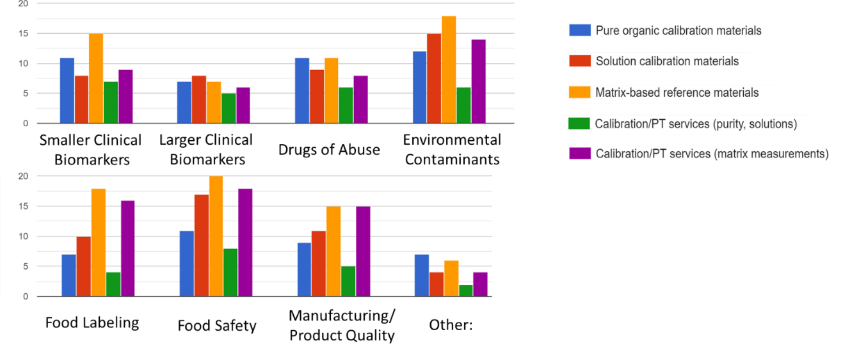

**Figure 2** Ranking of institute’s interest for both INTEREST AREAS and TYPES OF SERVICES related to the OAWG.

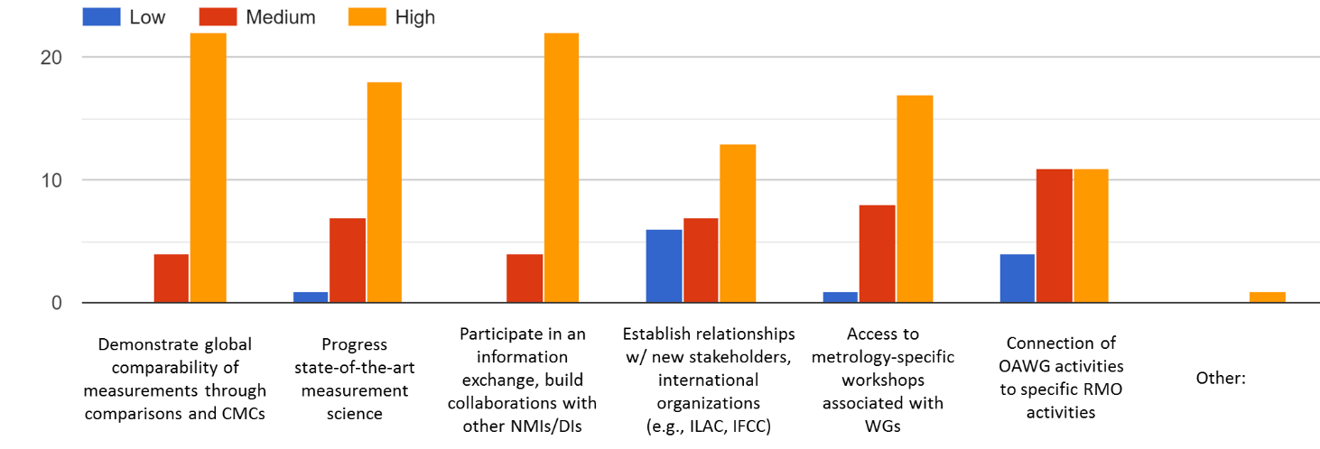

**Figure 3** Ranking of institute's interest in the general objectives of the CCQM and the benefits of your institute’s participation in the OAWG.

**Lindsey Mackay and Katrice Lippa July 2020**