Report from the CCQM Gas Analysis Working Group for the period (April 2019 – April 2020)
During this period, the 41st CCQM-GAWG meeting was held at METAS on 8th and 9th October 2019, attended by 37 delegates from 23 institutes and five virtual meetings took place on 20th, 21st,22nd,23rd and 28th April 2020. Paul Brewer and Sangil Lee started their terms as Chair and Vice Chair respectively. Under the new leadership, there is a continued focus to demonstrate international comparability, advance the states of the art in measurement science and meet the need of stakeholders. The GAWG also has a progressive mission to increase impact and throughput with the same resource, accelerate the progress of developing NMIs and enhance the interface with the regional metrology organisations.
1. Demonstrating and documenting the global comparability of measurements
At the 25th meeting of the CCQM, CCQM-K164 (hydrogen purity) and CCQM-K165 (dimethyl sulphide in nitrogen) were approved. BIPM.QM-K1 (Ozone) with NIST, FMI (Finland), DHMZ (Croatia), ISCIII (Spain), KRISS (Korea), CCQM-K116 (H₂O in nitrogen), CCQM-K120 (CO₂ in air), CCQM-K121 (monoterpenes in nitrogen), CCQM-K137 (30 and 70 µmol mol⁻¹ in nitrogen) and CCQM-K112 (Biogas) have been published. A new initiative to publish a guidance document with each key comparison to support the CMC review process and implementation of the GAWG strategy has started. Figure 1 shows the list of active key comparisons.
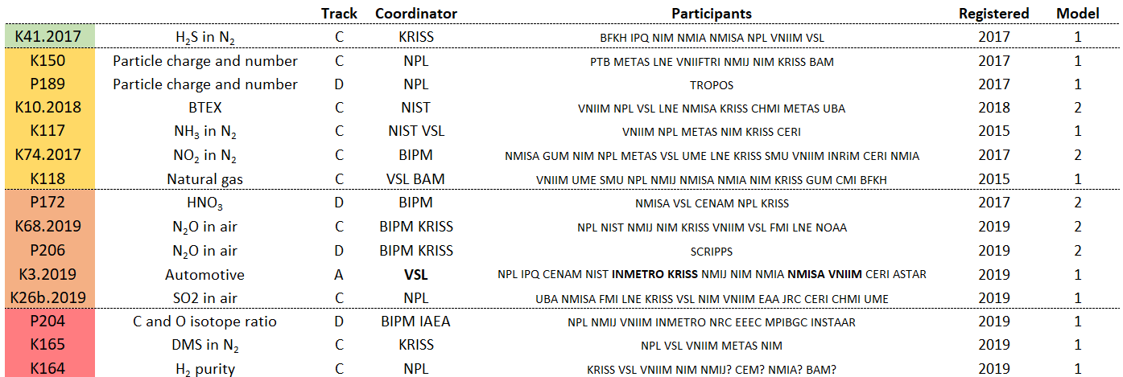
Figure 1 Active CCQM-GAWG comparisons (green – draft B, yellow – draft A, orange – measurements, red – planning).
Figure 2 lists the planned comparisons in the strategic plan for 2020-2024.
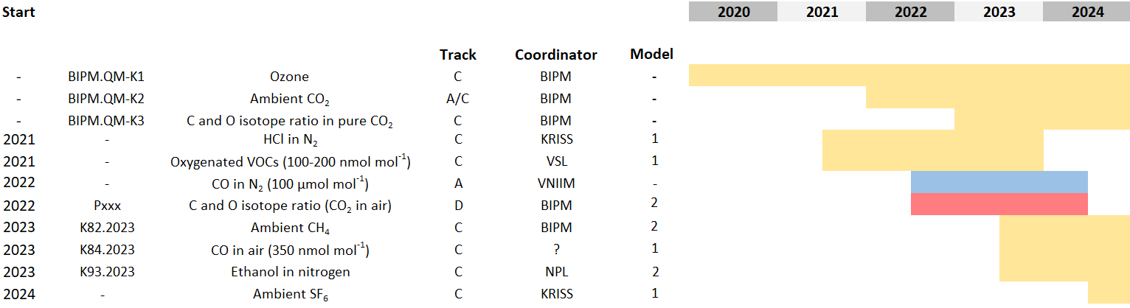
Figure 2 Planned comparisons for the period 2020 – 2024 (blue – track A, yellow – track C, red – track D)
Full proposals for key comparisons on 20 – 100 μmol mol⁻¹ HCl in nitrogen (track C) led by KRISS , 100 – 200 nmol mol⁻¹ oxygenated VOCs in air (track C) led by VSL and 100 μmol mol⁻¹ CO in nitrogen (track A) led by VNIIM have been approved by the GAWG and require approval by the CCQM.

2. Working group activities progressing the state of the art of measurements science
At the 20th WMO/IAEA Carbon Dioxide Experts Meeting (GGMT-2019), an updated carbon dioxide scale (WMO-CO2‑X2019), the primary reference on which all global background observations of carbon dioxide are based, was presented. The scale will be used by the WMO Global Atmosphere Watch programme in its global monitoring network for tracking trends in the background carbon dioxide amount fraction in the atmosphere to provide the global information for policy decisions. The accuracy of the scale was demonstrated by CCQM-K120, coordinated by the BIPM. The comparison was a substantial undertaking involving the analysis of the composition of 46 gas reference materials from 13 NMIs and The National Oceanic and Atmospheric Administration (NOAA), the institute designated by the WMO to disseminate and maintain the global scale. Progress in reducing uncertainties in SI traceable standards has led to a key comparison reference value for carbon dioxide in air amount fractions with state-of-the-art uncertainties of parts in 10⁴. This has enabled benchmarking of international comparability and provided support for a change to the global scale.
CCQM-K120 required methods to accurately calibrate optically based instruments for δ¹³C and δ¹⁸O measurements to be developed at the BIPM as well as a manometric facility for future on-going comparisons of CO₂ in air standards. This has set the scene for a new pilot study coordinated by the BIPM (CCQM-P204), aimed at evaluating the level of compatibility of laboratories’ measurement capabilities to value assign isotope ratios in samples of pure CO₂ gas, (δ¹³C vs. VPDB and δ¹⁸O vs. VPDB-CO₂). It will also provide insight into the traceability chains and reference standards being employed to currently achieve these measurement results. The pilot study is a collaboration with the IRWG and several expert organisations.
GAWG collaborative publications:
P J Brewer et al. Advances in reference materials and measurement techniques for greenhouse gas atmospheric observations, Metrologia, 56 034006, May 2019.
J T Hodges et al. Recommendation of a consensus value of the ozone absorption cross-section at 253.65 nm based on a literature review, Metrologia, 56 034001, Apr 2019.
3. Working group stakeholder engagement activities
A joint workshop between the GAWG and IRWG took place on 10th October at METAS. The objectives were to highlight novel research and advances in isotope ratio measurements for gas analysis, promote scientific exchange amongst NMIs, expert laboratories and stakeholders and identify future measurement requirements and opportunities. There were three technical sessions on advances in isotope ratio gas reference materials, advances in SI traceable measurements and advances in spectroscopy and field measurements.
A document has been drafted on a recommended value of the ozone absorption cross-section per molecule at 253.65 nm for applications including the measurement of atmospheric ozone amount fractions (CCQM/20-03). This follows the work completed by the CCQM-GAWG Task Group on ozone cross-section which includes the value and uncertainty published. A workshop is planned at the BIPM in September to develop a plan and timetable to allow a globally coordinated and universal implementation of the new value.
4. Additional items from the working group meetings
Two new task groups have been established. The first to develop a document detailing the GAWG policy on purity analysis and the impact on uncertainty to address concerns raised by the KCWG that GAWG approach excludes the use of reference materials of pure components and differs to other working groups. The second on coordinating key comparisons to articulate to CCQM how GAWG interprets and applies the guidelines set out in CIPM MRA-D-05 and CIPM MRA-G-04 CIPM MRA, to provide less experienced NMIs and DIs with the information required to support more diversity in laboratories coordinating key comparisons and to improve the efficiency of the GAWG and minimise timescales for key comparisons.
A document on operation of GAWG key comparisons has been prepared and published on the GAWG website (GAWG/20-02).
Videoconferencing has been useful. It has enabled much more extensive discussions on comparison results than would have been possible in the working group meetings. The GAWG is considering using video conferences in future for preliminary discussions on key comparisons with participants after the draft A1 report has been issued with the intention to ensure the account is more substantiated for the working group meeting.
Jennifer Carney has been appointed to represent the GAWG on the KCWG.
Paul Brewer 26-05-2020

