Consultative Committee for Photometry and Radiometry (CCPR)
WORKING GROUP ON KEY COMPARISONS (WG-KC)
Draft minutes of the meeting on 5th June 2024 at BIPM, Sèvres, Cedex, France.
VERSION 2.0

The meeting was held in the Petit Pavilion at the BIPM, Sèvres, Cedex, France in the afternoon of 5th June 2024, with hybrid online participation.

Participants

Name | Institute | CCPR Role | Presence
 | A-STAR |  | In Person
Mohammad Al Fohaid | SASO / NMCC |  | In Person
Errol Atkinson | NMIA |  | In Person
In Ho Bae | KRISS |  | In Person
Anatolii Bescupschi | NMI (MD) |  | In Person
Joaquin Campos Acosta | IO-CSIC |  | Online
Aleksandr Dunaev | VNIIOFI |  | In Person
Martin Dury | NPL |  | In Person
Nigel Fox | NPL |  | In Person
Arnold Gaertner | NRC |  | Online
Angela Gamouras | NRC |  | Online
Haiyong Gan | NIM | CCPR WG-KC Chair | In Person
Erkki Ikonen | MIKES |  | In Person
Jane Ireland | NPL |  | In Person
Boris Khlevnoy | VNIIOFI |  | In Person
Annette Koo | MSL |  | Online
Stefan Kück | PTB |  | In Person
Seon-Do Lim | KRISS |  | In Person
Hui Liu | NIM |  | In Person
Farshid Manoocheri | MIKES-Aalto |  | Online
Thiago Menegotto | INMETRO |  | Online
Cameron Miller | NIST |  | Online
Maria Nadal | NIST | CCPR WG-SP Chair | In Person
Hiroki Ninomiya | NMIJ/AIST |  | In Person
Gaël Obein | LNE-LCM/Cnam |  | In Person
Yoshihiro Ohno | NIST | CCPR WS Chair | In Person
Maria Luisa Rastello | INRIM | CCPR President | In Person
Hiroshi Shitomi | NMIJ/AIST |  | In Person
Neil Swift | MSL |  | Online
Minoru Tanabe | NMIJ/AIST |  | In Person
Li-Lin Tay | NRC |  | In Person
Andrew D. Todd | NRC |  | In Person
Joële Viallon | BIPM | CCPR Executive Secretary | In Person
Brenda Lee | SCL |  | In Person
Shing Lung Steven Yang | SCL |  | In Person
Howard Yoon | NIST |  | Online
Weiqiang Zhao | NIM |  | In Person

Opening and introductions, appointment of recording secretary
The meeting opened at 14:00, chaired by Haiyong Gan, who welcomed the participants and invited participants to intoduce themselves.
WG-KC members present included: VNIIOFI, KRISS, LNE, MSL, NIM, NIST, NMIA, NMIJ/AIST, NPL, NRC, PTB, and MIKES.
Except for AFRIMET, all RMO Chairs were present.
Maria Luisa Rastello, CCPR President, was present.
Joële Viallon, CCPR Executive Secretary, was present.
Three TG Chairs were present, except Rheinhardt Sieberhagen (NMISA) as TG1 Chair.
Observers were present (as other participants listed in the table).
Martin Dury was appointed as the recording secretary.

Approval of the agenda
Version 3 of agenda was distributed on 06/05/2024.
Minor changes made to the agenda. Annette Koo could not attend this meeting in person. Meeting agenda adjusted so that Annette could present earlier (action 9.2 and 10.3 moved to after review of task groups).
No extra changes to this agenda were proposed.

Documents presented to the meeting
WDoc Name | Title | Author(s)
WGKC-23-01 | Draft Agenda of CCPR WG-KC Meeting 2024, Version 2 | H. Gan
WGKC-23-02 | Minutes of CCPR WG-KC Meeting 2023 Version 3 | H. Gan
WGKC-23-03 | Decisions and Action Items from the 2023 WG-KC Meeting, Version 4 | H. Gan
WGKC-23-04 | Progress report of CCPR-K4.2017 | H. Shitomi
WGKC-23-05 | Progress report of CCPR-K2.a.2016 | J. Ireland
WGKC-23-06 | Progress report of CCPR-K5.2019 | F. Manoocheri
WGKC-23-07 | Progress report of CCPR-K1.b.2024 | H. Yoon
WGKC-23-08 | Progress report of CCPR-K2.c.202X | H. Yoon
WGKC-23-09 | Activity report of TG2 | E. Woolliams
WGKC-23-10 | Activity report of TG3 | A. Koo
WGKC-23-11 | Activity report of APMP TCPR 2023 | A. Koo
WGKC-23-12 | Activity report of COOMET TCPR 2023 | A. Bescupschii
WGKC-23-13 | Activity report of EURAMET TCPR 2023 | J. Campos
WGKC-23-14* | Report from WG-CMC meeting 2024 (*to be added) | M. Smid
* The CCPR WG-CMC meeting is usually held before the CCPR WG-KC meeting. However, in this case the CCPR WG-CMC meeting is being held after the WG-KC meeting and the report will be submitted afterwards.

Approval of the minutes of the 2023 meeting
PTB had been repeated twice within the TG members section in section 5 (Review of membership of WG-KC and Task Groups) of the minutes and the repeated one was removed.
No further comments were received to the previous minutes of the 2023 meeting and the minutes were approved at 14:12.

Review of action items from the 2023 meeting

DECISION | Description | Agenda No.
DP-2023-01 | CCPR WG-KC TG2 (RMO linkage) is closed after the action AP-2023-05 is completed. | 10.2
DP-2023-02 | A new task is assigned to CCPR WG-KC TG3 (Comparison Analysis) to create a numerical tool for data analysis, which can be also used for RMO linkage. | 10.3
List of the 2023 decision points items WD WGKC-23-03

List of the 2023 action items WD WGKC-23-03
ACTION | Description | Agenda No. | Assigned to | Status
AP-2023-01 | WG-KC Chair revises G4 to clarify that the usage of the artefacts from the previous comparison is only allowed when they are “not identified by the pilot nor by other participants.” | 6.6 | WG-KC Chair | Email discussion sent to Howard Yoon on 7 Feb 2024 and Cameron Miller replied on 21 Feb 2024 that K1.b participants agreed that previous artifacts can be used.  H. Yoon: Other instances of using old artefacts in comparison: used trap detectors from previous comparison; filters from previous comparison.  Unclear on whose integrity might be compromised.  Reputable NMI: should realize scale for intercomparison.  Need to economise: buying new artefacts is expensive.  Serious matter: previous artefacts can be used, but we rely on the integrity of the pilot.
AP-2023-02 | Dong-Hoon Lee re-sends the review comments of CCPR WG-KC on CCPR-S3.x to the pilot lab NPL (Teresa Goodman). | 8.1 | Dong-Hoon Lee (former WG-KC Chair) – WG-KC Chair | WG-KC comments email re-sent on 14 Dec 2023 and Teresa replied on 20 May 2024 with an unofficial response for pre-approval.  Teresa wishes for comments and new responses before the next iteration of the report is submitted. Haiyong will store document in review list.  Hiroshi clarified the situation: NMIJ are waiting for the final documents. Will receive after the review. Teresa has made the changes and hopes to know that the response OK before she can ask for NPL final approval to generate the final document.  HIROSHI SHITOMI (NMIJ/AIST): WG-KC – to receive report for comments for final report.
AP-2023-03 | Rheinhardt Sieberhagen organizes an online meeting of the task group TG1 (with additionally interested participants NRC, MIKES, CMI, and NIM) to discuss the technical approach for a comparison. | 10.1 | Rheinhardt Sieberhagen (former TG1 Chair) | Rheinhardt sent email on 30 Apr 2024 about his resignment from NMISA. WG-KC Chair sent email to Natasha Van der Walt for advice about next steps. No respond yet received.  JV - Natasha Van der Walt no longer works at NMISA.  NFOX – next contact is Rheinhardt’s boss.  JV to give WG-KC Chair contact details.
AP-2023-04 | WG-KC Chair contacts Joële Viallon to organize a change of contact person for TG1 from Natasha Van der Walt to Rheinhardt Sieberhagen. | 10.1 | WG-KC Chair / Joële Viallon | Request email sent to Joële and Joële took over on 6 Feb, 2024 and soon updated the webpage. Extra arrangement needed due to AP-2023-03.
AP-2023-05 | Emma Woolliams revises the current guidelines G6 with a footnote indicating cautions to the equation usage. | 10.2 | Emma Wooliams (TG2 Chair) | Done on 2 Jun 2024.
AP-2023-06 | Joële Viallon forwards the comments from Andrea Peruzzi, NRC, to old and new WG-KC Chairs, plus TG3 Chair. | 11 | Joële Viallon | Email forwarded on 8 Sep. 2023.

Review of membership of WG-KC and Task Groups
No changes. Membership also discussed during yesterday’s WG-SP meeting.
WG-KC Chair appreciates the importance of the CCPR members coming together in person, but understand that some CCPR members may only be able to attend online.

Reports by pilots of on-going CCPR Key Comparisons

Final reports published since the last meeting (Exec. Secretary)
No publication at CC level since 2023 meeting.

K4.2017 Luminous flux (NMIJ)
Short report - in summary, (it is) difficult in continuing with this comparison. Last meeting, reported that NMIJ was preparing for pre-draft A2. (But it is) On hold due to export control issue (reported last meeting). Still ongoing. (It needs) Long-lasting negotiations with JP government (GOV). Situation did not change. NMIJ will have to wait until situation changes.
Maria Nadal (NIST): Question - is it a common problem for all of the CCs (with NMIJ and JP GOV).
HIROSHI SHITOMI (NMIJ/AIST): Yes. JP GOV asked not to distribute data.
Gael Obien – could BIPM director help with this? As a diplomatic problem?
JVallon – when measures taken by countries, very difficult for BIPM to have an impact on such decisions.
WG-KC Chair – were all measurements completed?
HIROSHI SHITOMI (NMIJ/AIST) – yes, all measurements were done. Cannot distribute data outside JP to anyone. Cannot move onto next step.
HOWARD YOON (NIST) – (are you) able to participate in other comparisons? As a pilot or participant?
HIROSHI SHITOMI (NMIJ/AIST) – suitation for both. (We have) Difficulty in submitting data to pilot.
WG-KC Chair – still trying to find a way of resolving the situation?
HIROSHI SHITOMI (NMIJ/AIST) - many negotiations with GOV.
WG-KC Chair – can other NMI help with communication?
HIROSHI SHITOMI (NMIJ/AIST) – unsure whether it would work.
NIGEL FOX (NPL) – (I) suspect (such) situation will exist with other NMIs in various cases.

K2.b.2016 Spectral Responsivity 300 – 1000 nm (KRISS)
Dong-Hoon Lee: draft A procedure was completed in April 2024 and the draft B report is submitted to CCPR WG-KC Chair for review on 28 May 2024.

K2.a.2016 Spectral Responsivity 900 – 1600 nm (NPL)
Jane Ireland provided summary of measurements: 3 rounds, plus rounds 4 and 5.
Update since last meeting: temperature coefficient report complete. Sent out in February.
Missing wavelengths issue: didn’t measure at 50 nm steps, only 100 nm steps. Proposed additional round 5 at 50 nm steps. First stage of measuring all detectors was complete. Now the participants were doing second stage. The pilot lab wll analyse all 5 rounds of NPL measurements. The pilot will use data as basis of comparison analysis. Until the pilot lab looked at all of data, the pilot lab will know whether to work. Otherwise the comparison will have to go to 100 nm steps. Indications suggest will work.
The comparison schedule was updated and sent to participants last week.
The pilot lab will organise an online meeting with participants.

K5.2019 Spectral Diffuse Reflectance (MIKES)
Reported by Farshid Manoocheri (WGKC-23-11 Progress report of CCPR-K5.2019, number 6).
- 2nd round measurements started in April 2023.
- One participant’s second round measurements completed.
- Issues with customs and excise affecting distribution of measurements.
- Fluorescence of ceramic tiles issues was identifed and the case will be worked on after all measurements were completed.

K1.b.2024 Spectral irradiance 200 nm to 400 nm (NIST)
Reported by Howard Yoon (WGKC-23-12 Progress report of CCPR-K1.b).
200 nm to 400 nm
10 nm steps
Distance of 30 cm or 50 cm
Accomodating preference to measure at one of two different distances.
Wanted to start this year.
Timetable presented:
Start date: 1st May 2025.
Star comparison at participant NMIs.
3 types of lamps to use: Gigahertz, oreil and PTB lamps.
Different participant labs list presented
NIST – realization done on synchrotron.
Other NMIs blackbodies: spectral dependence issues. Working standards checked directly against the synchrotron.
Measuements done on photometric bench. Alignment and validation tools.
NIST UV radiometer
UV-CAS Spectroradiometer.
Gigahertz Optic spectroradiometer.
5m long alignment laser.

Next steps :
Protocol final agreement
BORIS KHLEVNOY (VNIIOFI) – clarified measure lamps at other facility and own lamps against synchrotron?
HOWARD YOON (NIST) – Yes, correct. Scale will not just reside with lamps, but also spectrograph. Multiple checks to ensure that scale is not changing.

CCPR K2.c.202x Spectral Responsivity from 200 nm to 400 nm
Measurements will start likely in 2027.
Different types of detectors identified.
Schedule of key comparison shown.
Invitation letters sent and received.
Big ask to WG - decides on participants and TG membership.
Will convene a task group.
Will decide on detectors (to be used).
Participants needs to be limited to 12, currently 14.
Participant capabilities listed - thought of way of eliminating countries. Detectors working well at 250 may not work well at 200 nm. Want detectors with capailites across the entire range.
Primary detectors.
Some NMIs think PQEDs down to 200 nm. Challenging to achieve in time for comparison.
Different sources: laser driven light source. Big concern is detector damage from NMIs with high power sources.
Working detectors: NIST UV enhanced photodiodes. Concerns over silicon detectors.
Want to duplicate pilot labs setup.
Less than half particpants can measure full range.
Most NMIs measure in 10 nm steps
Most NMIs use a comination of sources and detectors.
The LDLS is the most common UV sounce
Power levels at the detcetor range up to 5 mW???
Qs.
- Which NMIs should particpate in CCPR-K2.c?
- Which NMI should join the TG in developing protocol, selecting detectors? All participants volunteered.
WG-KC Chair – maybe NIST responsible (to decide).
HOWARD YOON (NIST) – some NMIs want to use a PQED down to 200 nm. Can those be achieved within the next year?
Erkki Ikonen (MIKES) – (it is the) first time that PQEDs used down to 200 nm. Need to check how stable in these conditions.
WG-KC Chair – New item. If NMI capable of measuring.
NIGEL FOX (NPL) – is decision of NMI participating as to when traceability down to 200 nm, it is there risk and problem? Comparison should not wait for them to complete research on whether they can achieve this. PQED to determine scale.
HOWARD YOON (NIST) – 14 participants and capabilities. A*STAR wants to use PQED. SASO want to build a new facility.
NIGEL FOX (NPL) – we have a set of rules on reducing participants.
Maria Nadal (NIST – G2 section 3: selectrion of participants.
Must be a member of CCPR.
Must be willing to ser…..
NIGEL FOX (NPL) – first set of criteria is the starting point. If doesn’t allow to make decsion, then pilot can ask WG-KC for exceptions to be made due to some reasons. Not participants asking for exception to be made due to whatever reasons. Need to prioritize.
Maria Nadal NIST – formin TG, the pilot lab should send proposal of particpants to WG-KC Chair and the pilot lab should decide.
YOhno – labs not meeting the whole range are not qualified. Exceptions can be proposed by the pilot. Sometime ago, K1.a or K1.b, not so many participants meeting the full range. Pilot requested. Howards could request flexibility.
NIGEL FOX (NPL) – first criteria: not having an independent scale. This is immediate the starting point and is the first criterion that stops need to participate.
YOhno – willing to participate as a link lab.
Yoon – issue of COOMET.
BORIS KHLEVNOY (VNIIOFI) – Ukraine is in Euramet.
HOWARD YOON (NIST) – understood.
NIGEL FOX (NPL) – special arrangement between Euramet and COOMET. Link lab to exist for that region. Reason for not going down this route.
BORIS KHLEVNOY (VNIIOFI) – how many?
Yoon – pare down number to 12 based on selectin criteria (decision tree) also make a decsion tree on the techncial working roup. List of requirements and tasks and get to the WG-KC Chair.
Gael Obein – come back to the primary realisation. Interesting point, NMI takes risk. For community to see realization like this with the result.
Erkki Ikonen (MIKES) – doesn’t say that PQED would be used down to 200 nm. A*Star did not comment how to do the realisation.
A*Star – (Our plan is to use) primary standard to do the visible wavelengths, calibrate detectors ad then use pyroelectric for UV measurements.
NIGEL FOX (NPL) – be careful, no disrespect, establishing a new scale at this moment is submittng a request to particiapte at this moment do not have an independent scale.
A*star You are right.
HOWARD YOON (NIST) – have K2b result?
A*star – Yes was in 2016, link (traceable) to CR (cryogenic radiometer).
NIGEL FOX (NPL) – yes, not active and alive now.
HOWARD YOON (NIST) – have trap detectors.
A*star – CR is down. Replacing with PQED.
HOWARD YOON (NIST) – do we agree that PQED is an absolute realisation method?
NIGEL FOX (NPL) – see no reason to disspute.
Errfki – for the visible.
Nigel Fox (NPL) – if we did go down new techniques, questionable useful for a key comparison. May increase uncertainties. Should not be using untested and unverified methods. Othersie, (there will be) severe uncertainties.
AnrewTodd- arguement not to do option 3 (of AKoo’s options).
NIGEL FOX (NPL) – yes, because of outliers.
Gael Obin – before you get to a validated scale. We have to take into account that diversity of realization is interesting. If CR is biased, will never know.
NIGEL FOX (NPL) – agree, but have to account of outliers. Otherwise large ucnertainties.
Stefan Kück (PTB) – ensure that every uncertainty componentis accounted for.
Stefan Kück (PTB) – do not need to have every KC with 12 participants. More critical for RMO involvement. Why let more participants.

2nd-round CCPR KCs

Review of time schedule for 2nd round KCs
2024 K2.d has stopped.
2024 K2.c PTB will not be able to pilot comparison due to resource issues. Need to find a new pilot.
The meeting took a break at 10:29. The meeting to resume at 10:50.
After the break NIST volunteered to pilot.
Meas.  Start | Id | Quantity | Pilot | Status
2013 | K6.2010 | Regular spectral transmittance | MSL | Published
2014 | K3.2014 | Luminous intensity | NRC | Published
2016 | K4.2017 | Luminous flux | NMIJ | Pre-draft A process
2016 | K2.b.2016 | Spectral responsivity 300 nm to 1000 nm | KRISS | Draft B submitted
2016 | K2.a.2016 | Spectral responsivity 900 nm to 1600 nm | NPL | Measurement in progress
2017 | K1.a.2017 | Spectral irradiance 250 nm to 2500 nm | VNIIOFI | Published
2019 | K5.2019 | Diffuse spectral reflectance | MIKES | Measurement in progress
2024 | K1.b.2024* | Spectral irradiance 200 nm to 400 nm | NIST | Technical protocol in review
202X | K2.c | Spectral responsivity 200 nm to 400 nm | NIST | In preparation

Comparison Review

Updates of the comparison review
No. | ID | Type | Time Received | Time Assigned | Status
1 | APMP PR-K3.a Draft B-2 | Review | Jan 15, 2024 | Feb 26, 2024 -  Mar 26, 2024 | R. Sieberhagen: Approve (Mar 7, 2024); J. Campos: Approve (Mar 27, 2024)
2 | COOMET PR-K1.a Draft B | Review | Jan 24, 2024 | Mar 11, 2024 -  Apr 22, 2024 | J. Campos: No comments from EURAMET (May 3, 2024); E. Woolliams: Looks OK (Mar 12, 2024)
3 | GULFMET.PR-K4.2021 Draft B | Review | Mar 15, 2024 | Mar 25, 2024 -  May 6, 2024
4 | SIM.PR-k3.2023 Tech. Protocol | Review | Apr 12, 2024 |  | TBD
5 | CCPR-S3 Draft B | Review | May 21, 2024 |  | TBD
6 | CCPR-K2b-2016 Draft B | Review | May 28, 2024 |  | TBD
7 | EURAMET.PR-Sx.2023 | Comment | Mar 6, 2024 | Mar 11, 2024 -  Apr 8, 2024 | Y. Lin: Approve (Apr 9, 2024)
8 | COOMET.PR-S13 | Comment | May 14, 2024 | May 14, 2024 -  Jun 11, 2024

Issues raised in the review
For RMO SCs, WG-KC only comments and the final approval is up to the RMO TC Chair. Nevertheless, it is recommended that RMO TC Chair shares the results of the review (e.g. revisions considering the comments or responses from the pilot) with WG-KC Chair and CCPR Executive Secretary.
Problems: N/A

Solutions: N/A

Reports from the RMOs on comparison activities

Final reports published since the last meeting (Exec. Secretary)
COOMET.PR-S5 report published in Metrologia (2023 Metrologia 60 02003).
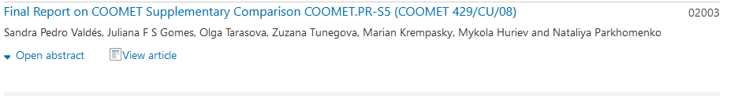

Reports from RMO representatives (AFRIMETS, APMP, COOMET, EURAMET, SIM, GULFMET)

AFRIMETS
AFRIMETS by Reinhardt Sieberhagen – no activity reported.

APMP
Key comparisons:
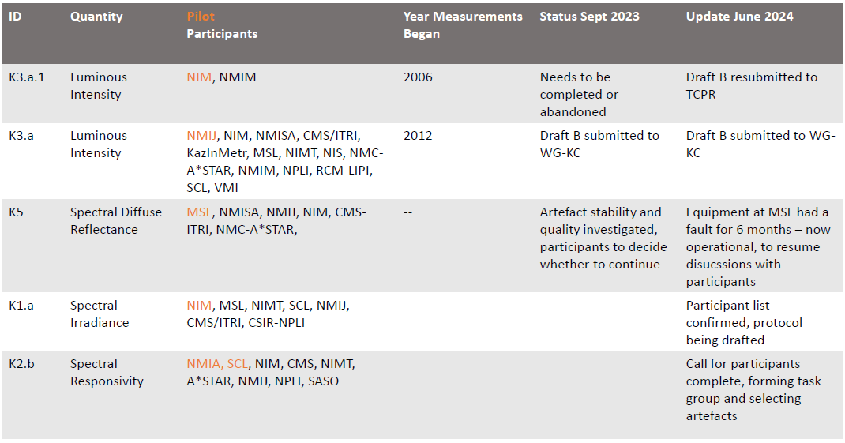Supplemetary comparisons:
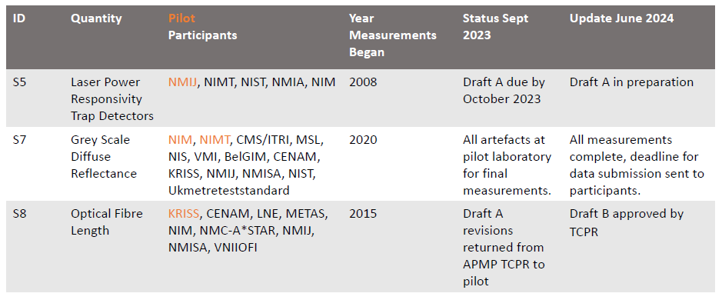Pilot studies
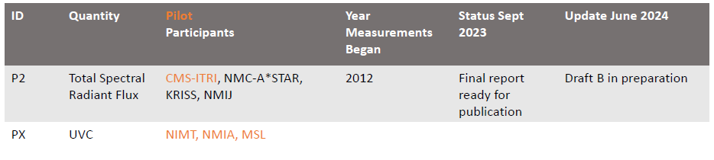Planned comparisons:
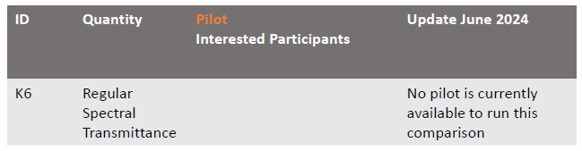Comments
WG-KC Chair: S5 – 2008 Has been running for a long time.
HIROSHI SHITOMI (NMIJ/AIST): change in coordinator. New coordinator has taken over responsivity and trying to summarise all of the data.
HOWARD YOON (NIST)- ID quantities. RMO supplementaries also attach the year? Clarification needed on the comparison ID.
WG-KC Chair: when comparison registered, does it have year added automatically?
JV – not automatic, name of year.
AKOO – all have APMP in front of them. Not automatically year added. No reason can’t add better IDs.
JDubard – noticed that pilot comparison at UVC: one specific wavelength for source or radiometer
AKOO- will be a detector, 3 different types of source.
Neil Swift confirmed: Mercury, 280 nm LED, and additional source. Split into 3 separate comparison.

COOMET Presentation
Anatolii Bescupshii TC-1.7 activity. Aleksandra Dunaev new RMO Chair.
 | On going | Completed | New
Key | 1 | 0 | 0
Supplementary | 3 | 2 | 1
Pilot study | 2 | 0 | 0
TOTAL | 6 | 2 | 1

Ongoing key comparison:
COOMET  Project # | KCDB  registration | Subject | Participants | Status | Start  of Meas. | End  of Meas.
741/RU/18 | COOMET.PR-K1.a. | Spectral Irradiance 250-2500 nm | VNIIOFI (Russia) pilot, link  PTB (Germany) – link  BelGIM (Belarus)  NSC IM (Ukraine)  UME (Turkey) | Draft B report is under review at WG-KC | 2019 | -

Supplementary comparisons:
COOMET  Project # | KCDB  registration | Subject | Participants | Status | Start  of Meas. | End  of Meas.
429/CU/08 | COOMET.PR-S5 | Spectral regular transmittance  wavelength range: 250 nm to 635 nm | INIMET (Cuba) - pilot  BelGIM (Belarus)  INMETRO (Brazil)  SMU (Slovakia)  Ukrmetrteststandart (Ukraine) | Approved and published  01 November 2023 | 2010 | 2012
640/BY/14 | COOMET.PR-S10 | Color, transmitted | BelGIM (Belarus) - pilot  VNIIOFI (Russia)  NSC IM (Ukraine)  INM (Moldova)  KazInMetr (Kazakhstan)  NIMT (Thailand)  UME (Turkey)  NIM (China)  GUM (Poland) | Draft-B  (in progress) | 2016 | 04.2018
743/UA/18 | COOMET.PR-S11 | Color, surface | NSC IM (Ukraine) – pilot  VNIIOFI (Russia)  Ukrmetrteststandart (Ukraine)  BelGIM (Belarus)  NIMT (Thailand)  UME (Turkey)  NIM (China)  GUM (Poland)  INM (Ramania) | Approved and published  14 February 2023 | 2019 | 2020
785/Ru/19 | COOMET.PR-S12 | Supplementary comparison of Laser  Power Responsivity at wavelengths of 0,532; 1,064 and 10,6 µm | VNIIOFI (Russia)  - pilot  BelGIM (Belarus)  NIM (China)  METAS (Switzerland) | Measurements in progress | 2022 | -
801/BY/20 | COOMET.PR-SXX | Supplementary comparisons of measurement standards for  polarization mode dispersion in optical fiber | BelGIM (Belarus)  – pilot  VNIIOFI (Russia) | Protocol under review process at WG-KC | 2024 | -
878/RU/23 | COOMET.PR-S13 | Wavelength of spectrally-selective transmitting material, from 250 nm to 2500 nm | VNIIOFI (Russia)  - pilot  BelGIM (Belarus)  UzNIM (Uzbekistan)  KazStandard (Kazakhstan) | Measurements in progress | 2024 | -

Pilot studies:
781/UZ-a/19 | Pilot comparison of spectral regular transmittance from  400 to 1000 nm | UzNIM (Uzbekistan)  - pilot  BelGIM (Belarus) | Draft A | 2020 | 2020 | 781/UZ-a/19
804/UZ-a/20 | Pilot comparisons of measurement standards of  attenuation and average power of a signal in optical fiber | UzNIM (Uzbekistan)  - pilot  VNIIOFI (Russia)  BelGIM (Belarus) | Measurements in progress | 2022 | 2022 | 804/UZ-a/20

Planning Comparison:
Subject | Participants | Status | Start  of Meas. | End  of Meas.
Refractive Index  (COOMET suplementary comparison) | VNIIOFI (Russia) pilot  KazStandard (Kazakhstan) | Protocol under discussion | March 2025

EURAMET Presentation
Report by Joaquim Campos Acosta: WG-KC-23-06 Comparison activity report of EURAMET TCPR 2023
Comparison Identifier | Description | Measurement period | Pilot institute | Status
EURAMET.PR-K3.2020 | Luminous intensity | 2021-2023 | METAS | Measurement in progress
EURAMET.PR-K5.2022 | Spectral diffuse reflectance | 2022 - 2023 | UME | Measurement in progress
EURAMET.PR-K6.2015 | Spectral regular transmittance | 2016 - 2018 | LNE-LCM/Cnam | Draft A
EURAMET.PR-K6.2015.1 | Spectral regular transmittance | 2018 - 2019 | LNE-LCM/Cnam | Draft A
EURAMET.PR-K1.a.xxxx | Spectral irradiance (250 nm to 2500 nm) |  |  | In preparation

Comparison Identifier | Description | Parameters | Pilot institute | Status
EURAMET.PR-S4 | Calibration of UVA power meters at relatively high irradiance levels | Wavelength: 365 nm | LNE | Draft A
EURAMET.PR-S7 | Primary realizations of Gloss Scales | Measurement geometries; 20°, 60°, according to the ISO 2813:2014. | METAS | Just started

Supplementary comparison
- Supplementary comparison on Fibre optics wavelength piloted by IO-CSIC. Drafting protocol.
- Supplementary comparison on cryogenic radiometers, piloted by DFM. Drafting protocol.
HOWARD YOON (NIST) – explain more on CR comparison
Joaquim Campos Acosta – group of 4 NMIs. Drafting protocol: DFM, RI.SE, INRIM,
NIGEL FOX (NPL) – suggest comparison title change to: ‘Supplementary comparison on abolsute spectral radiant power using cryogenic radiometers’
Next EURAMET.PR-KCs:
- K4. Luminous flux:
  - Pilot selected.
  - Linking laboratories pre-committed.
  - Interested participant list.
- K2.b. Spectral responsivity (300 nm to 1000 nm):
  - Preliminary preparations: pilot laboratory, linking laboratories, interested participants.

Other activities:
- Training course on piloting comparisons in PR (January 2024). Organized with the support of EURAMET Capacity Building officer and BIPM.

SIM Presentation
Report by Juan Pablo Barbaro.
Planned comparisons:
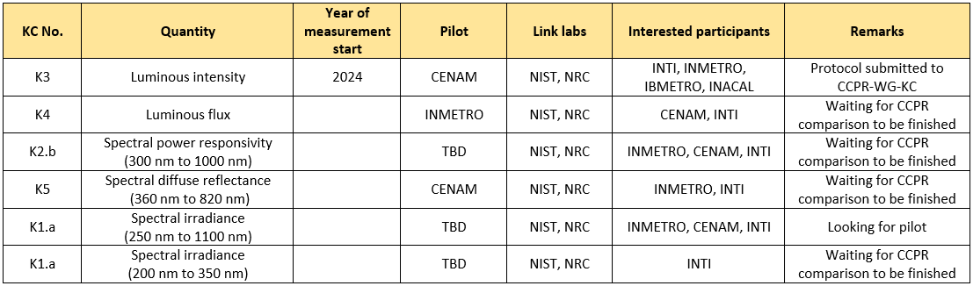
SIM MWG2 for Photometry and Radiometry
SIM-PR.K3 - luminous intensity
Participants from other RMOs
Pilot CENAM
Link laboratories: CCPR-K3.2014: NIST and
Protocol reviewed and approved by patricpants.
Submited to KC on May 11 th 2024
Only planned comparison working on right now.
List of planned comparisons shown:
K3, K4, K2.a, K5 …
Supplementary comparisons:
There are no supplementary comparisons planned at SIM for photometry and radiometry. However, some SIM members indicated they would be interested in comparisons for some non-key comparison quantities. The list of quantities is shown below
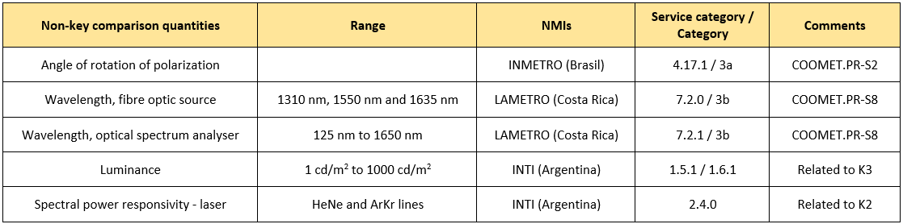
One question (NIM): (what is the) transfer standard for luminous intensity.
JPB – use different lamp depending on NMI.

GULFMET
Report by Mohammad Al Fohaid (SASO / NMCC): WGKC-XX-XX Comparison activity report of GULFMET TCPR 2024
Comparison type : | Conducted by | Measurand : | Transfer device : | Pilot Institute : | Participants : | Time of measurements:
Key Comparison | GULFMET | Luminous Flux | Three Polaron LV200W type of the luminous flux lamp | TUBITAK UME (TÜBITAK Ulusal Metroloji Enstitüsü, Türkiye) | 1. NIS (National Institute for Standards, Egypt)  2. SASO-NMCC (National Measurement and Calibration Center – Saudi Standards, Metrology and Quality Organization, Saudi Arabia) | 2021 - 2023

List of Planned/suggested Comparisons (Key and Supplementary)
ILC Symbol | Quantity | Field | Pilot
GULFMET.PR-K4.a | Total Luminous Flux  (Goniometry) | Photometry | SASO-NMCC
GULFMET.PR-K3.b | Luminous Responsivity | Photometry | SASO-NMCC
GULFMET.PR-S1 | Luminance Meter | Photometry | SASO-NMCC
GULFMET.PR-S2 | Laser power  (laser power meters) | Radiometry | SASO-NMCC
GULFMET.PR-S3 | Diffused reflectance + reflected color coordinates | Spectrophotometry | SASO-NMCC
GULFMET.PR-S4 | Reference solar cell (DSR & Irradiance) | Photovoltaics | SASO-NMCC

One KC: K4 luminous flux. Finished measurement and now in draft B.
PILOT: TUBITAK.
2021 to 2023. Issues transferring lamp (long than expected).
List of planned and suggested (key and supplementary comparisons).
Seeking link laboratory.
Q. Boris Khlevnoy (VNIIOFI) – K3 comparison: K3.b last CCPR comparison was K3.b was 25 years ago and was comparison using detectors. Last one was with lamps. Mean luminous responsivity.
Do not have a luminous responsivity KC
Stefan Kück (PTB) K. Can derive from K3.
Mohammad Al Fohaid (SASO / NMCC): plan to use gonio.
YOhno – supplementary comparison. K4 not limited to any methods.
Stefan Kück (PTB) K. prove that you have a scale then
Mohammad Al Fohaid (SASO / NMCC) – more K4 and K3 from plan.
NIGEL FOX (NPL) – suggesting creating addition work for self, unless other reason for otherparticipants who have not participated to take part.
Mohammad Al Fohaid (SASO / NMCC) – Uzbek asked to take place. Plan new comparison, using gio system.
NIGEL FOX (NPL) – UZBek wishes to do a bilateral. Different erason, providing comparison to them as part of process. DO you need another link lab for the bilateral?
Stefan Kück (PTB). K. – internally for the validation. Have to wait for the next comparison. Wait for the goniometer.

Updates from WG-CMC
Report after tomorrow’s meeting via email.
Report by Marek Smid: WGKC-23-15 Report from WG-CMC meeting 2023

Reports from Task Groups

TG1 Pilot comparison for spectral regular transmittance in the UV (N. Nel-Sakharova)
Missing the Chair (resigned from NMISA). Needs to get in touch with NMISA about the chairpersonship.

TG2 RMO linkage (E. Woolliams)
Presentation and report produced and shared by Emma Wooliams. Summary slides (below) presented on behalf of Emma Woolliams by Martin Dury.

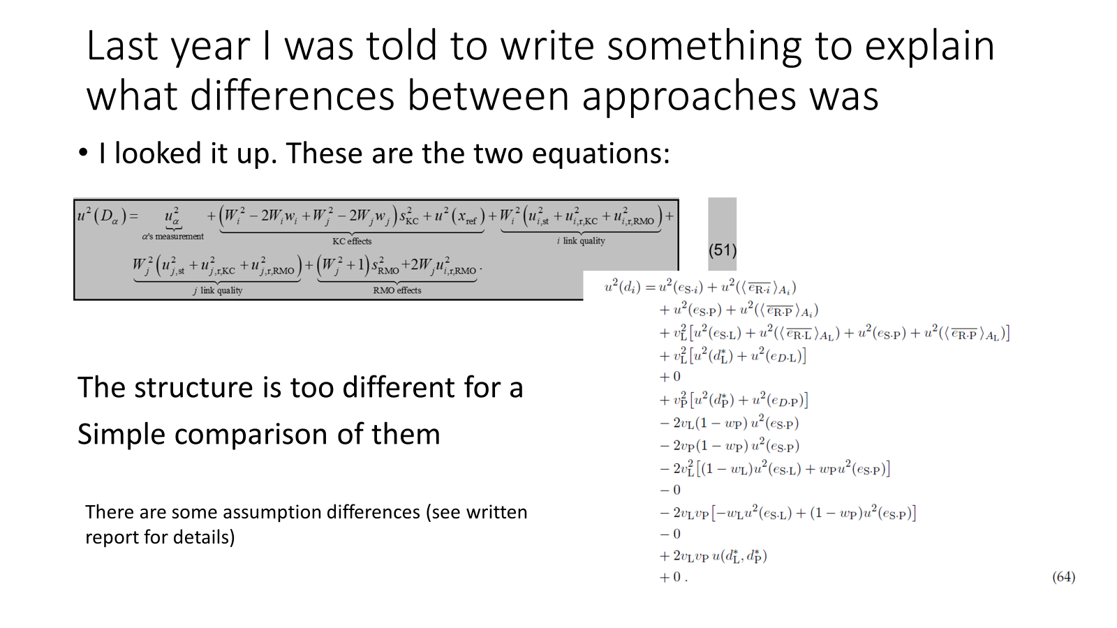 | 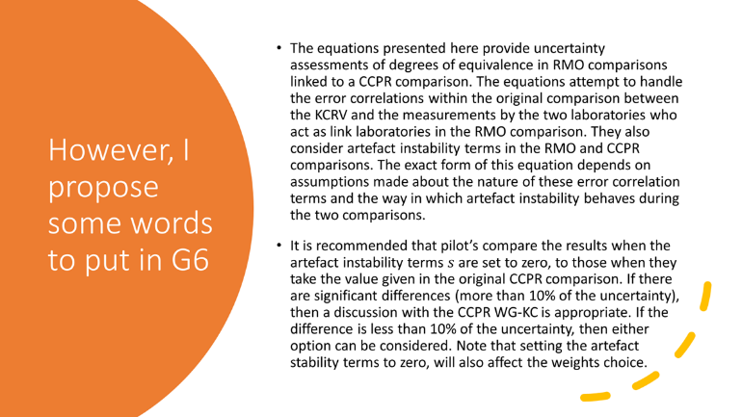
 | 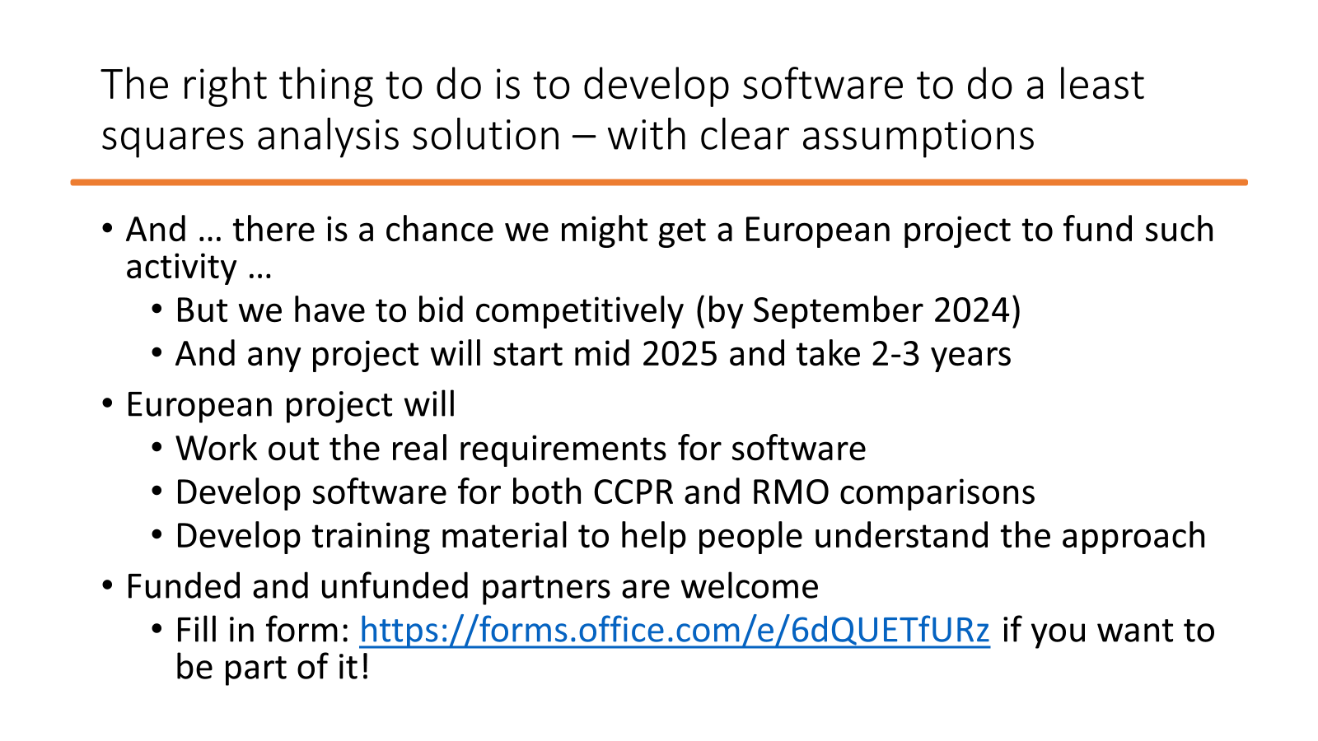

NIGEL FOX (NPL) – Comment or question: if we did option 3. To achieve consistency in the comparison. Does that mean that quote by NMS. Allowable process?
AK – we do number 3, we don’t have to increase CMCs
NIGEL FOX (NPL) – can we not continue with that procss
AK – we have CMCs in the database. Not equivalent services.
NIGEL FOX (NPL) – makes sense. If not allowed to do 3, then would do option 4. We don’t do 3 well or consistently. Do review process at beginning of phase. Go through NMIs to increasing uncertainties beyon what they are, because of issues in the comparion process. No longer meet customer needs.
Stefan Kück (PTB) – currently at option 3, but without increasing uncertainty. Subject to appeal? Not happened yet? Make it simple, but not too simple. Any statistics on this? Maybe not increase too much. Without history, would go for option 3.
AK – think asking: how big is the problem? Is there a problem? Didn’t do analysis on what comparisons are like. At workshop, showed that analysis to achieve consistencey was significant (of order of smallest participant). Do have evidence that results are equivalent,
Erkki Ikonen (MIKES) – instruction that CIPM: cannot remove any more obvious outluers. Did before and no added uncertainty. For putlies that are clearly out and participant wantsto keep them , then uncertainty becomes very large. Detrimental uncertainties of other NMIs that got smaller uncerts.
Stefan Kück (PTB).K. are there other models?
AKoo – there are other, very different model.s Can just calculate weihted average (option 2). Every NMI has estimated error, weigted that. Everyone takes value from weighted mean, no test for consistency. If far away from mean, then add a lot of uncertainty to get equivalence. Would have to come up with rules for CMC assessment.
JV – not only CCPR are discussing this issue. Calculation: shades of dark uncertainty identified in gases comparison. Not an easy discussion. Should have at some point an extra discussion on is there dark uncertainty and don’t know reason why. Happens in chemistry and accepted. Are there outliers for good, technical reasons. May want to look at this (gases) community and have some links, no exact solution.

TG3 Comparison analysis (A. Koo)
Report by Annette Koo: WGKC-23-07 Updates of TG3
Broad agreement that in photometry and radiometry:
- We are pushing the limits of uncertainties every time we carry out a comparison
- Lots of sources of error which are not well controlled (facilities, artefacts, not uniform practice, lack of awareness)
- A large range of reported uncertainties
- It is not usually clear which laboratory(ies) have made an error, whether results should be excluded or whether uncertainties have been underestimated.
- Our field is still maturing.
Options Presented:
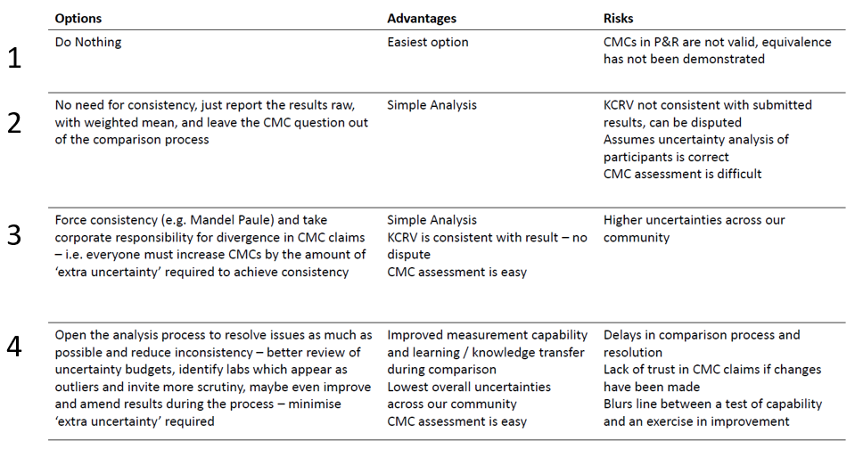
A.KOO – proposal to require all participants to add extra uncertainties to their CMCs. Workshop on how to manager inconsistent results in comparison.
In Photometry and Radiometry. Pushing limits of comparison. Lots of ucnertainty sources uncontrolled. Particpants with smaller uncertainties.
Problem is not to solve. In our field, we are still maturing. Looking at electrical, most participants have. Issue for us for some time.
Slide presented with options:
do nothing, no rigour behind claims of KCDB.
Weight results. Comparisons don’t need to be consistent. Just weight the results. If participant failed to be in equivalent. Can argue problem with KCRV.
Force consistency: Corporate responsibility. KCRV consistentwith the result, no dispute
Open analysis process: do we try to solve the problem as we go along. Lowest overall uncertainties in to KCDB. Risk lack of trust in CMC claims made during the process of the comparison. Blurs line between a test of capability and in improvement.
TG2. Develop software for comparison analysis – Emma’s report.

TG4 Pilot study for the use of alternative standards for photometric comparisons (E. Ikonen)
Presentation highlight:
- All participants have completed the purchase processes of comparison artifacts
- Preparation of the flux comparison protocol is ongoing
- Preparation of the intensity comparison protocols has not started
Two types of lamp. NIM lamp and PTB lamp comparison.
Problems to be solved: suggest use of coffee breaks.

Armin Sperling – add that in principle. Need others to look at technical protocol and seek traps. Need to make protocol capable of making comparison, takes into account LED sensitivities,
YOHNO – are masurements in progress yet?
Erkki Ikonen (MIKES) – protocol has to be agreed
Boris Khlevnoy (VNIIOFI) – NIM lamp prices and PTB lamps are different. PTB lamps much more expensive. How many particpants have bought PTB lamps?
Erkki Ikonen (MIKES) – about half. Many particpant have bought oth
AS- in prinicple these are two very different types of lamps. PTB lamps are temp stabilised and NIM lamps not. Really important
BK – totally agree, that’s a question
Gael Ob – didn’t know of discussion in group
Boris Khlevnoy (VNIIOFI) – VNIIOFI in the list, but have disappeared. Can VNIIOFI take part in comparison where NIM is pilot, but not PTB?
Erkki Ikonen (MIKES) – low number of participants. From community point of view, get this progressed.
WG-KC Chair – maybe other extra works
Boris Khlevnoy (VNIIOFI) – what is problem for VNIIOFI taking part?
Erkki Ikonen (MIKES) – in our case, we would need to split up.
Boris Khlevnoy (VNIIOFI) – if NIM are pilot and VNIIOFI participate, then you have to step up

Guidelines
Status and issues on Guidelines
NIGEL FOX (NPL) – have to accept that Emma’s text should gointo guideline G6. We are in a position to agree or not to agree, Just a technicallity to type it in.
Erkki Ikonen (MIKES) – someone should take the responsibility to input into G6
NIGEL FOX (NPL) – everyone agrees words at meeting, Words to be added to appendix.
All agreed – WG-KC Chair to add text to G6 appendix.
YOHNO - report if more than 12 participants.
NIGEL FOX (NPL) – different Q. Decision is that to have 12, a distribution or a fair distribution: RMO groups have been assigned a number. GULFMET does not sit wthin any of groups.
YOHNO – AFRIMET very small.
NIGEL FOX (NPL) – make decision as to where GULFMET sits.
In G4. Max. num of particpants (3.5.1)
GULMET TC Chair – APMP + AFRIMETS
HIROSHI – don’t think that RMO should say anything about. WG-KC should decide.
NIGEL FOX (NPL) - Case of whether or not we are happy with that.
WG-KC Chair – TC chairs not here
NIGEL FOX (NPL) – Quorate meeting, importance of being here.
Hiroshi – recepient groups should not say anything
Stefan Kück (PTB) – CCPR should decide in tomorrow’s meeting. Guidelines
YOHONO – make reveison draft then make proposal.
NIGEL FOX (NPL) – in report make recommendation for the CCPR to approve on Thursday or Friday.
Erkki Ikonen (MIKES) – same with Emma’s G6 comment. Has to be approved by the CCPR.
Maria-Luisa – need to present draft to approve. For further recommendation.

Other business
Aleksandr Dunaev (VNIIOFI) – Kazak what to be linked to K6 comparisons using link VNIIOFI laboratory. Not in KCDB not planned.
WG-KC Chair – asking for second linked lab
BK – asking for permission to have one linked lab.
BK – combined in same protocol.
GO – combined with one link as well.
WG-KC Chair – one trilateral and one bilateral.
YOHNO – maybe written in ccpr guidelines. Document shows requires for how many link labs.
Stefan Kück (PTB). In G5 it is section 1.4. Two or three are combined as one comparison.
BK – (not clearly recorded)
WG-KC Chair – do you want decision in the meeting?
BK – we don’t need a decision. If no decision, will prepare protocol anyway for approval.
GO – just have to follow the guidelines.

Next meeting
To be announced.

Adjourn
The meeting was adjourned at 17:41.

Summary of Decision Points and Action Points
- DP-2024-01 CCPR to decide placement of GULFMET within RMO task groups (APMP + AFRIMETS).
- DP-2024-02 TG2 is to be closed and G6 should be updated.
- AP-2024-01 Both G3 and G4 to be updated by WG-KC Chair and then be reviewed by CCPR.
- AP-2024-02 WG-KC Chair to update G6 and submit it for CCPR review.
- AP-2024-03 TG1 needs a new chair. Joële Viallon will provide WG-KC Chair with contact details a NMISA.

