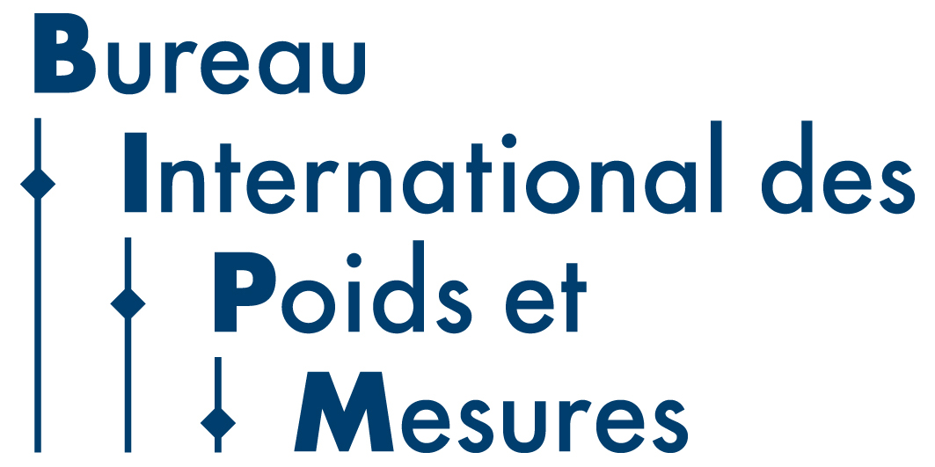

Draft Agenda for the 30th meeting of CCQM – 10-11 April 2025

Venue: Pavillon du Mail, BIPM, Sèvres, France.

Hybrid meeting with on site and online participation

Day 1: Thursday 10 April 2025
CCQM Plenary Session
Chair: Sang-Ryoul Park

Session 1: Opening Session
09.00-09.20 1. Opening of the meeting, welcome and introductions
2. Appointment of a Rapporteur and approval of the agenda
09.20-09.40 3. Opening remarks of the CCQM President and actions from the 29th meeting of the CCQM
09.40-09.50 4. Plans for the 150 year anniversary of the Metre Convention (M.Milton)
4.1 Plans for Metrologia

Session 2: Stakeholder Engagement and Sector Focus
5. Reports from CCQM Task Groups including outcomes of workshops
09.50-10.10 5.1 CCQM Task Group on Food Metrology: Progress Report (J. Melanson)
10.10-10.30 5.2 CCQM Nano- and Microplastics Measurements and Standards Task Group: Report and workshop outcomes (A. Jamting) [CCQM/2025-29]

10.30-11.00 Coffee Break

11.00-11.15 5.3 CCQM Task Group on Metrology for Pandemic Preparedness: Progress Report (J. Braybrook
11.15-11.30 5.4 CCQM Task Group on Metrology for Li-ion Batteries: Progress Report (S. Seitz)
11.30-11.40 5.5 Activities of the CCQM Task Group for gene delivery systems. (J. Braybrook) [CCQM/2025-33]
11.40-12.00 5.6 Discussion on Task Group activities

6. CCQM Workshops and Sector Engagement
12.00-12.15 6.1 Update from the CIPM STG on Climate and Environment (R. Wielgosz) [REPORT]
12.15-12.30 6.2 CCQM Workshop on Digital and FAIR Chemical and Biological Reference Data
and Certificates and proposal for a CCQM Digitalization Task Group (C. Gonzalez) [CCQM/2025-03] [CCQM/2025-04]
12.30-12.45 6.4 CCQM Workshop on Protein Structure and Activity (M. Ryadnov)
12.45-13.00 6.5 Report from the JCTLM (M. Panteghini) [CCQM/2025-09]

13.00-14.00 Lunch

14.00-14.20 6.6 Report from the IFCC (C. Cobbaert)
14.20-14.30 6.7 Discussion on CCQM activities in support of Laboratory Medicine

Session 3: CCQM Strategy, Reports and Committee Activities
7. CCQM Strategy
14.30-14.45 7.1 Progress with update on the CCQM 2021-2030+ strategy (R. Wielgosz)
14.45-14.30 7.2 Discussion on CCQM Strategy updates

8. Reports from the CCQM Working groups
15.00-15.30 8.1 Organic Analysis (M. Fernades-Whaley) [CCQM/2025-34]

15.30-16.00 Coffee Break

16.00-16.30 8.2 Inorganic Analysis (M. Winchester) [CCQM/2025-30]
16.30-17.00 8.3 Gas Analysis (P. Brewer) [CCQM/2025-07] [CCQM/2025-12]
17.00-17.30 8.4 Isotope Ratio (Z. Mester) [CCQM/2025-25]
17.30-18.00 8.5 Surface Analysis (A. Shard) [CCQM/2025-31] [CCQM/2025-36]

18.00-19.00 Reception at BIPM

Day 2: Friday 11 April 2025

09.00-09.30 8.6 Protein Analysis (C. Swart) [CCQM/2025-08] [CCQM/2025-32]
09.30-10.00 8.7 Cell Analysis (J. Braybrook) [CCQM/2025-10] [CCQM/2025-15]
10.00-10.30 8.8 Nucleic Acid Analysis (J. Huggett) [CCQM/2025-35]

10.30-11.00 Coffee Break

11.00-11.30 8.9 Electrochemical Analysis and Classical Methods (S. Seitz) [CCQM/2025-11] [CCQM/2025-17]
11.30-12.00 8.10 Key Comparison and CMC Quality (A. Botha) [CCQM/2025-16]
12.00-12.30 8.11 BIPM Headquarters Program on Metrology in Chemistry (R. Wielgosz) [CCQM/2025-22] [CCQM/2025-23]
12.30-12.40 8.12 CCQM Task Group on KCRV estimation (S. Ellison) [CCQM/2025-38]
12.40-12.50 8.13 ad hoc WG on the mole (R. Brown) [CCQM/2025-06] [CCQM/2025-14]
12:50-13:00 8.14 Approval of proposals for CCQM Comparisons [CCQM/2025-05]

13.00-14.00 Lunch
14.00-14.30 9. CC Governance and Operational Issues
9.1 Questions on ‘Overlapping broad and specific CMCs’ (M. Fenandes-Whaley)
9.2 Issues with transport of comparison samples (C. Swart)
9.3 Future process for rereview of CMCs and CMCs not supported by comparisons (A.Botha)

14.30-15.00 10. Reports from RMOs (AFRIMETS[CCQM/2025-18], APMP[CCQM/2025-19], COOMET[CCQM/2025-21], EURAMET[CCQM/2025-13], GULFMET, SIM[CCQM/2025-27])

15.00-15.30 11. Discussion and questions on written reports from International Organizations in liaison with the CCQM (International Atomic Energy Agency [IAEA] [CCQM/2025-24], European Commission Joint Research Centre [JRC] [CCQM/2025-26], International Union of Pure and Applied Chemistry [IUPAC] [CCQM/2025-37] , ISO TC/334- Reference Materials [CCQM/2025-28], Cooperation on International Traceability in Analytical Chemistry [CITAC] [CCQM/2025-20], International Federation of Clinical Chemistry and Laboratory Medicine [IFCC]

15.30-15.50 12. CCQM Meetings
12.1 CCQM WG meetings to be held in 2025
12.2 Dates CCQM meetings in 2026 and 2027

15.50-16.00 13. Closing remarks from the CCQM President
16.00 Close

