Report from the CCQM Nucleic Analysis Working Group for the period (April 2024 – 2025)

During this period the 18th and 19th CCQM NAWG meetings took place ‘in person’ in Paris (April) and Berlin (October) respectively with 27 institutes represented. Once again, the hybrid format of the meeting allowed more NAWG member to attend with >50 participants present at both meetings. The 19th Meeting hosted by PTB Berlin included the second joint meeting of the biological metrology working groups and their second joint meeting held on the 9th October 2024. This format is planned to be repeated in September 2025 WG meetings hosted by NIST.

The NAWG’s efforts to increase support for CMCs beyond food testing has succeeded through the completion of two new Key Comparisons during this reporting period, representing the first examples of NAWG KCs focussed on clinical valuable analytes for cancer and infectious disease diagnostic testing. The NAWG continues to run a range of KCs and pilot studies to support NMIs with nucleic acid analysis metrology needs to address an increasing range of measurement needs associated with nucleic acid analysis.
Completed Key Comparisons and Pilot Studies
- CCQM K176/P218 (NAWG) Breast cancer biomarker HER2 copy number variation (CNV) measurement
CCQM K176/P218, led by NIM China, with support of NML at LGC represents the first NAWG Key Comparison focusing on nucleic acid analysis of human genetic material (the HER2 gene sequence is an important clinical measurand to guide breast cancer treatment). Ten laboratories participated in CCQM-K176 support participants’ claim for measurement of defined DNA sequence/gene copy number concentration in the range ~10⁴-10⁶ μL⁻¹ and ratio (of a defined target sequence expressed relative to a reference gene sequence) in the range from 1.0 to 40.0.
https://iopscience.iop.org/article/10.1088/0026-1394/61/1A/08017
- CCQM K181/P227 (NAWG) SARS-CoV-2 RNA copy number quantification
CCQM K181/P227 was a follow up study of CCQM P199 and P199.b and focuses on virus RNA sequence copy number concentration measurement to support calibration and measurement claims when measuring viral load, or copy number concentration of RNA molecules containing SARS-CoV-2 (the pathogenic cause of COVID-19) gene sequences. 17 NMIs successfully participated in CCQM-K181 to support CMC claims associated with determining RNA copy number concentration in the range from 10¹ μL⁻¹ to 10⁶ μL⁻¹ SARS-CoV-2 target sequences in a non-target RNA matrix or as a single template in aqueous solution.
The final report for CCQM-K181 is complete and awaiting a DOI

Ongoing Key Comparisons and pilot studies
  - CCQM-K189/P242 Measurement of Single Nucleotide Variation (SNV) and Small Deletion in Cancer Biomarker of PIK3CA and EGFR
The aim of K189 is to measure number concentration and fractional abundance of mixtures of the sequences variants to provide support for CMC claims when measuring variants in purified genomic DNA. The variants in question represent actionable sequences the presence of which is used to guide diagnostic and treatment in lung cancer. These targets are more challenging to measure than those evaluated by K176 (see above) as they must be distinguished from closely related variants that represent the predominant human genome sequence.
The NAWG would like to thank Lianhua Dong and colleagues at NIM China for leading this study with support from Alison Devonshire and colleagues at NML and Young-Kyung Bae and colleagues at KRISS.

  - CCQM P231: The specific meat composition determination of DNA extracted from meat
The study rationale is to support qualitative analysis (species-specific sequence presence/absence ‘nominal property’ examination) by the results of DNA sequence analysis and quantitative analysis of animal species DNA presence using the species-specific gene sequence in a single or mixture of samples which are the lyophilized DNA extract of unknown meat species. This included single species (chicken) and mixtures of different species (pork, goat and horse). CCQM P231 results were presented at the 19th NAWG meeting (Figure 1) and the pilot report drafting is in progress. In all cases the correct species were identified from the respective materials by all participants with most laboratories providing agreed proportions of relative mixtures for the material comprising mixtures of species.
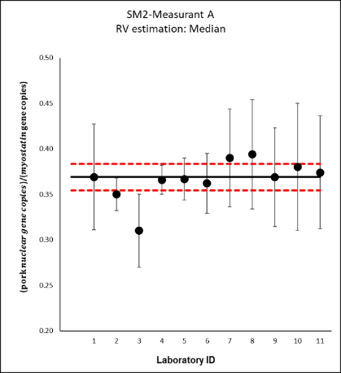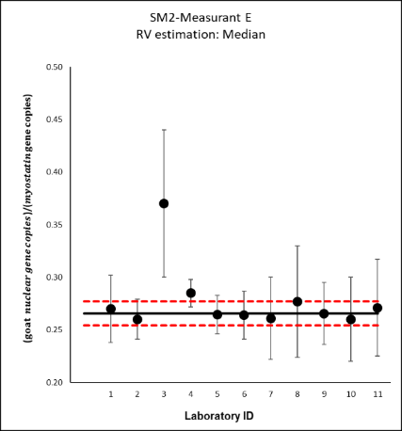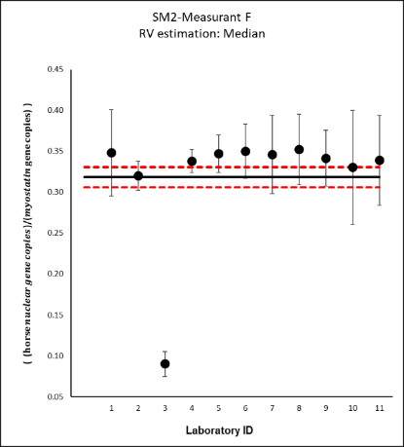
Figure 1. Result from material with mixtures of three different species.
This study differs from previous KCs and pilots studies in food testing area as it introduces the notion of uncertainty when considering identity while also tests participants ability to measure sequence quantity without knowing what species is present in the samples.
The NAWG would like to thank Burhanettin YALÇINKAYA, Müslüm Akgöz and colleagues at Tubitak UME and Phattaraporn Morris and colleagues at NIMT for leading this study.

  - CCQM P94.3 Quantitative analysis of DNA methylation of a defined human genomic DNA region
Nucleic Acid methylation occurs with the addition of a methyl groups to some nucleotides in the Nucleic Acid sequences. This addition is an example of an epigenetic modification that are used as markers for disease progression necessitating reference measurement system to support for the quantitative analysis. This study underscores the importance of validated methods to support low-level DNA methylation analysis and promotes the development of SI-traceable measurement systems for epigenetic biomarkers. Such advancements are particularly relevant in support of evaluation of the performance of diagnostic tests. The NAWG would like to thank Sema Akyürek and colleagues at Tubitak UME and Inchul Yang and colleagues at KRISS for leading study which reflects an increasingly important aspect of nucleic acid analysis and for VNIIM for assisting with the statistical analysis. The final draft of CCQM P94.3 is currently being circulated and the final report is anticipated soon.
  - CCQM K86.d/P133.5 (NAWG) Quantification (and fractional abundance) of genomic DNA extracted from a protein matrix
CCQM K86.d is led by NIMT and Tubitak UME, with statistical support from VNIIM, and expands the K86 series scope by measuring nucleic acids sequences in a high protein meat matrix (a mix of pork and beef) relevant for processed food. While there have been some delays K86.d the draft A has been circulated and the NAWG is grateful to Phattaraporn Morris and colleagues at NIMT , TUBITAK UME and VNIIM for leading this study which is anticipated to be completed in the coming months.
  - CCQM P232: Fire Drill Influenza RNA copy number quantification
The CCQM ‘roadmap to metrology readiness for infectious disease pandemic response’ recommends a series of ‘fire drills’ exercises to explore and develop the capacity within the NMI/DI community to meet the need for fast development of reference measurement procedure in response to rapid diagnostic deployment. A variety of analytes (including antigens, antibodies, nucleic acids) will be planned for the future fire drill activities as they were targeted in the diagnostic response to COVID-19 and are analyte candidates for future outbreaks. CCQM P232 is led by NML at LGC and NIST and represents the first of the CCQM fire drills and targets avian influenza (H5N1) RNA sequences; which are the target analyte of molecular diagnostic methods like PCR. Two different purified RNA sequence synthetic materials (in vitro transcribed gene fragments) were shared with 15 participating laboratories who had to select their in-house assays based on the sequence alone. The NAWG would like to thank Denise O’Sullivan and colleagues at NML at LGC and Megan Cleveland and colleagues at NIST for leading study which will contribute to demonstrating the potential future role for NMIs in supporting pandemic diagnostic response. The drafts of CCQM P232 has been circulated for comment.
  - CCQM NAWG P244: Lipid Nanoparticles with Encapsulated RNA
P244 explores measurements associated with Lipid Nano Particle (LNP) mRNA therapeutics. The first LNP drug was approved in the US in 2018 (Onpattro). In 2020, Covid vaccines using mRNA LNP technology were given emergency use approval. Pharmaceutical companies measure various attributes for LNPs such as size, polydispersity, RNA encapsulation, and RNA content yet these measurements are in their infancy and could benefit from better reference measurement procedures and improved reference materials/standards. P244 is led by NIST, with support from NML, and will explore measurements of mRNA lipid nanoparticles and also includes SAWG and IAWG participation. Materials are currently being distributed for P244 which will allow NAWG members to explore and develop their capacity to assist the growing area of nucleic acid therapeutics including RNA number concentration and LNP encapsulation efficiency measurements. It is anticipated P244 result will be reported in September 2025
  - CCQM-K190/CCQM-P249 and P250: Whole Virus Key comparison and Pilot Study
CCQM-K190 will support NAWG members in making measurement claims for quantification of viral genomic material. This builds on K181 (and the P199 series) by necessitating the measurement of RNA from whole virus and thus represents the first KC measuring a clinically relevant nucleic acid requiring preprocessing and extraction. This KC will include an assessment of the lysis and extraction and will also consider relative measurements performed in the clinic relative to the WHO international standard material. This KC will be led by NML at LCG, MHRA (formerly NIBSC) and NIST and will also begin to explore nucleic acids absolute quantification as the pilot study P250 in the whole biological material matrix as detailed in the NAWG strategy. Materials are currently being characterised (figure 2) and it is anticipated that distribution will occur later in 2025.
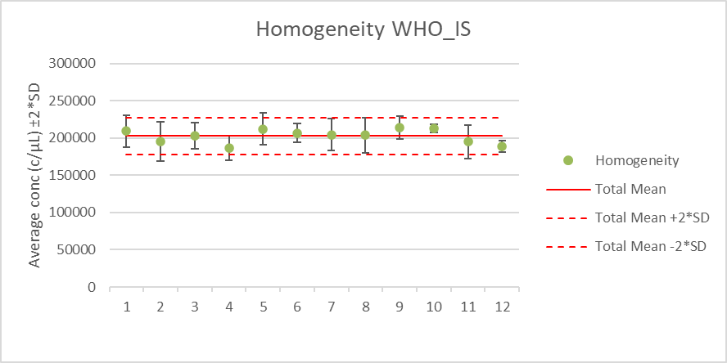
Figure 2. Homogeneity assessment of the 2nd WHO international standard for SARS-CoV-2.This is the first example of such an analysis of a WHO nucleic acid standard by the NAWG. Solid red line corresponds to mean with dashed lines corresponding to ± 2 SD

- Plans for the near and medium future
The NAWG is planning to propose one Key Comparisons be initiated in the 2025-26 period.
This will address the fact that while several of NAWG members have deployed orthogonal methods to explore biases associated with the SI traceability of molecular methods like digital PCR, the NAWG has not conducted any comparisons to allow NMIs to claim associated CMCs for such orthogonal methods. This KC will further enable NAWG members by supporting CMCS to stakeholders making genetic measurements in the areas of precision medicine and pharmacogenomics.
Additional topics for potential activities in the near future include bacterial genome quantification, liquid biopsy analysis as well as the increasingly relevant topic of environmental DNA analysis; many of these topics offer co activities with other working groups.
In addition to future key comparisons and pilot studies, the NAWG continues to explore routes to broaden stakeholder interaction both within and beyond the NMI community. NAWG members are also actively involved in CCQM task groups including Terms, Quantities and Units for Bioanalytical Measurement when considering counting and it is anticipated this will include wider stakeholder interaction.
Jim Huggett and Maxim Vonsky -04-2025

