An Interpretation of CIPM MRA-G-11
Implications and Impacts for CCRI

In 2021 the International Committee for Weights and Measures (CIPM) published a new guidance document concerning the undertaking of measurement comparisons in the context of the CIPM Mutual Recognition Arrangement (MRA). This document, “Measurement Comparisons in the CIPM MRA: Guidelines for Organizing, Participating and Reporting” (CIPM MRA-G-11, https://www.bipm.org/documents/20126 /43742162/CIPM-MRA-G-11.pdf/9fe6fb9a-500c-9995-2911-342f8126226c) effectively derives from parts of previous documents CIPM MRA-D-05 (“Measurement Comparisons in the CIPM MRA”) and CIPM MRA-D04 (“Calibration and Measurement Capabilities in the context of the CIPM MRA”) and supersedes them. Several key points (key comparison reference values are restricted to CIPM/BIPM key comparisons, degrees of equivalence are not mandatory for supplementary comparisons, a measurement result is not complete without its associated measurement uncertainty and accompanying uncertainty budget, etc.) remain and are reiterated. A clarification made in CIPM MRA-G-11 explicitly notes that pilot studies [developmental in nature and not usually considered supportive of calibration and measurement capability (CMC) claims] are not to be registered nor published on the Key Comparison Database (KCDB). Only those institutions participating in the CIPM MRA (https://www.bipm.org/en/cipm-mra/participation) are listed on the public website of the KCDB for any key or supplementary comparison.
Background and Key Points

Differences between the older and the current documents are relatively minor and are mainly focused on clearer language and improved readability. By and large, CIPM MRA-G-11 attempts to codify what had been the practical implementation of CIPM MRA-D-05 within the context of CIPM MRA-D04. Two significant changes in what needs to be included in the technical protocol for key (and, by extension, supplementary) comparisons were adopted based partly on comparison experiences since the establishment of the CIPM MRA:
Technical Protocols Points

- The metrological parameter(s) that need to be measured are to be specified
- A statement indicating which service categories/CMCs can be supported by the comparison, or criteria to identify such categories/CMCs (i.e., ‘how far the light shines’) must be included (and should be reiterated in subsequent comparison reports).
In CCRI, although CIPM MRA-G-11 does not require an RMO (Regional Metrology Organization) supplementary comparison protocol to be reviewed or approved by the corresponding Key Comparison Working Group (KCWG), presenting it to the wider community presents an opportunity for support and suggestions, as well as the possibility to garner interest from other RMOs. Even with no obligation to share an RMO supplementary comparison plan and activities beyond the RMO, the CCRI Section (or through its KCWG) will review (over six weeks) the Final Report for commenting and editorial control before it can be posted on the KCDB. Therefore, it is useful to have the CCRI Section aware of the comparison early in the process. The KCWG (and Section) can also be useful during the Draft B stage should modifications be needed or if results are discrepant.
Participation in CIPM/BIPM key comparisons are restricted to laboratory signatories to the CGPM (https://www.bipm.org/en/member-states) with “the highest technical competence and experience” in the technical field. These are normally member laboratories of the relevant Consultative Committees (CC) or, in the case of the CC for Ionizing Radiation (CCRI), one of the relevant Sections (dosimetry, radioactivity or neutron measurements), to which the invitation to participate in a comparison is sent by the pilot institution (usually via the Executive Secretary). Participation in RMO key comparisons can be broader in that they are open to all RMO members according to the rules of the RMO, including Associates of the CGPM (https://www.bipm.org/en/associates). When results from Associates are included in a comparison, they must be clearly so indicated in reports and generally do not contribute to the reference value (but may do so, especially in supplementary comparisons, if of significant scientific value to the participants).
Participants

CIPM MRA-G-11 specifies (in Section 3.2, “Points for consideration”) that results (although it is not specified that these be final results) should normally be available for CC discussion within 2 or 3 years (by the time of a next meeting). However, considering that the starting date for a comparison is declared by the pilot (or decided-upon among the participants), such a constraint seems difficult to enforce. In any case, CIPM MRA-G-11 strongly encourages a relatively tight timetable for comparisons to be run. CCRI Sections’ comparison timetables tend to be longer due to various factors (including shipping regulations, source availability, etc.). In any case, care must be taken in declaring the starting date for a comparison (for example, the “start” for some comparisons might be considered to be upon actual shipment of an artifact rather than at some predetermined date).
Timetable

CIPM MRA-G-11, like the previous CIPM MRA-D-05, defines the general constraints under which measurement comparisons are organized, performed, and reported. It is clear that the pilot institute [which may be supported by a coordinating group of other National Measurement or Designated Institutes (NMIs/DIs), particularly if this is their first experience as a comparison pilot] is responsible for all of the administrative tasks associated with a comparison (registering, running, and keeping the KCDB updated as to progress). It is the pilot institute which (with assistance from the coordinating group if one has been established) writes the comparison protocol and reports, distributes the Drafts A among participants, submits the Draft B to the relevant committee [the Sections or their KCWGs for CCRI and RMO-key comparisons via the Executive Secretary or, in the case of RMO supplementary comparisons, to the RMO Technical Committee/Metrology Working Group (TC/MWG) via the relevant chairman] for review, and, once the Draft B is approved, submits the now-Final Report to the KCDB. The pilot institute also presents any planned RMO-key comparison (including the general protocol and anticipated participants), either before or after registering on the KCDB, to the relevant CCRI Section (via the KCWG as appropriate).
Coordination and Reporting

RMO Key Comparisons are intended to be linked back to a corresponding CIPM/BIPM Key Comparison (as stipulated in Section 2) and are therefore treated in the same way (except for the selection of pilot institution and of participants) as if they were CCRI Key Comparisons (i.e., follow the usual procedures). Note that, in CCRI, there are also both CCRI/BIPM and RMO supplementary comparisons; CCRI/BIPM supplementary comparisons are treated in the same way as CCRI/BIPM key comparisons in presentation to, and approval from, the relevant Section (generally through the corresponding KCWG). CIPM MRA-G-11 places the specific role of the CC in the processing of an RMO supplementary comparison (for comment and editorial control) only at the final report stage; approval of RMO supplementary comparisons (in addition to assignation of pilot and selection of participants) is given by the RMO committee (TC or MWG) and does not require approval by the CC.
Procedures

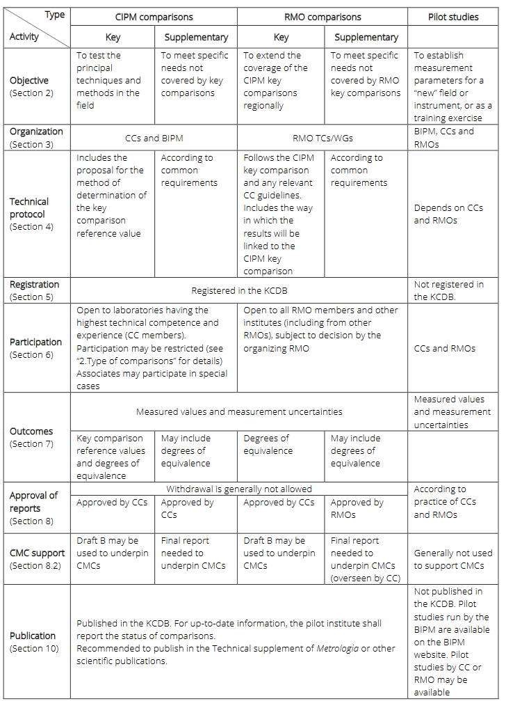
CIPM MRA-G-11 succinctly summarizes the specifications of the various types of comparisons (Key, Supplementary and pilot, whether under the CIPM/BIPM or the RMOs) run within the framework of the CIPM MRA:
Summary
Su
- Pilot Institute (with possible coordinating group)
  - Comparison proposal (to KCWG/CCRI Section)
  - Call for participants (through Exec Sec)
  - Recipient of results (may request 3rd party)
  - Report preparation
  - Document sharing (through Exec Sec)
  - Update KCDB
- Participants (key and supplementary)
  - CCRI/BIPM: CIPM members
  - RMO: CIPM members/associates/others
  - Submit results to pilot institution
- Approvals
  - CCRI(Section): all key, CCRI supplementary
  - RMO: RMO supplementary (may request CCRI Section support)
- CMC Support
  - Draft B for Key Comparisons
  - FINAL report for Supplementary Comparisons

CIPM MRA-G-11, while not changing how comparisons are to be run in CCRI (for example, how to handle results that conflict with published CMCs) systematically codifies the expectations for a rigorous comparison (i.e., one meeting the stringent rules as set out by the CIPM MRA). Of particular note is the new (compared to CIPM MRA-D-05) requirement to include a statement of CMC support in the protocol; this statement should be reiterated in follow up reports. Although the Pilot Institute has a large job and is responsible for all aspects (other than participants’ individual efforts) of a comparison, the relevant KCWG, members of the appropriate Section (especially the Executive Secretary), and (if desired) a coordinating group of experts are available for guidance and support. Finally, the difference between the planning and review processes for all Key and CCRI/BIPM Supplementary comparisons (ultimately done at the KCWG/CCRI Section level) and that for RMO Supplementary comparisons (the CIPM MRA-G-11 states only a 6-week review by the KCWG/CCRI Section but with final approval by the RMO) must be kept in mind; the KCWG/CCRI Sections are available to assist in RMO Supplementary comparisons, but this is not required. Nevertheless, to be assured that a comparison will be acceptable to CMC reviewers as valid support, RMOs are encouraged to work with the relevant KCWG or directly with the Section from early in the process.

